**Round Top Church Christian Fellowship**

**Resurrection Series**

Acts of the Holy Spirit - Acts 8:5-25

By Faith: Saul, Philip, Peter and John

October 13th, In the Year of Our Lord 2024

Pastor Matthew Diehl

(All Scripture is from the New American Standard Bible, unless otherwise noted.)

Sermon Audio and Texts: roundtopchurch.org / Under Member’s tab

Note: Final version of sermon is posted with possible additions.

Email questions to Pastor: [rtchurch@cvctx.com](mailto:rtchurch@cvctx.com)

For our visitors, we will continue the sermon series in the book of Acts.The Gospel writer Luke wrote Luke and Acts chronicling major events in the infancy life of the Way (name of the early church - Acts 9:2). As we read the texts of our sermon today, we need to keep in mind the introduction Luke writes in the beginning of the book of Acts of the Holy Spirit in the lives of the Apostles and followers of Jesus.

**Acts 1:1** The first account I composed, Theophilus, about all that Jesus began to do and teach,

2 until the day when He was taken up *to heaven*, after He had by the Holy Spirit given orders to the apostles whom He had chosen.

3 To these He also presented Himself alive after His suffering, by many convincing proofs, appearing to them over *a period of* forty days and speaking of the things concerning the kingdom of God.

4 Gathering them together, He commanded them not to leave Jerusalem, but to wait for what the Father had promised,

"Which," *He said*, "you heard of from Me; 5 for John baptized with water,

but you will be baptized with the Holy Spirit not many days from now."

6 So when they had come together, they were asking Him, saying,

"Lord, is it at this time You are restoring the kingdom to Israel?"

7 He said to them,

"It is not for you to know times or epochs which the Father has fixed by His own authority; 8 but you will receive power when the Holy Spirit has come upon you; and you shall be My witnesses both in Jerusalem, and in all Judea and Samaria, and even to the remotest part of the earth."

9 And after He had said these things, He was lifted up while they were looking on,

and a cloud received Him out of their sight.

10 And as they were gazing intently into the sky while He was going,

behold, two men in white clothing stood beside them.

11 They also said,

"Men of Galilee, why do you stand looking into the sky?

This Jesus, who has been taken up from you into heaven, will come in just the same way as you have watched Him go into heaven."

12 Then they returned to Jerusalem from the mount called Olivet,

which is near Jerusalem, a Sabbath day's journey away.

**Today we are in Acts 8, starting with God’s Holy Spirit acting in Philip**.

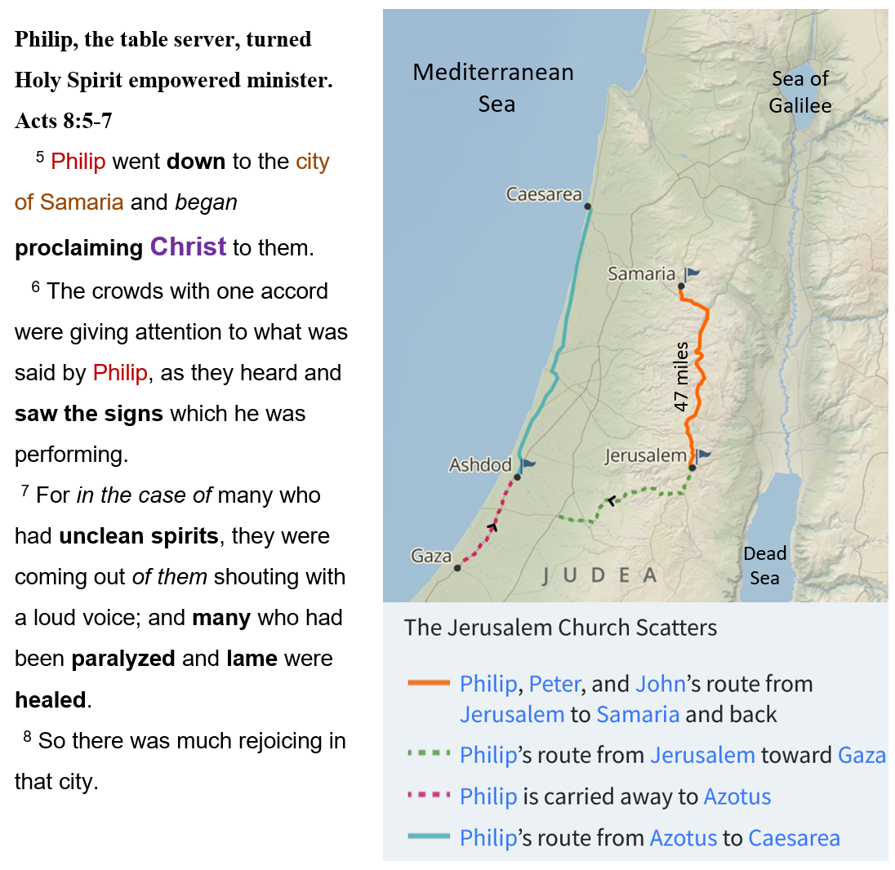

Acts 8 details Philip’s mission to Samaria. Therefore, there needs to be clarity in understanding the significance and detail of the *Way* expanding into Samaria. The Samaritans were not viewed favorably by the Jews. Remember, the *Samaritan woman at the well* (John 4), whom, by Jewish culture, Jesus was not supposed to be talking with her. And the Parable of the *Good Samaritan* (Luke 10:33) highlighted the disdain the Jews had for the Samaritans which is why Jesus named them in His account.

The Samaritans are a group that occupied the Promise Land during the Babylonian captivity which lasted seventy years (606 B.C. - 536 B.C.). These years are based upon the first deportation to Babylon. . . to the first altar sacrifice at the Feast of Booths upon the Jews returning to Jerusalem. The Temple itself was not complete and dedicated until 515 B.C. The Babylonian captivity was a result of God judging Israel for not keeping the Sabbath year for a span of 430 years. In the Sabbath year, the Hebrews were to rest the land (Leviticus 25:4, Exodus 23:11). However, they did not. Of course, there were many other rebellious things the Hebrews did in violation of God’s Law code. The ignoring of the Sabbath rest led to many other rebellious behaviors.

**Jeremiah 25:8-12**

8 "Therefore, thus says the LORD of hosts, 'Because you have not obeyed My words,

9 behold, I will send and take all the families of the north,' declares the LORD, 'and *I will send* to Nebuchadnezzar king of Babylon, My servant, and will bring them against this land and against its inhabitants and against all these nations round about; and I will utterly destroy them and make them a horror and a hissing, and an everlasting desolation.

10 'Moreover, I will take from them the voice of joy and the voice of gladness, the voice of the bridegroom and the voice of the bride, the sound of the millstones and the light of the lamp.

11 'This whole land will be a desolation and a horror, and these nations will serve the king of Babylon seventy years.

12 'Then it will be when seventy years are completed, I will punish the king of Babylon and that nation,' declares the LORD, 'for their iniquity, and the land of the Chaldeans; and I will make it an everlasting desolation.

Now, concerning the Samaritans and how they fit into the New Testament narrative. . . it is commonly taught by biblical scholars that historian Josephus and Jewish tradition assign Samaritan origins to the time of the Northern kingdom’s occupation under the Assyrians and their final destruction by them by 721 B.C. The remnant of Jews left in the northern kingdom intermarried with Assyrians, thus producing a half-Jewish, half-Gentile race called Samaritans. During the time of the Babylonian captivity, the Samaritan’s developed their own sect and claimed that they possessed the pure Tora, (Samaritan Pentateuch) the Law God gave to Moses and built a Temple on Mount Gerizim with a claim that they were the true covenant people, and the Jerusalem Temple and its leaders were not pure. Today, it is reported that there are about eight-hundred (800) Samaritans alive. . .half living in Holon (south of Tel Aviv) and the other half on mount Gerizim. So, by the time of Jesus’ ministry years, the Jews had despised Samaritans for a few hundred years from the time of the return from Babylon in the 5th century B.C. Therefore, the Jews would have nothing to do with them.

From reading Acts 8:5-7, we see that Philip, who was qualified to be a table server, by being full of wisdom and the Spirit of God,. . . had matured in spirit to the point that demons were coming out of people in his presence, and many who had been paralyzed and lame were being healed. This is no surprise. We reflect back to Jesus’ words in John 14.

**John 14:12-17**

12 "Truly, truly, I say to you, he who believes in Me,

the works that I do, he will do also;

and greater *works* than these he will do;

because I go to the Father.

**14 This is the confidence which we have before Him, that,**

**if we ask anything according to His will, He hears us. (1 John 5:14)**

13 "Whatever you ask in My name,

that will I do, so that the Father may be glorified in the Son.

14 "If you ask Me anything in My name, I will do *it*.

15 "If you love Me, you will keep My commandments.

16 "I will ask the Father,

and He will give you another Helper, that He may be with you forever;

17 *that is* the Spirit of truth, whom the world cannot receive,

because it does not see Him or know Him,

*but* you know Him because He abides with you and will be in you.

From the verses, we receive a clear biblical application of all the elements that must be in place to accomplish ministry goals for God, like Philip in Acts 8. Here is a list of seven elements that must be present and at work to manifest the works such as with Philip.

1. Believe in Jesus and the works that He does.

(Teaching, Miracles, Resurrection, Ascension, Return to Judge)

1. The words “I go to the Father” means believe that Jesus ascended to the Father after the 40-day resurrection ministry.
2. Asked in the name of Jesus – So the Father is Glorified not the one using the gifts.
3. Believers keep the commandments of Jesus, highlighting their love for Him.
4. The Spirit of Truth is the Helper who is “exclusively” with Believers forever.
5. Those who do not see or know the “Spirit of truth” have not received the Spirit.
6. The Spirit abides in Believers because the Spirit knows them.

Philip’s use of God’s Spiritual gifts glorifying Him drew the attention of many people including a man named Simon, who was a well-known magician. However, Simon attempted to use God’s spiritual power for personal glorification, fame and financial gain. It is revealing that we just finished the sermon series on the *Word of Faith Movement* and their aberrant theology who are modern-day Simons. Let us read the account and receive the truth in God’s Word.

**Simon the “Prosperity Practitioner” sought to claim & name fame for himself.**

**Acts 8:9** Now there was a man named Simon,

who formerly was practicing magic in the city

and astonishing the people of Samaria,

claiming to be someone great;

10 and they all, from smallest to greatest, were giving attention to him, saying,

"This man is what is called the Great Power of God."

11 And they were giving him attention

because he had for a long time astonished them with his magic arts.

12 But when they **believed** Philip preaching the good news about

the kingdom of God and the name of Jesus Christ,

they were **being baptized**, men and women alike.

13 Even Simon himself **believed**; and after **being baptized,**

he continued on with Philip,

and as he observed signs and great miracles taking place,

he was constantly amazed.

There are so many things wrong with Simon, beginning with his claim to be great based upon his own powers. Simon’s work was inconsistent with and totally contrary to the seven elements (page 5) that empowered Philip. Simon did not believe in Jesus and His works. Simon did not work under Jesus’ name, keep the commands of Jesus, or know the Holy Spirit. Simon only believed in himself, having selfish motives he sought to deceive people while turning a profit. Simon’s tricks did not help anyone. . . just entertain them. Simon’s popularity was based on entertaining people and not improving their day-to-day life or their eternal life with God. Simon’s perceived power originated in him.

Philip’s power and authority only came from God. Without God empowering Philip, the things people saw him do would not happen. Simon basked in the attention he received especially with his followers who attributed to him “the great power of God”. It is evident that Simon was skilled in the magic arts of his day because he was astonishing people. However, like magician shows today, there are the tricks-of-the-trade that a skilled magician knows that makes him appear to stand apart from the known laws of physics. When Simon saw the miracles, he thought Philip was doing, he wanted part of the action. Simon did not realize that it was God at work through Philip. Simon witnessed something that was not a slight-of-hand or tricks-of-the-trade application of which he had knowledge. In reality, God’s Spirit at work in the Apostles and His followers overshadows all of fallen man’s abilities.

In addition, Simon lost his audience because people believed what Philip was preaching about the kingdom of God and the name of Jesus Christ. There was such a response that people were being water-baptized as a sign and symbol of turning and surrendering their hearts to the Good New of Jesus Christ. It is important to observe that when Philip first came to Samaria that people were healed, and unclean spirits were departing from his presence. However, it was not until Philip preached the Good News about the kingdom of God and the name of Jesus Christ that people witnessed their heart-surrendered faith in/by water-baptism. The point being. . . it was not the seeing evil spirits flee or the healings, it was upon hearing the Good News of Jesus Christ when they responded in faith that gave them forgiveness of sin and eternal life. And, yes, Simon too. . . Scripture tells us he believed and was water-baptized. But as we will see. . . Simon’s witness in water-baptism may have been motivated by his desire to possess and use the power he saw in Philip, and not because he had a heart-felt surrender to God. The evidence we see in Scripture is that Simon believed in the power not the power Maker. Jesus said:

"For the gate is small and the way is narrow that leads to life, and there are few who find it.

"Beware of the false prophets, who come to you in sheep's clothing, but inwardly are ravenous wolves.

"You will know them by their fruits.

Grapes are not gathered from thorn *bushes* nor figs from thistles, are they?

"So every good tree bears good fruit, but the bad tree bears bad fruit.

"A good tree cannot produce bad fruit, nor can a bad tree produce good fruit.

"Every tree that does not bear good fruit is cut down and thrown into the fire.

"So then, you will know them by their fruits.

"Not everyone who says to Me, 'Lord, Lord,' will enter the kingdom of heaven,

but he who does the will of My Father who is in heaven *will enter*.

Matthew 7:14-21

Soon we will see the fruit of Simon.

Now with all this news of Samaritans converting to the Good News of Jesus Christ, there was a report back to Jerusalem and the apostles. . . who, by their response, had great concern in the process of how this was taking place. So much concern. . . that two of the leading apostles, being Peter and John, were dispatched to Samaria. Remember, the Samaritans were not part of the religious Jewish system headquartered in Jerusalem. We must also remember the experiences of Peter and John with Jesus and their own salvation conversions as we review the events unfolding in Samaria.

**Acts 8:14** Now when the apostles in Jerusalem

heard that Samaria had received the word of God,

they sent them Peter and John,

15 who came down and prayed for them that they might receive the Holy Spirit.

16 For He had not yet fallen upon any of them;

they had simply been baptized in the name of the Lord Jesus.

17 Then they *began* laying their hands on them, and they were receiving the Holy Spirit.

Peter and John were eyewitnesses to the life-ministry of Jesus Christ for three and one-half years. Peter and John were Believers during Jesus’ ministry time. . .which meant they had surrendered to God as Jesus Christ. . .who is the Holy Spirit. Remember that Jesus imparted (Breathed) His Spiritual presence into the apostles (John 20:21-22) because He was not going to physically be with them after He ascended. This was the one and only transitional time in the history of man’s relationship with the incarnate God that this took place. So, Peter and John were “saved” (born again - John 3:16) with God’s/Jesus’ Spirit within them but had not received functioning gifts of the Spirit until Pentecost as Jesus said they would receive (Acts 1:5-8).

And they were all filled with the Holy Spirit and began to speak with other tongues,

as the Spirit was giving them utterance. (Acts 2:4)

From Peter and John’s own experience, and from what we are to read in Acts, we see that God’s Holy Spirit. . .first, it convicts people of their sin (John 16:8) leading to salvation, and then second, He impowers them with spiritual gifts to be used in an outward manifestation. We also see this in Acts 2:38, with Peter’s Holy Spirit preaching that convicted the Jews first, who responded with a cut-heart. . .surrendered to Christ and then they received the gift of the Holy Spirit. The Holy Spirit gifting was to be used to correctly fulfill the Great Commission. This is why Peter and John came to Samaria. They wanted to make sure there was a clear understanding of how God operated within Believers. And to oversee the unity between the Believers in Samaria with the Jerusalem leadership, which was led by James, Jesus’s half-brother.

I want to be clear that from reviewing all the conversion experiences in the book of Acts. . . they do not all have the same order regarding heart-cut-surrender, water-baptism then Holy Spirit gifting. It is true that they all started with a heart-cut-surrender or *circumcision of the heart* (Deut. 30:6-9) by and to God. But, note that with Peter’s Holy Spirit preaching at Cornelious’s house (Acts 10), the Gentiles (not Jews), listening to the Word of God, were convicted of their sin and started speaking in tongues before Peter finished. In other words, Peter did not give an altar call nor had these Gentiles been water-baptized. After Peter witnessed their Holy Spirit gifting as they spoke in tongues, Peter said . . . “Surely no one can refuse the water for these to be baptized who have received the Holy Spirit just as we *did*, can he?" And he ordered them to be baptized in the name of Jesus Christ. Then they asked him to stay on for a few days. (Acts 10:47-48).

We see the order is different with Peter on two different occasions. This highlights Jesus’ teaching to Nicodemus in John 3. . ."Do not be amazed that I said to you, 'You must be born again.' "The wind blows where it wishes and you hear the sound of it, but do not know where it comes from and where it is going; so is everyone who is born of the Spirit."

(John 3:7-8)

In addition to spiritual gifting, there are other elements that need to be considered for Peter and John to travel to Samaria. Remember that with the Spirit-Commissioning in John 20, Jesus also charged and empowered the apostles “and all Believers” to witness the Good News by telling people that they can be forgiven of their sin, and, at the same time, if they do not surrender to God. . .then their sins will not be forgiven (John 20:23). This commissioning was not exclusively given to just the eleven Apostles. We see the Old Testament prophets, and Paul, also telling people they can be forgiven of their sins. Obviously, the Old Testament prophets and Paul were not present at the

Commissioning recorded in John 20. This is an issue because some religious institutions claim that only the eleven Apostles received the commissioning to tell people they can be forgiven of their sins.

**Peter himself declares** "Of Him all the prophets bear witness that through His name everyone who believes in Him receives forgiveness of sins." Acts 10:43

**Paul, who was not present in John 20 when Jesus commissioned the eleven, speaks** **in** **Acts 13:38** "Therefore let it be known to you, brethren, that through Him forgiveness of sins is proclaimed to you, 39 and through Him everyone who believes is freed from all things, from which you could not be freed through the Law of Moses.

**Act 16:4** Now while they were passing through the cities, they were delivering the decrees which had been decided upon by the apostles and elders who were in Jerusalem, for them to observe.

These Scriptures reveal that Jesus’ Great Commissioning included all Believers who can tell people that they can be forgiven or not forgiven of their sin depending on their heart-surrender to God. The laying on of hands (Acts 8:17) was a display of solidarity with the leadership in Jerusalem. There was no spiritual power derived from within Peter and John that they were passing on to the Samaritans. God’s spiritual power is from Him not man. Simon wrongly perceived the origin of God’s spiritual power was within Peter and John that he could purchase. Now, let us read the remaining account of Simon and the fruit of his spiritual life.

18 Now when Simon

saw that the Spirit was bestowed through the laying on of the apostles' hands,

he offered them money, 19 saying,

"Give this authority to me as well,

so that everyone on whom I lay my hands may receive the Holy Spirit."

20 But Peter said to him,

"May your silver perish with you,

because you thought you could obtain the gift of God with money!

21 "You have no part or portion in this matter, for your heart is not right before God.

22 "Therefore, repent of this wickedness of yours, and pray the Lord that, if possible,

the intention of your heart may be forgiven you.

23 "For I see that you are in the gall of bitterness and in the bondage of iniquity."

24 But Simon answered and said,

"Pray to the Lord for me yourselves,

so that nothing of what you have said may come upon me."

25 So, when they had solemnly testified and spoken the word of the Lord,

they started back to Jerusalem,

and were preaching the gospel to many villages of the Samaritans.

**AMEN**