Round Top Church Christian Fellowship
Sermon
The Incarnation – Part V
Shepherd My People. . . To The Ends of the Earth
Micah 5:2-4
December 31st, In the Year of Our Lord 2023
Pastor Matthew Diehl
(Unless otherwise noted, NAS is quoted – New American Standard Bible)

Read and/or print sermon notes from our website – roundtopchurch.org

We start a new calendar year tomorrow…being January 1, 2024. As our traditional New Year’s Eve falls on the Lord’s Day (Sunday) and the last day of the two-thousand and twenty-third year since the Messiah’s birth. (I know, this calculation excludes Dionysius’ Calendar error. . . but we move forward.)
I see that it is fitting to have the refreshing spiritual observation of the birth of Jesus Christ with the start of the new year. I mean, why not make your New Year’s Eve Resolution to grow in your understanding of the life of Jesus, the Christ (Greek) Messiah (Hebrew).
So, I think a good and life-changing resolution is to become more knowledgeable about Jesus, including His life and times.
A new life, a baby boy was born in the outlying regions of the Roman empire. . .where in the grand affairs of the world, no one should have noticed. And, if it were not for the local leaders looking over their shoulder for someone creeping up behind them to take their throne, we may not have the historical documentation we have regarding the challenge to world leaders this innocent new-born babe would have. Let us look into the affairs of King Herod and the worldview of 1st c. Judaism chronicled in the Matthew’s Gospel.
Essential elements to these six verses:
After Jesus’s birth Bethlehem of Judea
King Herod King of the Jews
Magi inquiry Astronomical observations
Religious leaders All Jerusalem
Micah the prophet
Matthew 2:1-6
1 Now after Jesus was born in Bethlehem of Judea in the days of Herod the king, magi from the east arrived in Jerusalem, saying,
2 "Where is He who has been born King of the Jews?
For we saw His star in the east and have come to worship Him."
3 When Herod the king heard this, he was troubled, and all Jerusalem
with him.
4 Gathering together all the chief priests and scribes of the people,
he inquired of them where the Messiah was to be born.
5 They said to him, "In Bethlehem of Judea; for this is what has been
written by the prophet:

6 'AND YOU, BETHLEHEM, LAND OF JUDAH, ARE BY NO MEANS LEAST AMONG THE LEADERS OF JUDAH; FOR OUT OF YOU SHALL COME FORTH A RULER WHO WILL SHEPHERD MY PEOPLE ISRAEL.'" (Micah 5:2)

Most people read verses 1 - 6 and get the idea that King Herod did not want to be replaced. This is correct, but there is more here than a passive reading provides. Verse 3 reveals that King Herod was troubled “and all Jerusalem with him”. So much so that King Herod called for the highest-ranking leaders from the Temple that were over the people. The fact that King Herod had to do this indicates he did not know Jewish history. In fact, Herod did not have a centuries-long Jewish pedigree.
Herod’s Jewish identity was always a sore point; he was simply not Jewish enough for most of his reluctant subjects. The Gospel of Matthew (2:1–20), the Talmud (b. Baba Batra 4b), and even Josephus (Ant. 17:304–308) at times, label Herod as a cruel king whose legitimacy to the throne was questionable, at best. The Sages, writing centuries after Herod’s lifetime, describe Herod as being the “Hasmonean slave,” showing how Jewish tradition doubted Herod’s Jewishness.

Certainly, his ethnic and religious background was complicated: On his father’s side, he was an Idumean-Jew, from a family of Idumean converts; on his mother’s side, he was Nabatean—his mother was a Nabatean Princess—an Arabic tribe in southern Jordan (near Petra).[4] Moreover, as an aristocrat in Judea, he had both a Hellenistic and a Jewish upbringing; it is no wonder he had a complicated relationship with religious identity.
https://www.thetorah.com/article/how-jewish-was-herod
But the people in Jerusalem and the religious leaders knew all too well the significance of God’s prophet Micah. Reading Micah 5:2 by itself in a singular context is not alarming. However, in the context of Micah’s setting in Jewish history and the words God declared through his pen is most alarming to anyone who knew the significance of Micah 5:2, 9.

Micah prophesied (762-680 BC.) during the reigns of kings Jotham, Ahaz, and Hezekiah of Judah. Hezekiah ruled from 728 to 687 BC. Micah was active in Judah from before the fall of Israel in 722 BC to the Assyrians and experienced the devastation brought by Sennacherib's invasion of Judah in 701 BC. Micah was from Moresheth, (Moresheth-Gath), a rural small town in southwest Judah. Micah rebuked the corruption of city life in Israel and Judah. The target of his message was towards the privileged classes. Micah was a contemporary of the prophets Isaiah, Amos, and Hosea. Jeremiah, who prophesied about thirty years after Micah, recognized Micah as a prophet. https://en.wikipedia.org/wiki/Micah_(prophet)

Let us read from Micah 5:3-15 to receive the prophetic message that was extremely impactful upon King Herod, the Temple leadership and the Jewish people.

Micah 5:3-15 Therefore He will give them up until the time When she who is in labor has borne a child. Then the remainder of His brethren Will return to the sons of Israel.
4 And He will arise and shepherd His flock In the strength of the
LORD, In the majesty of the name of the LORD His God. And they will remain, Because at that time He will be great To the ends of the earth.
5 This One will be our peace. When the Assyrian invades our land,
When he tramples on our citadels, Then we will raise against him Seven shepherds and eight leaders of men.
6 They will shepherd the land of Assyria with the sword, The land of
Nimrod at its entrances; And He will deliver us from the Assyrian
When he attacks our land And when he tramples our territory.
7 Then the remnant of Jacob Will be among many peoples Like dew
from the LORD, Like showers on vegetation Which do not wait for man Or delay for the sons of men.
8 The remnant of Jacob Will be among the nations, Among many
peoples Like a lion among the beasts of the forest, Like a young
lion among flocks of sheep, Which, if he passes through, Tramples down and tears, And there is none to rescue.
9 Your hand will be lifted up against your adversaries, And all your
enemies will be cut off.
Note here. . . that the remnant of Jacob will defeat its adversaries, but then there is a shift in focus to the judgement of the remnant themselves. . . it is not the enemies of Judah/Israel that will judge them, but it is God.
10 "It will be in that day," declares the LORD,
"That I will cut off your horses from among you And destroy your
chariots.
11 "I will also cut off the cities of your land And tear down all your
fortifications.
12 "I will cut off sorceries from your hand, And you will have fortune-
tellers no more.
13 "I will cut off your carved images And your sacred pillars from
among you, So that you will no longer bow down To the work of your hands.
14 "I will root out your Asherim from among you And destroy your
cities.
15 "And I will execute vengeance in anger and wrath On the nations
which have not obeyed."
So, and therefore, Herod learned the significant prophetic context of Micah 5:2 of which the religious leaders and the real Jewish population already knew. This unknown babe, born in the manger due to no room at the Inn, was the Messiah that will usher in the prophetic words of Micah who prophesied over seven-hundred (700) years prior. These prophetic words declared God’s own judgement upon the people. It is not too large a leap to historically connect the words of Jesus to Micah 5 (Matthew 24:1-2). . . Truly I say to you, not one stone here will be left upon another." Jesus was referring to the Temple. The fulfillment of those words took place when the Romans destroyed the Temple in 70 AD. To this day, only the foundation stones are left as a remnant of the Temple. This is the outer western wall of the Second Temple courtyard, where Jews can pray (known as the Wailing Wall). Micah 3:12 also declared the destruction of the “First” Temple which did happen in the Babylonian conquest and captivity time (586 BC.) In Jesus’ time, scholars refer to the Jerusalem Temple as the “Second Temple” dedicated by 515 BC after the return from Babylon.
We can conclude from the context of Micah’s prophecy that the religious leaders and the Jewish people knew that the person of the Messiah was tied to God’s judgement and the destruction of the Temple.
With this said. . . the main mission of the Incarnation in the 1st c. was to go to the Cross and pay the price for the sins of the world in order to make salvation from sin and eternal life with God possible.

1 John 4:14 ESV And we have seen and testify that the Father has sent his Son to be the Savior of the world.
1 John 2:2 ESV He is the propitiation for our sins, and not for ours only but also for the sins of the whole world.
Luke 19:10 ESV For the Son of Man came to seek and to save the lost.”
Matthew 1:21 ESV She will bear a son, and you shall call his name Jesus, for he will save his people from their sins.” (1 Timothy 1:15)

Jesus’ atoning sacrificial act opened the door to salvation, because no one else could have accomplished the same goal. God did what fallen mankind could not. The Messiah’s Cross affords all people an opportunity to surrender their hearts to God. “For everyone who calls on the name of the Lord will be saved (Romans 10:13). This teaching does not stand alone. Anyone can repeat these words. The sincere person calls out to God to change their life. . .not to get an insurance policy. Those who love Jesus keep His commandments (John 14:15). Since the Fall (Genesis 3), at some point in human history, the Cross had to happen.
Then, at the end of the Age, Jesus Christ is united with Believers to be with Him for an eternity (Revelations 21:1-7).
Hebrews 9:28 so Christ, having been offered once to bear the sins of many, will appear a second time, not to deal with sin but to save those who are eagerly waiting for him. ESV

Back to Matthew 2:7-23
Herod deceived Magi and plotted to kill baby Jesus.
7 Then Herod secretly called the magi and determined from them the
exact time the star appeared.
8 And he sent them to Bethlehem and said, "Go and search carefully
for the Child; and when you have found Him, report to me, so that I too may come and worship Him."

Magi found baby Jesus and gave gifts.
9 After hearing the king, they went their way; and the star, which they
had seen in the east, went on before them until it came and stood over the place where the Child was.
10 When they saw the star, they rejoiced exceedingly with great joy.
11 After coming into the house they saw the Child with Mary His
mother; and they fell to the ground and worshiped Him. Then, opening their treasures, they presented to Him gifts of gold, frankincense, and myrrh.

God warned Magi and Joseph through an angel in a dream.
12 And having been warned by God in a dream not to return to Herod,
the magi left for their own country by another way.
13 Now when they had gone, behold, an angel of the Lord appeared to
Joseph in a dream and said, "Get up! Take the Child and His mother and flee to Egypt, and remain there until I tell you; for Herod is going to search for the Child to destroy Him."
14 So Joseph got up and took the Child and His mother while it was
still night, and left for Egypt.
15 He remained there until the death of Herod.
This was to fulfill what had been spoken by the Lord through the prophet: "OUT OF EGYPT I CALLED MY SON." (Hosea 11:1)

Herod’s plot spoiled but murdered all male children under two years of age.
16 Then when Herod saw that he had been tricked by the magi, he
became very enraged, and sent and slew all the male children who were in Bethlehem and all its vicinity, from two years old and under, according to the time which he had determined from the magi.
God’s prophecy through Isaiah is fulfilled.
17 Then what had been spoken through Jeremiah the prophet was
fulfilled:

18 "A VOICE WAS HEARD IN RAMAH, WEEPING AND GREAT MOURNING, RACHEL WEEPING FOR HER CHILDREN; AND SHE REFUSED TO BE COMFORTED, BECAUSE THEY WERE NO MORE." (Jeremiah 31:15)
Note: From Jerusalem, Herod ordered all the male children to be murdered not only in Bethlehem but also included the “vicinity” which encompassed Ramah. Both towns are within eight (8) miles of Jerusalem.

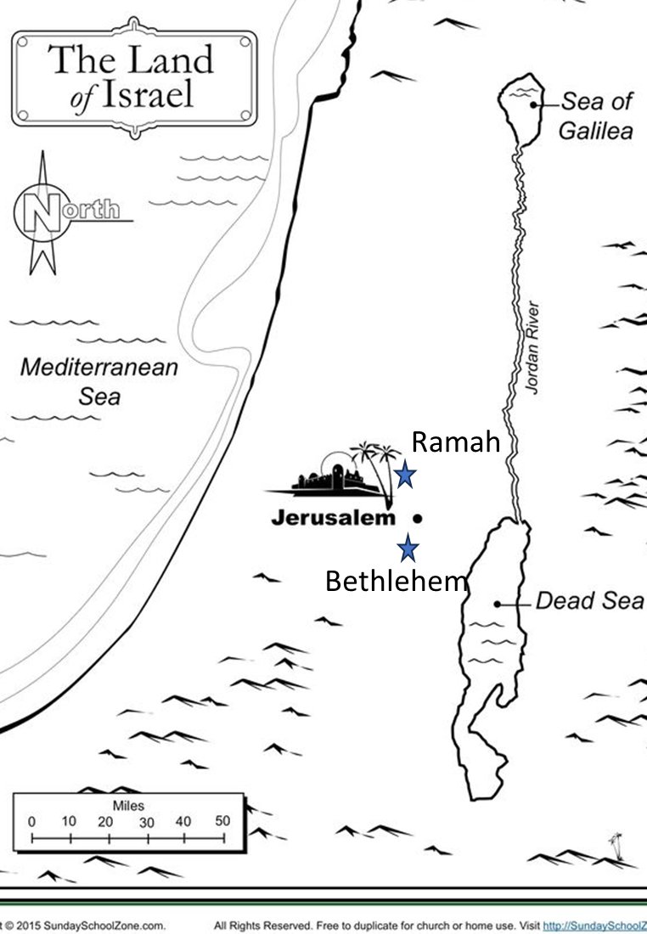
Herod died. God’s angel directed Joseph in a dream to go back to Israel, then Nazareth in Galilee.

19 But when Herod died, behold, an angel of the Lord appeared in a
dream to Joseph in Egypt, and said,
20 "Get up, take the Child and His mother, and go into the land of
Israel; for those who sought the Child's life are dead."
21 So Joseph got up, took the Child and His mother, and came into the
land of Israel.
22 But when he heard that Archelaus was reigning over Judea in place
of his father Herod, he was afraid to go there. Then after being
warned by God in a dream, he left for the regions of Galilee,
23 and came and lived in a city called Nazareth.
This was to fulfill what was spoken through the prophets:
"He shall be called a Nazarene."
(a Despised person: Psalm 22:6–7 and Isaiah 53:3)
Summation
What a story, I mean this account reveals the core aspect of human emotion and sin. Herod’s pride (the root of all sin), Jesus’s birth, Herod’s death, the murder of innocent children, the fear of the religious leaders and the people, faith of the Magi, the faith commitment and obedience to God in Joseph leading his wife Mary, God communicating through angels and dreams, Old Testament prophecy fulfilled, human suffering and weeping, spiritual encounters with God and more.
This account also highlights God’s outreach to the greatest human need. . . to be loved unconditionally despite human rejection. This is why John 3:16 is so powerful. . . For God So loved the world. We can try to place ourselves in God’s perspective but will fall short. However, think of your efforts to help someone who did not realize they needed help. I mean the kind of help that would keep them alive. I likened what God did in the Incarnation to calling-out to a blind and deaf man walking at night, who unknowingly is on a path that ends at a drop-off ledge to the abyss and all you can do is watch. But then. . . we are not God, and He has bottomless patience and waits for anyone to call on His name not wanting one to be lost. The Lord is not slow about His promise, as some count slowness, but is patient toward you, not wishing for any to perish but for all to come to repentance. (2 Peter 3:9). God shepherds His people to the ends of the earth (Micah 5:2,4). AMEN

