Round Top Church Christian Fellowship
Sermon
The Incarnation – Part IV
The Birth of The Prince of Peace
Isaiah 9:6
December 24th, In the Year of Our Lord 2023
Pastor Matthew Diehl
(Unless otherwise noted, NAS is quoted – New American Standard Bible)

Read and/or print sermon notes from our website – roundtopchurch.org

Thanks for joining us here for Sunday service on the day before Christmas traditionally called Christmas Eve. I deeply want everyone to understand God’s intent and purpose for Christmas. The account of Christmas starts at the beginning of human history at the Fall (Genesis 3) when Adam and Eve freely chose to go their own way away from God, thus creating the need for the Savior of the world (Genesis 3:15).
This is a traditional day for many to attend a Christian worship service who do not normally. We are glad you have joined us. I want to take this time to inform you of some important facts about the miraculous birth of Jesus. I have often said that God, our Creator, obviously has the power and authority to design nature and life, and, with this ability, uses the same power and authority to incarnate himself as Jesus. God’s Word specifically declares that He became flesh and dwelt among us (John 1:14). This is all a miracle and beyond human understanding and knowledge. But. . . then, so is the origin of life itself. I am open to visit about all of this with anyone. Please reach out to me via email (rtchurch@cvctx.com).
I believe Christians and non-Christians should be informed of the whole truth. Obviously, this morning, time does not permit the fullest explanation. So, let us review some foundational facts.
Christmas, even though is technically only one day, has the yearly effect of putting all of the Western world into a seasonal economy and work schedule. In addition, the Christmas season calls for a holiday to remember, celebrate, worship, observe or just provide a reason to have a party and days off. Our Gregorian Calendar directs us to a singular year in history to lay claim to the birth of Christ, the Messiah, God Incarnate.
For you detailed historians. . . we know that when the State and Church transitioned (525 AD) from the Roman calendar that was based on the founding of the city of Rome to the birth of Christ, there was an error by the man, Dionysius the Little, charged with the task. Dionysius incorrectly dated the death of King Herod, then he calculated Jesus’ birth from Herod’s death. We know the error was discovered at least by 1582 AD when Pope Gregory XIII’s astronomers revised the Gregorian Calendar to arrive at the correct date for the Resurrection based on the calculation set at the Council of Nicaea in 325 AD. Obviously, to go back and correct over a thousand years of every legal document was too much. So, the western world moved forward and everything worked just fine. . . but it is worthy to note the end of the world predictions during the Y-2K era. Originally the Y-2K scare was a computer date error that was resolved. However, others forecasted the end of the world was to come at the passing of two thousand years from the birth of Christ. But they failed to realize that the 2nd millennium from the birth of Christ started sometime between 1994-1996 AD. Fear drove them, and they obviously did not know their history. But then. . . most people do not know history and as the saying goes. . . “are doomed to repeat it”. They are too busy being entertained or seeking entertainment.
Okay, so does any of this change the fact that Jesus was born regardless of the year? No! There have been times within the last one-hundred years that some atheists have attempted to popularize the idea that Jesus was a fictional character. However, we have many Roman, Jewish and Greek sources independent of Christian sources that correctly document the historical person of Jesus. This is Jesus of Nazareth, born in Bethlehem under the reign of King Herod (Herod the Great). Along with these witnesses to the life of Jesus, we have their documentation of His death. Below is lists of citations for the standard teaching about independent sources from the 1st and 2nd century witnessing to the life of Jesus.
Babylonian Talmud: Jewish rabbinical writing
Josephus: Jewish historian
Tacitus and Suetonius: Roman historian
Pliny: Roman governor of Bithynia in Asia Minor
https://www.bethinking.org/jesus/ancient-evidence-for-jesus-from-non-christian-sources

Add Greek sources:
Thallos: Greek Samaritan historian
Mara bar Serapion: Greek Syriac Stoic Hellenistic 7philosopher
Celsus: Hellenistic Greek: 2nd-century Greek philosopher (opponent Christianity)
https://3dchristianity.wordpress.com/2012/04/17/the-historicity-of-jesus-ancient-pagan-sources/

Prince of Peace and the City of Peace
Isaiah 9:6-7
6 For a child will be born to us, a son will be given to us; And the government will rest on His shoulders; And His name will be called Wonderful Counselor, Mighty God, Eternal Father, Prince of Peace. 7 There will be no end to the increase of His government or of peace, On the throne of David and over his kingdom, To establish it and to uphold it with justice and righteousness From then on and forevermore. The zeal of the LORD of hosts will accomplish this.
It is my belief and worldview that God incarnated Himself to bring peace to the world. Peace is accomplished by reconciling the enmity between God and fallen humanity (Ephesians 2:15,16). God’s desire is to also bring peace between people, hence the two greatest commands. . . love God and you neighbor (10:27). Let us start with a basic foundation of knowledge by defining the name of Jesus and Jerusalem.
Jesus: Strong’s 2424 Ἰησοῦς Iesous Jesus or Joshua, the name of the Messiah,
Meaning: meaning The LORD saves,
Hebrew: Yeshua (Joshua), Greek: Christos (Christ), Messiah = Anointed One
2 Sameul 7:12-16; Psalm 89:3f; 132:11; Isaiah 9:6f; 11:1; Matthew 9:27; 1:1-6, Luke 1:32, 1:69, 3:32-34; John 7:42; Acts 13:23; Romans 1:3; Revelations 22:16; Genesis 22:18; Galatians 3:16

Jerusalem: Strong’s 03389 יְרוּשָׁלַםִ Yerushalaim or יְרוּשָׁלַיִם Yerushalayim (436c)
Meaning: 'foundation of peace,' capital city of all Israel.
Hyphenated word [Jeru-salem]

Jeru- "the foundation" divinely given stability, Psalm 87:1; Isaiah 14:32; Hebrews 11:10)
Jebusi "the Jebusite" (Joshua. 15:8; 18:16,28; Judges 19:10,11) and the city itself. Jebus, Jerusalem the more modern name.

-shalem, "of peace". Salem is the oldest form (Ps. 76:2; Heb. 7:2; Gen. 14:18).
Salem ("peace"). The oldest name, Jehus the next, Jerusalem (seeing, or the foundation of peace) the latest, of Jerusalem. Salem is Jerusalem.
Psalm 76 identifies Salem with Jerusalem.
Salem: Strong’s 08004 שָׁלֵם Shalem
Meaning: 'peaceful,' an early name of Jerusalem

Salem & Melchizedek (King of Peace) and Abraham
Melchi-zedek ("king of righteousness", " king of Jerusalem (Josh. 10:1), the name being a hereditary title of the kings of Jerusalem which is "the city of righteousness" (Isaiah 1:21,26). Psalm 110 connects Melchizedek with Zion, as other passages do with Salem. The king of Salem met Abram after his return from the defeating of the kings.

Genesis 14:18-19 And Melchizedek king of Salem brought out bread and wine; now he was a priest of God Most High. 19 He blessed him and said, "Blessed be Abram of God Most High, Possessor of heaven and earth;
Psalm 76:2 His tabernacle is in Salem; His dwelling place also is in Zion.
Hebrews 7:1 For this Melchizedek, king of Salem, priest of the Most High God, who met Abraham as he was returning from the slaughter of the kings and blessed him,
Hebrews 7:2 to whom also Abraham apportioned a tenth part of all the spoils, was first of all, by the translation of his name, king of righteousness, and then also king of Salem, which is king of peace.

Mt. Moriah - Abraham and Isaac
Genesis 22:2 He said, "Take now your son, your only son, whom you love, Isaac, and go to the land of Moriah, and offer him there as a burnt offering on one of the mountains of which I will tell you."

Therefore, Salem is also known as Moriah, which is the place where God directed Abraham to take his son Isaac to be an offering. For the Hebrew people, the significance of Abraham’s tithing to Melchizedek is that Abraham was the father of the Hebrew people (Hebrews 7:1). In addition, Abram received a blessing through Melchizedek. Thus, Melchizedek was kind-of a go-between Abraham and God. . . a mediator. Hebrews 5:6ff and chapter 7 cast Christ in the order of the Priest Melchizedek. Melchizedek had no genealogy.
Hebrews 7:2- 3 2 to whom also Abraham apportioned a tenth part of all the spoils, was first of all, by the translation of his name, king of righteousness, and then also king of Salem, which is king of peace. 3 Without father, without mother, without genealogy, having neither beginning of days nor end of life, but made like the Son of God, he remains a priest perpetually. (Hebrews 7:3)
This is significant regarding Jesus Christ who is titled Prince of Peace (Isaiah 6:9). The book of Hebrews highlights this relationship. Remember, God established His covenant with Abraham (Genesis 12:3) and his descendants, and all the families of the earth (nations).
The account of Abraham and Isaac was God teaching all of humanity that He does not require a person to earn/merit their forgiveness of sin (sacrificing themselves or another). This is in sharp contrast to the pagan practice of human sacrifice to appease one of their fictional gods. God’s plan, from the beginning, was to show Abraham that it was his faith he required (Romans 4). God demonstrated His desire by providing a ram in substitution for Isaac.

Genesis 22:14 Abraham called the name of that place The LORD Will Provide, as it is said to this day, "In the mount of the LORD it will be provided."

God never intended for sacrifice to be the mechanism to make us perfect. This point is made in Hebrews 10, which I encourage everyone to read. God’s intent is demonstrated again two thousand years later at the Cross of Christ, when substitutionary atonement for sin was made (provided) by God himself who demonstrated His victory over sin and death when he left His tomb in Jerusalem, the city of peace.
God did not go through with the sacrifice of Isaac and has never directed a human sacrifice like the pagans commit. God used Abraham to demonstrate that his faith made him righteous (Genesis 15:6).
Keep in mind that in Genesis 22:14, God directed Abraham to the land of Moriah. So, the location of Salem is also known as Mount Moriah. Salem (or Mt. Moriah) is the unique geographic focus point in human history of sacrifice for a sin offering to God. From Abram, in about 2000 B.C. to Christ, to today (2023) . . . we have about 4000 years that this earthly location has been the geographic point where God’s relationship with humanity is specifically focused. However, Believers know that the High Priest of Peace, Jesus, resides in our hearts.
John 14:27 "Peace I leave with you; My peace I give to you; not as the world gives do I give to you. Do not let your heart be troubled, nor let it be fearful.
God is the only one who could have accomplished this peace. There have been many claims for others to be the Messiah, but there is no other tomb found to be empty in human history than Jesus’ in the city of peace. . . Jerusalem.
Ephesians 2:14-19
14 For He Himself is our peace, who made both groups into one and broke down the barrier of the dividing wall,
15 by abolishing in His flesh the enmity, which is the Law of commandments contained in ordinances, so that in Himself He might make the two into one new man, thus establishing peace,
16 and might reconcile them both in one body to God through the cross, by it having put to death the enmity.
17 AND HE CAME AND PREACHED PEACE TO YOU WHO WERE FAR AWAY, AND PEACE TO THOSE WHO WERE NEAR; (Isaiah 57:19)
18 for through Him we both have our access in one Spirit to the Father.
19 So then you are no longer strangers and aliens, but you are fellow citizens with the saints, and are of God's household.

God Directs David to Build an Altar on “The Threshing floor of Ornan (Araunah)”
(also known as Mount Moriah = Salem)
1 Chronicles 21:18 Then the angel of the LORD commanded Gad to say to David, that David should go up and build an altar to the LORD on the threshing floor of Ornan the Jebusite.
1 Chronicles 21:22 Then David said to Ornan, "Give me the site of this threshing floor, that I may build on it an altar to the LORD; for the full price you shall give it to me, that the plague may be restrained from the people."
1 Chronicles 21:28 At that time, when David saw that the LORD had answered him on the threshing floor of Ornan the Jebusite, he offered sacrifice there.
But. . . God Directed David Not to Build the Jerusalem Temple
1 Chronicles 28:2-3 Then King David rose to his feet and said, "Listen to me, my brethren and my people; I had intended to build a permanent home for the ark of the covenant of the LORD and for the footstool of our God. So, I had made preparations to build it. 3 "But God said to me, 'You shall not build a house for My name because you are a man of war and have shed blood.'
Here we see God at work through the lives of people like David who were greatly flawed and had great personal sin of which they sought forgiveness, repented and turned from their sin (Psalms 51). God chooses to work through fallen people through generations, centuries, and millenniums.
Isaiah 2:2 2 Now it will come about that in the last days The mountain of the house of the LORD Will be established as the chief of the mountains, and will be raised above the hills; And all the nations will stream to it.

Jehovah's vision to David in the same spot, before the preparation for building the temple there, revived the name Moriah (2 Sam. 24:16,24,25.) The threshing floor of Araunah (Ornan) the Jebusite was the spot-on which David reared an altar by Gad's direction from Jehovah. The Angel of Jehovah had stood by Araunah's threshing floor. Jehovah testified His acceptance of David's sacrifice there by sending down fire to consume it (Leviticus. 9:24; 1 Kings 18:24,38; 2 Chronicles 7:1). So thenceforth David sacrificed there. God's answer to his sacrifice at this altar of the threshing floor, and God's removal of the plague, determined David's choice of it as the site of the temple (1 Chronicles 28:2; 21:28; 22:1; 2 Chronicles 3:1). It lay, like all threshing floors, outside the city, upon Mount Moriah.
(Condensed notes from BibleWorks 10)

Mt. Moriah – Salem - Jerusalem – David – Solomon – 1st Temple

2 Chronicles 3:1 Then Solomon began to build the house of the LORD in Jerusalem on Mount Moriah, where the LORD had appeared to his father David, at the place that David had prepared on the threshing floor of Ornan (Arauhah) the Jebusite.

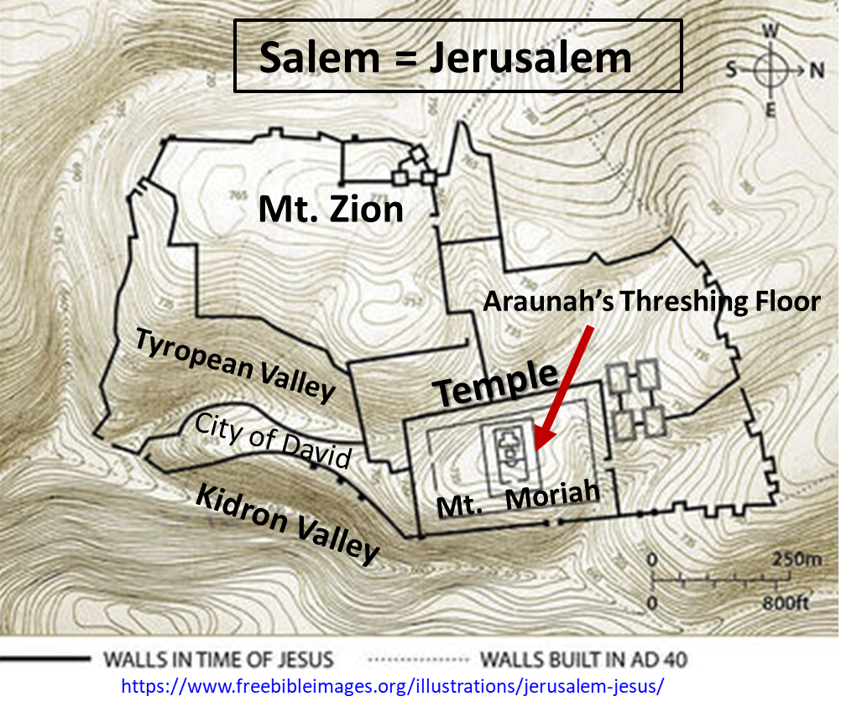
Zion (Semitic etymology includes “Hill Fortress”) = Salem = Jerusalem
In Psalm 76:2, (of Asaph) Salem and Zion are linked. Zion is used as another name for Salem. . . thus, Jerusalem. “His tabernacle is in Salem; His dwelling place also is in Zion”. At first, Salem and Zion (fortress or fortress of David) were two distinct sites but very close together only separated by the Tyropean valley. David defeated the Jebusites there (2 Samuel 5:6ff). David built a palace there from which to rule Israel. In time, Jerusalem grew and its walls took in David’s fortress and the two hills we referenced as one place. In addition, through the centuries, the Tyropean valley has been filled in making the area look like the same general area.
Therefore, in time, Zion, City of David, City of God, land of Judah (Jeremiah 31:12), Israel (Zechariah 9:13) and Jerusalem (Isaiah 40:9) all referred to the same place which also included a spiritual meaning for the people of God (Isaiah 60:14), Heavenly Jerusalem (Hebrew 12:22). Zion also was applied to the Temple Solomon built (Psalm 2:6; 48:2, 11–12; 132:13). Jesus Christ is referred to as the Cornerstone in Zion (1 Peter 2:6; Isaiah 28:16. (Psalm 118:22, Acts 4:11, Romans 9:33, Matthew 21:42, Mark 12:10, Luke 20:17).
Remember that Abraham (born early 20th c. BC) lived about one thousand (1000) years before Solomon who built the first permanent Temple (completed in about 960 BC). From Abraham to the time of the Incarnation, two-thousand (2000) years had passed when God fulfilled Old Testament prophecy. We shared last Sunday that there are hundreds of Old Testament prophecies the Incarnation fulfilled.
(Previous sermons can be found on our website: roundtopchurch.org/sermons

The All-In-One Incarnation
Jesus is the Temple High Priest, Prince of Peace of Our Salvation
Mount Moriah = Salem = Threshing floor of Araunah the Jebusite = Jerusalem Temple Site = Zion = The Temple = Jesus the Choice Corner Stone
1 Peter 2:6 For this is contained in Scripture: "BEHOLD, I LAY IN ZION A CHOICE STONE, A PRECIOUS CORNER stone, AND HE WHO BELIEVES IN HIM WILL NOT BE DISAPPOINTED." (Isaiah 28:6)
In Jesus’ lifetime, the High Priest was the presiding officer of the Sanhedrin who were the high court and legislative body over the Temple and Israel. We read the names of Annas and Caiaphas who presided at Jesus’ trial. Annas was the father-in-law of Caiaphas and High Priest before his term (John 18:13, from AD 6 to 15). Jesus is brought before Annas first after his arrest.
When we read the book of Hebrews, we see that Jesus Christ is the High Priest that takes the place of the existing High Priest serving in the Temple. Jesus also replaces the entire Temple System including the Holy of Holies room where the Ark of the Covenant was housed and on the Day of Atonement when sacrificed animal blood was sprinkled on top of the Mercy Seat by the High Priest representing substitutionary atonement symbolic of Abraham and Isaac.
The Peace Mission of the Incarnation - Reconciliation
This sacrificial system was never intended to justify fallen humanity to God (Hebrews 10). It was an object lesson demonstrating man’s futile effort to save himself. God’s Holy Spirit indwells every Believer who has surrendered to God. David experienced God’s Holy Spirit indwelling (Psalm 51:11). Forgiveness of sin takes place in the Believer’s heart.
1 Corinthians 6:19-20 19 Or do you not know that your body is a temple of the Holy Spirit who is in you, whom you have from God, and that you are not your own? 20 For you have been bought with a price: therefore, glorify God in your body.
Jesus, the Prince of Peace, the superior High Priest, made a one-time offering with His blood spilt on the Cross replacing the entire Temple-High-Priest system which was only a tutor (Galatians 3:24,25) that pointed to Christ. Again, the sacrificial system administered by the priests never was meant to take away sin (Hebrews 10). This is the main message of the book of Hebrews and the mission of the Incarnation.
Hebrews 3:1 Therefore, holy brethren, partakers of a heavenly calling, consider Jesus, the Apostle and High Priest of our confession. (Hebrews 4:14, 5:5,9, 6:19, 7:1,15,26, 9:11)

AMEN

