Round Top Church Christian Fellowship
Sermon
The Completeness of Christ and His Cross
Colossians 1: 24
Pastor ~ Matthew Diehl

August 28th, In the Year of Our Lord - (Anno Domini A.D.) 2022

(Unless otherwise noted, NAS is quoted – New American Standard Bible)
Listen, read and/or print sermon notes from our website – roundtopchurch.org

Today’s sermon is about freedom from religion through the completeness of the Cross of Christ. Remember that the word ‘religion’ can mean anything. Therefore, through my studies of human history. . . I have observed that religion is fallen man’s claim to be a god or create and control a path to gods or “The” God who gave us life.
Our Creator does not call us to have a religious relationship with Him through mediating ceremonial rites practiced on a rigid yearly schedule officiated by men in costumes who wrote their own religious rules barking eternal fear and guilt to keep them in power. No, He does not. . . we are called to have a personal relationship for an eternity based on eternal love, grace and forgiveness not officiated by a mediator.
The love of God cannot be manufactured or mechanically processed through manmade religion. Most of us know that 1 Corinthians 13 is the most complete definition of love given in the Bible. Then there is 1 John 4.
1 John 4:8-13
8 The one who does not love does not know God, for God is love.
9 By this the love of God was manifested in us, that God has sent His only begotten Son into the world so that we might live through Him.
10 In this is love, not that we loved God, but that He loved us and sent His Son to be the propitiation for our sins.
11 Beloved, if God so loved us, we also ought to love one another.
12 No one has seen God at any time; if we love one another, God abides in us, and His love is perfected in us.
13 By this we know that we abide in Him and He in us, because He has given us of His Spirit.
1 John 4:16-18
16 We have come to know and have believed the love which God has for us. God is love, and the one who abides in love abides in God, and God abides in him.
17 By this, love is perfected with us, so that we may have confidence in the day of judgment; because as He is, so also are we in this world.
18 There is no fear in love; but perfect love casts out fear, because fear involves punishment, and the one who fears is not perfected in love.
Yes, Christ is freedom. I remember a poster that hung on one of my professor’s door that read, “Jesus came to set your mind free”. In the context of 1st century Judaism, that truth rang above the phariseaic religious authorities’ voices to the point that twelve men, many women and others believed in Jesus’ Good News and followed Him to His Cross in the face of deadly opposition. The Cross of Jesus not only set a Believer’s mind free in this temporal fallen world, it also set a Believer eternally free to inherit God’s heavenly kingdom of love free from the law of sin and death
Religious Bondage
Do you know someone who cannot get free from religious bondage because their religious authorities have burdened them with their sectarian version/interpretation of the Bible that cripples them spiritually? Once a person is spiritually crippled, their whole family suffers. Their children most likely will be burdened with the same religious entrapment of mind, body and soul for their entire lives. The Truth in God’s Word sets people free. Jesus told us in John 14:6 "I am the way, and the truth, and the life; no one comes to the Father but through Me.
And with the same goals. . . God tells us in the book of Hebrews 10:19 “Therefore, brethren, since we have confidence to enter the holy place by the blood of Jesus. . .”. Does this verse say that we will enter the holy place by the blood of Jesus added to our good suffering works? No! The continuing verses declare. . .
20 by a new and living way which He inaugurated for us through the veil,
that is, His flesh,
21 and since we have a great priest over the house of God,
22 let us draw near with a sincere heart in full assurance of faith, having
our hearts sprinkled clean from an evil conscience and our bodies washed
with pure water. (Hebrews 10:19-22) (See also: Ephesians 2:13, 18; Hebrews 9:12)

Let us now read the biblical text of . . .
Colossians 1:24 Now I rejoice in my sufferings for your sake,
and in my flesh, I do my share on behalf of His body,
which is the church,
in filling up what is lacking in Christ's afflictions.

The Completeness of the Cross of Christ
The correct understanding of Colossian 1:24, penned by Paul, can be clearly seen in his other letters. Paul is not talking about adding to the work of Christ on the Cross. He is talking about the partnership with Christ in suffering that extends to him and the Church. . . that is ongoing. . . and still to come. Let us read the Scripture which is self-explanatory.
2 Corinthians 1:5-7 5 For just as the sufferings of Christ are ours in abundance, so also our comfort is abundant through Christ.
6 But if we are afflicted, it is for your comfort and salvation; or if we are comforted, it is for your comfort, which is effective in the patient enduring of the same sufferings which we also suffer;
7 and our hope for you is firmly grounded, knowing that as you are sharers of our sufferings, so also you are sharers of our comfort.
2 Corinthians. 4:7-12
7 But we have this treasure in earthen vessels, so that the surpassing greatness of the power will be of God and not from ourselves;
8 we are afflicted in every way, but not crushed; perplexed, but not despairing;
9 persecuted, but not forsaken; struck down, but not destroyed;
10 always carrying about in the body the dying of Jesus, so that the life of Jesus also may be manifested in our body.
11 For we who live are constantly being delivered over to death for Jesus' sake, so that the life of Jesus also may be manifested in our mortal flesh. 12 So death works in us, but life in you.

2 Timothy 2:10-12 10 For this reason I endure all things for the sake of those who are chosen, so that they also may obtain the salvation which is in Christ Jesus and with it eternal glory. 11 It is a trustworthy statement: For if we died with Him, we will also live with Him; 12 If we endure, we will also reign with Him; If we deny Him, He also will deny us;
Romans 8:16-18 16 The Spirit Himself testifies with our spirit that we are children of God,
17 and if children, heirs also, heirs of God and fellow heirs with Christ, if indeed we suffer with Him so that we may also be glorified with Him.
18 For I consider that the sufferings of this present time are not worthy to be compared with the glory that is to be revealed to us.
In these verses, we can see that Paul accepts that the sufferings of Christ are extended to him and the whole body of Christ (The Church). They are all joined together in suffering through persecution in order to spread the Gospel Message. With this complete biblical insight, the work of Christ is not finished in all Believers. . . but is ongoing. . . and therefore, lacking. Christ’s suffering work on the Cross was completed by Him for the atonement of sin. But the suffering work of the Church to spread the Gospel is ongoing. This suffering will not be completed until God brings this age to a close. This suffering work is inherent in order to spread the Gospel Message (not atone for sin) in this fallen hostile world. Paul sees his life and the Church (The Body of Christ) joined in partnership with the sufferings of Christ continuing in them in order to proclaim and spread the Good News (2 Corinthians 1:5, 4:10; 2 Timothy 2:12; Romans 8:17). Jesus told Paul he would have to suffer for His name’s sake (Acts 9:16).
Colossians 1:24 has been taken out of its biblical context by some over the centuries in order to position their organization to be a mediating agent between people and God. How? By assigning people meritorious works and, at times, works of physical suffering on long pilgrimages and other unspeakable acts to be forgiven of sin. The teaching was that these works would earn people ‘right standing’ with God that could lead to eternal life. However, Jesus’ sacrifice (Body and Blood) on the Cross is the only power to give life.
John 6:53 So Jesus said to them, "Truly, truly, I say to you, unless you eat the flesh of the Son of Man and drink His blood, you have no life in yourselves.
Biblical Interpretation Rules / Hermeneutics and Exegetical What?
First, what happens when the correct rules of biblical interpretation are ignored. We recently studied other passages of Scripture (Matthew 16:18) that also have been taken out-of-context to promulgate a lie in order to substantiate the founding of the state church by Peter to be in Rome. See sermon Christ – Head of the Heaven and Earth Church (July 31, 2022).
Unfortunately, political, sectarian and cultural influences have too often adulterated the biblical text. The result is that billions of people over the centuries have been deceived in living life under fear and guilt. . . never to be relieved of their temporal burdens. When these saints arrived in heaven, they then realized the tormenting deception that the state church and its officers had inflicted upon them. I have said before. . .Christianity has been the most mistaught belief on the planet. It is unfortunate that many children grow-up in works-based religious systems. When they reach adulthood, they are closed-minded to Biblical Christianity. . .not even wanting to listen. No wonder many of the historical church buildings in Europe have become museums.
Every sentence in the Bible does not stand alone outside the entire biblical context. Solid hermeneutics (theory and methodology of interpretation) and exegetical (critical explanation or interpretation) processes must be taken in order to arrive at biblical truth.
To illustrate the correct biblical context, let us read a few verses before and after Colossians 1:24. Then we will look at the broader context of Scripture.
Colossians 1:19-20 19 For it was the Father's good pleasure for all the fullness to dwell in Him, 20 and through Him to reconcile all things to Himself, having made peace through the blood of His cross; through Him, I say, whether things on earth or things in heaven.
Colossians 2:9-10, 14 9 For in Him all the fullness of Deity dwells in bodily form, 10 and in Him you have been made complete, and He is the head over all rule and authority; . . . 14 having canceled out the certificate of debt consisting of decrees against us, which was hostile to us; and He has taken it out of the way, having nailed it to the cross.
So, in verse 20, Paul identifies Christ as the one reconciliation is to come through because He/Christ made peace on His Cross. No one else is added to Paul’s statement. Paul even includes the realm of heaven as a place Christ also reconciled all things. Then after verse 1:24, in verse 2:9, Paul declares that we have been made complete in Christ. Again, no one else is mentioned. The Greek word “pleroo” literally means to “make full”.
Verse 14 literally states that it was Jesus who canceled our debt certificate and nailed it to the Cross. This is a finality statement. Nothing left to do. . . “It is finished!” (John 19:30).
Complete - Strong’s 4137 Greek: πληρόω pleroo
Meaning: to make full, to complete

So, the meaning of Colossians 1:24 cannot mean that Paul is claiming to add anything to the Cross of Christ. . . like his own sufferings. To illustrate this point, consider the following formula. [One Messiah + Your Works = Eternal Life?]
The above formula is exactly what some religious authorities turn Colossians 1:24 to mean. Again, this is out-of-context with the complete biblical witness. No one can add to the Cross of Christ. Jesus’ sacrifice stands alone and is complete. There has never been or will be another Messiah come to live as one of us (John 1:14) in order to die for the sins of the world upon “The” Cross.
Matthew 20:28 just as the Son of Man did not come to be served, but to serve, and to give His life a ransom for many." (See also: Mark 10:45) Romans 5:7-8 7 For one will hardly die for a righteous man; though perhaps for the good man someone would dare even to die. 8 But God demonstrates His own love toward us, in that while we were yet sinners, Christ died for us.

Christ is the one and unique being in history who accomplished what no one else could do. To further illustrate the uniqueness of Jesus Christ and His Cross, we need to make the observation from Old Testament prophecy.
In addition, Ephesians 2:8-9 (by no works are you saved); 2 Timothy 1:9 (saved not according to works); Titus 3:5 (saved not on basis of deeds); and Romans 3:5, 20, 27; Galatians 2:16 all refute that any kind of works/merit saves a person.
The completeness of Christ and His Cross fulfilled the Old Testament Messianic prophecies and is mathematically impossible for another person to accomplish. This includes Jesus being the perfect sinless sacrifice to being from the blood-line of David.
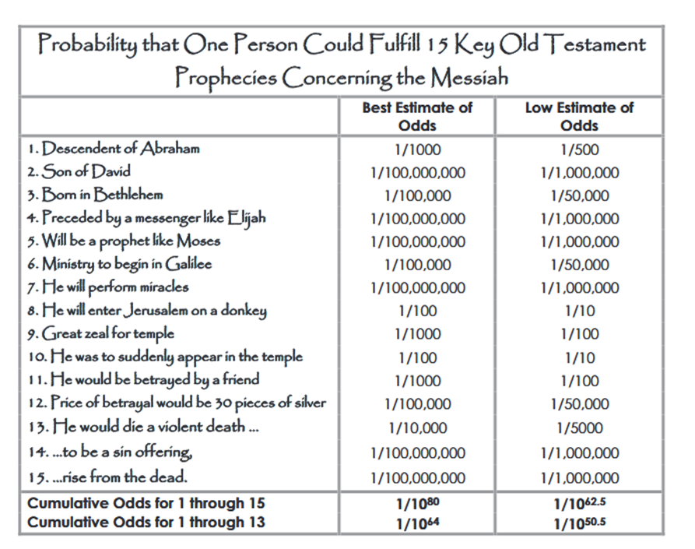
A random chance of 1 in 1050 or less is considered to be scientifically impossible. These results indicate that it would have been scientifically impossible for Jesus of Nazareth to fulfill these 15 prophecies by random chance.
There are over 300 references to the Messiah in the O.T. that were fulfilled by Jesus of Nazareth. Forty-eight of the key prophecies were selected and the probability of one person fulfilling all 48 was calculated to be 1 chance out of 13 trillion. Several such probability calculations have been performed by different individuals and they all conclude that it is mathematically impossible that one person could fulfill all of these prophecies by chance. The mathematics point to the fact that someone had to guide history over the last 4000 years. God as revealed in the Bible is the only logical choice.
https://s3.amazonaws.com/media.cloversites.com/ea/ea20e45a-2a48-4caa-b5ba-6ae8b1397791/documents/Prophecy_Probability_Table.pdf
See also: https://empower.global/the-mathematical-probability-that-jesus-is-the-christ/

By fulfilling all these prophecies, the completeness of Christ and His Cross accomplished all the work God had planned.
John 17:4 "I glorified You on the earth, having accomplished the work which You have given Me to do.
John 19:28 After this, Jesus, knowing that all things had already been
accomplished, to fulfill the Scripture, said, "I am thirsty."
John 19:30 Therefore when Jesus had received the sour wine, He said,
"It is finished!" And He bowed His head and gave up His spirit
Jesus’ words (“It is finished!”) from the Cross make the eternal summation of His ministry and sacrifice. Jesus was superior to the High Priest who presided over the Temple in Jerusalem. For it was fitting for us to have Jesus as such a high priest, who is holy, innocent, undefiled, sinless and exalted above the heavens; Jesus does not need to daily, like those Jewish high priests, offer sacrifices, first for His own sins and then for the sins of the people, because Jesus did this once and for all when He offered Himself (Hebrews 7:26-27).
I see that many religious organizations are designed by misguided understanding or with political intent to replace the Jewish Temple/Law system with their “made by their own hands” meritorious system. . . to be overseen by mediating officials. Jesus came to turn people away from this exact understanding. By continuing in religious mediating ritual formulas manufactured by human hands, like the Jews conducted, . . . religious institutions throughout history and, in our time, ignore the Incarnation/appearance of God as Jesus Christ.
Because when Christ appeared as a high priest of the good things to come, He entered through the greater and more perfect tabernacle, not made with hands, that is to say, not of this creation; and not through the blood of goats and calves, but through His own blood, He entered the holy place once for all, having obtained eternal redemption. Hebrews 9:11-12
John 6:27 "Do not work for the food which perishes, but for the food which endures to eternal life, which the Son of Man will give to you, for on Him the Father, God, has set His seal." AMEN

