Round Top Church Christian Fellowship
Sermon
Thanks to God’s Longsuffering for America
Colossians 1:3-6
Pastor ~ Matthew Diehl

July 10th, In the Year of Our Lord - (Anno Domini A.D.) 2022

(Unless otherwise noted, NAS is quoted – New American Standard Bible)
Read and/or print sermon notes from our website – roundtopchurch.org

How can we reflect upon Paul’s words in Colossians 1:3-6 in application to the American experience and the date of July 4th, 1787?
First, let us read the text penned by the Apostle Paul almost two thousand years ago under the guidance of God’s Holy Spirit.
3 We give thanks to God, the Father of our Lord Jesus Christ,
praying always for you,
4 since we heard of your faith in Christ Jesus
and the love which you have for all the saints;
5 because of the hope laid up for you in heaven,
of which you previously heard in the word of truth,
the gospel.
6 which has come to you,
just as in all the world also
it is constantly bearing fruit and increasing,
even as it has been doing in you
also since the day you heard of it
and understood the grace of God in truth;
Paul is writing to Believers in Colossae encouraging them to carry-on with the faithful application of the Gospel of Christ Jesus. We, too, in America, are to be encouraged to carry forward the God-given country embedded with the foundation of the Judeo-Christian ethic and worldview.
Remember that it was Ben Franklin and Thomas Jefferson who proposed that the Great Seal of the new Republic be a depiction of God leading His people during the Exodus.
Franklin chose an allegorical scene from Exodus, described in his notes as "Moses standing on the Shore, and extending his Hand over the Sea, thereby causing the same to overwhelm Pharaoh who is sitting in an open Chariot, a Crown on his Head and a Sword in his Hand. Rays from a Pillar of Fire in the Clouds reaching to Moses, to express that he acts by Command of the Deity." Motto, "Rebellion to Tyrants is Obedience to God." Jefferson suggested a depiction of the Children of Israel in the wilderness, led by a cloud by day and a pillar of fire by night for the front of the seal; https://en.wikipedia.org/wiki/Great_Seal_of_the_United_States
We know the below seal was eventually adopted. It is beneficial to review the meaning of the components of America’s Great Seal adopted in 1782 A.D.
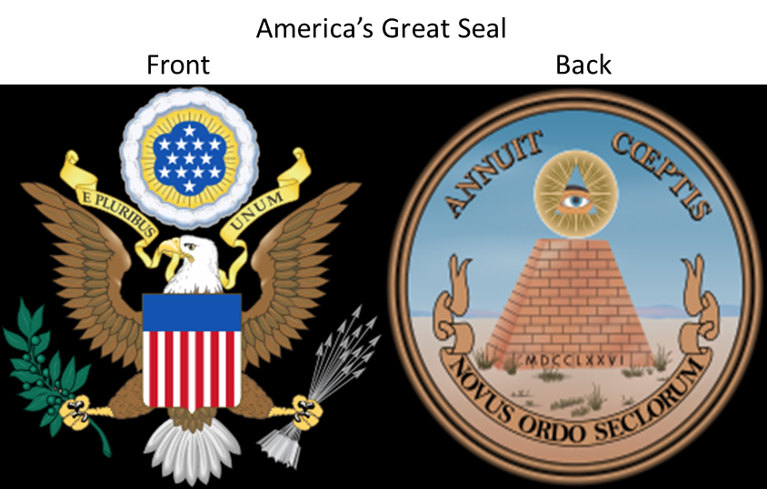
The front depicts the national arms, including the Latin phrase E Pluribus Unum (out of many, one).
The reverse depicts "A pyramid unfinished. On the top of the pyramid is the Eye of Providence, surrounded by a “glory, proper" and the Latin mottoes Annuit cœptis and Novus ordo seclorum.
Unfinished Pyramid and Date
On the base is the date of independence (MDCCLXXVI)
1000 + 500 + 100 + 100 + 50 + 10 + 10 + 5 + 1 = 1776
The official description of the Great Seal does not specify the number of layers of stone in the pyramid, but it has been traditionally depicted with thirteen. Obviously, a reference to the thirteen colonies. In addition, the meaning is also viewed as. . .
"The generation which commences a revolution rarely completes it." - Thomas Jefferson
"American history is not something dead and over. It is always alive, always growing, always unfinished." – John F. Kennedy
The Eye of Providence (or the All-Seeing Eye of God) is a symbol that depicts an eye, often enclosed in a triangle and surrounded by rays of light or glory, meant to represent divine providence, whereby the eye of God watches over humanity. A well-known example of the Eye of Providence appears on the reverse of the Great Seal of the United States, which is depicted on the United States one-dollar bill.
Glory proper (from the Latin gloria, "fame, renown") is used to describe the manifestation of God's presence as perceived by humans according to the Abrahamic religions.
Annuit cœptis (/ˈænuɪt ˈsɛptɪs/, Classical Latin: [ˈannʊ.ɪt ˈkoe̯ptiːs]) is one of two mottos on the reverse side of the Great Seal of the United States. The literal translation is "favors (or "has favored") [our] undertakings", from Latin annuo ("I approve, I favor"), and coeptum ("commencement, undertaking"). Because of its context as a caption above the Eye of Providence, the standard translations are "Providence favors our undertakings" and "Providence has favored our undertakings".
The phrase Novus ōrdō sēclōrum (English: /ˈnoʊvəs ˈɔːrdoʊ sɛˈklɔːrəm/, Latin: [ˈnɔwʊs ˈoːrdoː seːˈkloːrũː]; "New order of the ages") is the second of two mottos added by the secretary of the Congress of the Confederation, Charles Thomson,
Following are two more renderings with descriptions. 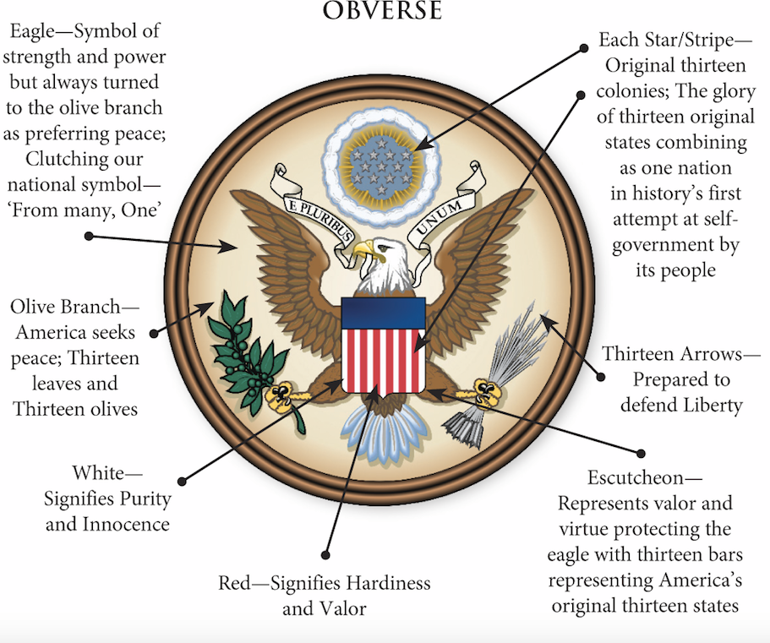
“Symbolically, the Seal reflects the beliefs and values that the Founding Fathers attached to the new nation and wished to pass on to their descendants.” – U.S. Department of State, Bureau of Public Affairs https://thefounding.net/great-seal-united-states-america/
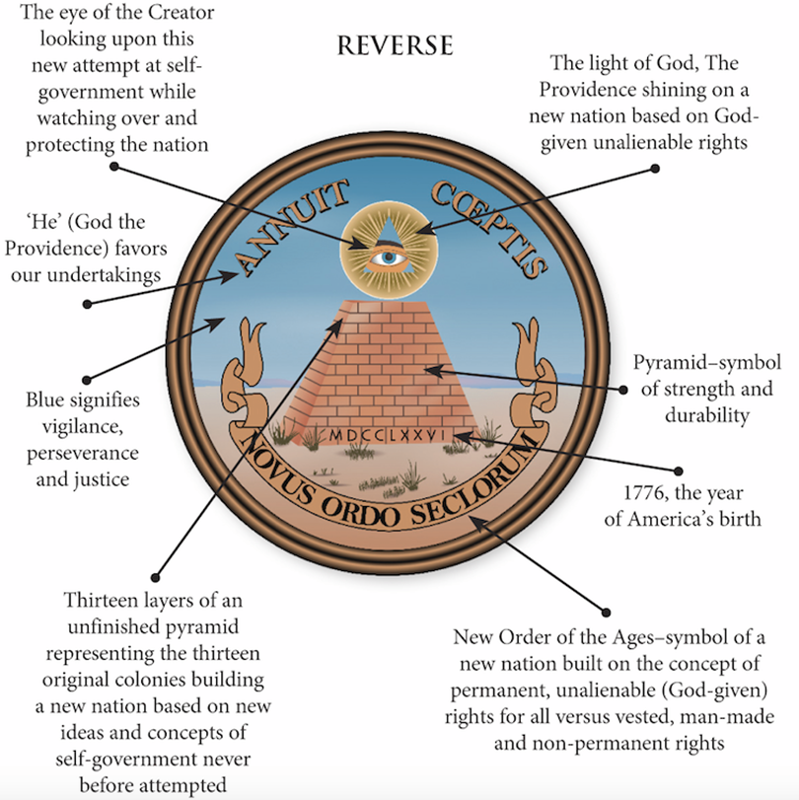

My Reflections on America’s Great Seal
America marched forward in time and matured under these Godly ethics and virtues to be a self-governing people. . . A Republic. Consider these three summations.
- God is the origin of unalienable human rights.
- God’s providential lights. . . illuminates America.
- From these first two pillars come vigilance, perseverance, justice that seeks peace first in defense of Liberty.
There is not any doubt that the Great Seal with its words and symbols embodies the purest form of conduct and government for which we have been stiving. God’s Word set the standard for which we are to strive. When God directed Samuel to crown a king (Saul -1 Samuel 9) for the first time, the nation of Israel struggled under his leadership. Saul failed to meet God’s instructions for national leadership. However, God continues to choose to work through fallen people. In a fallen world environment, we continue to strive for the application of all of these principles of God. God’s Word tells us that He does not want to lose one person.
8 But do not let this one fact escape your notice, beloved, that with the Lord one day is like a thousand years, and a thousand years like one day. 9 The Lord is not slow about His promise, as some count slowness, but is patient toward you, not wishing for any to perish but for all to come to repentance. (2 Peter 3:8-9)
So, too, in America, our goal is not to leave one person from God’s plan for a free people. In pursuit of “not leaving one person”, America has fought a Civil War, and many have died and suffered throughout its history in pursuit of God’s plan. War and suffering came because the principles enshrined in the Great Seal were pursued and not forgotten. Mankind constantly struggles to fulfill God’s calling.
In the struggles, America has been blessed by a few unique factors. Yes, there is the geography of America that has made possible to a great degree a separation from the toils of European entanglements. But, above the distance of geography, there is the Founding Fathers of America that produced foundational documents that launched the idea of a free people to grow in understanding and application of freedom under the governance of a Republican form of government. So, we stand here today still in a maturing process of God’s initial instruction for America.
Applying Colossians 1 to America
So, in application to America, Paul writes a God-inspired message to the Colossians and directly to us today. Therefore, inspired by Paul’s writing. . . we too can say. . .

We give thanks to God, the Father of our Lord Jesus Christ,
praying always for our neighbors. We lift up all people in God’s love to see the grace gift of America to whom God has given His Word and guiding Light. And we know of the faith in God of many Americans who had previously heard the Word of Truth, the Gospel. . . because we have heard of those saints who believe and live faithful lives under the Gospel of Christ Jesus. We also know that God, the providential power and authority behind the establishment of America, has laid up for them, in His heaven, a place that He has gone before us and prepared (John 14:3).
And we know that this same Gospel Truth that came to America has gone forth from her shores to be that Light to all the world. Therefore, God’s Light through America is constantly bearing fruit and increasing.
We Made it This Far. America is a Miracle.
Matthew 19:26 And looking at them Jesus said to them,
"With people this is impossible, but with God all things are possible."
Mark 10:26-27
26 They were even more astonished and said to Him,
"Then who can be saved?"
27 Looking at them, Jesus said,
"With people it is impossible, but not with God;
for all things are possible with God."
So, we know that the reason America is still here is because of God’s providence at work. At least through enough faithful people. Remember, Lot, in Genesis 18:32, when God told him that He would not destroy Sodom and Gomorrah, if there were ten righteous people? “God puts up with a whole lot of sinning for a long time.”
How do we know that God put up with fallen humanity for a long time? After Solomon’s death, the United Kingdom was divided, due to his sin (1 Kings 11). The Northern Kingdom was called “Israel” and the Southern Kingdom was called “Judah”. In the Northern Kingdom, there was not one righteous king who reigned over its realm. So, from about 931B.C. (Death of Solomon) to 722 B.C. (Assyrian Destruction), there were only kings who did evil in the sight of the Lord.
The Southern Kingdom had some righteous kings and survived till 586 B.C. (Babylonian Conquest and Deportation). We can see that God allowed the Northern Kingdom (Israel) to exist for over two-hundred (200) years and the Southern Kingdom (Judah) for about three-hundred & forty-five (345) years. I would say that God is longsuffering with fallen humanity.
God is Long-Suffering with America
My observation is that God was pleased with many aspects of American’s founding. However, since the fall of man, God’s best plans became tainted when fallen man moves to implement them. America was not any exception. We know that the Founding Fathers were a product of their era that included the international state-sponsored slave trade in which that they all grew-up. Starting with Presidents Washington and Jefferson whose policies eroded the slave practice, in time, and through the battles of Civil War and passage of the Civil Rights Act about one hundred years later, the country changed. God was long-suffering with America through all of these years.
There were many other growing pains in America’s governance of the Industrial Revolution and Westward Expansion. Through these and more events, the providential founding documents gave guidance.
The Founding Fathers put together founding documents that could amend government over time, but not all at once. We see this as an example. . . the U.S. Senate has six-year terms with one-third elected every two years. God has been long-suffering through all of these changes. The most recent change of monumental impact was the U.S. Supreme Court’s decision to return the management of abortion to the states. However, by most conservative counts, there have been over sixty million abortions-on-demand from 1973 A.D. to 2022 A.D. Researchers show that about 90% of these were not for reasons of health of the mother, rape or incest. And, Florida, where the state keeps meticulous records, reports that about 97 % of abortions were elective-on-demand. God has been and continues to be long-suffering with America.
The Skeptical Republic
So, we have arrived at the date of July 4, 2022 A.D. despite the skeptical and apprehensive views held by many upon the passage of the Constitution in 1787 A.D. at the Constitutional Convention held in Philadelphia’s Independence Hall. Many quotes are cited over the years from delegates at the convention. None more celebrated than quotes by Benjamin Franklin. I have written an account of one of Franklin’s famous quotes researched from a few online sources.
Historians take from the journal of James McHenry who penned his reflection of the Constitutional Convention on September 18, 1787. McHenry was Maryland’s delegate to the Constitutional Convention who chronicled the question asked to Benjamin Franklin by Mrs. Elizabeth Willing Powel, a prominent society figure and the wife of Philadelphia Mayor Samuel Powel. Franklin was walking from Independence Hall after the Constitutional Convention, and she asked him, “Doctor, what have we got? A republic or a monarchy?” Mr. Franklin replied, “A republic, if you can keep it.”
This is all we generally hear of the exchange between Mr. Franklin and Mrs. Powel. But there is more to the exchange that is most relevant to U.S. history and is most evident today.
Mrs. Powel immediately shoots back, “And why not keep it?” Franklin responds, “Because the people, on tasting the dish, are always disposed to eat more of it than does them good.” https://www.washingtonpost.com/history/2019/12/18/republic-if-you-can-keep-it-did-ben-franklin-really-say-impeachment-days-favorite-quote/
https://blogs.loc.gov/manuscripts/2022/01/a-republic-if-you-can-keep-it-elizabeth-willing-powel-benjamin-franklin-and-the-james-mchenry-journal/

Praise God! He is longsuffering with America.
Since 1787 A.D., there has been about 235 years for God to be longsuffering with America. We have a lot for which to praise God.
Psalm 86:15 But You, O Lord, are a God merciful and gracious, Slow to anger and abundant in lovingkindness and truth.
Numbers 14:18 'The LORD is slow to anger and abundant in lovingkindness, forgiving iniquity and transgression; but He will by no means clear the guilty, visiting the iniquity of the fathers on the children to the third and the fourth generations.'
Romans 2:4 Or do you think lightly of the riches of His kindness and tolerance and patience, not knowing that the kindness of God leads you to repentance?
AMEN

