Round Top Church Christian Fellowship
Sermon
The Will of God in the Apostles of Jesus Christ
Colossians 1:1-2
Pastor ~ Matthew Diehl

June 19th, In the Year of Our Lord - (Anno Domini A.D.) 2022

(Unless otherwise noted, NAS is quoted – New American Standard Bible)
Read and/or print sermon notes from our website – roundtopchurch.org

Key Passage in Colossians – verse 2:8
See to it that no one takes you captive through philosophy and empty deception, according to the tradition of men, according to the elementary principles of the world, rather than according to Christ.

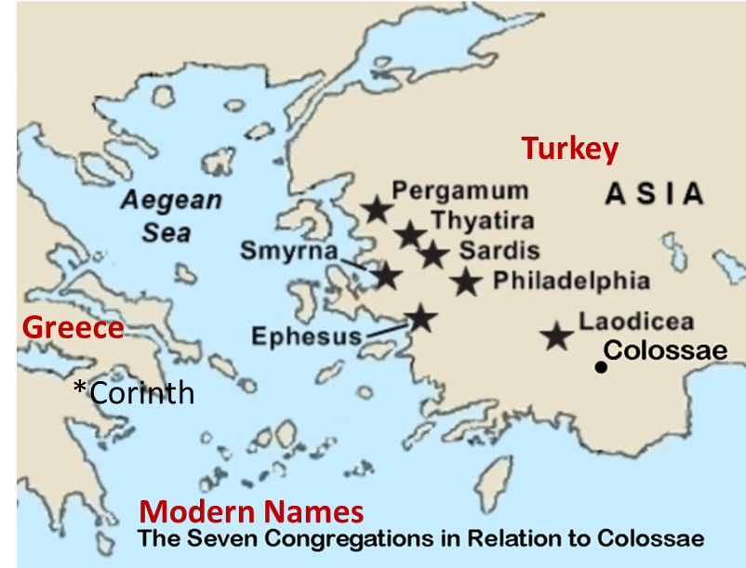
Colossians 1:1 Paul, an apostle of Jesus Christ by the will of God,
and Timothy our brother,
2 To the saints and faithful brethren in Christ who are at Colossae:
Grace to you and peace from God our Father.
And, so, we read the opening statement in Paul’s letter to the Believers in Colossae. We know that Paul wrote to the assembly in Colossae in about 61 or 62 A.D. while he was awaiting trial by Caesar in Rome. Remember, Paul had been arrested in Jerusalem by the Jews and appealed his case as a Roman citizen to Caesar. Acts 21:27 to the end of the book (28:31) chronicles Paul’s arrest, trials, witness and travels to Rome.
Acts 28:30-31
30 And he stayed two full years in his own rented quarters and was welcoming all who came to him, 31 preaching the kingdom of God and teaching concerning the Lord Jesus Christ with all openness, unhindered.
We know that Paul wrote the four letters commonly called the “Prison Epistles” during this two-year period (Ephesians, Philippians, Colossians and Philemon).
Scholars note that Paul most likely evangelized Colossae from Ephesus. In Acts 19:10, we are told that Paul spent two years in Ephesus so that all who lived in Asia heard the word of the Lord, both Jews and Greeks. In verse 1:7, we see that it was Epaphras, a student of Paul, who witnessed the Gospel to the people in Colossae, which was most likely his hometown.
By writing to the saints in Colossae, Paul is acknowledging their lives in Christ and warning them not to go back to their old pagan religion and, at the same time, delivering the truth in God’s Word that Christ is superior to all in creation. Jesus Christ is the fullness of Deity dwelling in Him, being the head over all rule and authority, making faithful believers complete before God (Colossians 1and 2).
This passage in the book of Hebrews makes a declarative statement about the superiority of Jesus Christ.

23 The former priests, on the one hand, existed in greater numbers because they were prevented by death from continuing,
24 but Jesus, on the other hand, because He continues forever, holds His priesthood permanently.
25 Therefore He is able also to save forever those who draw near to God through Him, since He always lives to make intercession for them.
26 For it was fitting for us to have such a high priest, holy, innocent, undefiled, separated from sinners and exalted above the heavens;
27 who does not need daily, like those high priests, to offer up sacrifices, first for His own sins and then for the sins of the people, because this He did once for all when He offered up Himself.
28 For the Law appoints men as high priests who are weak, but the word of the oath, which came after the Law, appoints a Son, made perfect forever. (Hebrews 7:23-28)

Colossians 1:1 Paul, an apostle of Jesus Christ by the will of God,
and Timothy our brother,

And so are the first words of Paul’s letter to the saints in Colossae. With these words, we continue to see the Biblical worldview that was highlighted at the close of our sermon series in Philippians. What words? Particular attention is given to Apostle, Jesus Christ and the will of God. Someone reading the Bible for the first time may not be familiar with the terms and context of God’s Word and may have questions.
What or who is an Apostle?
Is there significance in saying Jesus Christ?
What does it mean to call upon the will of God?
An Apostle (Greek: apostolos a person sent) in the New Testament context of the Twelve (plus Paul) is a person who actually knew Jesus Christ and preached His Gospel message. Since that time, no one can claim to be equivalent to those that walked and talked with Jesus Christ and whom He sent to preach the Good News, the Gospel message.
In addition to the twelve, Paul met Jesus Christ on the road to Damascus (Acts 9) when He commissioned him/Paul to proclaim His name and Message to the Jews, gentiles and kings. In Luke 6:13, we read. . . And when day came, He called His disciples to Him and chose twelve of them, whom He also named as apostles.
By a plan meaning of the word “apostle”, it was applied to Barnabus, Andronicus, Junias and Epaphroditus who were also sent to preach the Gospel. It is my opinion that I would not use the title “apostle” today in ministry to thwart-off any boastful appearances and to respect God’s incarnation ministry in choosing the first disciples.
As the church grew, we see titles used today from the Greek words Presbyteroi (Acts 11:30, 21:18; 1 Timothy 5:17, 19; Titus 1:5) to be translated. . . priest or presbyterian and “episkopoi” to be translated “Bishop” in Acts 11:30; Philippians 1:1; 1 Timothy 3:2; Titus 1:7.
It needs to be noted that titles mean things. Jesus specifically stated "Do not call anyone on earth your father; for One is your Father, He who is in heaven (Matthew 23:9). Therefore, we need to be aware of those who hold themselves out as “Father”.
Obviously, God as Jesus delineated spiritual gifts and callings as we can see in Ephesians 4:10-12 for the purpose of equipping and growing the Church.
10 He who descended is Himself also He who ascended far above all the heavens, so that He might fill all things. 11 And He gave some as apostles, and some as prophets, and some as evangelists, and some as pastors and teachers, 12 for the equipping of the saints for the work of service, to the building up of the body of Christ.
From this, we can see that the Church (body of Believers) is uniquely called and gifted with varieties of gifts by the same Spirit/Lord to accomplish many ministries. God works all things in all persons giving each one the manifestation of the Spirit for the common good (1 Corinthians 12:4-7).
We pastors are visible to the public because we speak in church on the day of worship. From my experience, there are many saints working behind the scenes to support the pastor. I liken this to the U.S. military where it is reported that they need to have ten people logistically supporting the frontline soldiers. God’s plan is to have everyone equipped to participate. Prayer is something that all pastors need. And a word of encouragement to everyone is appreciated. Within this cultural framework, the body of Christ works. This is God’s will for the Church.
The significance in saying “Jesus Christ”
Jesus is a first name and in this context by using the name “Christ”, Paul points to the Messiahship of Jesus. Jesus’ name in Hebrew is from the name Joshua (Yehoshua) which means the Lord is salvation. This full name is used to highlight the reality of the incarnation and the prophetic mission of God as the Messiah in the flesh who came and lived with us, ministering, witnessing and making the one-time substitutionary atonement for the sins of the whole world on the Cross. . . then rising from the tomb to walk again with us testifying to His power over sin and death. . . to ascend to heaven. . . to one day return to judge the quick and the dead bringing an end to this age (Isaiah 9:7, ch-53; Daniel 7:13,14).
With all of the above stated, we see that there is power and authority in the name of Jesus Christ. We Believers are joined to Jesus Christ in this life and the next eternal life.
Romans 6:3 Or do you not know that all of us who have been baptized into Christ Jesus have been baptized into His death?
4 Therefore we have been buried with Him through baptism into death, so that as Christ was raised from the dead through the glory of the Father, so we too might walk in newness of life.
5 For if we have become united with Him in the likeness of His death, certainly we shall also be in the likeness of His resurrection,
6 knowing this, that our old self was crucified with Him, in order that our body of sin might be done away with, so that we would no longer be slaves to sin;
Galatians 3:26 For you are all sons of God through faith in Christ Jesus. 27 For all of you who were baptized into Christ have clothed yourselves with Christ.
And then there is the ultimate power and authority of God, as Jesus Christ, stated in Romans 8:1 Therefore there is now no condemnation for those who are in Christ Jesus.
2 For the law of the Spirit of life in Christ Jesus has set you free from the law of sin and of death.

To call upon the will of God is one of those life-changing abilities that Believers have access. With these words, Paul is saying. . . that his Apostleship is only made possible by God. God is the One who chose to intervene in Paul’s life on the Road to Damascus (Acts 9) while Paul was breathing threats and murder against the disciples of the Lord.
Question? Would you want God to intervene in your life if you were breathing threats and murder against someone?
Sounds like a good idea.
On a milder note. . . maybe we need to surrender to God’s intervention in our heart when that crazed driver cuts in front of us on the freeway. Or is it when the neighbor’s dog just dug up your flower beds that you were hoping to get the award for yard of the month. Ok, out in the country, it is armadillos that have my ire. Or, as it recently happened to my friend when we were ordering food at a restaurant. . . the waiter ripped the menu from his hands and walked off without waiting for the complete order. He just ran off. And then. . . once again, for us husbands who just can’t seem to put something completely together without our wives saying. . . Honey, did you read the instructions?
Then there is the ultimate intervention we all need right now and that is watching the evening news. I personally do not watch the T.V. soap opera news shows. Talk about the need for God to intervene. . . my solution is. . .why put yourself through the torturous politically motivated broadcast. I can determine what is taking place in the world through online sources. My thought is that I cannot fix it anyway, and I can only manage what is right in front of me. I often think that God’s will is being carried out. . . in that these evil doers have been turned over to their own desires (Romans 1:24-26). This is not pleasant to watch. But this is where God’s Word tells us that by surrendering to His Will, we will be able to endure.
Remember that we do not see the Christians in the New Testament worrying about elections. Their political leaders were appointed or gained office by heredity. The Gospel of the Resurrected Lord is by design to go forward under the most oppressive political and cultural conditions. The Gospel of God endures.
1 Corinthians 10:12-13 Therefore, let him who thinks he stands take heed that he does not fall. No temptation has overtaken you but such as is common to man; and God is faithful, who will not allow you to be tempted beyond what you are able, but with the temptation will provide the way of escape also, so that you will be able to endure it.
From this verse, we see that God knows we will be tempted, but those temptations are common to all of us. God knows of our failures and provides us a path to recovery. It is God, not us, who provides the way of escape. Notice the verse ends with “you will be able to endure it”. The verse does not say we will escape calamity. God is telling us that when we are in hard places that it is He who will equip us with the ability to endure. Endure means to bear-up under the suffering of physical and mental pressure, pain and frustration. This message coming from Paul, who had been beaten and left for dead and more, (1 Corinthians 11:23ff) carries the weight of reality and experience in the service of God.
I do see that God is at work in all of this fallenness. Remember that God loves us first (1 John 4:19). God reaches out to all people with His Holy Spirit (John 16:8) and calls to them. . . “stop”. . . "Turn to Me and be saved, all the ends of the earth; For I am God, and there is no other. (Isaiah 45:22).
My experience in life. . . is that my life is not my own. . . my thoughts, my ambitions and plans are misplaced if I had not sought-out the Lord’s plan for my life. For it is God who has plans in which for us to walk (Ephesians 2:10). At times, I have asked myself why is life so hard? Then, I reflect on my circumstances and ask myself one question: Did God direct me to go down that road? I have often given myself heartache and disappointment and then I think of this verse in 1 Corinthians 10, that God works through Believers to endure.
God does provide a way of escape for us. . . and in this escape through the power of God’s Holy Spirit operating inside of us. . . it has become clearer to me that Believers are to spiritually mature to be at peace with God in this fallen-calamity taking place all around us.
Romans 8:31 What then shall we say to these things? If God is for us, who is against us?
Romans 8:35 Who will separate us from the love of Christ? Will tribulation, or distress, or persecution, or famine, or nakedness, or peril, or sword?
Romans 8:38-39 For I am convinced that neither death, nor life, nor angels, nor principalities, nor things present, nor things to come, nor powers, nor height, nor depth, nor any other created thing, will be able to separate us from the love of God, which is in Christ Jesus our Lord.
AMEN

