Round Top Church Christian Fellowship
Sermon
The Lord is With Us - Overcoming
Philippians 2:19-30

Pastor ~ Matthew Diehl

March 20th In the Year of Our Lord - (Anno Domini A.D.) 2022

(Unless otherwise noted, NAS is quoted – New American Standard Bible)
Read and/or print sermon notes from our website – roundtopchurch.org

Paul writes to his dear friends in Philippi, about whom he cares deeply, and seeks to have someone personally deliver his letter. Evidently, at the time he is writing, there are not many associates with the “right spirit” to send on such a mission. Looking at the map, we can see that a person traveling from Rome, Italy to Philippi must cross the Aegean Sea.
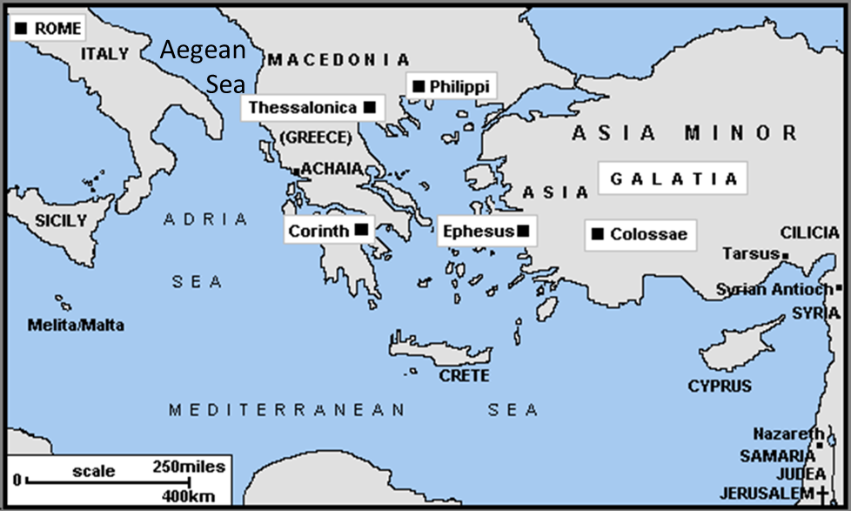
The trip would take several days with unanticipated delays. A committed person has to be chosen for this assignment. However, during the 1st century Roman world, this is how mail was dispensed throughout the empire. . . No FedEx or UPS. Obviously, Paul could not place his trust in the Roman guards to hand deliver his letter. It is of note that Paul was allowed to send his letter while under guard; more evidence that the Romans, at that time, did not view Paul to be a threat to them.
Paul presented two names, Timothy and Epaphroditus, as trusted coworkers in Christ. Paul announces that he will send Timothy “shortly” to see the Philippians. From this context, the purpose of sending Timothy is to check on the welfare of the church in Philippi. In verse 25, Paul also states he is sending/returning Epaphroditus to them who had brought support to Paul from the church in Philippi.
Philippians 4:18 But I have received everything in full and have an abundance; I am amply supplied, having received from Epaphroditus what you have sent, a fragrant aroma, an acceptable sacrifice, well-pleasing to God.
Paul had met Timothy when Timothy was a young man, during his mission travels right after the Jerusalem Council (Acts 15) that took place in about 48 A.D. Remember, Paul writes to the Philippians in about 61-62 A.D. during his Roman imprisonment. So, he had known Timothy for over twelve years. From reading Acts, we see that Timothy was a traveling companion of Paul’s.
Acts 16:1 Paul came also to Derbe and to Lystra. And a disciple was there, named Timothy, the son of a Jewish woman who was a believer, but his father was a Greek, 2 and he was well spoken of by the brethren who were in Lystra and Iconium. 3 Paul wanted this man to go with him; and he took him and circumcised him because of the Jews who were in those parts, for they all knew that his father was a Greek.
Timothy
Philippians 2:19-23
19 But I hope in the Lord Jesus to send Timothy to you shortly,
so that I also may be encouraged when I learn of your condition.
20 For I have no one else of kindred spirit
who will genuinely be concerned for your welfare.
21 For they all seek after their own interests,
not those of Christ Jesus.
22 But you know of his proven worth,
that he served with me
in the furtherance of the gospel like a child serving his father.
23 Therefore I hope to send him immediately,
as soon as I see how things go with me;

Paul sends his letter to provide guidance and with the anticipation of hearing back from them when Timothy returns to him (v.19). From the context of the letter, either Timothy or Epaphroditus could have carried the letter. Concerning Timothy and his return to Paul. . . it would take a few months for Timothy to make the round trip on foot and boat, which was the major modes of transportation for the masses. We note, other than Jesus’ riding into Jerusalem on a donkey one time, the New Testament does not chronicle the use of horses for transporting the Disciples.
From verse 21, we sense that Paul does not trust some of those around him to be the carrier to deliver his letter to the Philippians or check on their welfare and minister to them. From this, we see that not all those professing to be a follower of Jesus can be trusted because they still had their own interests that took precedent over Christ Jesus. Paul points to Timothy and Epaphroditus to have proven their worth and made sacrifices to serve the Lord. We glean from Paul’s remarks that both Timothy and Epaphroditus will be traveling to Philippi, but it is Timothy who will return to Paul and make a report of the condition of the church in Philippi.
Philippians 2:24
and I trust in the Lord that I myself also will be coming shortly.
In verse 24, we see Paul’s optimism about his release from the Romans. Biblical historians believe Paul was released before the end of 62 A.D. We have previously reflected that due to Paul’s Roman citizenship he was entitled to more personal civil rights than non-citizens. Historians position that the complaining witnesses from Jerusalem never showed-up to testify against him in Rome. So, after about two years of being held in house arrest, Paul was released.
During Paul’s time of detention, he had many companions who stayed close to him in Rome. In addition to Timothy and Epaphroditus, we read the names of Tychicus, Onesimus and Aristarchus were (Colossians 4:9,10) also with Paul at some point during his house arrest.
Epaphroditus
Whatever work Epaphroditus did for Paul it was for Christ. Paul acknowledges Epaphroditus’ illness and commends him for his service under such circumstance. In verse 30, we see from the text that the Philippians were indebted to Paul and sending Epaphroditus to him was in some way a compensation.
25 But I thought it necessary to send to you Epaphroditus,
my brother and fellow worker and fellow soldier,
who is also your messenger and minister to my need;
26 because he was longing for you all
and was distressed because you had heard that he was sick.
27 For indeed he was sick to the point of death,
but God had mercy on him, and not on him only but also on me,
so that I would not have sorrow upon sorrow.
28 Therefore I have sent him all the more eagerly
so that when you see him again you may rejoice
and I may be less concerned about you.
29 Receive him then in the Lord with all joy,
and hold men like him in high regard;
30 because he came close to death for the work of Christ,
risking his life to complete what was deficient in your service to me.
So, what do we glean from these verses?
We see that Paul is very personal with his words written to his friends in Philippi. The New Testament is a collection of letters. . . of which many are personally directed at a particular group or in one circumstance, to one person . . . that being Philemon. God is personal.
We see that Paul has people close to him during his Roman imprisonment. Paul was not abandoned.
We see a continued letter writing campaign. We know that Paul wrote Ephesians, Philippians, Colossians and Philemon during his first Roman imprisonment between 60-62 A.D.
We see Paul is under the constant power of the Holy Spirit.
We see that those who stayed with Paul were active and continued to serve him even though the Roman authorities are present.
We see Paul’s anticipation to be released in the face of persecution. He never gives-up his continuing mission from Christ. We can hold-on to being an eternal optimist serving God.
We see that churches far away continue to assist Paul. Epaphroditus was sent by the Philippians.
We see that citizens’ rights are to be used to defend ourselves in times of persecution. In Paul’s case, asserting his civil rights as a Roman citizen to appeal placed him in front of the highest courts and their officers in Judea and Rome. The Gospel was witnessed through persecution to audiences Paul would never had an opportunity to have accessed.
We see that Paul was considered a leader in the Christian movement due to others attending to him during his detention. In this leadership role, Paul writes letters that are distributed throughout the Christian church. These letters become part of the collection of letters that came to be known as the New Testament we have today. . . 2,000 years later.
In the midst of the persecutions, arrest, beatings, trials, ship wrecks and the general harsh conditions. . . the Disciples prevailed in delivering the Gospel Message.
The account we read from Paul about his relationships and circumstances are details of an Apostle’s life. Paul’s words also provide pieces to a chronology of his life and the life of others like Timothy and Epaphroditus. This is a view to mission work in the fledging 1st century church. A work of God to advance His kingdom into a fallen debauched world. Mission work can be costly in terms of money and personal sacrifice.
My observation is that Paul and all the Disciples were serving God during a time of great persecution towards any belief that deviated from the cultural norms of the day. I have often said that it would have been easier for God to incarnate Himself as a white man birthed in the state of Kansas in the mid-20th century into the world’s leading Super Power nation that had legislated all the civil rights guaranteed to his race with the advent of the modern age of electronic communications maturing to reach a global audience.
However, God did not choose the easy road. God chose one of the harshest environments to incarnate Himself. I see that God wanted to demonstrate that through the harshest adversities and adversaries that His Gospel Message would not only survive but be sought to save the prevailing pagan empire of the world. . . Rome. By the 2nd decade of the 4th century, Emperor Constantine looked to Christianity to unite the Roman Empire under one belief system. Good, bad, indifferent, this state church unification catapulted God’s salvation message to the whole world over the centuries since that time.
No doubt that fallen man and the state church manipulated God’s Word often to accomplish selfish ambition and benefit, which created one war after another and enslaved millions. This is the lot of fallen mankind. However, we know that God causes all things to work together for good to those who love God, to those who are called according to His purpose. (Romans 8:28). This verse does not tell us that God will prevent every bad action from taking place, but He can use bad events that fallen people create for His good. God planned and used the Cross of Christ as a launching pad to victory. The Cross, like the state church, may have seemed to be a defeat for God but it was not.
Psalm 22 is a victory Psalm detailing the fallen observations of man. Fallen man sees that physical death is the end of life. But no, God is not far. . . I will live to tell of His majesty and glory to the world! Jesus, draws attention to Psalm 22 when He calls from the Cross, “My God, my God, why have You forsaken me?” (Matthew 27:46; Mark 15:34)
Psalm 22:14 -28
14 I am poured out like water, And all my bones are out of joint; My heart is like wax; It is melted within me.
15 My strength is dried up like a potsherd, And my tongue cleaves to my jaws; And You lay me in the dust of death.
16 For dogs have surrounded me; A band of evildoers has encompassed me; They pierced my hands and my feet.
17 I can count all my bones. They look, they stare at me;
18 They divide my garments among them, And for my clothing they cast lots.
19 But You, O LORD, be not far off; O You my help, hasten to my assistance.
20 Deliver my soul from the sword, My only life from the power of the dog.
21 Save me from the lion's mouth; From the horns of the wild oxen You answer me.
22 I will tell of Your name to my brethren; In the midst of the assembly I will praise You.
23 You who fear the LORD, praise Him; All you descendants of Jacob, glorify Him, And stand in awe of Him, all you descendants of Israel.
24 For He has not despised nor abhorred the affliction of the afflicted; Nor has He hidden His face from him; But when he cried to Him for help, He heard.
25 From You comes my praise in the great assembly; I shall pay my vows before those who fear Him.
26 The afflicted will eat and be satisfied; Those who seek Him will praise the LORD. Let your heart live forever!
27 All the ends of the earth will remember and turn to the LORD, And all the families of the nations will worship before You.
28 For the kingdom is the LORD'S And He rules over the nations.
Then Comes Psalm 23 . . . The Lord is my shepherd, I shall not want . . . He restores my soul. . . Even though I walk through the valley of the shadow of death, I fear no evil, for You are with me. . .
So, despite the corruption of the state church, billions have received the knowledge of the Cross. Even though there were abuses, there were faithful people that spoke the truth of God’s salvation. Therefore, today. . . the Church, in all its many manifestations, has blossomed into settings that avail us the opportunity to know the truth in God’s Word. . . which has been preserved on paper and in the hearts and minds of Believers. Here we are.
Did all these pieces ever come together with a normal person who surrendered to God in modern times? Yes. I consider Billy Graham (Nov 7, 1918 -Feb 21, 2018) to be the leading preacher who God used to take advantage of the growing modern communication technology to deliver God’s Good News. It is recorded that when Billy Graham went to South Korea (June 3,1973), there were over 1 million people present in one audience. During Graham’s visit, he preached to more than 3 million overall. He spoke to them with the aide of a microphone and large speaker system. Obviously, prior to the harnessing of electricity and the invention of the microphone and speakers, this would not have taken place. It is recorded that Rev. Graham preached in person to 215 million people in 185 countries during his life. The invention of the airplane in the 20th century made this possible. In addition, modern television sets allowed audiences worldwide to receive the Gospel. Currently, the internet (www) provides access to everyone. Today, hundreds of millions hear or have access to hearing the Gospel Message on a daily basis.
It is a matter of opinion which Scriptures we could share with someone to give a “cliff note” witness of God’s salvation. Consider this list:
Genesis 1:1 In the beginning God created the heavens and the earth. 2 The earth was formless and void, and darkness was over the surface of the deep, and the Spirit of God was moving over the surface of the waters. 3 Then God said, "Let there be light"; and there was light. 4 God saw that the light was good; and God separated the light from the darkness.
Genesis 2:16,17 – God’s Desire ; Genesis 3 – the Fall
John 1:1 In the beginning was the Word, and the Word was with God, and the Word was God. 2 He was in the beginning with God. 3 All things came into being through Him, and apart from Him nothing came into being that has come into being. 4 In Him was life, and the life was the Light of men. 5 The Light shines in the darkness, and the darkness did not comprehend it.
John 1:14 And the Word became flesh, and dwelt among us, and we saw His glory, glory as of the only begotten from the Father, full of grace and truth.
John 3:16 "For God so loved the world, that He gave His only begotten Son, that whoever believes in Him shall not perish, but have eternal life."
John 3:18 "He who believes in Him is not judged; he who does not believe has been judged already, because he has not believed in the name of the only begotten Son of God."
John 3:36 "He who believes in the Son has eternal life; but he who does not obey the Son will not see life, but the wrath of God abides on him."
John 6:40 "For this is the will of My Father, that everyone who beholds the Son and believes in Him will have eternal life, and I Myself will raise him up on the last day."
John 11:25 Jesus said to her, "I am the resurrection and the life; he who believes in Me will live even if he dies,"
John 14:15 "If you love Me, you will keep My commandments."
John 20:31 but these have been written so that you may believe that Jesus is the Christ, the Son of God; and that believing you may have life in His name.
1 John 1:5-10
5 This is the message we have heard from Him and announce to you, that God is Light, and in Him there is no darkness at all. 6 If we say that we have fellowship with Him and yet walk in the darkness, we lie and do not practice the truth;
7 but if we walk in the Light as He Himself is in the Light, we have fellowship with one another, and the blood of Jesus His Son cleanses us from all sin. 8 If we say that we have no sin, we are deceiving ourselves and the truth is not in us. 9 If we confess our sins, He is faithful and righteous to forgive us our sins and to cleanse us from all unrighteousness. 10 If we say that we have not sinned, we make Him a liar and His word is not in us.
1 John 4:9 By this the love of God was manifested in us, that God has sent His only begotten Son into the world so that we might live through Him. 10 In this is love, not that we loved God, but that He loved us and sent His Son to be the propitiation for our sins.
2 Thessalonians 2:16 Now may our Lord Jesus Christ Himself and God our Father, who has loved us and given us eternal comfort and good hope by grace,
2 Peter 3:9 The Lord is not slow about His promise, as some count slowness, but is patient toward you, not wishing for any to perish but for all to come to repentance.
Revelation 1:5 and from Jesus Christ, the faithful witness, the firstborn of the dead, and the ruler of the kings of the earth. To Him who loves us and released us from our sins by His blood.
Revelation 22:21 The grace of the Lord Jesus be with all. Amen.

