Round Top Church Christian Fellowship
Sermon
An Introduction to Philippians & God’s δοῦλος

Pastor ~ Matthew Diehl

January 23rd In the Year of Our Lord - (Anno Domini A.D.) 2022

(Unless otherwise noted, NAS is quoted – New American Standard Bible)
Read and/or print sermon notes from our website – roundtopchurch.org

Biblical Background to Philippians
We remember that Paul wrote four letters during his house arrest in Rome between 61-62 A.D. Paul had been arrested by the Jewish religious leaders in Jerusalem and then handed to the Roman authorities. Once in Roman custody, Paul called upon his Roman citizenship to appeal his case to Caesar. Along the way to Rome, Paul witnessed to many Roman and Jewish leaders. The account of Paul’s journeys is chronicled in the book of Acts. In fact, Acts ends with Paul in Rome awaiting trial by Caesar.
Like the congregation in Ephesus, to whom he wrote a letter, Paul also knew the Saints in Philippi. Acts 16:8-40 chronicles Paul’s introduction to the community and the events that took place there. These events were typical of Paul’s challenges with the Jewish and pagan communities to whom he witnessed.
Here is a brief synopsis of the events when Paul first went to Philippi.
(Acts 16:8-40). 2nd Missionary Journey, late 49 A.D. - Fall of 51 A.D.

Paul travels by boat to Philippi from Troas due to a night vision about a man from Macedonia calling for his help.
(Philippi was a leading city in the Roman district of Macedonia,) 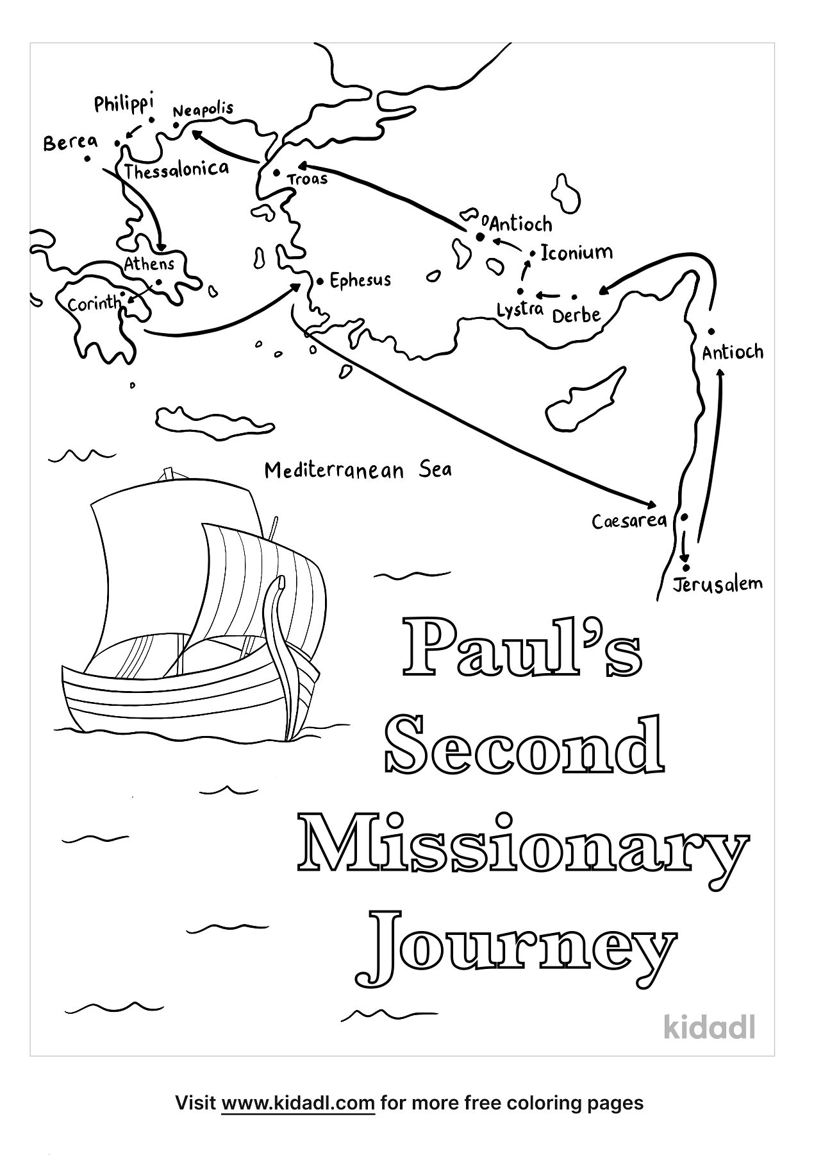
Note: Alexander the Great (356 - 323 B.C.) was from Macedonia. This is important to know. He is the military and political leader who defeated the Persians, thus taking their lands and others. His empire stretched from India to North Africa taking in Judea and all of what we consider the Holy Land and Middle East today. With this conquest, there was the spread of the Greek language, culture and religion. The New Testament was written in Greek. So, Philippi is located in an area that has a long history of the Greek pagan cults that the Gospel of God opposes.
Synopsis of when Paul first went to Philippi - Acts 16:8-40
On the Sabbath Paul meets a woman who was listening to him, named Lydia, from Thyatira, a seller of purple fabrics, a worshiper of God. The Lord opened her heart to respond to the things spoken by Paul.
Lydia’s household was baptized and she invited Paul to stay with them.
While walking through the city, Paul meets a slave-girl possessed with a spirit of divination who was owned by men making money from her fortune telling.
The slave-girl followed Paul around for several days mocking him, saying,
"These men are bond-servants of the Most High God,
who are proclaiming to you the way of salvation."
Paul became annoyed and commanded the evil spirit
“in the name of Jesus Christ” to come out of her!
And it came out at that very moment.
Her masters saw what Paul had done and their hope of profit was gone, so they seized Paul and Silas and dragged them into the marketplace before the authorities,
Charging them. . . "These men are throwing our city into confusion, being Jews, and are proclaiming customs which it is not lawful for us to accept or to observe, being Romans."

Then the crowd rose up together against them,
and the chief magistrates tore their robes off them
and proceeded to order them to be beaten with rods.
When they had struck them with many blows,
they threw them into the inner prison fastening their feet in stocks, commanding the jailer to guard them securely;

But about midnight,
Paul and Silas were praying and singing hymns praising God.
As the other prisoners listened to them, suddenly a great earthquake took place, shaking the foundations of the prison.
Immediately all the doors were opened and everyone's chains were unfastened.

The jailer awakens. . . seeing the prison doors opened, he thought the prisoners had escaped. Believing he had failed his duties, he drew his sword to kill himself,
But Paul cried out with a loud voice, saying,
"Do not harm yourself, for we are all here!"

The jailer called for lights and rushed in trembling with fear. . .
he fell down before Paul and Silas,
The jailer brought them out of the prison and asked them
What he must do to be saved?"
They said, "Believe in the Lord Jesus, and you and your household will be saved,
So, they witnessed the word of the Lord to the jailer and his household.
The jailer took them and washed their wounds.
Since the Jailer and his whole household believed, they were baptized.

The next day, the chief magistrates sent their policemen, saying, "Release those men."
The jailer reported to Paul the magistrate’s orders for them to be released and go in peace.
But Paul said to them,
"They have beaten us, ‘men who are Romans’, in public without trial, and threw us in prison and now they want to secretly send us away”?
“No indeed! But let them come themselves and bring us out."
The policemen reported these words to the chief magistrates who became afraid when they heard that they were Romans,
Then the magistrates released them, appealing and begging them to leave the city.
Paul and his friends went out of the prison, going to Lydia’s house, encouraging them.

Once again, we see Paul has a personal relationship with the Believers in Philippi. Paul not only knew them but had risked his life in Philippi witnessing to them. Paul is not some scholarly academic writing to his friends he met on vacation. The New Testament is written in times of severe oppression to those that believed in the Gospel of God.
Why is the Gospel Message so offensive to the pagan world?
The Gospel Message is the one faith in the world that takes the place of man-made institutional religion, like Judaism practiced by the Hebrews, and all pagan cultures of belief. Romans 1 summarizes all pagan beliefs in that people have exchanged the incorruptible God for the corrupted creation.
Romans 1
20 For since the creation of the world His invisible attributes, His eternal power and divine nature, have been clearly seen, being understood through what has been made, so that they are without excuse.
21 For even though they knew God, they did not honor Him as God or give thanks, but they became futile in their speculations, and their foolish heart was darkened.
22 Professing to be wise, they became fools,
23 and exchanged the glory of the incorruptible God for an image in the form of corruptible man and of birds and four-footed animals and crawling creatures.
So, we take note that when Paul preached the Gospel of God in Philippi, Ephesus or anywhere else. . .he was invading the geographic and spiritual territory of Satan who was at work in the hearts and minds of fallen humanity. Everywhere Paul went, he faced severe opposition. Yes, there were a few God-fearers like the Roman Centurion (Acts 10) or Jews (Nicodemus in John 3) who were seeking the truth and responded to the Gospel, despite their cultural or state-religious upbringing. After all, the twelve apostles Jesus called in the beginning of His ministry made a choice, a decision to surrender to God’s call over their religious culture.

The Philippian Letter
Let us now read and explore the letter Paul wrote to his friends and coworkers in Philippi, under the guidance of God’s Holy Spirit. The first few verses need to be explained in the biblical context of being a missionary in the 1st century. However, in reality, we are all. . . to some degree. . . called by God to the same status as Paul or any other Believer.
Philippians
1:1a Paul and Timothy, bond-servants (Slaves) of Christ Jesus,
Bond-servant - Strong’s1401 Greek δοῦλος doulos
Do you not know that when you present yourselves to someone as slaves for obedience, you are slaves of the one whom you obey, either of sin resulting in death, or of obedience resulting in righteousness? (Romans 6:16)
Other references where Paul calls himself a bondservant of God.
Romans 1:1; Galatians 1:10; Titus 1:1
Other people referred to as a slave or bondservant
Luke 2:29 Simeon – the man who identified baby Jesus before he died.
Philippians 2:7 Reference to Christ’s incarnation
Colossians 1:7 Epaphras, a fellow worker with Paul
Colossians 4:7 Reference to Tychicus a fellow worker with Paul
2 Timothy 2:24 Paul’s referring to elder qualifications
James 1:1 James refers to himself
2 Peter 1:1 Simon Peter refers to himself
Jude 1:1 Jude refers to himself
Revelations 1:1 Reference to John the apostle
Revelation 15:3 Reference to Moses

As we can see, in the Bible, the term “slave” is assigned to many people who surrendered to God. This is a unique designation; in that it carries the meaning of a person who does not have a will of their own but who lives under the direction of God. Paul also declares this relationship in Galatians 2:20.
"I have been crucified with Christ; and it is no longer I who live, but Christ lives in me; and the life which I now live in the flesh I live by faith in the Son of God, who loved me and gave Himself up for me.”
Paul is direct and makes it clear to people in a world who fully understand the meaning of “slave”. There is not any better word to use to describe the relationship with God, who calls us from a fallen depraved world to surrender to His Will and have His Holy Spirit direct our lives. Do not be confused that God works as dictator ordering us around. The Believer’s life is not like that at all. The Believer willingly sees the greater good-plan God has for their life and pursues God’s goals as their own personal desire.
In our society, considering yourself a slave may have a negative association. However, Believers have freely chosen to be directed by God and have a predetermined life by God. Once a person humbles/surrenders themselves to God, they then come under His direction to live the purposed-life He has designed for them. Meaning that many decisions have already been made for us. In this, we pursue moral personal principles God has established to create and maintain a civilized society. Living this way frees us from destructive forces and enables us to be that Light of victory in the fallen world.
Ephesians 2:10 For we are His workmanship, created in Christ Jesus for good works, which God prepared beforehand so that we would walk in them.
What are those decisions?
All of our decisions are centered around God’s plan for our lives which brings about an automatic witness of living the victorious life.
God’s Holy Spirit directs our lives. . . for we are, at times, too weak or at a loss to guide ourselves. There are many Old and New Testament Bible verses to cite supporting God being with us as we witness to others and go through challenging times. Here are a few:
John 14:26 "But the Helper, the Holy Spirit, whom the Father will send in My name, He will teach you all things, and bring to your remembrance all that I said to you.
Psalms 32:8 I will instruct you and teach you in the way which you should go; I will counsel you with My eye upon you.
2 Timothy 1:7 For God has not given us a spirit of timidity, but of power and love and discipline.
Isaiah 41:10 Do not fear, for I am with you; Do not anxiously look about you, for I am your God. I will strengthen you, surely I will help you, Surely I will uphold you with My righteous right hand.'
Luke 21:14-15 14 "So make up your minds not to prepare beforehand to defend yourselves; 15 for I will give you utterance and wisdom which none of your opponents will be able to resist or refute.
In Romans 8:28-30, we are told that once a person surrenders to God, they become predestined to carry-out God’s will. . . thus under God’s servitude. . . or as Paul portrays himself. . . God’s slave. This opens a path that God has planned for all Believers to:
Work together for good
Have a purpose in life
Be conformed to the image of Jesus
Be justified to God (called) and then one day glorified
28 And we know that God causes all things to work together for good to those who love God, to those who are called according to His purpose.
29 For those whom He foreknew, He also predestined to become conformed to the image of His Son, so that He would be the firstborn among many brethren;
30 and these whom He predestined, He also called; and these whom He called, He also justified; and these whom He justified, He also glorified.
Ok, so now that we have read these Scriptures about predestination, there must be an explanation. The key to understanding predestination is in the text. For those God foreknew. . . He causes. . . (all of the above). Once a person surrenders to God then things are predestined for them, not prior/previously.
Remember that it is only God who foreknows who will chose to exercise their free-will-choice and come to Him. People do not have foreknowledge. We see this in John 6:64-66.
64 "But there are some of you who do not believe."
For Jesus knew from the beginning who they were who did not believe, and who it was that would betray Him.
65 And He was saying,
"For this reason, I have said to you, that no one can come to Me unless it has been granted him from the Father."
66 As a result of this many of His disciples withdrew and were not walking with Him anymore.
We learn from this passage that God is the One who knows the hearts of people accurately from the beginning. Thus, God has foreknowledge. Therefore, in this context, God is the One who qualifies people’s sincerity of heart.
Jesus frequently uses the father-son relationship during His earthly ministry in order to paint a picture that is clear for all to see. This is why we have the word “trinity” used to describe the applications of God’s functions from One nature. We see that God is One in nature casting three functions. Jesus highlights these functions in John 6:65.
Consider these three observations.
God the Creator: Can be referred to as God the Father.
(Genesis)
God the Son: God incarnated himself as human to pay the price for our sins. . . going to the Cross. And teaching us it is possible to live this temporal life with Him residing in our hearts. (The Gospels – John 1 and 3:16)
God the Holy Spirit: Convicts people of sin (John 16:8). Those who surrender to the Holy Spirit conviction have Him indwell their heart to guide their life and distribute spiritual gifts to them. (Acts 2:38; John 3; 1 Cor. 12:11)
So, in Jesus’ teachings, for our temporal clarity, God qualifies people’s sincerity as described in John 6:65. We see there that God is not limited in form or function. God is not confined to one role in history. Remember, in the Great Commission, Believers are charged to go and make disciples of all the nations, baptizing them in the name of the Father and the Son and the Holy Spirit, (Matthew. 28:19). And remember that it is God as Jesus who is the judge at the Great White Throne judgement chronicled in Revelation 20.
Referencing God’s perfect knowledge, regarding predestination, He knew Pharoah, Herod and Judas would betray Him and willfully choose to murder or plot to murder others. These people are examples of those that were ‘turned over to their own desires’ just as God declares in Romans 1:26-32. No other being knows what God knows. It frustrates fallen man not to be able to control the gate of heaven. There is only one gate to heaven. . . through God’s judgement at the Great White Throne. Read Revelation 20:11-15. Rebellious people try to control the gate to heaven by making false claims based upon out-of-context reading of Scripture. Any works-based-salvation-plan is the number one sign that a person or group has claimed to be the gate-keeper to heaven (Ephesians 2:8, Romans 4, Hebrews 10,11 to cite a few Scriptures).
With this said, Paul continues his introductory remarks which we will consider next Sunday.

Philippians 1:1b
To all the saints in Christ Jesus who are in Philippi,
including the overseers and deacons:
2 Grace to you and peace
from God our Father and the Lord Jesus Christ. AMEN

