Round Top Church Christian Fellowship

Sermon Series
Paul’s Letter to The Saints in Ephesus

Chapter 1 – God is Jesus “The” Messiah

Pastor ~ Matthew Diehl

June 20th In the Year of Our Lord
(Anno Domini A.D.) 2021
(Unless otherwise noted, NAS is quoted.)

Ephesus was a major seaport city in the Roman Empire and the world with a 1st century population of 250,000. Ephesus was the center of pagan worship for the goddess Artemis and supported the construction of a large amphitheater able to seat 24,000 people.

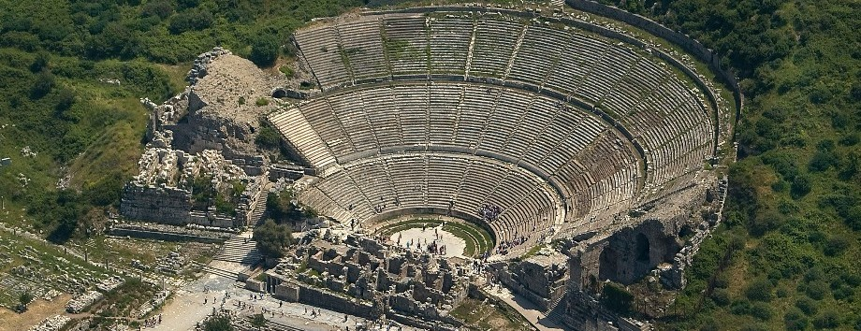

https://www.google.com/search?q=map+of+ephesus&rlz=1C1GGRV_enUS751US751&tbm=isch&source=iu&ictx=1&fir=qznOJsIwn445oM%252CWYhX0h1n_E7ucM%252C_&vet=1&usg=AI4_-kTg2cS75n2r0HSXB7DynkNk2Hmf3w&sa=X&ved=2ahUKEwiD3v6H55nxAhX4B50JHUMoAoMQ9QF6BAgHEAE#imgrc=XOIWBANtGwVTjM
The Christian church in Ephesus is one on the seven churches addressed in John’s “unveiling” (Greek – apokalupsis / English – apocalypse) letter of Jesus Christ”.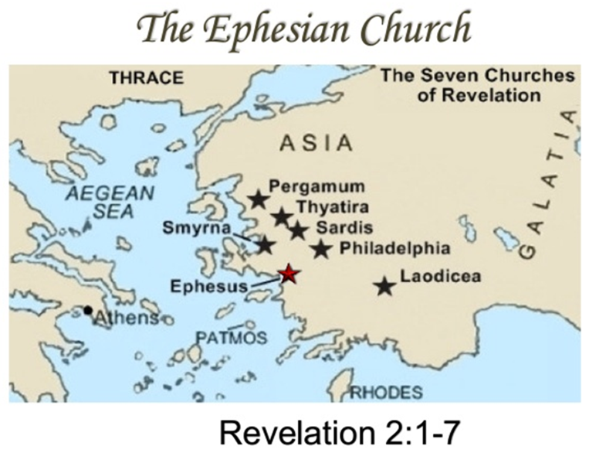
https://www.google.com/search?q=map+of+ephesus&rlz=1C1GGRV_enUS751US751&tbm=isch&source=iu&ictx=1&fir=qznOJsIwn445oM%252CWYhX0h1n_E7ucM%252C_&vet=1&usg=AI4_- kTg2cS75n2r0HSXB7DynkNk2Hmf3w&sa=X&ved=2ahUKEwiD3v6H55nxAhX4B50JHUMoAoMQ9QF6BAgHEAE#imgrc=kaOzyhS-S5x8SM

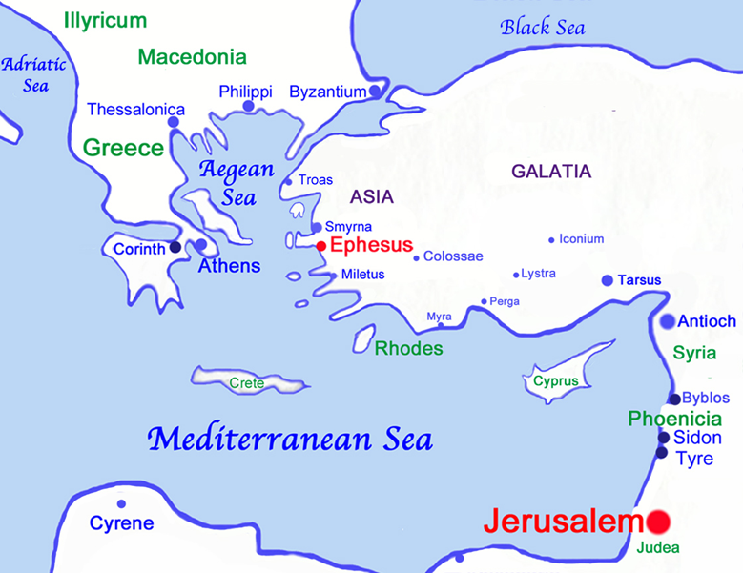
https://www.google.com/search?q=map+of+ephesus&rlz=1C1GGRV_enUS751US751&tbm=isch&source=iu&ictx=1&fir=qznOJsIwn445oM%252CWYhX0h1n_E7ucM%252C_&vet=1&usg=AI4_-kTg2cS75n2r0HSXB7DynkNk2Hmf3w&sa=X&ved=2ahUKEwiD3v6H55nxAhX4B50JHUMoAoMQ9QF6BAgHEAE#imgrc=e2DocEopk1xLZM
Since we have just completed our sermon series on the book of Acts, we know that the Apostle Paul wrote to the saints in Ephesus while he was under “house arrest” (prison) in Rome with a Roman soldier guarding him. Due to Ephesians 6:20, Paul is depicted by artists through the centuries to be chained to a wall or a Roman soldier in house quarters that he was allowed to rent at his expense. Paul had been brought to Rome as a prisoner by order of the Roman Governor of Judea, Festus. Paul was transported in the care of the Augustan Cohort, who served directly at the orders of Caesar. Paul had appealed to Caesar defending charges from the Jews in Jerusalem. Paul was allowed to have guests and freely witnessed God and His incarnation as Jesus Christ.
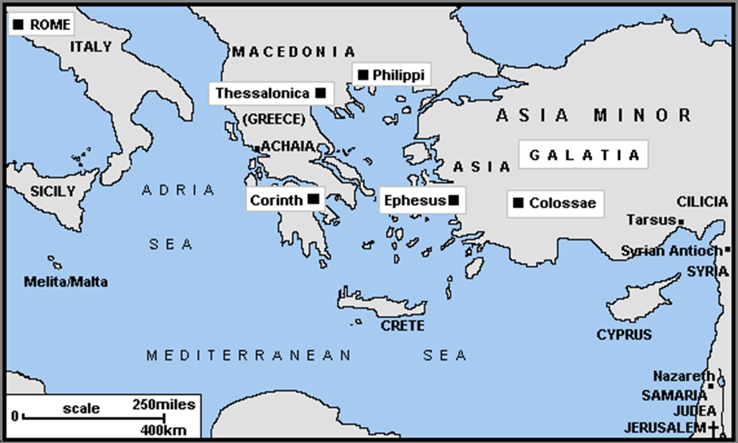
https://www.google.com/search?q=map+of+ephesus&rlz=1C1GGRV_enUS751US751&tbm=isch&source=iu&ictx=1&fir=qznOJsIwn445oM%252CWYhX0h1n_E7ucM%252C_&vet=1&usg=AI4_-kTg2cS75n2r0HSXB7DynkNk2Hmf3w&sa=X&ved=2ahUKEwiD3v6H55nxAhX4B50JHUMoAoMQ9QF6BAgHEAE#imgrc=4c2t_7xkN3bGIM
Like Paul, we need never lose sight of the fact that God, as Jesus, came to model the life Adam “was” to have lived (Romans 5:14, 1 Corinthians 15:45) . . . and to physically die on the Cross as the sinless (unblemished lamb) sacrifice for the sins of everyone who ever lived. . . and to rise from a tomb to continue teaching the Gospel leading to His ascension to heaven with a prophetic promise to return again one day to judge the living and the dead. Paul taught all of these things and more about Jesus.
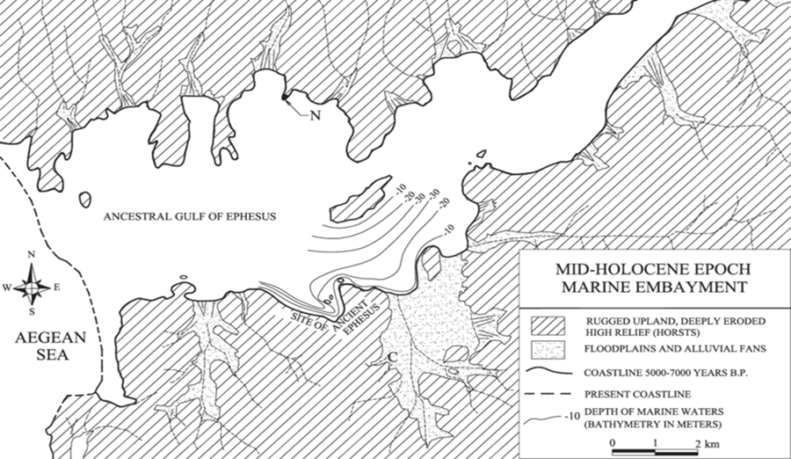
https://www.google.com/url?sa=i&url=https%3A%2F%2Fwww.researchgate.net%2Ffigure%2FA-map-of-the-mid-Holocene-ancestral-Gulf-of-Ephesus-at-peak-marine-transgression-6000_fig3_227658410&psig=AOvVaw2TP8kd7EzNdG1WOzjXfA40&ust=1623852245523000&source=images&cd=vfe&ved=0CAkQjhxqGAoTCKCY-ZPnmfECFQAAAAAdAAAAABCaAQ
During the last seven millennia, these marine indentations have silted up due to the continued progradation of the deltas of major rivers. The Küçük Menderes (Cayster, Kaystros) and the Büyük Menderes (Maiandros, Maeander) valleys, with Ephesos and Miletos, respectively, as the most prominent ancient cities.
Paul would not be a prisoner in Rome unless he had surrendered to God on that Damascus Road. So, Paul opens his letter to the Ephesians proclaiming that he is an Apostle of the One he met that day on the Damascus Road. Not only an apostle, but he is an Apostle by God’s will. . . is there any other kind? An Apostle is a person who is sent by God on a mission to deliver a message. Obviously, Paul delivered the message that God had directed him to give.
15 But the Lord said to him, "Go, for he is a chosen instrument (vessel/instrument) of Mine, to bear My name before the Gentiles and kings and the sons of Israel; (Acts 9:15)
History of Paul and the Ephesian Congregation
When you study the dating provided by scholars for Paul’s missionary journeys there is not a consistent view. This is due to the dating of various Roman and Jewish leader’s time in office.
In Acts 18:19, near the end of Paul’s Second Missionary Journey (49-53 A.D.), we see that when Paul first went to Ephesus he went to the synagogue and reasoned with the Jews but did not stay long. However brief a stay in Ephesus, we can assume Paul witnessed to the local population as evidenced in the appearance of Apollos witnessing for God. As great a witness as Apollos was, he did not have the full Gospel Message. It was at Ephesus where we see Priscilla and Aquila took Apollos aside and explained to him the way of God more accurately.
During Paul’s third Missionary Journey (53-58 A.D. / chronicled in Acts 19), it was at Ephesus where Paul witnessed the Holy Spirit to people who had only accepted John's baptism which pointed the way to the Messiah and gave a temporal commitment not to sin. Paul asked them if they had received the Holy Spirit when they believed. It is obvious that they had only believed in a life of “good deeds by works” of their “own power”. Due to their willing surrender to the Truth in Paul's witness, they were baptized again, but, this time, in the name of Jesus (not John). When this took place, the Holy Spirit came on them. In this occasion (as evidence of the Holy Spirit indwelling these disciples), they did speak in tongues and prophesy, which simply means to speak forth God's Word. Remember, speaking in tongues did not always happen as a result of water baptism.
During this same stay at Ephesus, Paul spoke boldly for three months in the synagogue, but some Jews hardened against Paul. So, he rented a private location for two years. Paul became well-known for his teaching and for performing miracles by healing the sick.
It was in Ephesus that the silversmith, Demetrius, who made silver shrines of the pagan goddess Artemis, whose grand temple was in the city, spoke against Paul. Paul said that "gods made with hands are no gods at all" (Acts 19:26). It was the town Clerk that brought a peace to the situation. See the Scripture - Acts 19:35 – 41, witnessing the Holy Spirit at work.
[Artemis, goddess of the pagan Greek religion, over wild animals, and hunting. Also, goddess of vegetation, chastity and childbirth. She was identified by the Romans as the goddess Diana. Artemis was held to be the daughter of Zeus and Leto and the twin sister of Apollo and the common person’s favorite goddess.]
https://www.google.com/search?q=temple+of+artemis&rlz=1C1GGRV_enUS751US751&tbm=isch&source=iu&ictx=1&fir=hnveFlbUd3l4wM%252CUiHCQsQ1z_CapM%252C_&vet=1&usg=AI4_-kT5UlLqf7-bvB3aOhJmBsdM8p598w&sa=X&ved=2ahUKEwir1qqBnZrxAhXSWc0KHWiCAmQQ9QF6BAgKEAE&biw=2496&bih=977#imgrc=9wC5Fx0PoFvyQM
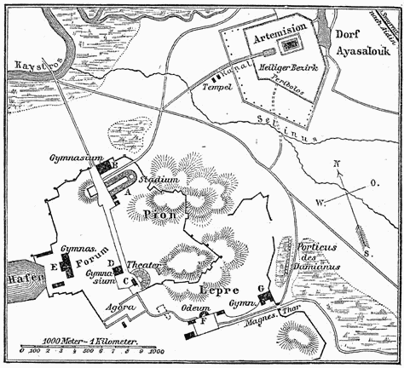
https://www.google.com/search?q=map+of+ephesus&rlz=1C1GGRV_enUS751US751&tbm=isch&source=iu&ictx=1&fir=qznOJsIwn445oM%252CWYhX0h1n_E7ucM%252C_&vet=1&usg=AI4_-kTg2cS75n2r0HSXB7DynkNk2Hmf3w&sa=X&ved=2ahUKEwiD3v6H55nxAhX4B50JHUMoAoMQ9QF6BAgHEAE#imgrc=p7NIAJYOb6cXGM&imgdii=aNk_5Ft0LP4htM

Paul calls the Elders of Ephesus to Miletus for a Farwell Address (Acts 20:16-38)

This is an emotional address. Paul believes he will not be seeing his close friends again to whom he had witnessed and seen grow in the Gospel of Jesus Christ.

Paul bears witness to The Saints in Ephesus
The “2000” year Old Letter - New Testament Book – Ephesians
Ephesians 1:1 (a) Paul, an apostle of Christ Jesus
by the will of God,
The title of Apostle is an office of God that carries a deeper commitment, a higher calling, a more in depth understanding and a more sacrificial service. Thank God, He does not call all of us to be an Apostle. I notice today that there are many who call themselves “Apostle” and wear their self-proclamation like a Rock Star title and assignment that everyone is to bow to them. Again, all the Apostles, save St. John, were all martyred. And so is the fate of Paul in Rome when he is under arrest a second time.
To The Saints
Paul had spent considerable time in Ephesus, making spiritual deposits and investments into individuals. He knew them personally. So, when God’s Holy Spirit directed Paul to address the letter to the “saints” of the Ephesian congregation, it was not a generic statement.
Ephesians 1:1 (b) To the saints who are at Ephesus
and who are faithful in Christ Jesus:
In theory, saints are faithful to Christ. So, it makes perfect sense that believers in Christ Jesus are faithful. In a practical meaning - this means they wake every morning and seek to make decisions following God’s Spirit operating inside their hearts. On the contrary, some people who live without God’s Spirit operating in their heart - wake every morning and are not focused on spiritual applications to life. Believers have an opportunity every day to operate in God’s Spirit. You know, the fruits of the spirit (Galatians 5:22,23): love, joy, peace, patience, kindness, goodness, faithfulness,
gentleness, self-control; against such things there is no law.
We know these life-changing attributes of God’s Spirit. The challenge is to implement them on a daily, hourly, minute-by-minute basis. I think that every politician in government should implement these spiritual attributes. The world would change on a dime. People ask - what kind of a difference can being a Christian make? The difference that makes the whole world come to peace with God and their neighbor. Of course, all this starts with a surrender to God, of which many people are too prideful and self-absorbed to do.
But it could happen. In December of 1914, during the trench warfare of WWI, British and German troops sang Christmas carols to each other across no-man’s land. The gunfire took a brief pause in the madness of war and the two sides left their trenches to exchange Christmas cheer with their enemy. Then, at the turn of a new day, gunfire returned and the killing continued. What did it take to get the two enemies to stop killing each other on that brief Christmas Eve? The observance of God incarnating Himself as one of us. This is the message of the Cross. God reaches-out to murderous fallen humanity in the midst of their killing and says, “Stop”! – "Turn to Me and be saved, all the ends of the earth; For I am God, and there is no other. (Isaiah. 45:22).
We see clarification of spiritual fruits in the life of faithful Believers in these verses listing the fruits of the spirit.
Galatians. 5:24-6:1
24 Now those who belong to Christ Jesus have crucified the flesh with its passions and desires. 25 If we live by the Spirit, let us also walk by the Spirit. 26 Let us not become boastful, challenging one another, envying one another.
Ephesians 1: 2 Grace to you and peace
from God our Father and the Lord Jesus Christ.
In all of Paul’s thirteen letters, he addresses the recipients by showering them with God’s Grace and peace.
Romans 1:7; 1 Corinthians 1:3; 2 Corinthians 1:2;
Galatians 1:3; Philippians 1:2; Colossians 1:2;
1 Thessalonica 1:1; 2 Thessalonica 1:2;
1 Timothy 1:2; 2 Timothy. 1:2; Titus 1:4; Philemon 1:3
Many scholars do not believe that Paul wrote the book of Hebrews, but that a student of his wrote the letter. Hebrews does not start like Paul’s thirteen letters with a salutation of grace and peace. However, God is named as the God of peace in Hebrews 13:20. Now the God of peace, who brought up from the dead the great Shepherd of the sheep through the blood of the eternal covenant, even Jesus our Lord.
As an apostle who brings forth God’s messages, Paul extends God’s grace and peace which are foundational in God’s outreach to fallen humanity. We do not let these two words get past us without recognizing the eternal significance in their origin. There are reasons Paul uses these two words in his opening remarks. They are not a casual salutation. These words are used under God’s sovereign love and authority. Grace is extending favor that is not earned. Peace is a result of God’s grace accepted. God’s love seeks to end the enmity between fallen humanity and Himself. For there to be peace between God and fallen humanity. . . there has to be the acceptance of God’s grace of the offending party – sinful man. To accept God’s grace, there has to be a humbling of the fallen human heart to the love of God.
Genesis 3:12-15
¹² The man said, "The woman whom You gave to be with me, she gave me from the tree, and I ate." ¹³ Then the LORD God said to the woman, "What is this you have done?" And the woman said, "The serpent deceived me, and I ate." ¹⁴ The LORD God said to the serpent, "Because you have done this, Cursed are you more than all cattle, And more than every beast of the field; On your belly you will go, And dust you will eat All the days of your life; ¹⁵ And I will put enmity Between you and the woman, And between your seed and her seed; He shall bruise you on the head, And you shall bruise him on the heel."

God The Father of All Creation
Founding Father of Hebrew People
Father of Redemption for Jews and Gentiles
Grace and peace are extended to us by our Father in heaven. It is important that we see Paul, who has a Hebrew upbringing, refer to God as “Father”.
Genesis 1:1 In the beginning God created the heavens and the earth.
Deuteronomy 32:6 "Do you thus repay the LORD, O foolish and unwise people? Is not He your Father who has bought you? He has made you and established you.

1 Chronicles 29:10-11 ¹⁰ So David blessed the LORD in the sight of all the assembly; and David said, "Blessed are You, O LORD God of Israel our father, forever and ever. ¹¹ "Yours, O LORD, is the greatness and the power and the glory and the victory and the majesty, indeed everything that is in the heavens and the earth; Yours is the dominion, O LORD, and You exalt Yourself as head over all.

Malachi 2:10 "Do we not all have one father? Has not one God created us? Why do we deal treacherously each against his brother so as to profane the covenant of our fathers?

Isaiah 43:1 But now, thus says the LORD, your Creator, O Jacob, And He who formed you, O Israel, "Do not fear, for I have redeemed you; I have called you by name; you are Mine!

Isaiah 63:16 For You are our Father, though Abraham does not know us And Israel does not recognize us. You, O LORD, are our Father, Our Redeemer from of old is Your name.

Isaiah 64:8 But now, O LORD, You are our Father, We are the clay, and You our potter; And all of us are the work of Your hand.

Hosea 1:10 Yet the number of the sons of Israel Will be like the sand of the sea, Which cannot be measured or numbered; And in the place Where it is said to them, "You are not My people," It will be said to them, "You are the sons of the living God."

Hosea 11:1 When Israel was a youth I loved him, And out of Egypt I called My son.

Romans 10:12-13
12 For there is no distinction between Jew and Greek; for the same Lord is Lord of all, abounding in riches for all who call on Him;
13 for "WHOEVER WILL CALL ON THE NAME OF THE LORD WILL BE SAVED." (Acts 15:9; Romans 3:22; 10:12; Colossians 3:11)

In verse 2, Paul ties the extension of grace and peace as coming
from both God their Father and the Lord Jesus Christ. In verse 3, Paul purposely, with inclusion, reaches-out to the Gentiles (Greeks) and directs their attention to Jesus Christ by using the word “our” Lord Jesus Christ.

Ephesians 1:3
Blessed be the God and Father of our Lord Jesus Christ,
who has blessed us with every spiritual blessing
in the heavenly places in Christ,
Paul also is pointing to God as being the Father of Jesus Christ. Paul does not just say Jesus. Paul ties the title of “Christ” to Jesus’s name which is the Greek word for the Hebrew word “Messiah”. The Messiah is the One who will deliver the Hebrew people and pay the price for the sins of the world (Psalm 22; Isaiah 61:6; chapter 53).

Paul writes to Titus: (2:13-15)
¹³ looking for the blessed hope and the appearing of the glory of our great God and Savior, Christ Jesus, ¹⁴ who gave Himself for us to redeem us from every lawless deed, and to purify for Himself a people for His own possession, zealous for good deeds. ¹⁵ These things speak and exhort and reprove with all authority. Let no one disregard you
1Timothy 2:6 who gave Himself as a ransom for all, the testimony given at the proper time.
I encourage all to read Isaiah 53. There are numerous references to the Messiah and His role as redeemer. Paul ties all of this together in his opening words to the Ephesians and the world. There is obviously more teaching that needs to be done concerning God the Father, Jesus the Son, and the Holy Spirit. For our purposes today, it is profitable to tie God the Father to Jesus the Christ through Scripture.
Isaiah 53:5-12
5 But He was pierced through for our transgressions, He was crushed for our iniquities; The chastening for our well-being fell upon Him, And by His scourging we are healed.
6 All of us like sheep have gone astray, Each of us has turned to his own way; But the LORD has caused the iniquity of us all To fall on Him.
7 He was oppressed and He was afflicted, Yet He did not open His mouth; Like a lamb that is led to slaughter, And like a sheep that is silent before its shearers, So He did not open His mouth.
8 By oppression and judgment He was taken away; And as for His generation, who considered That He was cut off out of the land of the living For the transgression of my people, to whom the stroke was due?
9 His grave was assigned with wicked men, Yet He was with a rich man in His death, Because He had done no violence, Nor was there any deceit in His mouth.
10 But the LORD was pleased To crush Him, putting Him to grief; If He would render Himself as a guilt offering, He will see His offspring, He will prolong His days, And the good pleasure of the LORD will prosper in His hand.
11 As a result of the anguish of His soul, He will see it and be satisfied; By His knowledge the Righteous One, My Servant, will justify the many, As He will bear their iniquities.
12 Therefore, I will allot Him a portion with the great, And He will divide the booty with the strong; Because He poured out Himself to death, And was numbered with the transgressors; Yet He Himself bore the sin of many, And interceded for the transgressors.

New Testament state of Jesus verified in the Old Testament

Matthew 1:23 "BEHOLD, THE VIRGIN SHALL BE WITH CHILD AND SHALL BEAR A SON, AND THEY SHALL CALL HIS NAME IMMANUEL," which translated means, "GOD WITH US."

Isaiah 7:14 "Therefore the Lord Himself will give you a sign: Behold, a virgin will be with child and bear a son, and she will call His name Immanuel.
Isaiah 9:6 For a child will be born to us, a son will be given to us; And the government will rest on His shoulders; And His name will be called Wonderful Counselor, Mighty God, Eternal Father, Prince of Peace.
Isaiah 9:7 There will be no end to the increase of His government or of peace, On the throne of David and over his kingdom, To establish it and to uphold it with justice and righteousness From then on and forevermore. The zeal of the LORD of hosts will accomplish this.

Micah 5:2 "But as for you, Bethlehem Ephrathah, Too little to be among the clans of Judah, From you One will go forth for Me to be ruler in Israel. His goings forth are from long ago, From the days of eternity."

AMEN

