Round Top Church Christian Fellowship

Paul’s Life for The Lord
A Responsive Life

I M P A C T I V E

Acts 28
Pastor ~ Matthew Diehl
June 13th In the Year of Our Lord
(Anno Domini A.D.) 2021
(Unless otherwise noted, NAS is quoted.)

I M P A C T
The Word of God, once read, has an impact upon a person and people groups. Included in God’s word is His incarnation as Jesus Christ the Messiah. The Apostle Paul highlights to the Jews and to the world that God’s Word contains prophetic announcements about the Messiah. We have looked at the astronomical odds for Jesus to fulfill all messianic prophecies. The mathematics dictate that the incarnation had purpose, meaning and direction. The incarnation was not a random process of evolution’s chance. The incarnation is like the creation having purpose, meaning and direction. Like the incarnation, the mathematical study of the odds is pivotal and defining. To rely upon a random process to produce the earth and life on the earth is pure ignorance of the scientific facts. The occurrence of the creation and the incarnation are beyond chance. We have referred to Dr. Douglas Axe’s book “Undeniable” as the most recent scientific study highlighting mathematics of creation. It is obvious someone planned and executed their plan. The most obvious candidate is God - of the Scriptures, the Bible - the Word.
With the Jews in Rome, Paul starts with God and the Old Testament (O.T.) prophets. For the Jews, they are recognized as a voice from God that cannot be ignored. To the rest of the world, these O. T. prophets do not have the same standing. But what we do have is reason. Yes, reason. God gave us reasonable cognitive ability to process what we analyze with our senses and consciousness. God does not ask us to live a life in la-la-land. This is why Paul refers to the O. T. prophets to assist the Jews, and the world, in seeing what God had accomplished by incarnating Himself as Jesus Christ.
The Word of God presents people with decisions to make:
1. Discern who the messenger is.
2. Determine the source of the message. Example: Man, or God.
3. Accept the message as a truth or opinion. Specifically, is Jesus the
Messiah who died on the Cross for people’s sin?
4. What is your internal response?
5. What is your public response?
6. What are the alternatives - what is a world without God like?
7. Can humanity exist without a belief, without love?
With atheism leading the way, the 20th century killed more people in wars than all the previous centuries combined. During the 20th century, atheistic powers seized control of Russia, Germany and the Axis powers. Japan did have a religious catalyst but that of religion that opposed the God of creation and the incarnation. Preceding this 20th century destruction, the 19th century German philosopher Fredrich Nietzsche led the atheistic way with his “God is dead” writings. With this view, Nietzsche positioned that the stronger person would not be held back by God, in that they should not consider their neighbor. The stronger person can rise at the expense of their neighbor. Therefore, the world got Lenin, Stalin and Hitler. This is also taught by Darwinian evolution as “survival of the fittest”.
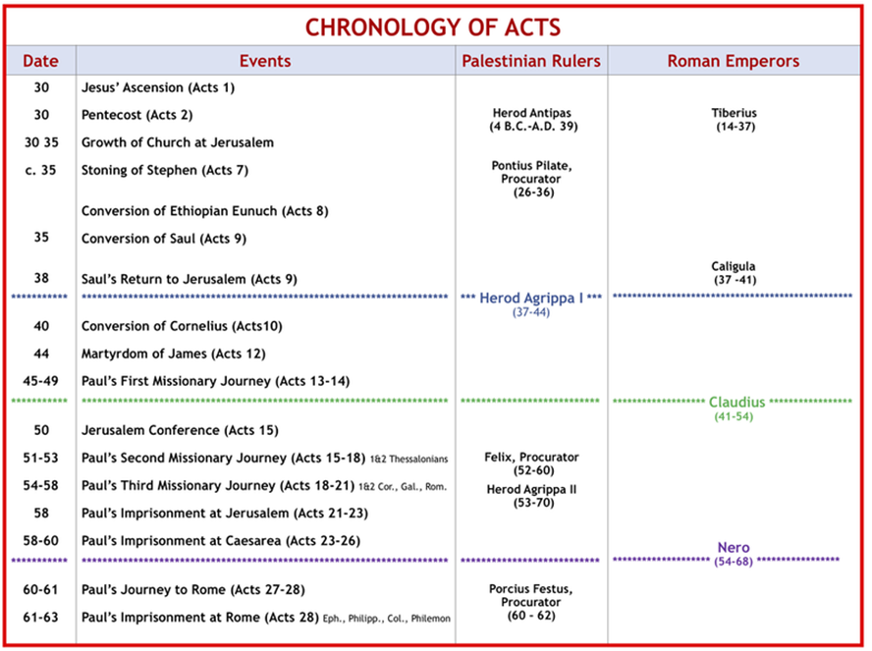
https://www.avcoc.org/chronology-of-acts.html.
Safely Ashore & Greeted with Kindness by the people of Malta
Acts 28:1 When they had been brought safely through, then we (Luke) found out that the island was called Malta.
2 The natives showed us extraordinary kindness; for because of the rain that had set in and because of the cold, they kindled a fire and received us all.
Snake Bite
3 But when Paul had gathered a bundle of sticks and laid them on the fire, a viper came out because of the heat and fastened itself on his hand.
4 When the natives saw the creature hanging from his hand, they began saying to one another,
"Undoubtedly this man is a murderer, and though he has been saved from the sea, justice has not allowed him to live."
5 However he shook the creature off into the fire and suffered no harm.
6 But they were expecting that he was about to swell up or suddenly fall down dead. But after they had waited a long time and had seen nothing unusual happen to him, they changed their minds and began to say that he was a god.

Paul Heals the Sick and is Well-Received by Local People
7 Now in the neighborhood of that place were lands belonging to the leading man of the island, named Publius, who welcomed us and entertained us courteously three days.
8 And it happened that the father of Publius was lying in bed afflicted with recurrent fever and dysentery; and Paul went in to see him and after he had prayed, he laid his hands on him and healed him.
9 After this had happened, the rest of the people on the island who had diseases were coming to him and getting cured.
10 They also honored us with many marks of respect; and when we were setting sail, they supplied us with all we needed.

On to Rome
11 At the end of three months we set sail on an Alexandrian ship which had wintered at the island, and which had the Twin Brothers for its figurehead.
12 After we put in at Syracuse, we stayed there for three days.
13 From there we sailed around and arrived at Rhegium, and a day later a south wind sprang up, and on the second day we came to Puteoli.
14 There we found some brethren, and were invited to stay with them for seven days; and thus, we came to Rome.
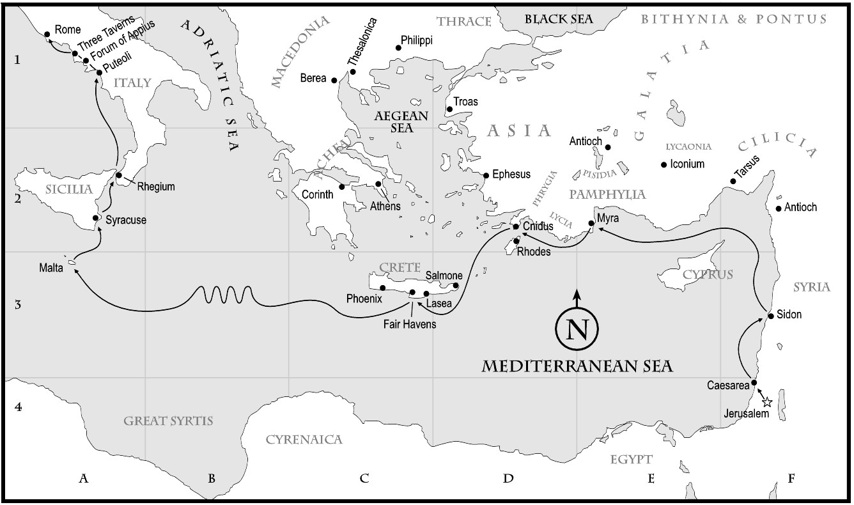
https://www.tiarastantrums.com/homeschool/missionary-map-project-pauls-journey-to-rome
Paul Encouraged by His Greeting in Rome by Believers
15 And the brethren, when they heard about us, came from there as far as the Market of Appius and Three Inns to meet us; and when Paul saw them, he thanked God and took courage.
These two locations are small towns on the road to Rome from the port town of Puteoli. This road is the well-known Appian Way.
The first of the great Roman roads, the Via Appia (Appian Way), begun by the censor Appius Claudius Caecus in 312 BCE, originally ran southeast from Rome 162 miles (261 km) to Tarentum (now Taranto) and was later extended to the Adriatic coast at Brundisium (now Brindisi). The long branch running through Calabria to the Straits of Messina was known as the Via Popilia.
https://www.britannica.com/technology/Roman-road-system
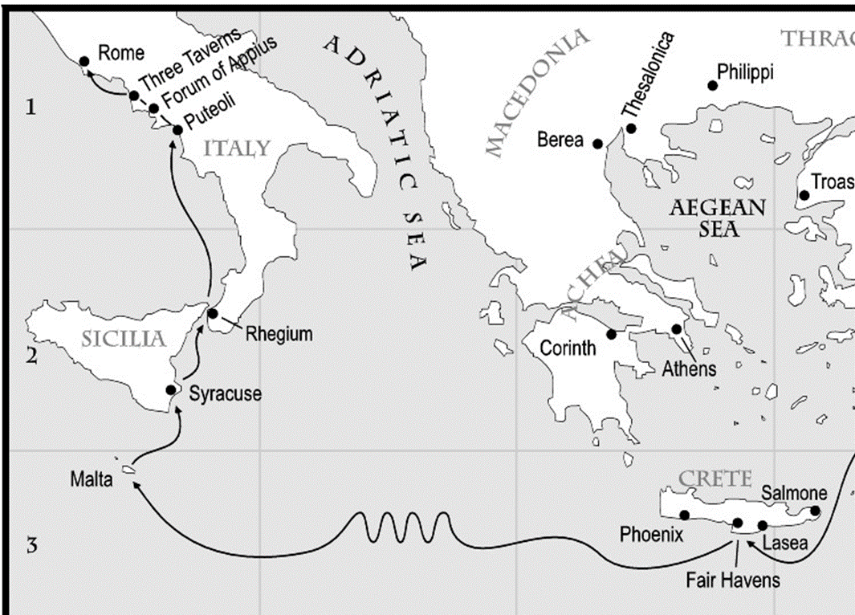
The modern name for ancient Puteoli is Pozzuoli and it is located west of Naples. It was a very important harbor in Roman Times. Most of the ancient travelers to Rome would land at Puteoli and then follow the Via Appia into the city—as Paul did. The large Roman grain ships, bringing grain from Alexandria Egypt, also docked here. Because in Paul’s day (ca. A.D. 60) Ostia, the main port of Rome, could not yet handle the very large Alexandrian grain ships, these ships often would dock at Puteoli and offload their grain on to smaller vessels that in turn would carry the grain to Ostia. Later, the port of Ostia was enlarged and could accommodate the large Alexandrian grain ships.
https://holylandphotos.wordpress.com/2019/01/21/puteoli-italy-paul-stayed-here-for-a-week-on-his-way-to-rome/
Acts 28:16 When we entered Rome,
Paul was allowed to stay by himself, with the soldier who was guarding him.
Paul Calls to Meet with Leading Jews in Rome
17 After three days Paul called together those who were the leading men of the Jews, and when they came together, he began saying to them,
"Brethren, though I had done nothing against our people or the customs of our fathers, yet I was delivered as a prisoner from Jerusalem into the hands of the Romans.
18 "And when they had examined me, they were willing to release me because there was no ground for putting me to death.
19 "But when the Jews objected, I was forced to appeal to Caesar, not that I had any accusation against my nation.
20 "For this reason, therefore, I requested to see you and to speak with you, for I am wearing this chain for the sake of the hope of Israel."
Paul’s opening statement to the leading Jews is a refutation of the charges in that he did not do anything wrong against “our” people or the customs of “our” fathers (meaning Abraham, Isaac, Jacob, Joseph and Moses particularly). Paul wants to identify himself as one of them. Remember, Paul’s last hearing was in front of the Jewish King Agrippa and Festus the Governor, who found nothing wrong with Paul. Note, at this point Paul does not present his teachings about God, Jesus the Messiah or the Resurrection.
21 They said to him,
"We have neither received letters from Judea concerning you, nor have any of the brethren come here and reported or spoken anything bad about you.
22 "But we desire to hear from you what your views are;
for concerning this sect,
it is known to us that it is spoken against everywhere."

Kingdom of God, Jesus, Moses, Prophets
23 When they had set a day for Paul, they came to him at his lodging in large numbers; and he was explaining to them by solemnly testifying about the kingdom of God and trying to persuade them concerning Jesus, from both the Law of Moses and from the Prophets, from morning until evening.
24 Some were being persuaded by the things spoken,
but others would not believe.
25 And when they did not agree with one another, they began leaving after Paul had spoken one parting word,
"The Holy Spirit rightly spoke through Isaiah the prophet to your fathers,
26 saying, ' [ from Isaiah 6:9,10 ]
GO TO THIS PEOPLE AND SAY,
"YOU WILL KEEP ON HEARING, BUT WILL NOT UNDERSTAND;
AND YOU WILL KEEP ON SEEING, BUT WILL NOT PERCEIVE;
27 FOR THE HEART OF THIS PEOPLE HAS BECOME DULL,
AND WITH THEIR EARS THEY SCARCELY HEAR,
AND THEY HAVE CLOSED THEIR EYES;
OTHERWISE THEY MIGHT SEE WITH THEIR EYES,
AND HEAR WITH THEIR EARS,
AND UNDERSTAND WITH THEIR HEART AND RETURN,
AND I WOULD HEAL THEM."'
Addition reference: Ezekiel 12:2 "Son of man, you live in the midst of the rebellious house, who have eyes to see but do not see, ears to hear but do not hear; for they are a rebellious house.
28 "Therefore let it be known to you that this salvation of God has been sent to the Gentiles;
they will also listen."
29 When he had spoken these words,
the Jews departed, having a great dispute among themselves.

Impact Upon the Jews
The Word of God presents people with decisions to make:
1. Discern who the messenger is.
2. Determine the source of the message. Example: Man, or God.
3. Accept the message as a truth or opinion. Specifically, is Jesus the
Messiah who died on the Cross for people’s sins?
4. What is your internal response?
5. What is your public response?
We can see that the Jews to whom Paul spoke were divided. Paul referred to God, the Law of Moses and the Prophets to prove that Jesus was the long-awaited, anticipated Messiah. Paul quotes Isaiah 6:9-10, in order to persuade the Jews in Rome to make a decision. Isaiah prophesied between 740-686 B.C.,700 years before God incarnated Himself as Jesus - the Messiah, and about 100 years before the Babylonian captivity which started in about 600 B.C. The Jews are very familiar with Isaiah and the time-line of God’s judgement upon the nation of Judah. These Jews knew Isaiah also prophesied about the Messiah. This quote from Isaiah is both judgmental and a plea for the Jews to accept God’s salvation through faith. This was a huge leap of faith for the Jews. They, mistakenly, believed that strict adherence to the Law of Moses approved them to God. In addition, the keeping of the Law of Moses held-off God’s judgement. The Jews did not want another Babylonian Captivity. Remember that the Jews, with the Jerusalem Temple (rebuilt after return from Babylon – Dedicated 515 B.C.) in place, had been practicing their religious culture for over five hundred years. Now, here is Paul telling them that they have misunderstood some things. Paul points to the long-view of God’s kingdom as evidenced through the Old Testament prophets coming true by God incarnating Himself as Jesus the Messiah, who goes to the Cross to fulfill the Law of Moses - being that one perfect sacrifice for their sins that the sacrifice with the blood of animals could never accomplish and fulfill (Hebrews 10). This message is the same Paul had preached from the beginning after He met the Resurrected Lord.
Acts 9:22 But Saul kept increasing in strength and confounding the Jews who lived at Damascus by proving that this Jesus is the Christ.
It is understandable that many of the Jews had to step aside and ponder about Paul’s witness. At least, these Jews did not go to the Roman authorities and seek to have more charges placed against Paul.
We see here in Acts 28 that the goals of Christ’s commission to Paul were being achieved.
Acts 9:15-16 15 But the Lord said to him, "Go, for he is a chosen instrument
of Mine, to bear My name before the Gentiles and kings and the sons of
Israel; 16 for I will show him how much he must suffer for My name's sake
Acts 19:21 Now after these things were finished, Paul purposed in the spirit to go to Jerusalem after he had passed through Macedonia and Achaia, saying, "After I have been there, I must also see Rome."
Acts 23:11 But on the night immediately following, the Lord stood at his side and said, "Take courage; for as you have solemnly witnessed to My cause at Jerusalem, so you must witness at Rome also."
Acts 27:24 saying, Do not be afraid, Paul; you must stand before Caesar; and behold, God has granted you all those who are sailing with you.
Two Full Years in Rome
30 And he stayed two full years in his own rented quarters
and was welcoming all who came to him,
31 preaching the kingdom of God and teaching concerning the Lord Jesus Christ with all openness, unhindered.
The Book of Acts ends without Luke detailing Paul’s hearing before Caesar. We can make some assumptions based upon the timing and content of other letters Paul wrote in the New Testament. In 2 Timothy 1:16,17, Paul writes “The Lord grant mercy to the house of Onesiphorus, for he often refreshed me and was not ashamed of my chains; 17 but when he was in Rome, he eagerly searched for me and found me--.
Here we see that Paul writes about his Roman imprisonment after the fact. Scholars chronical 2 Timothy to be written in about 67 A.D., right before Paul was executed under the Roman Emperor Nero. Paul had been arrested at the Jerusalem Temple in 57 A.D. and appealed his case to the Roman Emperor. Scholars note that Paul did not arrive in Rome until 60 A.D. Paul spends two years waiting for his appeal to be heard by Caesar. However, Paul is released in 62 A.D. We see that Paul anticipated his release when he wrote his letter to Philemon.
22 At the same time also prepare me a lodging, for I hope that through your prayers I will be given to you. (Philemon. 1:22)
There are only assumptions given why Paul was released. Did the Jews from Jerusalem go to Rome to testify against Paul? If not, then his rights as a Roman citizen would have released him. There is not any historical record detailing Paul’s release. However, we know that he was released and continued God’s mission.
Was Paul a productive minister for God during his imprisonment?
We know from the content of four books (letters) of the New Testament that they were written by Paul during his first Roman imprisonment (Ephesians, Philippians, Colossians, and Philemon).

Ephesians 3:1 For this reason I, Paul, the prisoner of Christ Jesus for the sake of you Gentiles—
Ephesians 4:1 Therefore I, the prisoner of the Lord, implore you to walk in a manner worthy of the calling with which you have been called,
Ephesians 6:20 for which I am an ambassador in chains; that in proclaiming it I may speak boldly, as I ought to speak.

Philippians 1:1 Paul and Timothy, bond-servants of Christ Jesus, To all the saints in Christ Jesus who are in Philippi, including the overseers and deacons:
Philippians 1:7 For it is only right for me to feel this way about you all, because I have you in my heart, since both in my imprisonment and in the defense and confirmation of the gospel, you all are partakers of grace with me. (See verses 13,14,17 “my imprisonment”)

Colossians 1:1 Paul, an apostle of Jesus Christ by the will of God, and Timothy our brother,
Colossians 4:7-12 7 As to all my affairs, Tychicus, our beloved brother and faithful servant and fellow bond-servant in the Lord, will bring you information.
8 For I have sent him to you for this very purpose, that you may know about our circumstances and that he may encourage your hearts;
9 and with him Onesimus, our faithful and beloved brother, who is one of your number. They will inform you about the whole situation here.
10 Aristarchus, my fellow prisoner, sends you his greetings; and also Barnabas's cousin Mark (about whom you received instructions; if he comes to you, welcome him);
11 and also Jesus who is called Justus; these are the only fellow workers for the kingdom of God who are from the circumcision, and they have proved to be an encouragement to me.
12 Epaphras, who is one of your number, a bondslave of Jesus Christ, sends you his greetings, always laboring earnestly for you in his prayers, that you may stand perfect and fully assured in all the will of God.

Philemon 1:1 Paul, a prisoner of Christ Jesus, and Timothy our brother, To Philemon our beloved brother and fellow worker
Philemon 1:9-11 9 yet for love's sake I rather appeal to you-- since I am such a person as Paul, the aged, and now also a prisoner of Christ Jesus--10 I appeal to you for my child Onesimus, whom I have begotten in my imprisonment, 11 who formerly was useless to you, but now is useful both to you and to me.
. . .
23 Epaphras, my fellow prisoner in Christ Jesus, greets you,
24 as do Mark, Aristarchus, Demas, Luke, my fellow workers.
25 The grace of the Lord Jesus Christ be with your spirit.

After Paul was released in Rome, he continued God’s missionary work. We know he continued to develop Timothy as a pastor. We see Paul wrote letters (62-64 A.D.) we call 1 Timothy and a letter to Titus, who is another minister Paul was instructing. Biblical historians see that Paul assigned Titus to be the head overseer (Bishop) on the island of Crete.
However, Paul’s second letter to Timothy (about 67 A.D.) is written by Paul when he is in his second Roman imprisonment. This letter is Paul’s last, of thirteen, New Testament letters he wrote for God. We know that Paul did not survive this second Roman imprisonment and is martyred outside of Rome by 68 A.D. Historical tradition teaches that Paul was beheaded. It is a miracle that we have Paul’s letters. Paul was a man in the 1st century Roman world who wrote letters for God’s new initiative declaring His incarnation for the salvation of all humanity. Just think – what are the odds of these letters surviving the ravages of history? Of all the people from the 1st century who made religious claims, Paul’s letters survive today. They are printed in Bibles and Bible portions around the world.
The Bible has been translated into many languages from the biblical languages of Hebrew, Aramaic and Greek. As of September 2020, the full Bible has been translated into 704 languages, the New Testament has been translated into an additional 1,551 languages and Bible portions or stories into 1,160 other languages. Thus at least some portions of the Bible have been translated into 3,415 languages
https://en.wikipedia.org/wiki/Bible_translations
The complete Quran has been translated into 119 languages. This is the highest number reported that I found. You can look for yourself on the WWW. http://www.geocities.ws/sjalam/translation.htm

I see that knowing these four New Testament letters (Ephesians, Philippians, Colossians and Philemon) were penned while Paul was in prison, pending a decision by the Roman Emperor to execute him, impacts the context of these letters.
We receive words not from an academician sitting in an ivory tower pondering a new thesis or hypothesis about humanity’s relationship with God, while his secretary freshens his coffee.
We do not receive letters from a man who self-proclaims himself to be the last of God’s prophets who all people should submit or die, while having nine wives and multiple sex slaves.
We do not receive letters from a man who sat under a bush or tree in the hot sun too long.
We do not receive letters from a man claiming to receive additional information from God who just happens to have multiple wives at God’s allowance and promise to be a god over his own planet.
NO. We receive letters from a man who humbled himself to God, dedicating his life of service to a martyr’s death. He did not fly around in a private jet and live in a multimillion-dollar estate. Paul sailed as a prisoner witnessing for God. Can you imagine how a call to ministry would be received today if that call included “for I will show him how much he must suffer for My name's sake."(Acts 9:16). Paul did not have any pension saved, nor a retirement plan, nor a summer house to vacation, nor any life or medical insurance, but he had the love of God that sustained him through this life. For it is no longer Paul we see, but the Spirit of Christ that indwelled him (Galatians 2:20).
"I have been crucified with Christ; and it is no longer I who live, but Christ lives in me; and the life which I now live in the flesh I live by faith in the Son of God, who loved me and gave Himself up for me.
AMEN

