Round Top Church Christian Fellowship
Three Weeks till the Resurrection - April 4, 2021
Are We Not All Missionaries? - Acts 20:1-38
Pastor ~ Matthew Diehl
March 14th In the Year of Our Lord
(Anno Domini A.D.) 2021

(Unless otherwise noted, NAS is quoted.)

Verse 1- 6 provides a travel log and list of fellow workers in Christ. It is obvious that the movement called the “Way” is growing. Paul has become one of the main organizers. With Paul’s unique background in Judaism (Pharisee), he is able to teach with authority and authenticity about the Messiah to his fellow Jews. He also made an impact upon the Gentile listeners. Obviously, they see Paul as an authority within Judaism who had turned to Jesus Christ as the one to fulfill Old Testament prophecy.
The Holy Spirit working through Paul plants numerous congregations all over Asia. Paul knows that eventually the Jewish leadership opposed to the Gospel will be successful in detaining him. One of the reasons Paul wanted to get back to Jerusalem was to deliver the offering. We see this concern in 1 Corinthians 16:3. We remember that the commissioning of Paul, by Christ, forecast trouble and suffering (Acts 9:15,16). Paul is like a soldier on a mission that has only one outcome -victory. However, the eternal victory will cost him his temporal life. For the greater good, Paul perseveres. It is understandable to see Paul as a man who reviewed his life of persecution from Jesus’ followers, prior to his conversion, as a catalyst to establish assemblies of Believers at whatever cost.
1 Corinthians 15:10 But by the grace of God I am what I am, and His grace toward me did not prove vain; but I labored even more than all of them, yet not I, but the grace of God with me.
This zeal seen in Paul, and others, was necessary to penetrate the fallen world systems. This is why Christianity throughout history has been regarded by despotic dictators to be a serious threat to their rule. Secular rulers cannot place a greater power, be it fear, pain or doubt, in the hearts and minds of a person who is empowered by the eternal Spirit of the living Creator God. Once a person knows that they possess a greater law than the “law of sin and death”, they will not abate their mission. Secular leaders have only two choices if they want to stop them, imprisonment or execution.
The authorities in Paul’s time arrested and imprisoned him at first. However, Paul used his Jewish and Roman citizenship rights to continue his mission. At times, while imprisoned, he received visitors and wrote letters to the congregations he helped establish. From the letters themselves, we can see that Ephesians, Philippians, Colossians, Philemon, and 2 Timothy were written by Paul while he was in a prison. We have thirteen of Paul’s letters today. Scholars believe he wrote more letters that have not survived the trials and pestilence of history. So, let us read Acts 20 and receive a view into Paul’s missionary travels for the Lord.
Acts 20:1 After the uproar had ceased, Paul sent for the disciples, and when he had exhorted them and taken his leave of them, he left to go to Macedonia.
2 When he had gone through those districts and had given them much exhortation, he came to Greece. (Corinth -See 1 Corinthians 16:1-7)
3 And there he spent three months, and when a plot was formed against him by the Jews as he was about to set sail for Syria, he decided to return through Macedonia. (Scholars place this time in the winter of 56-57 A.D.)
4 And he was accompanied by Sopater of Berea, the son of Pyrrhus, and by Aristarchus and Secundus of the Thessalonians, and Gaius of Derbe, and Timothy, and Tychicus and Trophimus of Asia.
5 But these had gone on ahead and were waiting for us at Troas.
6 We sailed from Philippi after the days of Unleavened Bread, and came to them at Troas within five days; and there we stayed seven days.
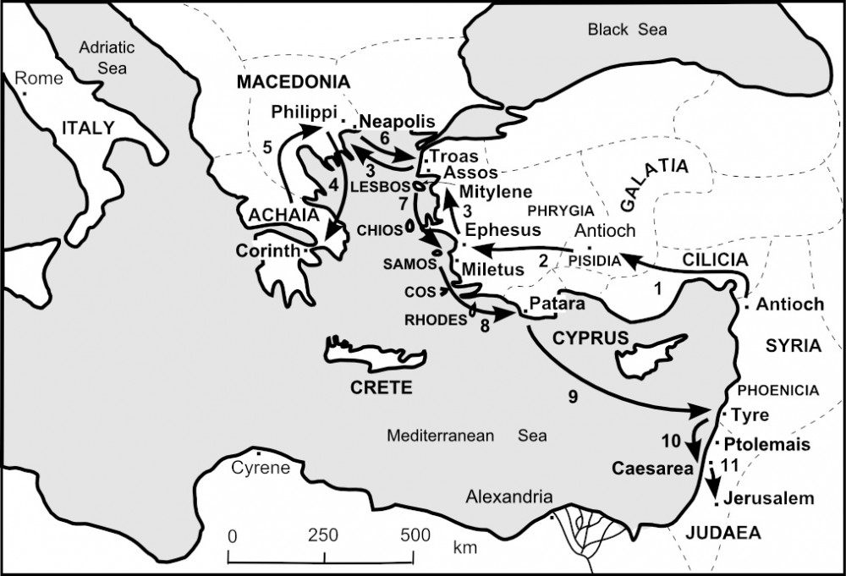
Breaking Bread in Troas - First Day of the Week
Paul Preaches Until Midnight
Young Man Falls Asleep - Falls Three Floors and Dies
(See. . .My Sermons are Not That Long and None of Y’all Fall Asleep)
Paul Embraces Man, finding life in him
7 On the first day of the week, when we were gathered together to break bread, Paul began talking to them, intending to leave the next day, and he prolonged his message until midnight.
8 There were many lamps in the upper room where we were gathered together.
9 And there was a young man named Eutychus sitting on the window sill, sinking into a deep sleep; and as Paul kept on talking, he was overcome by sleep and fell down from the third floor and was picked up dead.
10 But Paul went down and fell upon him, and after embracing him, he said, "Do not be troubled, for his life is in him."
11 When he had gone back up and had broken the bread and eaten, he talked with them a long while until daybreak, and then left.
12 They took away the boy alive, and were greatly comforted.
Paul Calls Ephesus Elders to Miletus for Final Message
13 But we, going ahead to the ship, set sail for Assos, intending from there to take Paul on board; for so he had arranged it, intending himself to go by land.
14 And when he met us at Assos, we took him on board and came to Mitylene.
15 Sailing from there, we arrived the following day opposite Chios; and the next day we crossed over to Samos; and the day following we came to Miletus.
16 For Paul had decided to sail past Ephesus so that he would not have to spend time in Asia; for he was hurrying to be in Jerusalem, if possible, on the day of Pentecost.
17 From Miletus he sent to Ephesus and called to him the elders of the church. 18 And when they had come to him, he said to them,

Paul’s Farewell Elder Speech
Paul Serves with Humility, Tears & Trials due to Jews
Paul Taught House to House the Gospel of God to All
Paul Ties Repentance to God - to Faith in Jesus Christ
"You yourselves know, from the first day that I set foot in Asia,
how I was with you the whole time,
19 serving the Lord with all humility
and with tears and with trials which came upon me
through the plots of the Jews;
20 how I did not shrink
from declaring to you anything that was profitable,
and teaching you publicly and from house to house,
21 solemnly testifying
to both Jews and Greeks
of repentance toward God
and faith in our Lord Jesus Christ.

Holy Spirit Guides Paul to Jerusalem - Where Bonds & Afflictions Await
22 "And now, behold, bound in spirit,
I am on my way to Jerusalem,
not knowing what will happen to me there,
23 except that the Holy Spirit solemnly testifies to me in every city, saying that bonds and afflictions await me. (See Acts 9:15,16)

Paul’s Ministry Mission More Important Than Temporal Life
24 "But I do not consider my life of any account as dear to myself,
so that I may finish my course and the ministry
which I received from the Lord Jesus,
to testify solemnly of the gospel of the grace of God.

Paul Tells Elders They Will Not See Him Again
25 "And now, behold, I know that all of you,
among whom I went about preaching the kingdom,
will no longer see my face.
Declared Whole Purpose of God
Guard Yourselves and The Flock from Savage Wolves
Holy Spirit Ordained You as Shepherds
Church Bought by Blood (Cross)
26 "Therefore, I testify to you this day that I am innocent of the blood of all men.
27 "For I did not shrink from declaring to you
the whole purpose of God.
28 "Be on guard for yourselves and for all the flock,
among which the Holy Spirit has made you overseers,
to shepherd the church of God
which He purchased with His own blood.
29 "I know that after my departure
savage wolves will come in among you, not sparing the flock;
30 and from among your own selves men will arise,
speaking perverse things, to draw away the disciples after them.

Be Alert
Paul Commends Elders to God
Word of God’s Grace Builds us up
Those Being Sanctified Receive Inheritance
31 "Therefore be on the alert,
remembering that night and day for a period of three years I did not cease to admonish each one with tears.
32 "And now I commend you to God
and to the word of His grace, which is able to build you up
and to give you the inheritance among all those who are sanctified.
Paul Provided for Himself
Paul Received Greater Blessing by Giving
33 "I have coveted no one's silver or gold or clothes.
34 "You yourselves know that these hands ministered to my own needs and to the men who were with me.
35 "In everything I showed you that by working hard in this manner
you must help the weak and remember the words of the Lord Jesus,
that He Himself said,
'It is more blessed to give than to receive.'"

Elders Embrace Paul in Prayer
Final Farewell
36 When he had said these things,
he knelt down and prayed with them all.
37 And they began to weep aloud and embraced Paul,
and repeatedly kissed him,
38 grieving especially over the word which he had spoken,
that they would not see his face again.
And they were accompanying him to the ship.

Reflections on Paul’s Farewell Address
This is one of the more emotional farewells in the Bible. Paul is one of the most engaging personalities in God’s Word. It is hard to put into words to convey the human emotion that filled the air as Paul gave his final address to the Elders of Ephesus. Paul had poured-out his life to them. He left all he had on the field of spiritual and physical battle. There was not any holding back. Paul took nothing from them, but availed himself to God’s Holy Spirit working inside his heart to impart God’s eternal plan of salvation to them. It was personal. They knew Paul was from God. They knew that all he said carried a supernatural weight that could have only come from God. Humanity rarely sees a person allow this much of God take control of their life.
Paul and Moses
Paul is one example comparable to Moses in the outcome of their life-work. Both men:
- were hesitant or denied service to God.
- had been involved with the taking of human life. Moses struck the Egyptian, after he assaulted a Hebrew. Paul heartily approved the stoning of Stephen as he held the robes of the people who threw deadly projectiles.
- were hard-headed and stubborn but yielded to God.
- were willing to give their temporal life in the service to God.
- delivered people from oppression. Moses delivered the Hebrew people form the bondage under their Egyptian oppressors. Paul delivered the message that the Hebrews could be free from an oppressive application of the Law administered by spiritually corrupt Temple Priests and their hierarchy.

Missionaries
When you google for a list of historical missionaries many of them start with the Apostle Paul. For good reason, Paul is seen as the pioneering missionary. https://urbana.org/blog/21-missionaries-you-should-know
There are many atheists/agnostics who blame Paul for the rise of Christianity. I would wear that charge as a badge of honor. In fact, some secularists put forth the idea that Paul created Christianity. This is the same crowd that denies Jesus was a real historical person. What these detractors fail to see is that God’s Holy Spirit made Paul the driving penetrating voice for God. In time, God’s Holy Spirit made every missionary the successful voice for God. A person does not make the mission successful. A person avails themselves to God’s Holy Spirit who works through them.
What makes a successful missionary? What do we see in Paul?
- Calling from God
1 Corinthians 1:1 Paul, called as an apostle of Jesus Christ by the will of God, and Sosthenes our brother,
2 Timothy 1:9 who has saved us and called us with a holy calling, not according to our works, but according to His own purpose and grace which was granted us in Christ Jesus from all eternity,
(See also - Acts 9, Galatians 1:15)
- Surrendering and transformed to God’s Call and Will
Renew your mind - This is for all Believers.
Romans 12:2 And do not be conformed to this world, but be transformed by the renewing of your mind, so that you may prove what the will of God is, that which is good and acceptable and perfect.

- Other Believers support and see God working in a person
Acts 9:27 But Barnabas took hold of him and brought him to the apostles and described to them how he had seen the Lord on the road, and that He had talked to him, and how at Damascus he had spoken out boldly in the name of Jesus.

Galatians 2:9 and recognizing the grace that had been given to me, James and Cephas and John, who were reputed to be pillars, gave to me and Barnabas the right hand of fellowship, so that we might go to the Gentiles and they to the circumcised.

- Perseverance
Giving hardships to the Holy Spirit empowers us to never quit.
Acts 9:27 But Barnabas took hold of him and brought him to the apostles and described to them how he had seen the Lord on the road, and that He had talked to him, and how at Damascus he had spoken out boldly in the name of Jesus.
- Focus on the end goal
1 Corinthians 1:7-8 7 so that you are not lacking in any gift, awaiting eagerly the revelation of our Lord Jesus Christ,
8 who will also confirm you to the end, blameless in the day of our Lord Jesus Christ.
2 Corinthians 2:14-17 14 But thanks be to God, who always leads us in triumph in Christ, and manifests through us the sweet aroma of the knowledge of Him in every place.
15 For we are a fragrance of Christ to God among those who are being saved and among those who are perishing;
16 to the one an aroma from death to death, to the other an aroma from life to life. And who is adequate for these things?
17 For we are not like many, peddling the word of God, but as from sincerity, but as from God, we speak in Christ in the sight of God.

- Constantly call upon God’s Spiritual guidance and power.
1 Thessalonians 3:10-11 10 as we night and day keep praying most earnestly that we may see your face, and may complete what is lacking in your faith? 11 Now may our God and Father Himself and Jesus our Lord direct our way to you;

- Life of prayer for all things
Colossians 4:2-4 2 Devote yourselves to prayer, keeping alert in it with an attitude of thanksgiving;
3 praying at the same time for us as well, that God will open up to us a door for the word, so that we may speak forth the mystery of Christ, for which I have also been imprisoned;
4 that I may make it clear in the way I ought to speak.
Romans 1:9-10 For God, whom I serve in my spirit in the preaching of the gospel of His Son, is my witness as to how unceasingly I make mention of you, 10 always in my prayers making request, if perhaps now at last by the will of God I may succeed in coming to you.

- Pray for those in the mission field.
Romans 1:8 First, I thank my God through Jesus Christ for you all, because your faith is being proclaimed throughout the whole world
Romans 10:1 Brethren, my heart's desire and my prayer to God for them is for their salvation.
Philippians 1:3-5 3 I thank my God in all my remembrance of you, 4 always offering prayer with joy in my every prayer for you all, 5 in view of your participation in the gospel from the first day until now.

- Seek oneness with God
Galatians 2:20 "I have been crucified with Christ; and it is no longer I who live, but Christ lives in me; and the life which I now live in the flesh I live by faith in the Son of God, who loved me and gave Himself up for me.

In truth, Believers are all Missionaries. Therefore, all believers should live a life encompassing these nine life practices. No doubt that we can add to this list of attributes. Some say that the Great Commission (detailed in Matthew 28) is just for the disciples Jesus was addressing. Then there are statements by Jesus that directly teach that all Believers have a responsibility, to some degree, regarding witnessing to others. We will all not be like Paul, Peter, John or Luke. However! We can be who God has called us to be and witness our life to others.

Matthew 10:32-33 32 "Therefore everyone who confesses Me before men, I will also confess him before My Father who is in heaven.
33 "But whoever denies Me before men, I will also deny him before My Father who is in heaven. AMEN

