Round Top Church Christian Fellowship
Nine Weeks till the Resurrection - April 4, 2021
Paul’s Second Mission - Acts 18
Pastor ~ Matthew Diehl
January 31st In the Year of Our Lord
(Anno Domini A.D.) 2021

(Unless otherwise noted, NAS is quoted.)

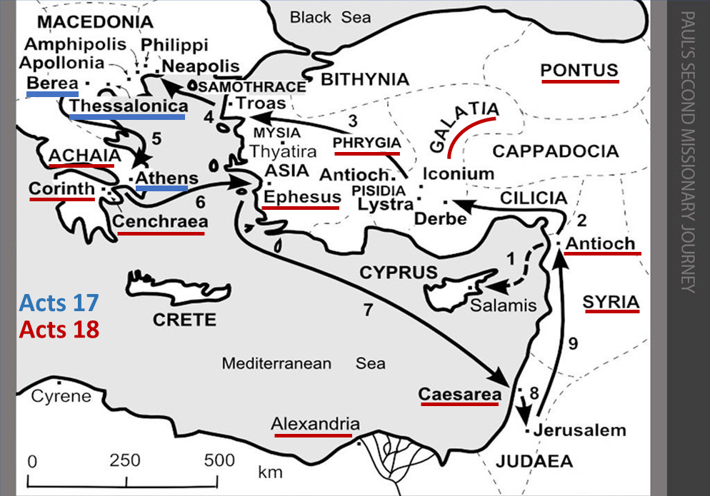

Paul to Athens then Corinth (verses 1-17)
Meets Aquila & Priscilla – tent-makers
1 After these things he left Athens and went to Corinth.
2 And he found a Jew named Aquila, a native of Pontus,
having recently come from Italy with his wife Priscilla,
because Claudius had commanded all the Jews to leave Rome. He came to them,
3 and because he was of the same trade, he stayed with them and they were working,
for by trade, they were tent-makers.
We observe Paul traveling from town to town led by the Holy Spirit. Reading the accounts of his travels, we see a free-flowing agenda in that there wasn’t any predetermined time designated to each town. There was not any plan that was previously mapped. The plan appeared to be for Paul and his fellow ministers to walk to the next town that was down the road. Upon arrival, they would go to the synagogue and use the traditions of allowing a man like Paul to speak. Paul stays as long as he is welcome or until he is led by the Spirit to leave. During this time, there are many people who come to know and surrender to God through the message of Jesus Christ. Paul announced that the Good News of the Resurrection was available to everyone who accepted God in their heart. This inclusion message reached to the Greeks. Paul’s challenge concerning the Jews was to convince them that Jesus was the long-anticipated Messiah. We see that the Greeks to whom Paul witnessed had a religious and/or spiritual worldview. Paul’s challenge was to get them to understand God’s working through the incarnation and resurrection.
We see leaders added to the evangelism team with Aquila and his wife, Priscilla. We see that Paul was not alone. Silas and Timothy joined him. Thus, the Church grew in members and leaders.
Paul Continues Synagogue visits
Silas and Timothy join Paul
Jews rebuff Paul’s Message – Turns to the Gentiles
4 And he was reasoning in the synagogue every Sabbath and trying to persuade Jews and Greeks.
5 But when Silas and Timothy came down from Macedonia,
Paul began devoting himself completely to the word,
solemnly testifying to the Jews that Jesus was the Christ.
6 But when they resisted and blasphemed, he shook out his garments and said to them,
"Your blood be on your own heads! I am clean. From now on I will go to the Gentiles."
What do we learn from Paul’s continued mission? Despite Paul’s declaration that “from now on, I will go to the Gentiles” after being rebuffed by the Jews, we see in later accounts that he persists in visiting synagogues in the towns where he travels. In verse 7, Paul stays in a house next to a synagogue. In verse 8, the leader of the synagogue comes forward as a Believer. Then we see (v. 9-10) the Lord coming to Paul at night in a vision telling him not to be afraid and to continue to speak. This placed Paul’s focus back on to the Jews, at least in Corinth. However, we see subsequent visits to synagogues.
It is of note that once the Lord told Paul not to be afraid or silent because He had many people in the city, Paul stayed for eighteen months in Corinth. He built many strong relationships there. Thus, we see that when Paul wrote the letters, we call 1st and 2nd Corinthians, he was writing from personal experience of living in their community.

Crispus, synagogue leader & Believer
Paul stays in Corinth 1 Year and 6 Months
7 Then he left there and went to the house of a man named Titius Justus, a worshiper of God,
whose house was next to the synagogue.
8 Crispus, the leader of the synagogue, believed in the Lord with all his household,
and many of the Corinthians when they heard were believing and being baptized.
9 And the Lord said to Paul in the night by a vision,
"Do not be afraid any longer, but go on speaking and do not be silent;
10 for I am with you, and no man will attack you in order to harm you,
for I have many people in this city."
11 And he settled there a year and six months, teaching the word of God among them.

The account with Gallio is revealing. Paul was in danger due to some of the Jews who took offense to the Gospel. However, he was not in Judea. Paul was in Greece, where the Jews did not control the local courts and magistrates. This worked to Paul’s advantage, because the Jews charged him with breaking Jewish religious laws, not Greek laws. When Gallio became aware of the religious charges, he dismissed Paul. Without the love and grace of God at work in the Jews, they turned on one of their own members. Sosthenes, the leader of the local synagogue, was beaten. From the context, the Jews thought Sosthenes should have known that Gallio was not going to prosecute Paul and save them the embarrassment of their religious law being dismissed.
Gallio has Paul arrested
12 But while Gallio was proconsul of Achaia,
the Jews with one accord rose up against Paul and brought him before the judgment seat,
13 saying, "This man persuades men to worship God contrary to the law."
14 But when Paul was about to open his mouth, Gallio said to the Jews,
"If it were a matter of wrong or of vicious crime, O Jews,
it would be reasonable for me to put up with you;
15 but if there are questions about words and names and your own law, look after it yourselves;
I am unwilling to be a judge of these matters."
16 And he drove them away from the judgment seat.
Poor Sosthenes
17 And they all took hold of Sosthenes, the leader of the synagogue, and began beating him in front of the judgment seat. But Gallio was not concerned about any of these things.

In verse 18, we see that the relationship Paul developed with Aquila and Priscilla paid-off. They joined Paul in his journey to Ephesus. They stayed in Ephesus, but Paul continues to the next town. The list of towns to which Paul traveled reveals the zeal and tenacity of Paul. This was the Holy Spirit at work in Paul. No doubt, God chose a man like Paul to carry-out His work.

Paul sails to Syria region / Cenchrea haircut to keep a vow
18 Paul, having remained many days longer, took leave of the brethren and put out to sea for Syria, and with him were Priscilla and Aquila. In Cenchrea he had his hair cut, for he was keeping a vow.
On to Synagogue in Ephesus for a brief visit
19 They came to Ephesus, and he left them there.
Now he himself entered the synagogue and reasoned with the Jews.
20 When they asked him to stay for a longer time, he did not consent,
21 but taking leave of them and saying,
"I will return to you again if God wills," he set sail from Ephesus.
On to Caesarea then Antioch
22 When he had landed at Caesarea, he went up and greeted the church, and went down to Antioch.
23 And having spent some time there, he left and passed successively through the Galatian region and Phrygia, strengthening all the disciples.

Here (v. 24-27) is one of the more interesting passages of Scripture.
Apollos receives more accurate instruction from Priscilla and Aquila
24 Now a Jew named Apollos, an Alexandrian by birth, an eloquent man, came to Ephesus; and he was mighty in the Scriptures.
25 This man had been instructed in the way of the Lord; and being fervent in spirit,
he was speaking and teaching accurately the things concerning Jesus,
being acquainted only with the baptism of John;
26 and he began to speak out boldly in the synagogue.
But when Priscilla and Aquila heard him,
they took him aside and explained to him the way of God more accurately.
27 And when he wanted to go across to Achaia, the brethren encouraged him and wrote to the disciples to welcome him; and when he had arrived, he greatly helped those who had believed through grace, 28 for he powerfully refuted the Jews in public, demonstrating by the Scriptures that Jesus was the Christ.
We know that Paul ‘comes off’ as somewhat patriarchal and teaches in . . . 1 Timothy 2:11-15 11 A woman must quietly receive instruction with entire submissiveness.
12 But I do not allow a woman to teach or exercise authority over a man, but to remain quiet.
13 For it was Adam who was first created, and then Eve.
14 And it was not Adam who was deceived, but the woman being deceived, fell into transgression.
15 But women will be preserved through the bearing of children if they continue in faith and love and sanctity with self-restraint.
1 Corinthians 14:34 The women are to keep silent in the churches; for they are not permitted to speak, but are to subject themselves, just as the Law also says. 35 If they desire to learn anything, let them ask their own husbands at home; for it is improper for a woman to speak in church.
In Judaism and Christian references, we see the quoting of Genesis 3:16 as the Law - Paul is referring, “Just as the Law says”.
To the woman He said, "I will greatly multiply Your pain in childbirth, In pain you will bring forth children; Yet your desire will be for your husband, And he will rule over you."
Also, a reference is made to Exodus 28:1 when God instructs Moses to select from among the “men” to be priests. There is not any mention to select women.
The passage in 1 Timothy appears to be a general instruction. It is a worthy observation that Paul points to himself saying, “I” do not allow, as if others might allow a woman to teach men.
The Corinthians text specifically identifies “churches” (Greek – Ekklesia) as a place for women to be silent. This leaves open the possibility for women to speak elsewhere? Paul also teaches that women are not to even “speak” in church. Paul directly ties his instruction to God.
1 Corinthians 14:37 If anyone thinks he is a prophet or spiritual, let him recognize that the things which I write to you are the Lord's commandment. 38 But if anyone does not recognize this, he is not recognized.
We always say that “context” is very important in receiving the truth from God’s Word. The context of 1 Corinthians 14 is “speaking in tongues”. It is within reason that Paul is saying that women should not speak in tongues in church. What about women speaking outside of a worship service? Does this mean women cannot speak in a church building regardless of the day of week or on-going function?
However, we see Pricilla not in conformity with Paul’s instruction to Timothy. From the presentation of events in Acts, we gather that Paul wrote to Timothy after these events chronicling Pricilla’s instruction to Apollos - a man. From this, we see an exception to Paul’s instructions to Timothy. However, Pricilla was not in a church, and she was with her husband who took Apollos aside to correct his understanding. Regardless of the location, Pricilla “a woman” participated in instructing a man.
Those of us who have read the Bible know of Prophet-Judge, Deborah, reported in the book of Judges 4. Obviously, Deborah, as a judge, told men what to do. Phillip had four prophetess daughters (Acts 21:8,9). Obviously, there are exceptions to Paul’s view of women teaching men. The main point we see here is that God is the one directing with exceptions. In 1 Corinthians 12:11, Paul writes - But one and the same Spirit works all these things, distributing to each one individually just as He wills. Therefore, God’s Spirit makes the assignment of gifts to be used under His will not man’s.
It is my opinion that the Church does not need to be seen as a patriarchal society. At the same time, we must honor God and His Word in His assignment of roles for all people. We see a general application, and, at times, specific roles for men and women in the Synagogue, Church and society at large. Alongside these applications, we see exceptions for the role, duties and function of women. It is clear that God is behind the placement of women to use their spiritual gifts with which He has equipped them. Both men and women rely upon God to direct their lives.
Today, as always, the Church endeavors to witness God’s Word and plan for people regardless of race, gender, traditions, culture or economic status. All three of the world’s monotheistic faiths are patriarchal in nature. For the most part, the role of women is separated from men and limited in roles. The Roman Catholic Church does not ordain women to the priesthood. There are sects within all three that have, at times, women lead in prayer and/or worship. This is seen more within Christian communities.
Concerning the role of Pastor in America, women fill the ranks of Pastor in several denominations. However, many of these communities have been politicized to satisfy the demand of secularism. Oftentimes, along with the ordination of women to be Pastors comes a political left philosophy. With this observation, it is not for anyone to instruct God on who to call to the ministry of Pastor, Prophet, Missionary or Teacher. We need to keep in mind that Jesus said we will know them by their fruit.
It is clear to me that today’s Church should notice the way Jesus interacted and spoke to women, particularly the “Woman at the well” (John 4) and women like Mary Magdalene. Jesus broke with strict Jewish traditions and customs to engage them. These relationships demonstrate, that with pure motives and acts, God’s grace and love overcomes strict rules governing relationships and people’s roles and function within the community of God. We see in God’s incarnation, “one size does not fit all”. There are exceptions. However, these exceptions did not become the rule. So, exceptions exist today. Through prayer and seeking spiritual discernment from God, we should all seek our role in God’s providences.
I do not think the Church should get ‘bogged down’ in the roles of men and women. “We will know them by their fruit”. We have bigger challenges. We should focus on gathering the attention of people to look in God’s direction. It is my opinion, and I have stated in the past, one of the biggest challenges, to not only the Church, but to Western Civilization, is the H.A.S. community – Humanism, Atheism, Secularism. It is true that the H.A.S. leaders use gender issues to drive a wedge between God and people. We need to confront the overall worldview of the H.A.S. community. In our time, this means understanding how the sciences are being used against God who created science. Real science proves the existence of God. This is why in recent years I have endeavored to study questions surrounding the origins of life and the maintenance of life. The schools of science that we need to understand in order to improve our witness, in our time, is in the field of cosmology, biology and anthropology. These sciences have been turned into weapons of mass destruction in public/private education and Western colleges and universities. Reference to Ben Stein’s movie “Expelled – No Intelligence Allowed” (2008).
One of the biggest failures since the Age of Enlightenment is the ill preparation of ministers to confront the misuse of God’s sciences. When I went to seminar (1991-1994), there was not one course addressing the science question. To be fair, there have been numerous publications since I graduated from seminary addressing this issue. Perhaps, the Church just needed a century or more to develop a response. I introduced three books in last week’s YouTube video: Stephen Meyer “Darwin’s Doubt”, Michael Behe “Darwin’s Black Box”, and Douglas Axe “Undeniable”.
At the same time, ministers in the field are struggling to present the Gospel message as relevant in the midst of “H.A.S.-science” presented as a worldview that denies the existence of God. The message is - you cannot be a scientist if you are a Christian. The message needs to be that you cannot be a scientist if you stop your research at the locked door of intelligent design for fear that there will be an intelligent designer behind the door.
I point to Frank Turek’s book, “Stealing from God”. Chapter 6 reveals the shortcomings of the materialistic-science only view. On page 168-169, he points to the long held view by scientists seeking only a materialistic solution in classifying DNA that did not code for proteins – that comprise about 98 percent of the human genome - had little function. They asserted that evolution had rendered that part of the genome largely useless junk. It was merely an accumulation of random mutations left over from the long trial and error process of evolution. That belief led many biologists to stop investigating the noncoding regions.
Thankfully, some did not stop, especially ID theorists who were predicting that the noncoding regions had function. . . They discovered that the noncoding regions have innumerable functions critical to life. These functions include turning on and off certain gene activity within the cell. They learned these have application for treating cancer and other diseases.
Granted, this is only one example of how the H.A.S. philosophy is detrimental to life. Time forbids more review, for now. Scientists of all beliefs have contributed to our understanding of our world. The point here is that there should not be shackles placed on scientists by the H.A.S. community steeped in Darwinian Evolution.
God is the creator, designer, the author of all the sciences. There are important issues, like the role of men and women within the Church. However, as they say. . . ‘there are bigger fish to fry’. Jesus made the point to the religious leaders that they had become legalist and neglected the most important part of God message. People need see God’s love in the application of His justice, mercy and faithfulness through Believers.
Matthew 23:23 "Woe to you, scribes and Pharisees, hypocrites! For you tithe mint and dill and cummin, and have neglected the weightier provisions of the law: justice and mercy and faithfulness; but these are the things you should have done without neglecting the others. 24 "You blind guides, who strain out a gnat and swallow a camel!
Psalm 146:8 The LORD opens the eyes of the blind; The LORD raises up those who are bowed down; The LORD loves the righteous; AMEN

