Round Top Church Christian Fellowship
Thirty-Second Week Since the Resurrection
The Spread of Christianity - Acts 11:19-30
Pastor ~ Matthew Diehl
November 22nd In the Year of Our Lord 2020
(Unless otherwise noted, NAS quoted.)

We can see here in Acts 11:19 that the stoning of Stephen was the catalyst to force Believers to migrate across Asia to the Mediterranean coastal towns and cities. There were political and technological advantages that contributed to the spread of God’s Good News. As Believers spread from Jerusalem, they interacted with many different cultures and religious traditions.
Political advantage: Since the conquest of Alexander the Great, starting the last third of the 4th century B.C. (330’s), the Greek language and culture had become dominant. This was an advantage for the spread of God’s Good News. The Romans continued Greek traditions of culture and language. The Romans did use the Latin language in many areas of their culture; however, the Greek language was used by the common person and has a more detailed structure to convey nuances of meaning. Greek was the best language to communicate the New Testament.
Falling under a political advantage, Believers, like Paul, could travel using Roman roads and had relatively safe travel through the empire. The Romans wanted peace and a fair exchange of commerce. The Pax Romana (Roman Peace) was a period of relative peace and stability across the Roman Empire which lasted for over 200 years, beginning with the reign of Augustus (27 BCE - 14 CE). The aim of Augustus and his successors was to guarantee law, order, and security within the empire, even if this meant separating it from the rest of the world and defending, or even expanding, its borders through military intervention and conquest. https://www.ancient.eu/Pax_Romana/
Technological advantage: Writing in a book form called “codex” was developed by the Romans in the 1st century. Codex is stitching together the edges of flat sheets of papyrus, parchment or velum to form a book spine. In time, the duplication, ease of use and transportation of Scripture became easier due to the codex. Today’s books are technically a codex.
So, using Roman roads, Pax Romana and the Greek language written on codex form (book form), Believers were able to rapidly spread the Good News around the Roman Empire. The martyrdom of Stephen, like the Cross, advanced God’s redemptive plan. What fallen man intended to use to stop God’s salvation call, God used to catapult the Good News across the world. God’s Holy Spirit fully engaged temporal lives and began to transition one soul at a time. God is personal.

Acts 11:19-30
¹⁹ So then those who were scattered because of the persecution that occurred in connection with Stephen

made their way to Phoenicia and Cyprus and Antioch,
speaking the word to no one except to Jews alone.

²⁰ But there were some of them,
men of Cyprus and Cyrene, (North Africa, Libyan coast)
who came to Antioch
and began speaking to the Greeks also,
preaching the Lord Jesus.
²¹ And the hand of the Lord was with them,
and a large number who believed turned to the Lord.
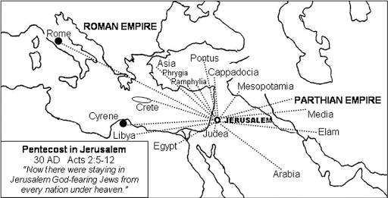
http://www.generationword.com/notes/bible-information/acts-maps.html
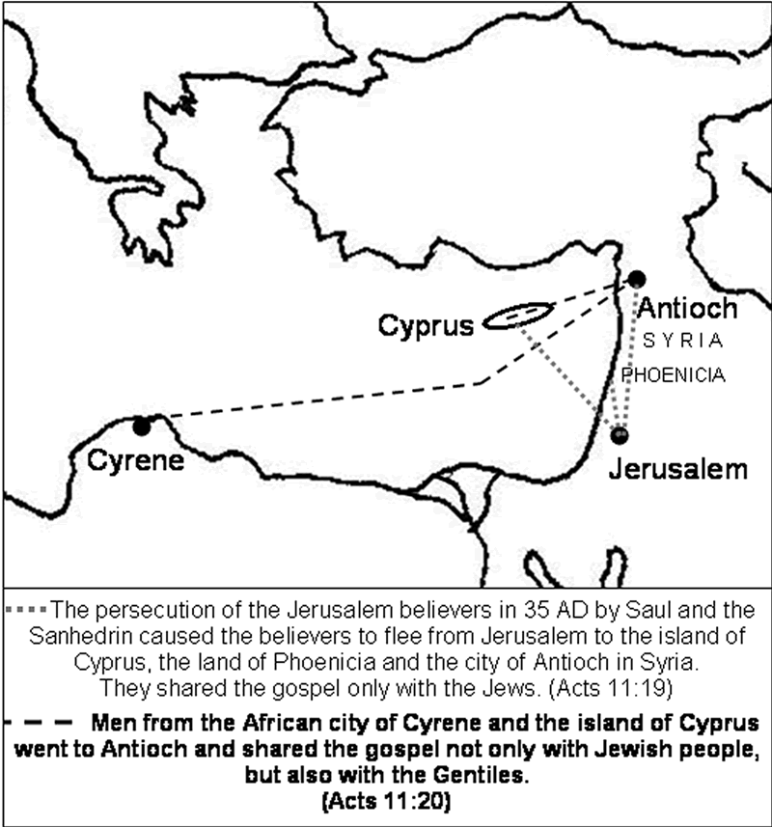
http://www.generationword.com/notes/bible-information/acts-maps.html

The simplicity of the spread of God’s Gospel was brought forth through the Holy Spirit (Lord with them) speaking and preaching. A large number of people believed. This must have been a well-known explosion in the growth of the early Church. The leaders in Jerusalem heard and sent Barnabus to oversee the evangelism. There must have been a concern about the accuracy of what was being spoken and preached. This is due to the fact that many of the Jews who had converted might have brought their legalisms with them. Remember, this is soon after the Jerusalem conference. Barnabus is sent and reports the “grace” of God, not the Law of God.

²² The news about them
reached the ears of the church at Jerusalem,
and they sent Barnabas off to Antioch.
²³ Then when he arrived
and witnessed the grace of God,
he rejoiced and began to encourage them all
with resolute heart to remain true to the Lord;
Tyndale Acts 11:23 Which when he was come and had sene the grace of God was glad and exhorted them all that with purpose of hert they wolde continually cleave vnto the Lorde.
English Standard Version Acts 11:23 When he came and saw the grace of God, he was glad, and he exhorted them all to remain faithful to the Lord with steadfast purpose,
²⁴ for he was a good man,
and full of the Holy Spirit and of faith.
And considerable numbers were brought to the Lord.

Luke transitions from Barnabus back to Paul. We are served well to read Galatians 1 and 2 in parallel with Acts. We can fill-in Paul’s journeys. Paul writes. . .
Galatians 1:15 But when God, who had set me apart even from my mother's womb and called me through His grace, was pleased
16 to reveal His Son in me so that I might preach Him among the Gentiles, I did not immediately consult with flesh and blood,
17 nor did I go up to Jerusalem to those who were apostles before me; but I went away to Arabia, and returned once more to Damascus.
18 Then three years later I went up to Jerusalem to become acquainted with Cephas, and stayed with him fifteen days.
19 But I did not see any other of the apostles except James, the Lord's brother.
20 (Now in what I am writing to you, I assure you before God that I am not lying.)
21 Then I went into the regions of Syria and Cilicia.
22 I was still unknown by sight to the churches of Judea which were in Christ;
23 but only, they kept hearing, "He who once persecuted us is now preaching the faith which he once tried to destroy."
24 And they were glorifying God because of me.

Galatians 2:1 Then after an interval of fourteen years I went up again to Jerusalem with Barnabas, taking Titus along also.
2 It was because of a revelation that I went up; and I submitted to them the gospel which I preach among the Gentiles, but I did so in private to those who were of reputation, for fear that I might be running, or had run, in vain.
3 But not even Titus, who was with me, though he was a Greek, was compelled to be circumcised.
Jumping to Acts 12:25 . . .
And Barnabas and Saul returned from Jerusalem when they had fulfilled their mission, taking along with them John, who was also called Mark.
. . . we see a detail about the travels of Paul that comes after the account in Galatians 2:1. From the accounts in Acts and Galatians, we can count at least 17 years of Paul’s training by God’s Holy Spirit and missionary travels before we see him again with Barnabus (Acts 11:25).

Continue on Acts 11
²⁵ And he left for Tarsus to look for Saul;
²⁶ and when he had found him,
he brought him to Antioch.
And for an entire year they met with the church
and taught considerable numbers;
and the disciples were first called Christians in Antioch.

We learn from these passages of Scripture that God’s plan for salvation is carried-out in the hearts of people who would not have come together if it were not for God’s Holy Spirit working in their lives. God chose to be personal, indwelling people’s hearts and guiding their lives. Remember that Jesus told the disciples that He would not leave them alone, that He would be with them forever, and the Helper would teach them (John 14:16,26; 16:7).

Comparing the spread of the Gospel to the spread of Islam
It is important for us to observe what we do see and do not see in the spread of Christianity. The sources for Islam are the Quran and the Hadiths, which are sacred books detailing what Muhammad did in his life. Muslims believe that whatever Muhammad did a Muslim can do. We do not have to go to non-Islamic sources to prove Islam is man-made and not compatible with civilized societies.
A critical point to make is the difference between “descriptive” and “prescriptive” passages in the Bible and in the Quran. The Bible does contain narratives when God instructed the Hebrew people to go to war. These accounts are telling us what happened (descriptive). These accounts are not telling us to go to war perpetually, because people do not believe the same thing we do. Islam also has accounts of Allah and Muhammad directing Muslims to go to war. However, Muslims use the war directives as marching orders (prescriptive) through history to continue warring until the world is conquered under Islam (Quran chapter 9).
- What we do see is that in the beginning of God’s relationship with His creation, He walks and talks to Adam and Eve directly (Genesis 1 and 2). God is personal with people throughout the Biblical account. This is to establish a love-relationship with each person. This is in contrast to Islam where Allah is distant and only reveals himself through mediators. We do not see Muhammad ever walking or talking with God.

- We do not see God directing the disciples to form armies for military conquest and defeat His enemies on the battle field. Muhammad forced people through threat of death to convert to Islam. He would allow other beliefs to practice their faiths if they paid a tax. At times, Muhammad would have treaties with non-believers. The details of the treaties required non-believers to pay a tax. If the non-believers stopped paying the tax, they were killed. It is obvious these forced religious taxes were a great resentment. Many non-believing groups would stop paying the tax and go to war with the Muslims.
Quran 9:5 But once the Sacred Months have passed, kill the polytheists ˹who violated their treaties˺ wherever you find them, capture them, besiege them, and lie in wait for them on every way. But if they repent, perform prayers, and pay alms-tax, then set them free. Indeed, Allah is All-Forgiving, Most Merciful.
Quran 9:25 Fight those who do not believe in Allah and the Last Day, nor comply with what Allah and His Messenger have forbidden, nor embrace the religion of truth from among those who were given the Scripture, until they pay the tax, willingly submitting, fully humbled.

Within the first 130 years of the Arab invention of Islam for military conquest, they ruled lands from Spain to encroaching into India. Muslim soldiers were promised the major portion of the spoils of war and all the sex-slaves they could capture. If they died in battle, they were promised heaven and seventy-two virgins. To their point of view, they could not lose.
https://en.wikipedia.org/wiki/Early_Muslim_conquests
Abu Sa'eed Al-Khudri narrated that the Messenger of Allah (s.a.w) said:
"The least of the people of Paradise in position is the one with eighty thousand servants and seventy-two wives. He shall have a tent of pearl, peridot, and corundum set up for him, (the size of which is) like that which is between Al-Jabiyyah and Sana'a."And with this chain, it is narrated from the Prophet (s.a.w) that he said: "Whoever of the people of (destined to enter) Paradise dies, young or old, they shall be brought back in Paradise thirty years old, they will not increase in that ever, and likewise the people of the Fire." And with this chain, it is narrated from the Prophet (s.a.w) that he said: "There are upon them crowns, the least of its pearls would illuminate what is between the East and the West."
Grade: Da'if (Darussalam)
English reference: Vol. 4, Book 12, Hadith 2562
Arabic reference: Book 38, Hadith 2760
https://sunnah.com/urn/678680
Also see: https://www.theguardian.com/books/2002/jan/12/books.guardianreview5

- We do not see the disciples allowed by God to take-up to four wives (Quran 4:3) and have as many intimate relationships with women slaves as they desired.

The Islamic State’s horrifying practice of sex slavery, explained:
https://www.washingtonpost.com/news/worldviews/wp/2015/08/20/the-islamic-states-horrifying-practice-of-sex-slavery-explained/

- We do not see Jesus promising an eternal trip to heaven for killing those who oppose His Message.
Quran 9:111, 61:10-12, 4:74
https://network.crcna.org/global-mission/two-guaranteed-tickets-islamic-paradise-and-challenge-church-cause-jesus

I could continue and list numerous other differences between the spread of Christianity and Islam. In time, I will share more citations from the Quran and the Hadiths that prove, in Islam’s own words, it is not compatible with Biblical Christianity, The Bible or Western civilizations.

Continue Acts 11
²⁷ Now at this time
some prophets came down from Jerusalem to Antioch.
²⁸ One of them named Agabus stood up and began to indicate by the Spirit that there would certainly be a great famine all over the world. And this took place in the reign of Claudius.

Historical Facts
Tiberius Claudius Caesar Augustus Germanicus; 1 August 10 BC – 13 October AD 54) was Roman emperor from AD 41 to 54.

The fourth century historian Orosius mentions this famine in Syria which occurred in 46 and 47 A.D. A translation of Orosius was later made by King Alfred of England during the middle ages and was quoted in what is known as 'The Anglo-Saxon Chronicle'. The Chronicle lists British history from 1 A.D. to 1154 A.D.
“A.D. 46 . In this year, Claudius, the second Roman emperor to invade Britain, put much of the island under his control and added the Orkneys to Rome’s kingdom. This took place in the fourth year of his rule. In this same year, a great famine in Syria took place which Luke mentions in his book, “The Acts of the Apostles.” Due to his incompetence, The Emperor Claudius Nero almost lost control of the British isle.
Also see Historians Josephus and Suetonius
www.biblehistory.net/newsletter/acts11_famine.htm

Continue on Acts 11
²⁹ And in the proportion that any of the disciples had means, each of them determined to send a contribution for the relief of the brethren living in Judea.
³⁰ And this they did,
sending it in charge of Barnabas and Saul to the elders.
What do we learn from this sermon? That Christianity spread by being persecuted and not persecuting others. The Good News spread through the witness of individual Believers and not through military conquest by marauding bands of materially driven hordes whose goal was to increase their wealth and satisfy men’s sexual desires. The spread of Christianity is through the message of God’s love and forgiveness. Eternal life is freely given as an act of God’s grace upon those who surrender their hearts by faith. Eternal life is not earned by killing or destruction. How much clearer can it be in quoting . . .
"YOU SHALL LOVE THE LORD YOUR GOD WITH ALL YOUR HEART, AND WITH ALL YOUR SOUL, AND WITH ALL YOUR STRENGTH, AND WITH ALL YOUR MIND; AND YOUR NEIGHBOR AS YOURSELF." Luke 10:27
AMEN

