Round Top Church Christian Fellowship
Ten Weeks till the Resurrection - April 4, 2021
Paul’s Second Mission - Acts 17
Pastor ~ Matthew Diehl
January 24th In the Year of Our Lord
(Anno Domini A.D.) 2021

(Unless otherwise noted, NAS is quoted.)

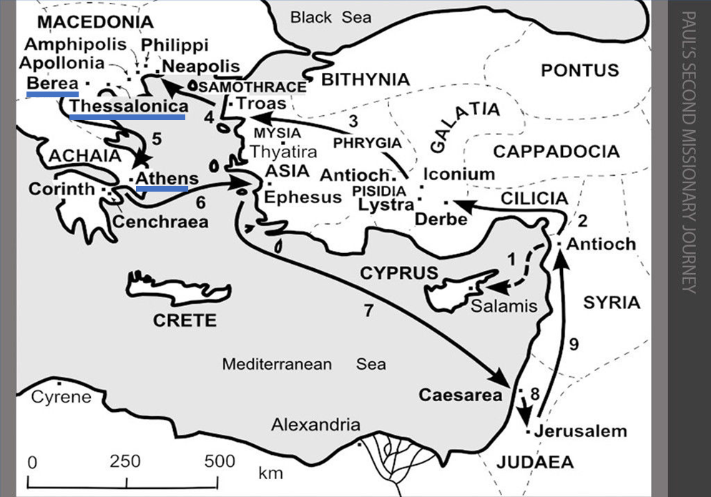

Thessalonica
Paul & Silas at Jewish Synagogue
Evidence Jesus is the Christ – rose from the dead
Some persuaded along with God-fearing Greeks & leading women
1 Now when they had traveled through Amphipolis and Apollonia,
they came to Thessalonica, where there was a synagogue of the Jews.
2 And according to Paul's custom, he went to them,
and for three Sabbaths reasoned with them from the Scriptures,
3 explaining and giving evidence that the Christ had to suffer and rise again from the dead, and saying,
"This Jesus whom I am proclaiming to you is the Christ."
4 And some of them were persuaded and joined Paul and Silas,
along with a large number of the God-fearing Greeks and a number of the leading women.
Jealous Jewish Mob
5 But the Jews, becoming jealous and taking along some wicked men from the market place,
formed a mob and set the city in an uproar;
and attacking the house of Jason,
they were seeking to bring them out to the people.
6 When they did not find them,
they began dragging Jason and some brethren before the city authorities, shouting,
"These men who have upset the world have come here also;
7 and Jason has welcomed them,
and they all act contrary to the decrees of Caesar,
saying that there is another king, Jesus."
8 They stirred up the crowd and the city authorities who heard these things.
9 And when they had received a pledge from Jason and the others,
they released them.
Berea
Paul & Silas into a Jewish Synagogue
Jews in Berea more noble-minded receiving word
10 The brethren immediately sent Paul and Silas away by night to Berea,
and when they arrived,
they went into the synagogue of the Jews.
11 Now these were more noble-minded than those in Thessalonica,
for they received the word with great eagerness,
examining the Scriptures daily to see whether these things were so.
12 Therefore many of them believed,
along with a number of prominent Greek women and men.
Jews from Thessalonica pursued Paul & Silas to Berea
13 But when the Jews of Thessalonica found out that the word of God had been proclaimed by Paul in Berea also,
they came there as well, agitating and stirring up the crowds.
14 Then immediately the brethren sent Paul out to go as far as the sea;
and Silas and Timothy remained there.
Athens
Paul reasons with Jews (in Synagogue) & God-Fearing Gentiles.
15 Now those who escorted Paul brought him as far as Athens;
and receiving a command for Silas and Timothy to come to him as soon as possible, they left.
16 Now while Paul was waiting for them at Athens,
his spirit was being provoked within him
as he was observing the city full of idols.
17 So he was reasoning in the synagogue with the Jews and the God-fearing Gentiles,
and in the market place every day with those who happened to be present.
Paul converses with Athenian Philosophers – Jesus Resurrected!
18 And also some of the Epicurean and Stoic philosophers were conversing with him. Some were saying,
"What would this idle babbler wish to say?" Others,
"He seems to be a proclaimer of strange deities,"—
because he was preaching Jesus and the resurrection.
19 And they took him and brought him to the Areopagus, saying,
"May we know what this new teaching is which you are proclaiming? 20 "For you are bringing some strange things to our ears; so we want to know what these things mean."
21 (Now all the Athenians and the strangers visiting there used to spend their time in nothing other than telling or hearing something new.)
Paul’s Sermon in Athens / Areopagus - aristocratic council
22 So Paul stood in the midst of the Areopagus and said,
(Compliments their religious nature)
"Men of Athens, I observe that you are very religious in all respects.
(Identifies with their view of God)
23 "For while I was passing through and examining the objects of your worship, I also found an altar with this inscription,
'TO AN UNKNOWN GOD.'
Therefore, what you worship in ignorance, this I proclaim to you.
Paul’s sermon contrast idols to God:
Their gods housed in temples.
God not served by people in temples.
God is the giver of life to all things.
God made from one man the nations of the earth.
God made man to seek Him who is not far-off.
As God’s children, we live in Him.
God not formed by thought of man represented in art.
God overlooks unknowingness but now reveals Himself and calls everyone to repent (turn) from their rebellious life.
God has fixed the day of judgement.
The Man who rose from the dead will be the Judge.
The Resurrection is proof of this Judge.
Some sneered at Resurrection, but others believed.
Dionysius and Damaris and others believed.
24 "The God who made the world and all things in it,
since He is Lord of heaven and earth,
does not dwell in temples made with hands;
25 nor is He served by human hands,
as though He needed anything, since He Himself gives to all people life and breath and all things;
26 and He made from one man every nation of mankind to live on all the face of the earth, having determined their appointed times and the boundaries of their habitation,
27 that they would seek God, if perhaps they might grope for Him and find Him, though He is not far from each one of us;
28 for in Him we live and move and exist, as even some of your own poets have said, 'For we also are His children.'
29 "Being then the children of God, we ought not to think that the Divine Nature is like gold or silver or stone, an image formed by the art and thought of man.
30 "Therefore having overlooked the times of ignorance, God is now declaring to men that all people everywhere should repent,
31 because He has fixed a day in which He will judge the world in righteousness through a Man whom He has appointed, having furnished proof to all men by raising Him from the dead." End of Paul’s Sermon
Reaction to The Resurrection
32 Now when they heard of the resurrection of the dead,
some began to sneer, but others said,
"We shall hear you again concerning this."
33 So Paul went out of their midst.
34 But some men joined him and believed,
among whom also were Dionysius the Areopagite
and a woman named Damaris and others with them.

Examining Paul’s Tactic
Chapter 17 of Acts highlights the Holy Spirit working through Paul, Silas and Timothy. They are totally reliant upon God’s Spirit to guide them as they went from town to town. They knew of the dangers that awaited them in each religious/political community, from Jews to Greeks who had centuries old religious systems or pagan gods they worshipped. In Thessalonica and in Berea, we see Paul refers to the Scriptures to reason with the Jews and God-fearing Greeks. In Athens, he includes in his sermon details of God’s work in Genesis. These references included Old Testament passages that proclaimed the coming Messiah. Paul must have pointed to the resurrection of the Messiah in passages like . . . Psalm 16:10 For You will not abandon my soul to Sheol;
Nor will You allow Your Holy One to undergo decay.
(Psalm 22, Isaiah 53:10–11, Daniel 12:2–3)

Paul is direct and persistent in his message. We notice that Paul was speaking to people who were religious and had a spiritual view of the world, in contrast to many people today who refuse to acknowledge God or any spiritual life. Due to Paul’s audience being spiritually minded, he related to their existing spirituality. This is a good middle ground to create an opening for discussion. Paul and his team were successful. We see that in all three locations people believed. The new converts were a combination of Jews and God-Fearing Greeks. Men and women accepted Paul’s resurrection message. We have the names Dionysius and Damaris, to be specific.
Evangelism was challenging in Paul’s day and is today. We see Paul, Silas and Timothy were challenged every step of the way, having success and then forced to flee for their safety. It was the resurrection of the dead that seemed to have caused the most problems. They also were accused of presenting “King Jesus” to be in competition with the Roman Caesar. This is an expected response when people are called to change their eternal belief system.
Paul is presenting the Gospel which challenges them to alter their course concerning how they live their life and what determines the state of their eternal existence. Just think about it. Should you have the surgery or not? You can keep on living for awhile with the condition that you have, but you will eventually die. The Gospel of God offers you an eternal life with Him. Seemingly not a hard decision to make. Heaven or Hell for an eternity. That is unless – (1) you do not accept that there is a next life after this one. And/or - (2) you do not want to humble yourself to God. "Blessed are the poor [humble] in spirit, for theirs is the kingdom of heaven. (Matthew 5:3)
I was watching an interview with two scientists discussing human biology with James Tour on his “The Science & Faith Podcast”. Dr. Tour interviewed Dr. John Sanford, a retired Cornell professor who studied and taught in the area of Genetic Entropy & Genome Degeneration. Genetic Entropy is the name of the book by Dr. Sanford.
https://www.youtube.com/watch?v=i-y_dmi_oF4&feature=youtu.be
I encourage everyone to take the time and watch this YouTube video. They discus Darwinian Evolution, Origins of life, Complexities of cells, Covid 19 and the life of viruses, and the history of the lifespan of humans. These are two excellent scientists who do real science without political motives. In my opinion, this is one of many interviews that totally disprove Darwinian Evolution concerning the origins of life. The response to these scientists from the secular Darwinian scientists ranges from cautious to none. This is due to the fact that a peer review response cannot refute Dr. Tour and Dr. Sanford.
From this interview, a person can come to the conclusion that the Creator/Designer/God who created the world with all its complexities can accomplish a virgin birth and resurrection without any problem. Scientists are at a point now that they can only watch and marvel at the machine processes inside the cell. They cannot, and from what they know, will never be able to duplicate the millions of inter cellular processes constantly ongoing to keep us alive.
Invariably, scientists who hold to Darwinian Evolution in the face of mountains of evidence contrary to their belief is due to the fact that they do not want there to be “The God of Bible” who is the author of morality and the definer of what is good.
This is much like the Jews who confronted Paul. They did not want to admit Paul was right. If they did, they would have to humble themselves to God and their neighbor. They would have to ‘step down’ from being religious overlords controlling people’s lives. Jesus described these leaders in Matthew 23, and pronounces seven woes against them.
However, those who humble themselves to God, have a different life now, and in the one to come. I see “God” speaking through John as he wrote 1 John. These are some of the most appealing words in the Bible. We have focused on chapter 4 before. Chapter 3 also proclaims the greatest message.
1 John 3:1 See how great a love the Father has bestowed on us, that we would be called children of God; and such we are. For this reason, the world does not know us, because it did not know Him.
2 Beloved, now we are children of God, and it has not appeared as yet what we will be. We know that when He appears, we will be like Him, because we will see Him just as He is.
3 And everyone who has this hope fixed on Him purifies himself, just as He is pure. . . .
7 Little children, make sure no one deceives you; the one who practices righteousness is righteous, just as He is righteous; . . .
11 For this is the message which you have heard from the beginning, that we should love one another; AMEN

