Round Top Church Christian Fellowship
Twelve Weeks till the Resurrection - April 4, 2021
Paul’s Second Mission
Acts 16:1-40
Pastor ~ Matthew Diehl
January 10rd In the Year of Our Lord
(Anno Domini A.D.) 2021

(Unless otherwise noted, NAS is quoted.)

The early missionaries of the Church were challenged to penetrate centuries of religious traditions and misunderstandings. We see here that Paul, the Pharisee who turned to Christ, had just left the Jerusalem council and met the young man Timothy. The outcome of the Jerusalem council was that circumcision was not going to be demanded to be in “right-standing” with God. Timothy had a Jewish mother and a Greek father. Due to this family lineage, the Jews viewed Timothy as a man who needed to be circumcised to be accepted as a spokesperson for God. From the context of the text, Timothy was not circumcised to be in “right-standing” to God; Timothy was circumcised in order to be accepted as a witness to those who thought that was a requirement, namely the Jews.
Paul’s Second Missionary Journey – Meets Timothy
Acts 16:1 Paul came also to Derbe and to Lystra. And a disciple was there, named Timothy, the son of a Jewish woman who was a believer, but his father was a Greek,
2 and he was well spoken of by the brethren who were in Lystra and Iconium.
3 Paul wanted this man to go with him; and he took him and circumcised him because of the Jews who were in those parts, for they all knew that his father was a Greek.
Delivering Jerusalem Council Decrees
Church Increased Membership
4 Now while they were passing through the cities, they were delivering the decrees which had been decided upon by the apostles and elders who were in Jerusalem, for them to observe.
5 So the churches were being strengthened in the faith, and were increasing in number daily.
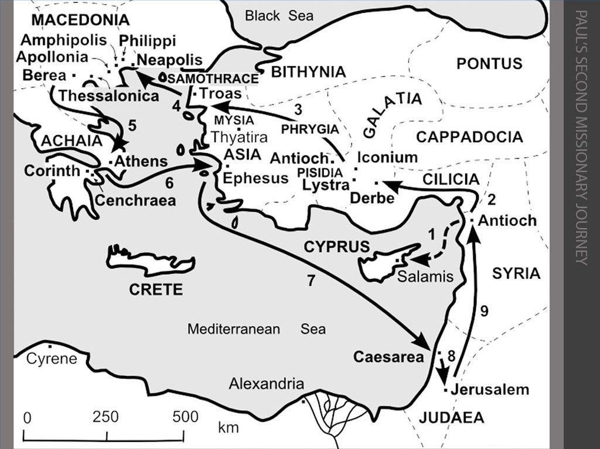
We take great notice that when the common person heard the Gospel presented without the requirements of works the Church was strengthened and grew. We have the same opportunity today. We do not attach the requirements of man-made traditions to the Gospel and the Church grows. It is my experience when a person sees that it is the love of God calling them to salvation, and not the religious institutions of man, people are more open to the Message. Reviewing, once again, the exchange between Jesus and the Lawyer:
Luke 10:25 And a lawyer stood up and put Him to the test, saying, "Teacher, what shall I do to inherit eternal life?"
26 And He said to him, "What is written in the Law? How does it read to you?"
27 And he answered, "YOU SHALL LOVE THE LORD YOUR GOD WITH ALL YOUR HEART, AND WITH ALL YOUR SOUL, AND WITH ALL YOUR STRENGTH, AND WITH ALL YOUR MIND; AND YOUR NEIGHBOR AS YOURSELF."
28 And He said to him, "You have answered correctly; DO THIS AND YOU WILL LIVE." [ See also Matthew 22:35- 40 adds. . ."On these two commandments depend the whole Law and the Prophets." ]
Here is another exchange between Jesus and a lawyer who asked Jesus about the great commandment in the Law. The point being that if a person followed these two commands the rest of the commands would also be fulfilled and, therefore, a person would be in “right-standing” with God. With the love of God operating inside a person’s heart, following the simple commands of the Lord are not hard (John 14:2, 1 John 5:3).
Clarifying Water-Baptism: Jesus commanded that “disciples” are to be baptized in His name (Matthew 28:19). Jesus did not command to baptize “non-disciples.” A “disciple” is a person who is already in “right-standing” with God. Therefore, water-baptism is a witness and statement of faith.
1 John 2:1 My little children, I am writing these things to you so that you may not sin. And if anyone sins, we have an Advocate with the Father, Jesus Christ the righteous;
2 and He Himself is the propitiation for our sins; and not for ours only, but also for those of the whole world.
3 By this we know that we have come to know Him,
if we keep His commandments.
4 The one who says, "I have come to know Him," and does not keep His commandments, is a liar, and the truth is not in him;
5 but whoever keeps His word, in him the love of God has truly been perfected. By this we know that we are in Him:
1 John 5:1 Whoever believes that Jesus is the Christ is born of God, and whoever loves the Father loves the child born of Him.
2 By this we know that we love the children of God, when we love God and observe His commandments.
3 For this is the love of God, that we keep His commandments; and His commandments are not burdensome.
4 For whatever is born of God overcomes the world; and this is the victory that has overcome the world-- our faith.

From Last Week’s Sermon
Do not be confused when Jesus said that He came to fulfill/accomplish the Law (Mathew 5:17,18). Jesus fulfilled the Law when He became the perfect sacrifice to take away the sins of the world which no animal or human blood could accomplish.
It is true that Jesus directed us to follow His commands (John 14:15) which are not burdensome (1 John 5:3). Jesus’ commands address our relationship with God and each other. They were not functionary Laws directing what to eat, when to go to worship or when not to harvest, as examples.
Jesus called Believers to be a servant to others, asking by faith of the Lord, render to Caesar, honor marriage, forgive others, judge by how you want to be judged, follow Him, repent, be reconciled to God and with your neighbor and keep your word are examples of Jesus’ commands. James learned from Jesus, and we see this in his judgement at the Jerusalem Council.
Why is this biblical truth in conflict with some religious leader’s taught traditions? Because the Bible does not support merit-based salvation.
* * *
Paul’s missionary journeys and trials demonstrated that he had a great love of God. Paul’s love for God catapulted his missionary service to the world and extended God’s love through him to all he witnessed.
Paul led by the Holy Spirit/Jesus Visions
6 They passed through the Phrygian and Galatian region, having been forbidden by the Holy Spirit to speak the word in Asia;
7 and after they came to Mysia, they were trying to go into Bithynia, and the Spirit of Jesus did not permit them;
8 and passing by Mysia, they came down to Troas.
9 A vision appeared to Paul in the night: a man of Macedonia was standing and appealing to him, and saying, "Come over to Macedonia and help us."
10 When he had seen the vision, immediately we sought to go into Macedonia, concluding that God had called us to preach the gospel to them.
11 So putting out to sea from Troas, we ran a straight course to Samothrace, and on the day following to Neapolis;
12 and from there to Philippi, which is a leading city of the district of Macedonia, a Roman colony; and we were staying in this city for some days.
Paul Meets Lydia of Thyatira
13 And on the Sabbath day we went outside the gate to a riverside, where we were supposing that there would be a place of prayer; and we sat down and began speaking to the women who had assembled. 14 A woman named Lydia, from the city of Thyatira, a seller of purple fabrics, a worshiper of God, was listening; and the Lord opened her heart to respond to the things spoken by Paul.
We take note here that one woman, in the group of women, a worshiper of God, was listening. Evidently, not all the women responded.
Many people today are worshiping God in their own way and understanding. Here, Paul comes along and adds to Lydia’s understanding of God. There is an epidemic of misunderstanding God. We see that God chooses to talk through servants like Paul. We are included in the ranks of saints through which God chooses to communicate. Talking to the lawyer, Jesus cut through the red tape. The lawyer wanted to know the heart of the matter regarding eternal life. Jesus gave it to him and to us. We, too, can add to a person’s understanding by witnessing the one requirement to love God, which in turn, leads them to the next requirement to love their neighbor. The first requirement to love God must be in place. We cannot love our neighbor by human love only. In this fallen world, it is the love of God in us that prevails and has victory over the law of sin and death that wages war within the members of our mind and body (Romans 7 and 8).
Romans 7:22 For I joyfully concur with the law of God in the inner man,
23 but I see a different law in the members of my body, waging war against the law of my mind and making me a prisoner of the law of sin which is in my members. 24 Wretched man that I am! Who will set me free from the body of this death? 25 Thanks be to God through Jesus Christ our Lord! So then, on the one hand I myself with my mind am serving the law of God, but on the other, with my flesh the law of sin.
Romans 8:1 Therefore there is now no condemnation for those who are in Christ Jesus. 2 For the law of the Spirit of life in Christ Jesus has set you free from the law of sin and of death.
Being clear – the love of God compels us to love our neighbor and to be water-baptized. OH, NO! But what if there is not any water in which to be baptized. I guess you’re ‘out of luck’ and your salvation is not complete, and you’re going to be estranged from God for eternity. All the love you have for God and your neighbor is not sufficient evidence of your salvation. Even if you are led by the Holy Spirit to follow all of the Lord’s commands of turning your life to Him, taking care of your neighbor, praying for your enemies, not having hate in your heart, pursuing peace and righteousness, humbling yourself to God, mourning for yourself and your neighbor’s sin, being joyous and singing praises to God when persecuted. . . sorry, you are dammed. Because you did not add the one work of water-baptism to the Cross of Christ, you are eternally separated to the lake of fire.
Great pause. Well . . . unfortunately, there are many religious orders in the world today that would agree with the above statement. This is what I mean when we can clarify a person’s misunderstanding, or partial understanding, of God. We have the great gift of God’s Word, the Bible. We are compelled to know the Biblical account and share.
The Biblical account with Lydia highlights her faith in God was in place before she heard Paul’s witness. Verse 15 indicates she and her household were water-baptized to show faithfulness to the Lord, not pertaining to an act for salvation. That would be contradictory to Scripture as detailed in Ephesians 2:8.

Lydia and Household Water-Baptized to Show Faithfulness to the Lord
15 And when she and her household had been baptized, she urged us, saying, "If you have judged me to be faithful to the Lord, come into my house and stay." And she prevailed upon us.
The rest of chapter 16 presents God’s power working through His missionaries. Paul has God’s Holy Spirit operating in him. We see this when he commands the evil spirit to come out of the slave girl. This ruined the slave girl’s master’s economic strategy, who then lodged a complaint with the authorities.
Often when we witness God’s Word, and there is an impact made turning a person, or people, away from exploitation, we can expect a negative response. Today, we see this when Biblical Christians confront abortion and the whole government’s ‘cradle to grave’ plantation system, which targets the most vulnerable members of our society. The abortion industry is big money. See the movie “Unplanned”. Here is one of the trailers for the movie. https://www.youtube.com/watch?v=gBLWpKbC3ww
Slave Girl & Spirit of Divination Mocking Paul
Paul Casts Out Evil Spirit
16 It happened that as we were going to the place of prayer, a slave-girl having a spirit of divination met us, who was bringing her masters much profit by fortune-telling.
17 Following after Paul and us, she kept crying out, saying, "These men are bond-servants of the Most High God, who are proclaiming to you the way of salvation."
18 She continued doing this for many days. But Paul was greatly annoyed, and turned and said to the spirit, "I command you in the name of Jesus Christ to come out of her!" And it came out at that very moment.
19 But when her masters saw that their hope of profit was gone, they seized Paul and Silas and dragged them into the market place before the authorities,
In Acts 9:16, we see that the Lord makes it known at Paul’s conversion that he will suffer for His name’s sake. The Paul we know from reading the New Testament wore his persecutions as an honor to serve the Lord. I see it was like an American military veteran wearing the Congressional Medal of Honor proudly. That is, if the veteran lived to tell-the-tell. Many did not. And we know Paul was eventually executed. Strong tradition reports that Paul was beheaded outside the city of Rome.
I think we should hold-up the Apostle Paul of Tarsus on a recruiting poster: “Martyrs Needed”. There is not any doubt that Paul and the rest of the Apostles, and disciples of the Lord, knew fully and anticipated to be martyred for preaching and teaching in the “Name of Jesus”. History tells us that all, save the Apostle John, were martyred.
Paul & Silas Arrested, Beaten and Imprisoned
20 and when they had brought them to the chief magistrates, they said, "These men are throwing our city into confusion, being Jews,
21 and are proclaiming customs which it is not lawful for us to accept or to observe, being Romans."
22 The crowd rose up together against them, and the chief magistrates tore their robes off them and proceeded to order them to be beaten with rods.
23 When they had struck them with many blows, they threw them into prison, commanding the jailer to guard them securely;
24 and he, having received such a command, threw them into the inner prison and fastened their feet in the stocks.

So, much for freedom of speech, association and religion. But never fear, God is here. Once again, God turns the jailing of His servants into a win. Regardless of our circumstances, we witness the Lord. We pray and sing hymns praising God. We may never be in prison, but we know that our society is in a secular prison. The H.A.S. (Humanism, Atheistic, Secular) community has engulfed many minds and placed psychological bars on ears and eyes. We know Jesus repeatedly said “those who have eyes to see and ears to hear” will know what I am saying.
Matthew 13:9-16 9 "He who has ears, let him hear." 10 And the disciples came and said to Him, "Why do You speak to them in parables?" 11 Jesus answered them, "To you it has been granted to know the mysteries of the kingdom of heaven, but to them it has not been granted.
12 "For whoever has, to him more shall be given, and he will have an abundance; but whoever does not have, even what he has shall be taken away from him. 13 "Therefore I speak to them in parables; because while seeing they do not see, and while hearing they do not hear, nor do they understand.
14 "In their case the prophecy of Isaiah is being fulfilled, which says, 'YOU WILL KEEP ON HEARING, BUT WILL NOT UNDERSTAND; YOU WILL KEEP ON SEEING, BUT WILL NOT PERCEIVE;
15 FOR THE HEART OF THIS PEOPLE HAS BECOME DULL, WITH THEIR EARS THEY SCARCELY HEAR, AND THEY HAVE CLOSED THEIR EYES, OTHERWISE THEY WOULD SEE WITH THEIR EYES, HEAR WITH THEIR EARS, AND UNDERSTAND WITH THEIR HEART AND RETURN, AND I WOULD HEAL THEM.' [Isaiah 6:9,10, Zechariah 7:11]
16 "But blessed are your eyes, because they see; and your ears, because they hear.
Paul & Silas Sing Praises to God - Earthquake
25 But about midnight Paul and Silas were praying and singing hymns of praise to God, and the prisoners were listening to them;
26 and suddenly there came a great earthquake, so that the foundations of the prison house were shaken; and immediately all the doors were opened and everyone's chains were unfastened.
When others see us in our persecution praising God, they take notice. Here in Acts 16, we see not only the jailer, but Paul is given a chance to address the jailer’s family who accept the Lord.
Note here that the jailer was going to kill himself for allowing the prisoners to escape. The jailer knew that his superiors would execute him for allowing prisoners to escape, as was the rule in the Roman guard system. This is another witness that the soldiers guarding the tomb of Jesus would not have allowed Jesus to walk from the tomb. Therefore, another contradiction in the story of the soldiers guarding the tomb or Jesus (Matthew 28:11-15).
11 Now while they were on their way, some of the guard came into the city and reported to the chief priests all that had happened.
12 And when they had assembled with the elders and consulted together, they gave a large sum of money to the soldiers,
13 and said, "You are to say, 'His disciples came by night and stole Him away while we were asleep.'
14 "And if this should come to the governor's ears, we will win him over and keep you out of trouble."
15 And they took the money and did as they had been instructed; and this story was widely spread among the Jews, and is to this day.
Jailer Saved from Death and Hell
27 When the jailer awoke and saw the prison doors opened, he drew his sword and was about to kill himself, supposing that the prisoners had escaped.
28 But Paul cried out with a loud voice, saying, "Do not harm yourself, for we are all here!"
29 And he called for lights and rushed in, and trembling with fear he fell down before Paul and Silas,
30 and after he brought them out, he said, "Sirs, what must I do to be saved?"
31 They said, "Believe in the Lord Jesus, and you will be saved, you and your household."
32 And they spoke the word of the Lord to him together with all who were in his house.
33 And he took them that very hour of the night and washed their wounds, and immediately he was baptized, he and all his household.
34 And he brought them into his house and set food before them, and rejoiced greatly, having believed in God with his whole household.
Paul & Silas Released
35 Now when day came, the chief magistrates sent their policemen, saying, "Release those men."
36 And the jailer reported these words to Paul, saying, "The chief magistrates have sent to release you. Therefore, come out now and go in peace."
37 But Paul said to them, "They have beaten us in public without trial, men who are Romans, and have thrown us into prison; and now are they sending us away secretly? No indeed! But let them come themselves and bring us out."
38 The policemen reported these words to the chief magistrates. They were afraid when they heard that they were Romans,
39 and they came and appealed to them, and when they had brought them out, they kept begging them to leave the city.
40 They went out of the prison and entered the house of Lydia, and when they saw the brethren, they encouraged them and departed.
What a story. The reality is that missionaries throughout history have endured the same treatment and, like Paul, were eventually martyred. Such is the life of many missionaries who God has called into a hostile mission field. To be clear, the whole mission field is hostile to the Word of God. Some areas are more hostile than others. We know that in most Muslim countries, where they are the majority, missionaries are not allowed or are persecuted. I have referenced organizations like Voice of the Martyrs previously. https://www.persecution.com/
From the Christian Fellowship, we support Josh and Jade Aduddell joshua.aduddell@cru.org in Košice, Slovakia. If you are so led, send them an encouraging email.
We pray for all missionaries all over the world. Here is a link to Wycliffe Bible Translators, who we support. This is a link to their page directing prayers for missionaries in the field. https://www.wycliffe.org/prayer/how-to-pray-for-missionaries From the Wycliffe prayer page, they post the following Scriptures.
PRAY FOR OPEN DOORS
Devote yourselves to prayer, being watchful and thankful. And pray for us, too, that God may open a door for our message. ...
— Colossians 4:2–3a (NIV)
PRAY FOR BOLDNESS
Pray also for me, that whenever I speak, words may be given me so that I will fearlessly make known the mystery of the gospel. ... — Ephesians 6:19 (NIV)

PRAY THAT GOD’S WORD WILL SPREAD
Finally, dear brothers and sisters, we ask you to pray for us. Pray that the Lord’s message will spread rapidly and be honored wherever it goes, just as when it came to you. — 2 Thessalonians 3:1 (NLT)
Pray ... For strength and stamina as missionaries encounter antagonistic spiritual forces (Ephesians 6:10–18).
That people will resist Satan’s plans to obstruct the spread of the gospel (James 4:7).
PRAY FOR PROTECTION
Pray, too, that we will be rescued from wicked and evil people, for not everyone is a believer. — 2 Thessalonians 3:2 (NLT)
PRAY FOR EFFECTIVE MINISTRY
“Yes, I am the vine; you are the branches. Those who remain in me, and I in them, will produce much fruit. For apart from me you can do nothing." — John 15:5 (NLT)
PRAY FOR TRAVEL
And then he told them, “Go into all the world and preach the Good News to everyone.” — Mark 16:15 (NLT)
PRAY FOR REFRESHMENT
Then Jesus said, “Come to me, all of you who are weary and carry heavy burdens, and I will give you rest. Take my yoke upon you. Let me teach you, because I am humble and gentle at heart, and you will find rest for your souls. For my yoke is easy to bear, and the burden I give you is light.” — Matthew 11:28–30 (NLT)
AMEN

