Round Top Church Christian Fellowship
Thirty-Sixth Week Since the Resurrection
Faith to Faith - Acts 14:8-28
Pastor ~ Matthew Diehl
December 20th In the Year of Our Lord 2020

(Unless otherwise noted, NAS is quoted.)

In Acts 14:8-20, we see the Apostles continue to preach the Gospel as they traveled from town to town. As previously, they were initially received well, but then the legalistic Jews came and stirred the audience to turn against them. This time, Paul was stoned and left for dead. However, God had other plans for Paul because he got-up and walked to another town.
Faith at Work
We need to clarify here that none of this would have taken place if it were not for faith being at work. Now faith is the assurance of things hoped for, the conviction of things not seen. For by it the men of old gained approval (Hebrews 11:1-2). Faith was at work in the lives of the Apostles and witnessed in the people they healed as evidenced in Acts 14:9-10. Looking to Paul’s letter that he wrote to the Romans; he is clear that the Gospel is God’s power for salvation. We also see that the faith in the Gospel is a power that heals. We know healing does not take place often but, at times, does happen to draw attention to God’s Message.
Paul also declares that the Gospel contains God’s righteousness which is revealed from one person’s faith to another person’s faith. This is exactly what happened in Acts 14:8-28. Paul, the faithful disciple, and the man healed had faith. When Paul looked into the lame man’s eyes, he saw his faith. The result was a healing miracle.
16 For I am not ashamed of the gospel, for it is the power of God for salvation to everyone who believes, to the Jew first and also to the Greek.
17 For in it the righteousness of God is revealed from faith to faith; as it is written, "BUT THE RIGHTEOUS man SHALL LIVE BY FAITH."
The healings were used by God to draw attention to the Gospel Message and righteousness (meaning morally right acts as defined by God). God is the definer of moral acts and therefore the definer of righteousness.
Faith Heals Lame Man - Acts 14:8-28
8 At Lystra a man was sitting who had no strength in his feet,
lame from his mother's womb, who had never walked.
9 This man was listening to Paul as he spoke,
who, when he had fixed his gaze on him
and had seen that he had faith to be made well,
10 said with a loud voice,
"Stand upright on your feet."
And he leaped up and began to walk.
11 When the crowds saw what Paul had done,
they raised their voice, saying in the Lycaonian language,
"The gods have become like men and have come down to us."
12 And they began calling Barnabas, Zeus, and Paul, Hermes,
because he was the chief speaker.
13 The priest of Zeus, whose temple was just outside the city, brought oxen and garlands to the gates, and wanted to offer sacrifice with the crowds.
14 But when the apostles Barnabas and Paul heard of it,
they tore their robes and rushed out into the crowd, crying out
15 and saying,
"Men, why are you doing these things?
We are also men of the same nature as you,
and preach the gospel to you that you should turn from these vain things to a living God,
WHO MADE THE HEAVEN AND THE EARTH AND THE SEA AND ALL THAT IS IN THEM?
Psalm 146:6 Who made heaven and earth, The sea and all that is in them; Who keeps faith forever;
16 "In the generations gone by He permitted all the nations to go their own ways; 17 and yet He did not leave Himself without witness, in that He did good and gave you rains from heaven and fruitful seasons, satisfying your hearts with food and gladness."

18 Even saying these things, with difficulty they restrained the crowds from offering sacrifice to them.
19 But Jews came from Antioch and Iconium, and having won over the crowds, they stoned Paul and dragged him out of the city, supposing him to be dead.
20 But while the disciples stood around him, he got up and entered the city. The next day he went away with Barnabas to Derbe.
21 After they had preached the gospel to that city and had made many disciples, they returned to Lystra and to Iconium and to Antioch [Asia Minor],
22 strengthening the souls of the disciples, encouraging them to continue in the faith, and saying, "Through many tribulations we must enter the kingdom of God."
23 When they had appointed elders for them in every church, having prayed with fasting, they commended them to the Lord in whom they had believed.
24 They passed through Pisidia and came into Pamphylia.
25 When they had spoken the word in Perga, they went down to Attalia.
26 From there they sailed to Antioch [Syria], from which they had been commended to the grace of God for the work that they had accomplished.
27 When they had arrived and gathered the church together, they began to report all things that God had done with them and how He had opened a door of faith to the Gentiles.
28 And they spent a long time with the disciples.

https://www.bible-history.com/new-testament/pauls-first-missionary-journey.html
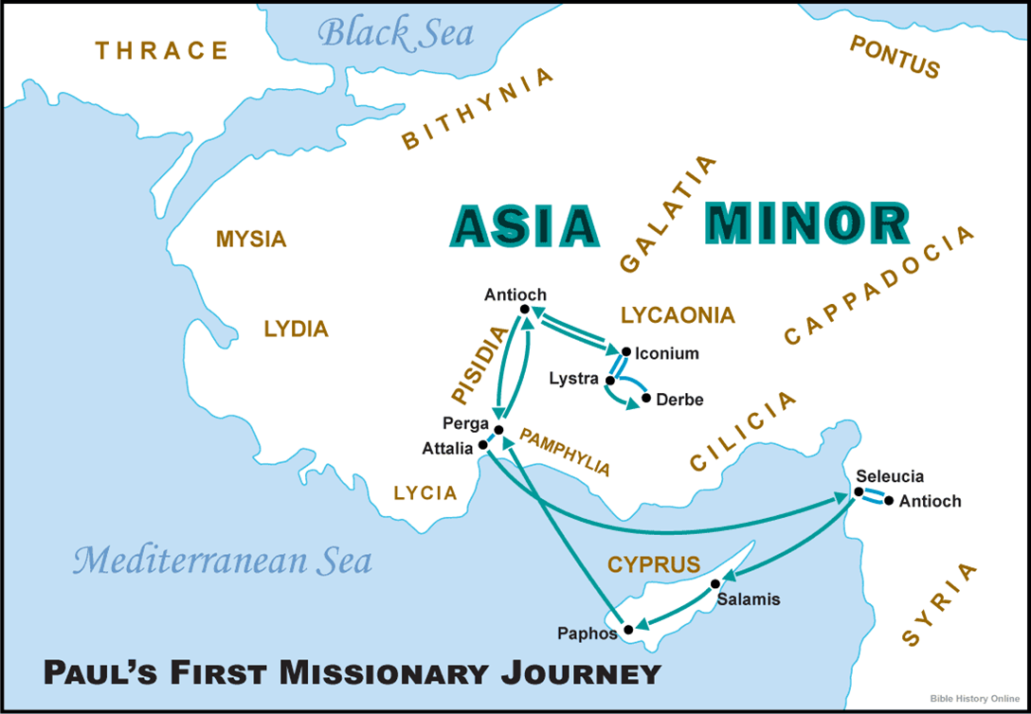

Faith, Love and Righteousness/Morality
This event of healing, via faith, draws the question – Why does not God’s righteous morality heal all the time or not allow people to get sick, be injured and/or die? Additionally, if a person has enough faith, can they be healed?
We have addressed these questions previously in the sermon preached on September 27, 2020, “God’s Life to Eternity”, which can be found on the Christian Fellowship website sermon list (roundtopchurch.org). In short, due to God creating the creation with the two attributes of “free-will choice” to “love” - there must be the opposite of love for love to be chosen (Genesis 2:17). These opposing forces to love allows bad things to happen. Love is not love if it is conditional on being only in the vacuum of a safe environment. Additionally, when bad things happen to people, there is an opportunity to apply loving words and actions of comfort and compassion. We see this throughout the Bible and in our lives. How many times have you had the opportunity to apply love to a tragic event? These are numerous opportunities in all of our lives. Love is the experience of a lifetime. And the good news is – being a person of faith in God, love can happen all the time. In the sermon noted, I stated that my view is that the reason God created us is to experience love. God is love (1 John 4:8), and we are created in His image (Genesis 1:26,27). Therefore, we are to be ambassadors of love.
God’s Love Extended in People
The first element in John 3:16 encompasses God’s love. The second element is the birth of Jesus and gift of the Cross. “He gave” points to the Incarnation and the Cross. “Begotten” is a misunderstood word. The direct Greek translation is “His only unique Son.” (unique – one of His kind). Then Faith is highlighted as the imperishable path to eternal life.
Begotten - Strong’s 3439 Greek μονογενής monogenes
Meaning: only begotten Origin: from 3441 and 1085
Usage: only (3), only begotten (6).
Notes: 1 Or unique, only one of His kind
Romans 5:8, 8:32; Ephesians 2:4; 2 Thessalonians 2:16; 1 John 4:9,10; Rev. 1:5
John 1:18, 3:18, 3:36, 6:40, 11:25f
16 "For God so loved the world, that He gave His only begotten Son, that whoever believes in Him shall not perish, but have eternal life.
The Love of God in The Christ Mass
The word Christmas comes from the name given to the worship service in observance of the Lord’s Supper, the “Christ-Mass.” Hence, every time Believers assemble for worship to participate in the taking of the Lord’s Supper, we celebrate and witness, among other things, the birth of Christ. We celebrate the fact that God loved us first and came to be one of us. God chose to become one of us, enduring the Cross, to pay the price for our sins, providing us with an opportunity to surrender to Him gaining for us eternal life.
Regarding Christmas as we know it, none of the Apostolic Fathers wrote about the celebration that we have today. Without going into detail and regardless of the pagan origins of December 25, we have a great opportunity to witness God and His faith at work inside our hearts. The incarnation did take place.
John 3:16 highlights God’s love in the Incarnation. This is the one and only time in human history God acts in this way. The only other time that came close to the Incarnation was when He created Adam. Jesus Christ is compared to the “first” Adam.
1 Corinthians 15:45-47 45 So also it is written, "The first MAN, Adam, BECAME A LIVING SOUL." The last Adam became a life-giving spirit. 46 However, the spiritual is not first, but the natural; then the spiritual. 47 The first man is from the earth, earthy; the second man is from heaven.
We see the distinct difference is that the first Adam was from the earth (Genesis 2:7) and the second from heaven (Matthew 1:20). This is a defining point aiming at the character of the Deity in Jesus. The first Adam was not God in the flesh, but the Second Adam (Jesus) was. This is evident in the sinless life of Jesus. Obviously, Adam sinned (Genesis 3).
Focus on Christ and a Life of Faith
So, we are in the time of year when the focus is upon the birth of Jesus Christ when the Word became flesh. One of the goals of the Incarnation of God was for Him to walk among us demonstrating works from faith to faith. “For we walk by faith, not by sight” (2 Corinthians 5:7). Paul declares Believers are to live the same life of faith. “But to the one who does not work, but believes in Him who justifies the ungodly, his faith is credited as righteousness. (Romans 4:5). Paul also testifies about his condition of faith to the Galatians. "I have been crucified with Christ; and it is no longer I who live, but Christ lives in me; and the life which I now live in the flesh I live by faith in the Son of God, who loved me and gave Himself up for me. "I do not nullify the grace of God, for if righteousness comes through the Law, then Christ died needlessly" (Galatians 2:20-21).

Let us look at the people through which God worked to accomplish the incarnation.
First, there were the Old Testament prophets, who proclaimed the coming of the Messiah. Most Believers are familiar with Isaiah 7 and 53. There are numerous Old Testament passages detailing the coming Messiah. The prophets had faith to write down the prophecy God gave them. Therefore, faith at work in the prophets displayed God’s righteousness. Prophecy being fulfilled brought about salvation in the fact “God saves.” The name “Jesus” is derived from the same name as Joshua, meaning “the Lord is salvation.”
Strong’s 03091 Johsua יְהוֹשׁוּעַ Yehoshua or יְהוֹשֻׁעַ Yehoshua
Meaning: 'the LORD is salvation,'
Origin: from Strong’s 3068 and 3467 Usage: Jeshua (28), Joshua (219).
Notes: Exo. 24:4; Exo. 34:27; Num. 33:2 Deut. 25:19; 1Sa 15:3
Strong’s 2424 Ἰησοῦς Iesous
Meaning: Jesus or Joshua, the name of the Messiah
Origin: of Hebrew word 3091 Usage: Jesus (904), Jesus' (7), Joshua (3).
Notes: Hebrew Yeshua (Joshua), meaning The LORD saves
Greek Christos (Christ), Greek for Messiah, which means Anointed One
2 Sam. 7:12-16; Psalm 89:3f, 132:11; Isaiah 9:6f, 11:1; Matthew 9:27;
Luke 1:32, 1:69; John 7:42; Acts 13:23; Romans 1:3; Rev. 22:16;
Matthew 1:1-6; Luke 3:32-34; Genesis 22:18; Galatians 3:16.

We see in the Gospel of Matthew (1, 2) the chronicled historic event of the Incarnation.
Faith Working Through Mary (Matthew 1)
Faith Working Through Joseph (Matthew 1)
Faith Working Through Zacharias. Father of John the Baptist (Luke 1)
Faith Working Through Elizabeth, mother of John the Baptist (Luke 1)
Faith Working Through the Magi (Matthew 2)
All of these had to overcome obstacles to achieve the role for which God had called them. The power of God’s faith at work in them overcame the forces opposing them. From the time the angel came to Mary, before she was married to Joseph, she had to overcome her fears of being an unmarried young woman with child. Joseph had to press through the stigma of Mary’s conception and accept by faith that it was God’s Holy Spirit at work.
The faithful Zacharias and Elizabeth were in advanced age when the angel of God came to them and told them that they would be blessed with a child, and that this child would be full of the Holy Spirit while in his mother’s womb. By faith, Zacharias had entered the temple of the Lord, believing that he would not be struck dead, and the angel came to him telling of the newborn son Elizabeth would deliver, who “will turn many of the sons of Israel back to the Lord their God. "It is he who will go as a forerunner before Him in the spirit and power of Elijah, TO TURN THE HEARTS OF THE FATHERS BACK TO THE CHILDREN, and the disobedient to the attitude of the righteous, so as to make ready a people prepared for the Lord" (Luke 1:16-17).
By faith, the Magi left their homeland and traveled for a few years to reach the child Jesus, giving Him gifts and worshiping Him. By faith, they listened to the angel and did not return to inform King Herod of the location of Jesus. By faith, Joseph and Mary listened to the angel of the Lord who directed them to flee to Egypt, protecting Jesus from Herod.
All of these faithful people could not have achieved for God their assigned mission if it were not for each of them believing that God worked in their lives to produce great things for them and their neighbor. So, the faith of God working through the Prophets, Mary, Joseph, Zacharias, Elizabeth and the Magi brought about the greatest gift humanity has every received.
We, too, are called by God, and, by faith, in the Lord’s plan for our lives, can witness to our families and communities the Lord’s Good News.
Merry “Jesus” Christmas.
AMEN

