Round Top Church Christian Fellowship
Thirty-Fifth Week Since the Resurrection
Gospel Tracts to Success - Acts 13:50 – 14:7
Pastor ~ Matthew Diehl
December 13th In the Year of Our Lord 2020
(Unless otherwise noted, NAS quoted.)

Acts 13:50 But the Jews incited the devout women of prominence and the leading men of the city, and instigated a persecution against Paul and Barnabas, and drove them out of their district. 51 But they shook off the dust of their feet in protest against them and went to Iconium. 52 And the disciples were continually filled with joy and with the Holy Spirit.
Acts 14:1 In Iconium they entered the synagogue of the Jews together, and spoke in such a manner that a large number of people believed, both of Jews and of Greeks.
2 But the Jews who disbelieved stirred up the minds of the Gentiles and embittered them against the brethren.
3 Therefore they spent a long time there speaking boldly with reliance upon the Lord, who was testifying to the word of His grace, granting that signs and wonders be done by their hands.
4 But the people of the city were divided; and some sided with the Jews, and some with the apostles.
5 And when an attempt was made by both the Gentiles and the Jews with their rulers, to mistreat and to stone them,
6 they became aware of it and fled to the cities of Lycaonia, Lystra and Derbe, and the surrounding region;
7 and there they continued to preach the gospel.
Gospel History
Reviewing the short history (first few decades) of the evangelism efforts chronicled in the book of Acts to chapter 14, for Peter, John, Paul, Silas, and Barnabus, it is easy to conclude that their success was based on the fact that thousands had come to surrender to God under the Good News proclaimed by Jesus Christ. Whatever else they believed – they accepted the Good News to be superior. For the Jews, they turned from a legalistic adherence to the Law of Moses. For the Gentiles, they abandoned the worship of idols, repented and worshipped God.
The Word of God accounts for humanity’s beginning and gives purpose for life. People learned that they were valued by God and, also, those who believe in God. God’s Word details how life is to be lived with love and compassion for others while possessing and applying joy, hope, gentleness, kindness and self-control - at the same time Believers are to pray for their enemies. All of these godly character traits are directed by God’s indwelling Holy Spirit. Instead of an external god who is distant and to be feared at all times, the Gospel proclaimed the reality of God residing in our hearts. For it is God who gives Believers a new heart so they can walk in the ways He has planned for them. The message that God is love and we are created in His image to have a personal relationship with Him is more drawing than the cold stone lifeless idols. Then there is the fact that God is not going to leave us here. God has an eternal-life-plan for each person who surrenders their heart to Him. This is why John 3:16 is overriding in its appeal to the human soul. The reality of a guaranteed eternal life to those possessed by God is announced by Paul to the Ephesians: In Him, you also, after listening to the message of truth, the gospel of your salvation-- having also believed, you were sealed in Him with the Holy Spirit of promise, who is given as a pledge of our inheritance, with a view to the redemption of God's own possession, to the praise of His glory (Ephesians 1:13-14). Paul is consistent with God’s message to the Corinthians - Now He who establishes us with you in Christ and anointed us is God, who also sealed us and gave us the Spirit in our hearts as a pledge (2 Corinthians 1:21-22).
The Gospel message spread by word-of-mouth from Jerusalem. Old Testament Scripture was read to support that Jesus fulfilled the prophesied Messiah. We see this happening from 33 A.D. to the first era of Paul’s recorded ministry in the mid- to late 40’s. Scholars have evidence to position the production of the book of James and Galatians before 50 A.D. Paul’s first letter to the Thessalonians is believed to have been written about 53 A.D. Following the life of Paul is a good view to see the growth of the Church. As we will see, the book of Acts ends with Paul waiting for his appeal to Caesar in about 67-68 A.D.
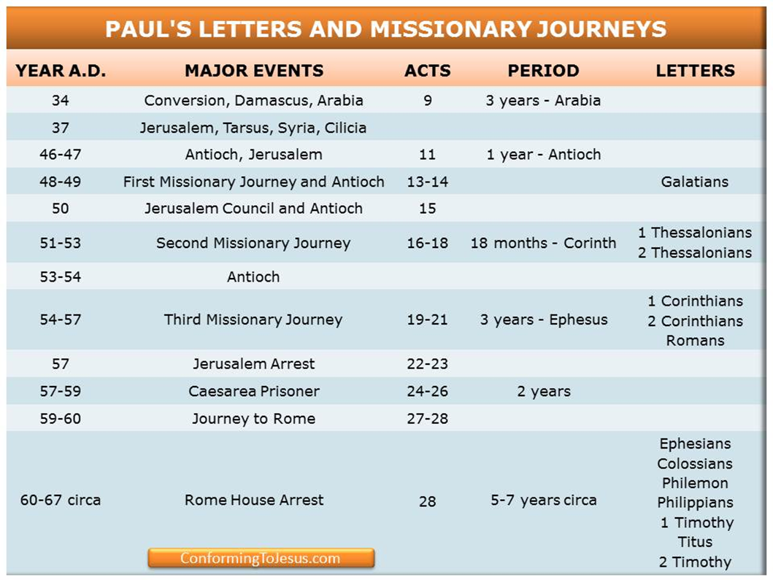
https://www.google.com/search?q=Paul%27s+letter+timeline&rlz=1C1GGRV_enUS751US751&tbm=isch&source=iu&ictx=1&fir=vH46oww6QWTKgM%252CV-CCA--BCVYyNM%252C_&vet=1&usg=AI4_-kTqLXkeSYB5np5nQhut7SmQRd_-_g&sa=X&ved=2ahUKEwi436XFtL_tAhVMRKwKHWsACOAQ9QF6BAgOEAE&biw=2560&bih=937#imgrc=KnJL4LTa0pAG2M
With the expansion of “The Way” (Acts 9:2) (Jesus is Way to the Truth to eternal life, John 14:6), there are a couple of events to keep in mind: The Jerusalem Council (Acts 15) and the destruction of Jerusalem in 70 A.D. This was due to the Jews rebelling against the Romans in 66 A.D. The rebellion ended at Masada in 72 A.D. where the last Jewish stronghold was defeated. It is interesting to note that there are many passages of Scripture foretelling of the destruction of Jerusalem, but there is not one after the event took place. All of Paul’s letters (13) were written prior to 68 A.D. All other books were believed to have been written prior to 70 A.D., with the exception of John. John is attributed to writing five books of the New Testament (John, 1st, 2nd and 3rd John and Revelation). Most, if not all of these books written by John are positioned by scholars to be pinned in the last decade of the first century. John does not specifically speak of the destruction of Jerusalem, the Jewish revolt or the fall of Masada.
What is the Gospel Message?
1 Corinthians 15:1
Now I make known to you, brethren, the gospel which I preached to you, which also you received, in which also you stand,
2 by which also you are saved, if you hold fast the word which I preached to you, unless you believed in vain.
3 For I delivered to you as of first importance what I also received, that Christ died for our sins according to the Scriptures,
4 and that He was buried, and that He was raised on the third day according to the Scriptures,
5 and that He appeared to Cephas, then to the twelve.
6 After that He appeared to more than five hundred brethren at one time, most of whom remain until now, but some have fallen asleep;
7 then He appeared to James, then to all the apostles;
8 and last of all, as to one untimely born, He appeared to me also.

Gospel Tracts to Success
Apostles Stayed on Message
The Apostles and other disciples of Jesus did not allow the enemies of God to highjack the Gospel. They protected what Jesus had taught them. They did not succumb to the fallen world and turn the positive saving spiritual empowering message of the Cross into another man-made religious system. God knows others tried.
Just think, if the apostles would have sold-out to Simon the Magician (Acts 8) or appealed to the material callings of the world - Christianity never would have succeeded. They did not turn God into a slot machine or an insurance policy like so many have done through history and today. It is easy to sell religion. It is impossible to fulfill prophecy and walk from an empty tomb after crucifixion without God. Charlatans pursue building earthly kingdoms. Jesus said His Kingdom was not of this world (John 18:36). God’s kingdom is being ushered into this fallen world through Believers. We are part of that process. Once a Believer, our lives transcend this temporal fallen world to be with God and His love, living in us, forever.
God Loved Us First. . .Therefore. . .
God Did All the Work for Salvation
The Message of God/Jesus from the Cross that “It is finished!” (John 19:30) resonated across religious cultures. The Good News declared that you no longer had to live your life in an effort to appease a god or an angry god. God loved us first (1 John 4:19) without us having to do anything. The Message clearly proclaimed a person did not have to earn the love of God. The gift of the “Free Cross” was universally appealing to the common person (General Atonement).
General Atonement
The fact is, God incarnated Himself as Jesus, lived with us for 30 years, then completed a three & one-half year ministry to be falsely accused, arrested, illegally tried, convicted, tortured and died on a cross to pay the price for the sins of the world, to rise from the dead and continue preaching - then ascended to be with God the Father to return one day to meet the living and the dead, separating the sheep from the goats (Matthew 25:32-34) and enter with His saints an eternal Heaven where there are not any more tears, nor sin and death, but only the light of the love of God, for He is Love (1 John 4:8). God did, and is going to do all of this for ONLY THE ELECTED LIMITED FEW!? Once again, “NOT.”
Did God create people, in His image, who could never have access to His love and forgiveness? There is not any Scripture to support that He did. In fact – consider the below Bible verses. Cain, Pharaoh, Jezebel, Herod and Judas to name a few, all had a free-will choice. At some point, God turned them over to their own desires (Romans 1:24). They all had a chance to surrender to the Lord.
John 1:29 The next day he [John] saw Jesus coming to him and said, "Behold, the Lamb of God who takes away the sin of the world!
John 3:14, -17 "As Moses lifted up the serpent in the wilderness, even so must the Son of Man be lifted up; 15 so that whoever believes will in Him have eternal life. 16 "For God so loved the world, that He gave His only begotten Son, that whoever believes in Him shall not perish, but have eternal life. 17 "For God did not send the Son into the world to judge the world, but that the world might be saved through Him.
John 6:40 "For this is the will of My Father, that everyone who beholds the Son and believes in Him will have eternal life, and I Myself will raise him up on the last day."
Titus 3:4 But when the kindness of God our Savior and His love for mankind appeared,
1Timothy 1:15 It is a trustworthy statement, deserving full acceptance, that Christ Jesus came into the world to save sinners, among whom I am foremost of all.
1Timothy 2:4 who desires all men to be saved and to come to the knowledge of the truth.
Isaiah 42:6 "I am the LORD, I have called you in righteousness, I will also hold you by the hand and watch over you, And I will appoint you as a covenant to the people, As a light to the nations,

Paul’s Witness to General Atonement
God – Equal Opportunity Savior
God’s equal opportunity is not any more apparent when the Pharisee-Jew, Paul, said that he was not ashamed of the Gospel. Paul declares to a mixed congregation of Jews and Gentiles in Rome that the Gospel is the power of God for salvation to everyone who believes. Paul does note that God revealed the Gospel to the Jews first but also included the Greeks. We see in other passages of Scripture that the Greeks and the Gentiles are included in God’s redemptive plan (Acts 13:47,48).

The Gospel Contains Righteousness
Faith Transfers the Good News
No Man’s Works Produces Righteousness
Faith Produces Righteous Living
In Paul’s letter to the Romans (1:16,17), he points to the Gospel Message of Jesus Christ and identifies that the righteousness of God is contained within.
16 For I am not ashamed of the gospel, for it is the power of God for salvation to everyone who believes, to the Jew first and also to the Greek. 17 For in it the righteousness of God is revealed from faith to faith; as it is written, "BUT THE RIGHTEOUS man SHALL LIVE BY FAITH."
Paul insisted that God’s Gospel is revealed from faith to faith. Paul, in Romans 1:17 quotes Old Testament teaching to support his witness. "BUT THE RIGHTEOUS man SHALL LIVE BY FAITH."
Genesis 15:6 Then he [Abraham] believed in the LORD; and He reckoned it to him as righteousness. (see Romans 4:3)
Psalm 98:2 The LORD has made known His salvation; He has revealed His righteousness in the sight of the nations.
Habakkuk 2:4 "Behold, as for the proud one, His soul is not right within him; But the righteous will live by his faith.
See also Isaiah 61:10-62:1; Romans 4; Hebrews 11; Genesis 12
Believers have the Living Lord inside their heart and mind. Faith in God produces the righteous life of good works. Good works never produce faith. Good works can enhance faith, but faith is not founded in a person’s works (James 2).

The Truth Shall Set You Free - John 8:31-32
You Will Never Die – John 8:51-52
John 8: 31 So Jesus was saying to those Jews who had believed Him, "If you continue in My word, then you are truly disciples of Mine; 32 and you will know the truth, and the truth will make you free."
John 8:51 "Truly, truly, I say to you, if anyone keeps My word, he will never see death." 52 The Jews said to Him, "Now we know that You have a demon. Abraham died, and the prophets also; and You say, 'If anyone keeps My word, he will never taste of death.'
People found peace and truth in God’s Word that announced that people can be free and never taste death. Obviously, these teachings are spiritual. For Believers, death is a door through which - God walks with us to an eternal life with Him. We know that life can be physically and mentally harsh. The Word of God does not sugarcoat life. At the same time, Believers are called to focus on the things that are not seen which are eternal.
1 Peter 5:10 After you have suffered for a little while, the God of all grace, who called you to His eternal glory in Christ, will Himself perfect, confirm, strengthen and establish you.
1 Jo hn 2:17 The world is passing away, and also its lusts; but the one who does the will of God lives forever.
2 Corinthians 4:16-18 - 16 Therefore we do not lose heart, but though our outer man is decaying, yet our inner man is being renewed day by day. 17 For momentary, light affliction is producing for us an eternal weight of glory far beyond all comparison, 18 while we look not at the things which are seen, but at the things which are not seen; for the things which are seen are temporal, but the things which are not seen are eternal.
The fallen world cannot break into the heart of a person who has surrendered to the Lord. We have observed many prisoners of war and persecuted Believers endure with the Living God in them.

For it is God Who is at Work in You
People listened to the apostles and compared the Gospel to their current religious system. They discovered that in Christ there is not any more of running the gauntlet through pagan cultic structures or man-centered legal systems. God accepts a humble person (poor in spirit – Matthew 5:3) who can mourn for their own and their neighbor’s fallen spiritual condition (Matthew 5:4). God can take a person where they are and then He commits to a spiritual work in them for a lifetime. The message of “It is God who is at work in you, both to will and to work for His good pleasure” (Philippians 2:13) freed people from reliance upon their own ability to justify themselves through their own work. God commits to an ongoing work in the heart and mind of every Believer.
Philippians 1:6 For I am confident of this very thing, that He who began a good work in you will perfect it until the day of Christ Jesus.
Colossians 1:9-12 9 For this reason also, since the day we heard of it, we have not ceased to pray for you and to ask that you may be filled with the knowledge of His will in all spiritual wisdom and understanding,
10 so that you will walk in a manner worthy of the Lord, to please Him in all respects, bearing fruit in every good work and increasing in the knowledge of God;
11 strengthened with all power, according to His glorious might, for the attaining of all steadfastness and patience; joyously
12 giving thanks to the Father, who has qualified us to share in the inheritance of the saints in Light.

Only Sinners Need Apply
All have Sinned and Fallen Short of the Glory of God – Romans 3:10,23
No one has to be perfect on the first day.
Mark 2:16 When the scribes of the Pharisees saw that He was eating with the sinners and tax collectors, they said to His disciples,
"Why is He eating and drinking with tax collectors and sinners?"
17 And hearing this, Jesus said to them,
"It is not those who are healthy who need a physician,
but those who are sick;
I did not come to call the righteous, but sinners."
From the first moment the general population hears of Jesus’ teaching, they had to make a decision. God directed the Gospel to all, but the more venerable population seemed to hear more clearly. Thus, we have the parable of the Rich Young Ruler (Luke 18:18ff) who was challenged to sell all his possessions and distribute to the poor. The Woman at the Well (John 4) is another example of Jesus reaching out to people regardless of their economic class. The ruler was wealthy and the woman at the well was common. Then there is the ultimate economic and social contrast of two individuals in Jesus’s account of Lazarus and the Rich Man (Luke 16:19-31). The appeal to all social and economic classes, especially the lower economic portion of society, made the case that we are all equal in the eyes of God. We all have the same need to find peace with God.
The Confronting Cross and Empty Tomb
God built into the soul (Greek = psuche / English = psyche) of people’s spiritual awareness. The Cross and the Empty Tomb is confronting. Once you hear of a man being crucified for claiming to be God, the Messiah, and walking from his burial tomb, there is a contemplative moment. He was either a mad man, along with others being delusional, or he and others are telling the truth.
The Cross begs the question - Why would a man knowingly push the authorities to crucify Him unless there was a supernatural authority at work? This is why Old Testament Scriptures, like Isaiah 53, are instrumental in highlighting the completion of the prophetic mission of God as Jesus the Messiah. And why would Jesus’ followers continue to proclaim the teachings of Jesus, under threat of death, unless they witnessed the resurrected Jesus?
Society in the first century was harsh due to oppressive rulers and life expectancy on average was short. The infant mortality rate was high. Therefore, death was more pressing in the face of the common person in contrast to the modern societies of today. However, the Cross and the empty tomb declares that life does not end here. Life was shorter and the Cross represented an end to life, but at the same time a new life, a new beginning in God’s eternal kingdom. Death is declared defeated.
There is more to defeating death than living eternally. Those who do not surrender to God will also live eternally. Tied to death is sin. Sin positions death to be the divider between God and people. There is a spiritual death (a spiritual separation) first then an eternal spiritual separation from God when our bodies die. Death is separation from God and his love. Therefore, defeating sin and death means that sin and death do not have power over you anymore. God’s love rules your life.
Romans 8:1 Therefore there is now no condemnation for those who are in Christ Jesus. 2 For the law of the Spirit of life in Christ Jesus has set you free from the law of sin and of death.
The Cross and Empty Tomb confront the fallen world and, at the same time, send the message that God paid the price for all our sins. This is a universal message. “It is finished”; people can rest – all God seeks from us is a surrender of the heart. A simple message that transcends cultures and societies. This is why the Believers Assembly, “The Way”, grew. AMEN

