Round Top Church Christian Fellowship
Seventeenth Week Since the Resurrection
Acts 6:1-7
Reputation, Spirit, Wisdom
Pastor ~ Matthew Diehl
August 9th In the Year of Our Lord 2020
(Unless otherwise noted, NAS is quoted.)

Acts 6 can be viewed in two parts. The first (verses 1-7) reports the need to appoint people to carry-out the task of the daily serving of food. This serving (Greek - diakonia), the minister’s task, was to address the reported complaint from the Hellenistic Jews about the widows. The second (verses 8-15) began the account of Stephen’s witness.
Regarding verses 1-7 – Who were these widows? Remember, the 3000 then 5000 converts reported to have surrendered to the Truth of Peter’s Holy Spirit preaching brought the need for more ministers. In addition, Acts 2:47, 5:14 reports that on a daily basis people were being added to their ranks.
Historians see that at the time of this event many Jews had returned to Jerusalem from all over the Roman empire, particularly from around the Mediterranean Sea, for the Pentecost observance. Jews from all language groups had also moved to Jerusalem in their old age anticipating the end of their life would be spent in the sacred city. They wanted to be buried in Jerusalem. Thus, historically, men die first, therefore leaving their wives widows. In Acts 6, we see these Greek-speaking widows speaking-up. So, why is it important for a Jew to be buried in Jerusalem? We find our answer in the Jewish Talmud and in Genesis 47.
The Talmud (/ˈtɑːlmʊd, -məd, ˈtæl-/; Hebrew: תַּלְמוּד‎) is the central text of Rabbinic Judaism and the primary source of Jewish religious law (halakha) and Jewish theology.[1][2][3] Until the advent of modernity, in nearly all Jewish communities, the Talmud was the centerpiece of Jewish cultural life and was foundational to "all Jewish thought and aspirations", serving also as "the guide for the daily life" of Jews.[4]
The term "Talmud" normally refers to the collection of writings named specifically the Babylonian Talmud (Talmud Bavli), although there is also an earlier collection known as the Jerusalem Talmud (Talmud Yerushalmi).[5] It may also traditionally be called Shas (ש״ס), a Hebrew abbreviation of shisha sedarim, or the "six orders" of the Mishnah.
https://en.wikipedia.org/wiki/Talmud

Jewish Talmud - Ketubot 111a § The verse states that Jacob commanded Joseph: “You shall carry me out of Egypt and bury me in their burying-place” (Genesis 47:30). Karna said: There are inner matters here, i.e., a secret meaning: Our Patriarch Jacob knew that he was completely righteous, and if the dead of the lands outside of Eretz Yisrael come alive, why did he trouble his sons to bring him to Eretz Yisrael? The reason is that he was concerned lest he not merit the tunnels.
On a similar note, you say: “And Joseph took an oath of the children of Israel, saying: God will surely remember you, and you shall carry up my bones from here” (Genesis 50:25). Rabbi Ḥanina said: There are inner matters here. Joseph knew concerning himself that he was completely righteous, and if the dead of the lands outside of Eretz Yisrael come alive, why did he trouble his brothers to carry his coffin four hundred parasangs to Eretz Yisrael? The reason is that he was concerned lest he not merit the tunnels.
https://www.sefaria.org/Ketubot.111a.21?lang=bi&with=Commentary&lang2=en

Genesis 47:29-31
29 When the time for Israel to die drew near, he called his son Joseph and said to him, "Please, if I have found favor in your sight, place now your hand under my thigh and deal with me in kindness and faithfulness. Please do not bury me in Egypt, 30 but when I lie down with my fathers, you shall carry me out of Egypt and bury me in their burial place." And he said, "I will do as you have said." 31 He said, "Swear to me." So he swore to him. Then Israel bowed in worship at the head of the bed.

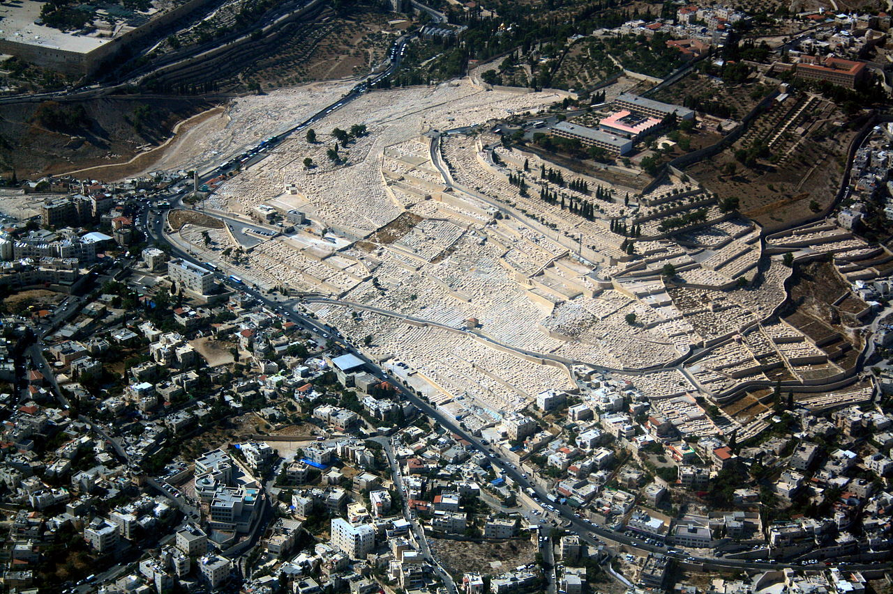
The Jewish Cemetery on the Mount of Olives, including the Silwan necropolis, is the most ancient and most important Jewish cemetery in Jerusalem. Burial on the Mount of Olives started some 3,000 years ago in the days of the First Temple, and continues to this day.[1] The cemetery contains anywhere between 70,000 and 150,000 tombs from various periods, including the tombs of famous figures in Jewish history.

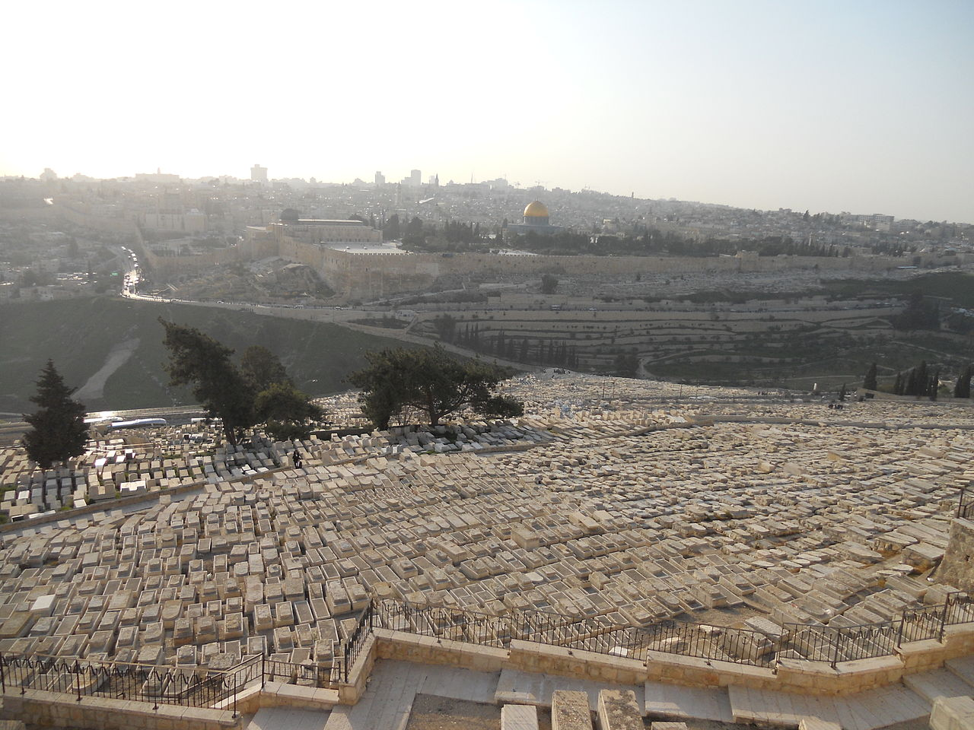
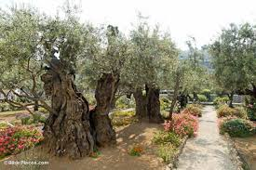
Today, as for thousands of years, Jews from around the world pay a lot of money to be buried on the Mt. of Olives. Despite opposition from Arab-Muslim groups harassing Jews going to the cemetery, the Jews continue to hold the Mt. of Olives as a sacred place not to be abandoned.

The cemetery today
As early as 1968, the Arabs began stoning the mourners on their way to the cemetery, through the Arab village. In 1992, with the burial of Prime Minister Menachem Begin on the Mount of Olives, it was decided to establish a dedicated security company for the cemetery, and to increase the protection of visitors to the site. In 2005, acts of harassment against Jews intensified, and it was decided to set up a guard unit for personal or group escort to those who came to the cemetery. In 2009, cars were attacked and many visitors were injured on the way to the cemetery. (Wikipedia)

Application for today
We see now why there were so many widows in Jerusalem 2000 years ago. With the Mt. of Olives’ cemetery holding a 3000 years history, the events recorded in the book of Acts are understandable.
This is important to anyone studying the right of the Jews to be there. This cemetery proves the presence of the Israelites in the Holy Land and specifically in Jerusalem since the time of King Saul, David and Solomon.
The Arab-Muslims did not have a presence there until the late 7th century A.D. about 1,650 years after the reign of King Saul, David and Solomon. The dome of the Rock shrine was built in 691 A.D. by the order of Umayyad Caliph Abd al-Malik (Malik). Inside the Dome of the Rock, there are inscriptions containing the first notation, in Arabic, of Muhammad’s name. This is important because that was about sixty years after Muhammad died. The Koran only lists Muhammad’s name four times. There are numerous references to the “Messenger” of Allah and other nouns used, but only four direct uses of the name Muhammad. The observation is that anyone can be a “messenger.” When I did a search on the name “Jesus” in the New Testament using my Bible research software, I found “Jesus” listed 947 times in the New American Standard Bible. So, the name “Muhammad”, as compared to the name “Jesus,” whose person and name, without ambiguity, was published in the Old Testament and written about in the New Testament within the decade after He was crucified on the Cross doesn’t compare.
So, why does this matter? It is an issue because this, and more historical evidence which is too numerous to present now, leave little doubt that Muhammad was a character chosen in Arab history to rally the troops. Malik needed a central religious leader to be perceived by the masses to be that person who their god directed. It is of note that in Muslim teachings, Allah never spoke to Muhammad directly. Muhammad claimed to have received messages from the angel Gabriel. By putting forth a known religious and military leader, Malik created an Arab geo-political movement with religion as the driving force. The simple goal was to carry out military conquest for land, money and resources including human trafficking. He developed a religion around a religious person, accepted as a prophet, and a book we know as the Koran.
Regarding the Temple Mount
Why does the founding narrative of Islam make a difference for us today? Because the truth is that any claim the Arab-Muslims have to the Temple Mount are not based on factual history. I will be available to discuss these facts with anyone.

Greeks, who had converted to Judaism, chosen.
Due to Alexander the Great’s conquest, three-hundred years prior, the Greek language and culture had become a common in the Roman Empire. It is often pointed-out that all the men chosen had Greek names and spoke the Greek language. Thus, they were able to overcome any language barrier that may have existed with Hebrew speaking servants who had been tending to the Hellenistic Believers.
The Apostles did not receive a revelation from God to choose these servants. We can assume that the Apostles were unified, and Spirit-filled themselves, from two points of reference. The resurrected Jesus had breathed His Spirit into them (John 20), and the Pentecost manifestation (Acts 2) of God’s Spirit, to be functioning in all of them.
We can say they were guided by God’s Spirit that was in them. This is the way a Believer’s life is supposed to be lived. They advised the people to “select from among you seven men.” There was no theophany where God made an appearance and gave them instruction like with Moses and the burning bush. In this process, the Apostles did provide qualifications that the men should have a “good reputation,” be “Spirit-filled” and have “wisdom.”
It is of note that Peter nor John are named as leading the discussion or presenting the decision. The text reveals that “the twelve” summoned the congregation and made a group statement. From this, we can see that it was the “counsel” of the Apostles functioning together to make decisions for the congregation. Even though we have the record in Acts of Peter being the leading “witness-voice” recorded, he was not the leading voice when it came to making a congregational decision for the Church, beginning from Jerusalem (Luke 24:47).
It is observed that there was not any vote from the congregation to approve the “Twelve’s” statement. The NAS was the standout English version that used the words “found approval.” The KJV, NKJ, ESV, Young’s, Tyndale, ASV, CSB and NIV all use the word “pleasing” to the whole multitude, group, company. We see that the Apostles set the parameters of selecting men within their group possessing three personal attributes. Given these rules, the Believer’s community actually selected the servants.
Acts 6
Increasing numbers
1a Now at this time while the disciples were increasing in number,
Complaint! 1b a complaint arose on the part of the Hellenistic Jews against the native Hebrews, because their widows were being overlooked in the daily serving of food.

Strong’s 1248 διακονία diakonia Meaning: service, ministry
Origin: from 1249
Usage: ministries(1), ministry(19), mission(1), preparations(1), relief(1), serve(1), service(7), serving(2), support(1). Acts 2:47; 4:35; 6:7; 9:29, 39,41; 11:20, 26, 29; 2 Corinthians 11:22; Philippians 3:5; 1Timothy 5:3

Strong’s 1247 διακονέω diakoneo
Meaning: to serve, minister Origin: from 1249
Usage: administered(1), administration(1), cared(1), contributing...support(1), do...the serving(1), employ...in serving(1), minister(3), ministered(2), ministering(3), servant(1), serve(4), serve as deacons(1), served(2), served as deacons(1), serves(5), services...rendered(1), serving(4),

Romans 16:1 I commend to you our sister Phoebe, who is a servant of the church which is at Cenchrea;
Strong’s 1249 διάκονος diakonos
Meaning: a servant, minister
Usage: deacons(3), minister(7), servant(10), servants(9).
Notes: deaconess 2 Corinthians 3:1; Acts 18:18

Managing Complaint
2 So the twelve summoned the congregation of the disciples and said,
"It is not desirable for us to neglect the word of God in order to serve tables.
Solution
3 "Therefore, brethren, select from among you seven men
of good reputation, full of the Spirit and of wisdom,
whom we may put in charge of this task.
4 "But we will devote ourselves to prayer and to the ministry of the word."

Pleasing Words (There wasn’t a vote)
5 The statement found approval (pleased) with the whole congregation;
and they chose Stephen,
a man full of faith and of the Holy Spirit,
and Philip, Prochorus, Nicanor, Timon, Parmenas and Nicolas, a proselyte from Antioch.

Acts 6:5 Greek & English (BGT)
And pleasing the words before all the multitude
καὶ ἤρεσεν ὁ λόγος ἐνώπιον παντὸς τοῦ πλήθους

and chose Stephen man full faith
καὶ ἐξελέξαντο Στέφανον, ἄνδρα πλήρης πίστεως

and spirit Holy and Philip and Prochorus and Nicanor and Timon
καὶ πνεύματος ἁγίου, καὶ Φίλιππον καὶ Πρόχορον καὶ Νικάνορα καὶ Τίμωνα
and Parmenas and Nicolas proselyte Antioch
καὶ Παρμενᾶν καὶ Νικόλαον προσήλυτον Ἀντιοχέα,

Conclusion
6 And these they brought before the apostles;
and after praying, they laid their hands on them.

Impact of Managing Complaint?
7 The word of God kept on spreading;
and the number of the disciples continued to increase
greatly in Jerusalem,
and a great many of the priests were becoming obedient to the faith.
What do we learn from this history of the early Church in Acts 6? We see that to be a table server, a person who proportions food to widows, that person must be called to have certain qualifications (good reputation, full of the Spirit and of wisdom). They were not called to preach or teach, but still these important qualifications were needed. Were they overqualified? No. This is what God required of them to serve in His kingdom. In God’s spiritual reality, these are basic qualities for all of us to have in order to carry-out simple tasks for the Lord.
These men did not have to be biblical scholars of God’s Word. They did not have to be brilliant academically. A person with these three qualifications can succeed at many things in life.
To have a good reputation means a person, through participating with others in life’s challenges, has earned the community’s trust. They do what they say they will do barring unusual circumstances. They do not selfishly put their interests above another. They earn the trust of others through repeated conduct and statements. Reputations are earned.
Full of the Spirit means a person contains God’s love, joy, peace, patience kindness, goodness, faithfulness, gentleness and self-control. In contrast to a good reputation that is earned, being full of God’s Spirit is a gift. This means that a person has surrendered and humbled themselves to the Lord. God’s Spirit grows in a person who is seeking the Lord’s direction in their life. These are spiritual traits that are manifested, for others to see, in our personal interaction with friends, neighbors, classmates, coworkers, employees and family members.
Wisdom is gained from living life as a Believer in the Lord. Wisdom is not earned. Wisdom is gained by allowing God to work in our lives. Again, this process is due to our surrender and humility to the Lord. We know that Scripture is true concerning wisdom.
Psalms 111:10 The fear of the LORD is the beginning of wisdom; A good understanding have all those who do His commandments; His praise endures forever
Job 28:20-28
20 "Where then does wisdom come from? And where is the place of understanding? . . . 27 Then He saw it and declared it; He established it and also searched it out. 28 "And to man He said, 'Behold, the fear of the Lord, that is wisdom;
And to depart from evil is understanding.'"
Proverbs 2:6-10 6 For the LORD gives wisdom; From His mouth come knowledge and understanding. 7 He stores up sound wisdom for the upright; He is a shield to those who walk in integrity, 8 Guarding the paths of justice, And He preserves the way of His godly ones. 9 Then you will discern righteousness and justice And equity and every good course. 10 For wisdom will enter your heart And knowledge will be pleasant to your soul;

Common sense tells us that wisdom comes through experience. Wisdom is knowing the right thing to do with the acquired knowledge gained through experience, wisdom is the application of experience. The older I have become I talk less and listen more. I see that I have missed key points in the past because my lips were moving. Wisdom is learning from experience by not repeating the same mistakes. Wisdom is having an ear to the Lord.
Can you visualize a person with these spiritual qualities distributing food rations to elderly widows? This is a basic task in ministry that calls for simple Godly-human qualities. Society would be greatly improved if these three qualities were lived-out in every person. There wouldn’t be any need for prisons or police departments. However, we do not live in such a society, because many people do not have a good reputation, being full of God’s spirit, and functioning with wisdom. Due to the presence and the working of evil, we have the mandatory need to have police departments. When I served, we considered ourselves that “thin blue line” protecting the good people from the evil people.
Over Qualified?
One Christmas, my Sargent asked us patrolmen and patrolwomen to help at a Christmas event. This event was at a hotel where he worked off-duty security. Houston police officers worked off-duty ‘extra’ jobs to increase their income. At the time, I was assigned to 15 district nights. We were a close-knit group of officers. On the streets, we depended on each other’s protection for our lives and safety. Most of us were veteran police officers who had served years in radio patrol. We were highly trained and experienced radio patrol police officers performing our jobs every night keeping the good citizens protected from the evil criminals.
As our Sargent spoke to us, at first, we thought the hotel needed extra traffic-control or general security guarding all of Santa’s gifts; but no. My Sargent explained to us we would be handing-out Christmas presents. We thought he was joking. Sargent explained that the hotel was sponsoring an event for children with cancer. Many of these children were terminally ill. Their parents would be with them seated at tables in the banquet hall. We, uniformed-officers, would go to each table and give the cancer-ill child a gift-wrapped present. Needless to say, we were all a bit shocked and had to process the Sargent’s request. We had to pivot our minds and hearts from being a street cop, fighting the bad guys every night, to giving children Christmas presents. Of course - we all said yes, like the dutiful officers that we were.
The night came, and my fellow officers and I found our uniformed-selves - gun, badge, handcuffs and all – “street crime-fighters”, standing in the hotel hallway. Right before the MC was to make the surprise announcement about our presence, we looked at each other and saw in each of our eyes that we were about to do something that was out of our norm. We felt out-of-place. What did we rely upon?
For starters, we all had a good reputation as being police officers who followed orders and did our jobs. My Sargent could not technically order us to give the Christmas presents, but we saw it as supporting him in his interest in the community. We also saw that it was simply a good community thing to do.
I cannot say that we were all full of God’s Spirit. But we did have the spirit of serving our neighbor and if needed, give our lives for our neighbor. We all knew the risk. We believed in the mission that was greater than our own individual interest.
The wisdom we possessed was to see that we could use our position in society to elevate someone who was hurting and, in many cases, did not have long to live. Many of the children had lost their hair due to chemo treatment. The children looked ill. The first gift-wrapped present I handed to a child brought me a sense of achievement that I had broken through the barrier of my nightly duties to reach-out to a child in need that I never would have encountered. Talk about the gift of Christmas – looking back, the Lord used His servants, uniformed police officers to tell a dying child, I know who you are, I know your name, and you will not be forgotten or left behind. We all also received the gift of Christmas.
Were we over-qualified police officers? No. We were underqualified with life experience to that date for the task at hand, but we gained a whole new experience that prepared us for the future.

How can God use us, His servants?
We may not see coming the assignment God has planned for us to do. We pray that we have His wisdom at work in our hearts and enough humility to see that task is of the Lord.
Amen

