Round Top Church Christian Fellowship
Sermon
Ekklesia Series
The Crusades
Where is God?
April 14th, In the Year of Our Lord 2019
Pastor Matthew Diehl
(Unless otherwise noted, NAU text is quoted)

Below are sermon notes sources to reference in order to paint a picture of the cause of world events called the Crusades. For the most part, the Crusades were military campaigns from 1095 (Pope Urban’s speech) to 1291 (Eight-Ninth Crusade) when the last attempt to retake Jerusalem failed. With the fall of Tripoli in 1289 and Acre in 1291, the European State-Church led Crusades against Islam had ceased.
The Crusades were, in part, nations defending their rights to protect their interests which were the people and the land. However, any time there has been a war conflict in human history between nations, the religions of both are involved. The Arabs used a religion known as Islam as a catalyst to legitimize and charge-up their soldiers in their ambition to take-over the world. The Christian states of Europe responded to the Arab aggression with Crusades. It is very interesting to note that when Pope Urban gave his famous speech in 1095, he did not refer to Islam or Muhammad. Urban called the enemy, “the people of Persia, an accursed and foreign race, enemies of God, the churches they have either destroyed or turned into mosques.” I just found it peculiar that a well-educated world leader of his time did not refer to his enemy as Arabs or Muslims or use the word Islam or Muhammad.
I see that the European states had a right to defend themselves and their people. However, the Pope and all state church leaders should not have misused their positions and manipulated the Word of God. The most glaring transgression was to encourage the killing of another person, in war or not in war, to earn forgiveness of sin. This is totally out-of-bounds. This is the historic Islamic view and teaching from the words of Muhammad.
We, as Believers, know that it is not mandatory to add anything to the Cross for salvation. Jesus is sufficient and didn’t leave any doubt when He said from the Cross, “It is finished.” We, Christians, have the right and are approved by God to enter into a just war (with just cause and actions) as soldiers for our country.
From Wikipedia: The Crusades were a series of religious wars sanctioned by the Latin Church in the medieval period. The most commonly known Crusades are the campaigns in the Eastern Mediterranean aimed at recovering the Holy Land from Muslim rule, but the term "Crusades" is also applied to other church-sanctioned campaigns. These were fought for a variety of reasons including the suppression of paganism and heresy, the resolution of conflict among rival Roman Catholic groups, or for political and territorial advantage. At the time of the early Crusades the word did not exist, only becoming the leading descriptive term around 1760.
Let us look at the Bible for a teaching about God and where He is. The main difference between The God verses all other claimed gods is that The God is not tied to one place. There isn’t any place that God is more present than in your heart as a Believers. Starting with Abram:
Abram
Genesis 12:1-7 1 Now the LORD said to Abram, "Go forth from your country, And from your relatives And from your father's house, To the land which I will show you;
² And I will make you a great nation, And I will bless you, And make your name great; And so you shall be a blessing;
³ And I will bless those who bless you, And the one who curses you I will curse. And in you all the families of the earth will be blessed."
⁴ So Abram went forth as the LORD had spoken to him; and Lot went with him. Now Abram was seventy-five years old when he departed from Haran.
⁵ Abram took Sarai his wife and Lot his nephew, and all their possessions which they had accumulated, and the persons which they had acquired in Haran, and they set out for the land of Canaan; thus they came to the land of Canaan.
⁶ Abram passed through the land as far as the site of Shechem, to the oak of Moreh. Now the Canaanite was then in the land.
⁷ The LORD appeared to Abram and said, "To your descendants I will give this land." So he built an altar there to the LORD who had appeared to him.

Exodus 3:1-6 ¹ Now Moses was pasturing the flock of Jethro his father-in-law, the priest of Midian; and he led the flock to the west side of the wilderness and came to Horeb, the mountain of God.
² The angel of the LORD appeared to him in a blazing fire from the midst of a bush; and he looked, and behold, the bush was burning with fire, yet the bush was not consumed.
³ So Moses said, "I must turn aside now and see this marvelous sight, why the bush is not burned up."
⁴ When the LORD saw that he turned aside to look, God called to him from the midst of the bush and said, "Moses, Moses!" And he said, "Here I am."
⁵ Then He said, "Do not come near here; remove your sandals from your feet, for the place on which you are standing is holy ground."
⁶ He said also, "I am the God of your father, the God of Abraham, the God of Isaac, and the God of Jacob." Then Moses hid his face, for he was afraid to look at God.
Exodus 3:13-14
¹³ Then Moses said to God, "Behold, I am going to the sons of Israel, and I will say to them, 'The God of your fathers has sent me to you.' Now they may say to me, 'What is His name?' What shall I say to them?"
¹⁴ God said to Moses, "I AM WHO I AM"; and He said, "Thus you shall say to the sons of Israel, 'I AM has sent me to you.'"
Exodus 5:1 And afterward Moses and Aaron came and said to Pharaoh, "Thus says the LORD, the God of Israel, 'Let My people go that they may celebrate a feast to Me in the wilderness.'"
² But Pharaoh said, "Who is the LORD that I should obey His voice to let Israel go? I do not know the LORD, and besides, I will not let Israel go."
³ Then they said, "The God of the Hebrews has met with us. Please, let us go a three days' journey into the wilderness that we may sacrifice to the LORD our God, otherwise He will fall upon us with pestilence or with the sword."

Christian Pilgrimage
Christianity has a strong tradition of pilgrimages, both to sites relevant to the New Testament narrative (especially in the Holy Land) and to sites associated with later saints or miracles.
The first pilgrimages were made to sites connected with the ministry of Jesus. Aside from the early example of Origen, who "in search of the traces of Jesus, the disciples and the prophets", already found local folk prompt to show him the actual location of the Gadarene swine in the mid-3rd century, surviving descriptions of Christian pilgrimages to the Holy Land and Jerusalem date from the 4th century. The Itinerarium Burdigalense ("Bordeaux Itinerary"), the oldest surviving Christian itinerarium, was written by the anonymous "Pilgrim of Bordeaux" recounting the stages of a pilgrimage to Jerusalem in the years 333 and 334.
Pilgrimage was encouraged by church fathers and established by Helena, the mother of Constantine the Great. Pilgrimages also began to be made to Rome and other sites associated with the Apostles, Saints and Christian martyrs, as well as to places where there have been apparitions of the Virgin Mary. Pilgrimage to Rome became a common destination for pilgrims from throughout Western Christianity in the medieval period, and important sites were listed in travel-guides such as the 12th-century Mirabilia Urbis Romae.
In the 7th century, the Holy Land fell to the Muslim conquests, and as pilgrimage to the Holy Land now became more difficult for European Christians, major pilgrimage sites developed in Western Europe, notably Santiago de Compostela in the 9th century. Political relationships between the Muslim caliphates and the Christian kingdoms of Europe remained in a state of suspended truce, allowing the continuation of Christian pilgrimages into Muslim-controlled lands, at least in intervals; for example, the Fatimid Caliph al-Hakim bi-Amr Allah ordered the destruction of the Church of the Holy Sepulchre, only to have his successor allow the Byzantine Empire to rebuild it. The Seljuk Turks now systematically disrupted Christian pilgrimage routes, which became one of the major factors triggering the crusades later in the 11th century.
The crusades were at first a success, the Crusader states, especially the kingdom of Jerusalem, guaranteeing safe access to the Holy Land for Christian pilgrims during the 12th century, but the enterprise of the crusades was ultimately doomed to failure, and the Holy Land was entirely re-conquered by the Ayyubids by the end of the 13th century.
Under the Ottoman Empire travel in Palestine was once again restricted and dangerous. Modern pilgrimages in the Holy Land may be said to have received an early impetus from the scholar Ernest Renan, whose twenty-four days in Palestine, recounted in his Vie de Jésus (published 1863) found the resonance of the New Testament at every turn.
Sources
E.D. Hunt, Holy Land Pilgrimage in the Late Roman Empire AD 312-460 1982.
Wickham, Inheritance of Rome
Pringle, Architecture in Latin East, Oxford History of the Crusades
Robin Lane Fox, The Unauthorized Version, 1992
https://www.christian-pilgrimage-journeys.com/biblical-sources/christian-history/christian-pilgrimage/

Pope Urban II orders first Crusade
On November 27, 1095, Pope Urban II makes perhaps the most influential speech of the Middle Ages, giving rise to the Crusades by calling all Christians in Europe to war against Muslims in order to reclaim the Holy Land, with a cry of “Deus vult!” or “God wills it!”
Born Odo of Lagery in 1042, Urban was a protege of the great reformer Pope Gregory VII. Like Gregory, he made internal reform his main focus, railing against simony (the selling of church offices) and other clerical abuses prevalent during the Middle Ages. Urban showed himself to be an adept and powerful cleric, and when he was elected pope in 1088, he applied his statecraft to weakening support for his rivals, notably Clement III.
By the end of the 11th century, the Holy Land—the area now commonly referred to as the Middle East—had become a point of conflict for European Christians. Since the 6th century, Christians frequently made pilgrimages to the birthplace of their religion, but when the Seljuk Turks took control of Jerusalem, Christians were barred from the Holy City. When the Turks then threatened to invade the Byzantine Empire and take Constantinople, Byzantine Emperor Alexius I made a special appeal to Urban for help. This was not the first appeal of its kind, but it came at an important time for Urban. Wanting to reinforce the power of the papacy, Urban seized the opportunity to unite Christian Europe under him as he fought to take back the Holy Land from the Turks.
At the Council of Clermont, in France, at which several hundred clerics and noblemen gathered, Urban delivered a rousing speech summoning rich and poor alike to stop their in-fighting and embark on a righteous war to help their fellow Christians in the East and take back Jerusalem. Urban denigrated the Muslims, exaggerating stories of their anti-Christian acts, and promised absolution and remission of sins for all who died in the service of Christ.
Urban’s war cry caught fire, mobilizing clerics to drum up support throughout Europe for the crusade against the Muslims. All told, between 60,000 and 100,000 people responded to Urban’s call to march on Jerusalem. Not all who responded did so out of piety: European nobles were tempted by the prospect of increased land holdings and riches to be gained from the conquest. These nobles were responsible for the death of a great many innocents both on the way to and in the Holy Land, absorbing the riches and estates of those they conveniently deemed opponents to their cause. Adding to the death toll was the inexperience and lack of discipline of the Christian peasants against the trained, professional armies of the Muslims. As a result, the Christians were initially beaten back, and only through sheer force of numbers were they eventually able to triumph.
Urban died in 1099, two weeks after the fall of Jerusalem but before news of the Christian victory made it back to Europe. His was the first of seven major military campaigns fought over the next two centuries known as the Crusades, the bloody repercussions of which are still felt today. Urban was beatified by the Roman Catholic Church in 1881.
Author History.com Editors Website Name HISTORY
URL https://www.history.com/this-day-in-history/pope-urban-ii-orders-first-crusade
Publisher A&E Television Networks / Last Updated February 22, 2019
Original Published Date November 24, 2009 / BY HISTORY.COM EDITORS

URBAN II, SPEECH AT THE COUNCIL OF CLERMONT (1095)
¹ In Clermont, France, in 1095, Pope Urban II (1088–1099) called for a crusade to wrest the Holy Land—and in particular Jerusalem—from Muslim control, which had been established in 637.
In his speech, Urban II spoke of atrocities committed against Christians in Jerusalem and appealed to a sense of honor. He urged the Franks to stop fighting each other and instead to unite against the Muslims in the Near East. Most importantly, the pope promised the remission (forgiveness) of sins for all those who joined the crusade in a spirit of selflessness and spiritual devotion.
Several more military ventures followed this First Crusade. Though the Crusades were destructive and ultimately failed, they taught the crusaders how to coordinate giant undertakings and brought Europeans into closer contact with the Byzantine Empire and the Islamic world, civilizations far more advanced than Western Europe at the time.
The speech, as presented below, appeared in a chronicle of the First Crusade by Robert the Monk, or Robert of Rheims (d. 1122). For the text online, click here.
In 1095 a great council was held in Auvergne, in the city of Clermont, Pope Urban II, accompanied by cardinals and bishops, presided over it. It was made famous by the presence of many bishops and princes from France and Germany. After the council had attended to ecclesiastical matters, the pope went out into a public square, because no house was able to hold the people, and addressed them in a very persuasive speech, as follows:
“O race of the Franks, O people who live beyond the mountains [that is, reckoned from Rome], O people loved and chosen of God, as is clear from your many deeds, distinguished over all other nations by the situation of your land, your Catholic faith, and your regard for the Holy Church, we have a special message and exhortation for you. For we wish you to know what a grave matter has brought us to your country. The sad news has come from Jerusalem and Constantinople that the people of Persia, ² an accursed and foreign race, enemies of God, ‘a generation that set not their heart aright, and whose spirit was not steadfast with God’ [Ps. 78:8], have invaded the lands of those Christians and devastated them with the sword, rapine,³ and fire. Some of the Christians they have carried away as slaves, others they have put to death. The churches they have either destroyed or turned into mosques. They desecrate and overthrow the altars. They circumcise the Christians and pour the blood from the circumcision on the altars or in the baptismal fonts. Some they kill in a horrible way by cutting open the abdomen, taking out a part of the entrails and tying them to a stake; they then beat them and compel them to walk until all their entrails are drawn out and they fall to the ground. Some they use as targets for their arrows. They compel some to stretch out their necks and then they try to see whether they can cut off their heads with one stroke of the sword. It is better to say nothing of their horrible treatment.
1 Oliver J. Thatcher and Edgar Holmes McNeal, (Ed.), A Source Book for Mediæval History: Selected Documents Illustrating the History of Europe in the Middle Age (New York: Charles Scribner’s Sons, 1905), 518-521. 2 Muslims inhabiting the lands of Persia, modern day Iran. 3 The violent seizure of one’s land. 2 women. They have taken from the Greek empire 4 a tract of land so large that it takes more than two months to walk through it.
Whose duty is it to avenge this and recover that land, if not yours? For to you more than to other nations the Lord has given the military spirit, courage, agile bodies, and the bravery to strike down those who resist you. Let your minds be stirred to bravery by the deeds of your forefathers, and by the efficiency and greatness of Karl the Great,⁵ and of Ludwig his son,⁶ and of the other kings who have destroyed Turkish kingdoms, and established Christianity in their lands. You should be moved especially by the holy grave of our Lord and Saviour⁷ which is now held by unclean peoples, and by the holy places which are treated with dishonor and irreverently befouled with their uncleanness.
“O bravest of knights, descendants of unconquered ancestors, do not be weaker than they, but remember their courage. If you are kept back by your love for your children, relatives, and wives, remember what the Lord says in the Gospel: ‘He that loveth father or mother more than me is not worthy of me’ [Matt. 10:37]; ‘and everyone that hath forsaken houses, or brothers, or sisters, or father, or mother, or wife, or children, or lands for my name’s sake, shall receive a hundredfold and shall inherit everlasting life’ [Matt. 19:29].
Let no possessions keep you back, no solicitude ⁸ for your property. Your land is shut in on all sides by the sea and mountains, and is too thickly populated. There is not much wealth here, and the soil scarcely yields enough to support you. On this account you kill and devour each other, and carry on war and mutually destroy each other. Let your hatred and quarrels cease, your civil wars come to an end, and all your dissensions stop.
Set out on the road to the Holy Sepulcher, ⁹ take the land from that wicked people, and make it your own. That land which, as the Scripture says, is flowing with milk and honey, God gave to the children of Israel. Jerusalem is the best of all lands, more fruitful than all others, as it were a second Paradise of delights. This land our Savior made illustrious by his birth, beautiful with his life, and sacred with his suffering; he redeemed it with his death and glorified it with his tomb.
This royal city is now held captive by her enemies, and made pagan by those who know not God. She asks and longs to be liberated and does not cease to beg you to come to her aid.
She asks aid especially from you because, as I have said, God has given more of the military spirit to you than to other nations. Set out on this journey and you will obtain the remission of your sins and be sure of the incorruptible glory of the kingdom of heaven.”
When Pope Urban had said this and much more of the same sort, all who were present were moved to cry out with one accord, “It is the will of God, it is the will of God.” When the pope heard this he raised his eyes to heaven and gave thanks to God, and, commanding silence with a gesture of his hand, he said: “My dear brethren, today there is fulfilled in you that which the Lord says in the Gospel, ‘Where two or three are gathered together in my name, there am I in the midst’ [Matt. 18:20]. For unless the Lord God had been in your minds you would not all have said the same thing. For although you spoke with many voices, nevertheless it was one and the same thing that made you speak. So, I say ⁴ The Byzantine Empire, from whom the Turks had taken most of Asia Minor by this time. 5 Charlemagne. 6 Also known as Louis the Pious, Charlemagne’s son and successor. 7 Jesus Christ. 8 Concern for something. 9 A Christian church within Jerusalem founded by Constantine the Great. 3 unto you, God, who put those words into your hearts, has caused you to utter them.
Therefore, let these words be your battle cry, because God caused you to speak them. Whenever you meet the enemy in battle, you shall all cry out, ‘It is the will of God, it is the will of God.’
And we do not command the old or weak to go, or those who cannot bear arms. No women shall go without their husbands, or brothers, or proper companions, for such would be a hindrance rather than a help, a burden rather than an advantage. Let the rich aid the poor and equip them for fighting and take them with them. Clergymen shall not go without the consent of their bishop, for otherwise the journey would be of no value to them. Nor will this pilgrimage be of any benefit to a layman ¹⁰ if he goes without the blessing of his priest.
Whoever therefore shall determine to make this journey and shall make a vow to God and shall offer himself as a living sacrifice, holy, acceptable to God [Rom. 12:1], shall wear a cross on his brow or on his breast. And when he returns after having fulfilled his vow he shall wear the cross on his back. In this way he will obey the command of the Lord, ‘Whosoever doth not bear his cross and come after me is not worthy of me’ ” [Luke 14:27].
When these things had been done, while all prostrated themselves on the earth and beat their breasts, one of the cardinals, named Gregory, made confession for them, and they were given absolution for all their sins. After the absolution, they received the benediction and the permission to go home.
http://media.bloomsbury.com/rep/files/Primary%20Source%205.3%20-%20Urban%20II.pdf

First Crusades success
Date | 1096–1099
Location | Mostly Levant and Anatolia
Result | Decisive Crusader victory
Territorial  changes | The Capture of Jerusalem  Creation of the Kingdom of Jerusalem and other Crusader states

Belligerents
Christendom:  - Kingdom of France  - Blois  - Toulouse  - Boulogne  - The Holy Roman Empire  - Flanders  - Kingdom of England  - Normandy  - Le Puy-en-Velay  - Vermandois  - Genoa  - Armenian Cilicia  - County of Sicily  - Taranto  - Roman (Byzantine) Empire | Ummah:  - Seljuq Sultanate  - Danishmends  - Fatimids  - Almoravid  - Abbasids
Commanders and leaders
Godfrey of Bouillon  Baldwin of Boulogne  Eustace III of Boulogne  Raymond IV of Toulouse  Stephen II of Blois  Robert II of Flanders  Adhemar of Le Puy  Hugh I of Vermandois  Robert II of Normandy  Bohemond of Taranto  - Tancred of Taranto  Guglielmo Embriaco  Alexios I Komnenos  - Tatikios  - Manuel Boutoumites  Constantine of Armenia | Kilij Arslan I  Yaghi-Siyan  Kerbogha  Duqaq  Fakhr al-Mulk Radwan  Ghazi ibn Danishmend  Iftikhar ad-Daula  Al-Afdal Shahanshah
Strength
Crusaders:  ~ 35,000 men  - 30,000 infantry  - 5,000 cavalry  Byzantines:  ~ 2,000 men^{[1]} | Unknown
Casualties and losses
High | High

Second Crusade | 1145–1149
Location | Iberia, Near East (Anatolia, Levant, Palestine), Egypt
Result | - Decisive Muslim victory in the Holy Land;  - Decisive Crusader victories in Iberia and the Baltic  - Failure to recreate the County of Edessa  - Peace treaty between the Byzantine Empire and Seljuq Turks  - Beginning of crusader advances into Egypt  - Collapse of Almoravids, and rise of the Almohads
Territorial  changes | Lisbon captured by the Portuguese and Tortosa captured by the Catalans, Wagria and Polabia captured by Saxon Crusaders, otherwise status quo a

Under Saladin's personal leadership, the Ayyubid army defeated the Crusaders at the decisive Battle of Hattin in 1187, leading the way to the Muslims' re-capture of Palestine from the Crusaders who had conquered it 88 years earlier. Though the Crusader Kingdom of Jerusalem would continue to exist for an extended period, its defeat at Hattin marked a turning point in its conflict with the Muslim powers of the region. Saladin has become a prominent figure in Muslim, Arab, Turk and Kurdish culture.^{[7]} In 1193 he died in Damascus, having given much of his wealth to his subjects. Saladin is buried in a mausoleum adjacent to the Umayyad Mosque.

The Third Crusade (1189–1192), also known as the Kings' Crusade, was an attempt by European leaders to reconquer the Holy Land from Saladin (Ṣalāḥ ad-Dīn Yūsuf ibn Ayyūb). The campaign was largely successful, capturing the important cities of Acre and Jaffa, and reversing most of Saladin's conquests, but it failed to capture Jerusalem, the emotional and spiritual motivation of the Crusade.

The Fourth Crusade (1202–04) was originally intended to conquer Muslim-controlled Jerusalem by means of an invasion through Egypt. Instead, in April 1204, the Crusaders of Western Europe invaded and sacked the Orthodox Christian city of Constantinople, capital of the Byzantine Empire. This is seen as one of the final acts in the Great Schism between the Eastern Orthodox Church and Roman Catholic Church, and a key turning point in the decline of the empire and of Christianity in the Near East.
The crusaders established the short-lived Latin Empire (1204–61) and other "Latin" states in the Byzantine lands they conquered. Byzantine resistance based on unconquered sections of the empire such as Nicaea, Trebizond, and Epirus ultimately recovered Constantinople. The Fourth Crusade is considered to be the last major campaign of the Crusades, and marked an end to any further serious attempts at reconquering the Holy Land.
The Fifth Crusade (1213–1221) was an attempt by Catholic Europeans to reacquire Jerusalem and the rest of the Holy Land by first conquering the powerful Ayyubid state in Egypt.
Pope Innocent III and his successor Pope Honorius III organized crusading armies led by King Andrew II of Hungary and Duke Leopold VI of Austria, and a foray against Jerusalem ultimately left the city in Muslim hands. Later in 1218, a German army led by Oliver of Cologne, and a mixed army of Dutch, Flemish and Frisian soldiers led by William I, Count of Holland joined the crusade. In order to attack Damietta in Egypt, they allied in Anatolia with the Seljuk Sultanate of Rûm which attacked the Ayyubids in Syria in an attempt to free the Crusaders from fighting on two fronts.
After occupying the port of Damietta, the Crusaders marched south towards Cairo in July 1221, but were turned back after their dwindling supplies led to a forced retreat. A nighttime attack by Sultan Al-Kamil resulted in a great number of crusader losses, and eventually in the surrender of the army. Al-Kamil agreed to an eight-year peace agreement with Europe.
The Sixth Crusade started in 1228 as an attempt to regain Jerusalem. It began seven years after the failure of the Fifth Crusade. It involved very little actual fighting. The diplomatic maneuvering of the Holy Roman Emperor, Frederick II resulted in the Kingdom of Jerusalem regaining control of Jerusalem and other areas for fifteen years.
The Seventh Crusade was a crusade led by Louis IX of France from 1248 to 1254. Approximately 800,000 bezants were paid in ransom for King Louis who, along with thousands of his troops, were defeated and captured by the Egyptian army led by the Ayyubid Sultan Turanshah supported by the Bahariyya Mamluks led by Faris ad-Din Aktai, Baibars al-Bunduqdari, Qutuz, Aybak and Qalawun.^{[3][4][5]}

Numbering
Historians consider that between 1096 and 1291 there were seven major Crusades and numerous minor ones.^{[9]} However, some consider the Fifth Crusade of Frederick II as two distinct crusades. This would make the crusade launched by Louis IX in 1270 the Eighth Crusade. In addition, sometimes even this crusade is considered as two, leading to a Ninth Crusade.

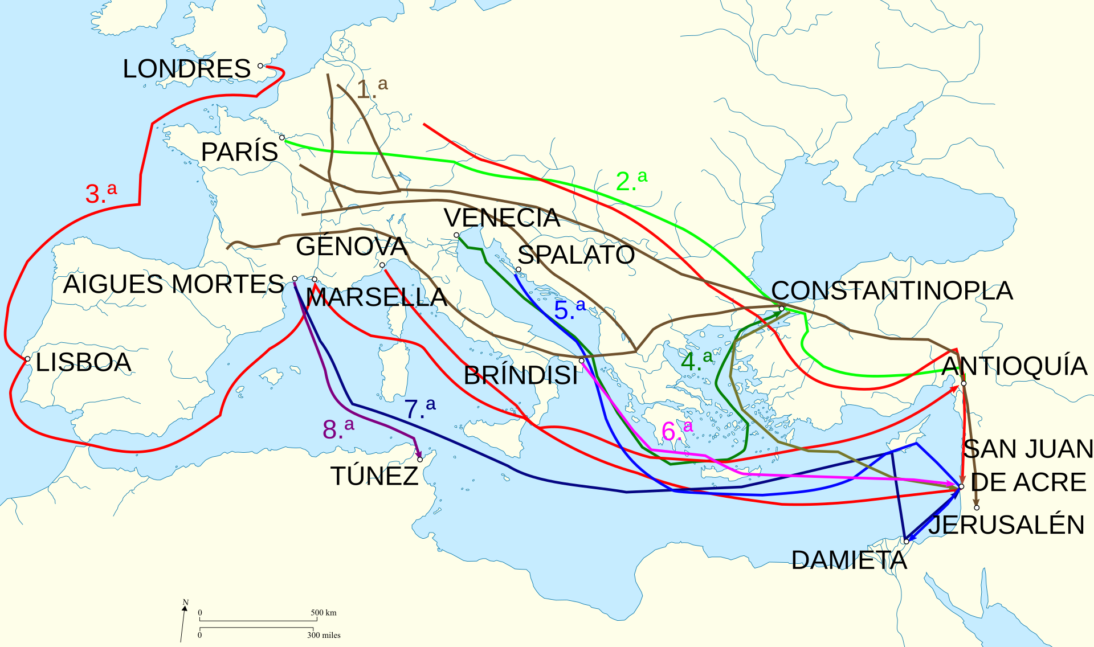
By CRUZADAS.JPG: Continentalis (talk · contribs)Blank map of South Europe and North Africa.svg: historicair (talk · contribs)derivative work: Rowanwindwhistler (talk) work: Rowanwindwhistler (talk) - CRUZADAS.JPGBlank map of South Europe and North Africa.svg, CC BY-SA 3.0, https://commons.wikimedia.org/w/index.php?curid=52026163

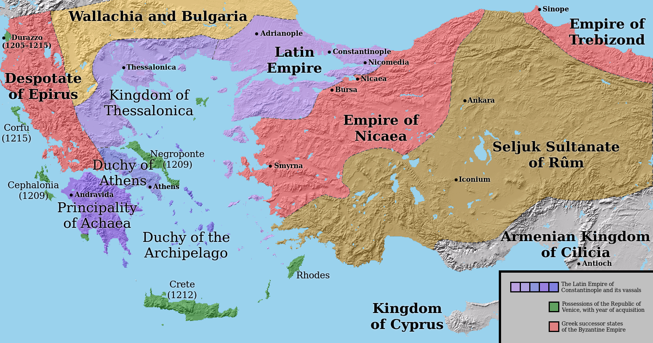
The Latin and Byzantine Empires in 1205
https://upload.wikimedia.org/wikipedia/commons/1/1d/LatinEmpire2.png
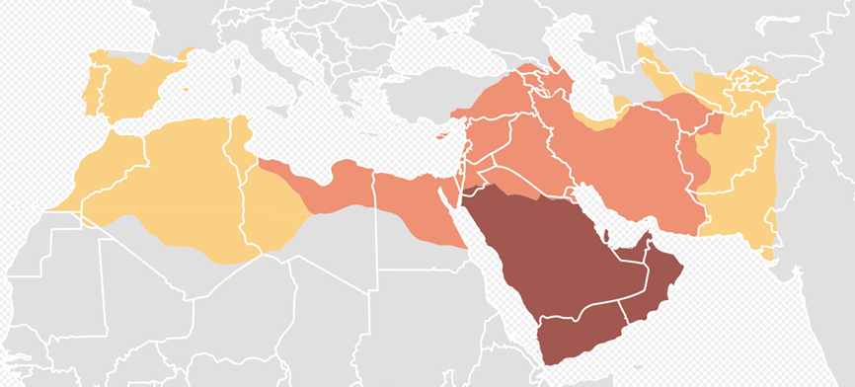

Age of the Caliphs Expansion under the Prophet Muhammad, 622-632 Expansion during the Patriarchal Caliphate, 632-661 Expansion during the Umayyad Caliphate, 661-750
https://upload.wikimedia.org/wikipedia/commons/thumb/7/72/Map_of_expansion_of_Caliphate.svg/1920px-Map_of_expansion_of_Caliphate.svg.png

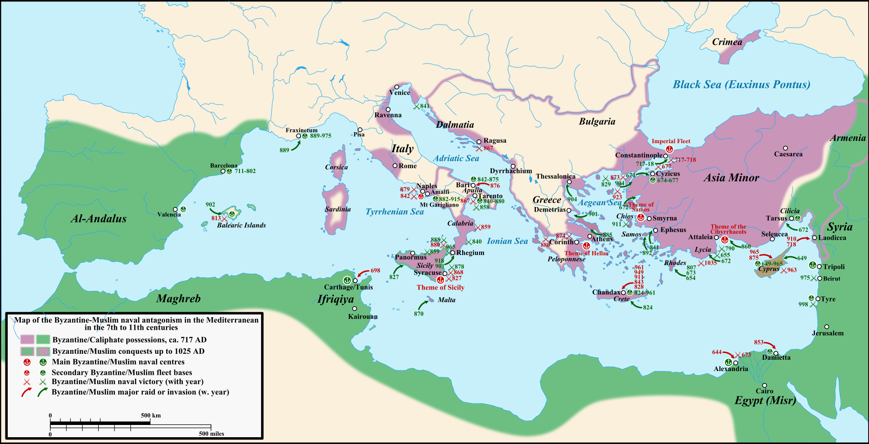
A map of the Byzantine-Arab naval competition in the Mediterranean, 7th to 11th centuries
By Cplakidas - Own work by uploader. Original blank map found here. Main source on the battles: John H. Pryor's Geography, Technology, and War: Studies in the Maritime History of the Mediterranean, 649-1571, p. 104; additional information, as well as 717 and 1025 borders based on atlases and John F. Haldon's Warfare, State and Society in the Byzantine World, 565-1204 and Warren T. Treadgold's A History of the Byzantine State and Society., CC BY-SA 3.0, https://commons.wikimedia.org/w/index.php?curid=5674456

