**Round Top Church Christian Fellowship**

**Sermon**

***Ekklesia Series***

***Witness Spirit of Light From***

***The God of Peace***

**March 10th, In the Year of Our Lord 2019**

**Pastor Matthew Diehl**

**(Unless otherwise noted, NAS text is quoted)**

**(Alert – this is not a politically correct sermon!**

**It is the Truth! If something in this sermon is not true then contact me and let me know.)**

Preaching through the history of the Church requires observations of when the religion known as Islam came into being. To be more accurate, when did the forces of opposing God raise their head in rebellion who became known as Muslims. Islam is not a new religion. It is a recasting of pagan religion(s) from ancient times that centered around human sacrifice and works. The particular pagan religion known as Baal worship in the Bible is continued in Islam. Muhammad is recognized as the founder of Islam who was born in about the year 570 A.D.

**On-line reference. Basic History**

The history of Islam concerns the political, social, economic developments of the Islamic civilization. Despite concerns about the reliability of early sources, most historians believe that Islam originated in Mecca and Medina at the start of the 7th century, approximately 600 years after the founding of Christianity. Muslims, however, believe that it did not start with Muhammad, but that it was the original faith of others whom they regard as prophets, such as Jesus, David, Moses, Abraham, Noah and Adam.

In 610 CE, Muhammad began receiving what Muslims consider to be divine revelations. Muhammad's message won over a handful of followers and was met with increasing opposition from Meccan notables. In 618, after he lost protection with the death of his influential uncle Abu Talib, Muhammad migrated to the city of Yathrib (now known as Medina). With Muhammad's death in 632, disagreement broke out over who would succeed him as leader of the Muslim community.

<https://en.wikipedia.org/wiki/History_of_Islam>

According to tradition, the Islamic prophet Muhammad was born in Mecca around the year 570. His family belonged to the Quraysh. When he was about forty years old, he began receiving what Muslims regard as divine revelations delivered through the angel Gabriel, which would later form the Quran. These inspirations enjoined him to proclaim a strict monotheistic faith, to warn his compatriots of the impending Judgement Day, and to castigate social injustices of his city. Muhammad's message won over a handful of followers and was met with increasing opposition from notables of Mecca. In 618, after he lost protection with the death of his influential uncle Abu Talib, Muhammad migrated to the city of Yathrib (subsequently called Medina) where he was joined by his followers. Later generations would count this event, known as the hijra, as the start of the Islamic era.

In Yathrib, where he was accepted as an arbitrator among the different communities of the city under the terms of the Constitution of Medina, Muhammad began to lay the foundations of the new Islamic society, with the help of new Quranic verses which provided guidance on matters of law and religious observance. The surahs of this period emphasized his place among the long line of Biblical prophets, but also differentiated the message of the Quran from Christianity and Judaism. Armed conflict with Meccans and Jewish tribes of the Yathrib area soon broke out. After a series of military confrontations and political maneuvers, Muhammad was able to secure control of Mecca and allegiance of the Quraysh in 629. In the time remaining until his death in 632, tribal chiefs across the peninsula entered into various agreements with him, some under terms of alliance, others acknowledging his prophethood and agreeing to follow Islamic practices, including paying the alms levy to his government, which consisted of a number of deputies, an army of believers, and a public treasury. A few months before his death, Muhammad delivered a sermon regarding his succession. The final verse of the Quran (Chapter 5, Verse 3) was revealed after Muhammad finished his sermon. After the sermon, Muhammad ordered the Muslims to pledge allegiance to Ali; the future Sunni leaders Abu Bakr, Umar, and Uthman were among those who pledged allegiance to Ali at this event. <https://en.wikipedia.org/wiki/History_of_Islam>

Testimony of a man who chose Christianity after being raised Muslim.

This is the cliff note version of his witness. I encourage all to visit the online sites.

**Ali Fadi,**

Saudi Arabian who gave testimony of his conversion to Christianity

<https://youtu.be/nYQ10rXUu-U> June 20, 2015

<https://www.youtube.com/watch?v=OMn3C8Esm8E> June 9, 2017

Al Fadi, former Wahabbi Muslim from Saudi Arabia and the founder of CIRA International: The Center for Islamic Research and Awareness, is on a mission to introduce Muslims to the Gospel of Jesus Christ.

http://www.cirainternational.com/

Studied in Mecca, Sharri law. Grew-up near Mecca. So, the presence of Islam was heavier there than other places.

Father offered to send him to America for school.

Muslims are brought-up being taught that Western society’s book, The Bible, is corrupt. So, their society is corrupted. Western liberal society is corrupt and immoral because their book, the Bible, is corrupt.

Ali attends University of Arizona.

Thought he would convert Americans to Islam, which he was raised to believe was the final religion. He was raised to believe that there is no hope to gain Paradise unless a person is a Muslim.

Was taught and believed that Muhammad was the last man to receive revelation from God, and he received the last instruction superseding all before him including Jesus.

Others, like Jesus, were sent for a specific purpose in their time.

The Koran is the final word from God. Other sacred books have been corrupted.

Muslims are the only chosen group by God to be in paradise. However, there is no certainty of salvation.

Islam calls for pious actions and words to earn Paradise but no hope, no certainty unless you die for Allah. So, men go to war, not to live, but to die. Ali was going to go to Afghanistan to die for his Islamic faith. His mother talked him out of it.

When 911 happened, he fully understood why the high-jackers did what they did.

Ali studied English but was not familiar with colloquial sayings.

‘What’s up?’ He would look-up. LOL.

The University recommended, “Friends of Internationals.” Their referral happened to be Christians. He met a real genuine Christian family who later came to his graduation and invested in him. He thought he would convert them over eight months or so. They did not convert.

Ali transferred to Arizona State University.

Was somewhat shocked by so-called Christians who did not practice their faith.

Graduated and met other Christians at work. Was going to convert his coworkers to Islam. However, a Christian man was able to refute his Islam conversion efforts. This called him to compare what the actual facts of Christianity are to what he had been told about Christianity during his childhood and teen years.

He accepted an invitation to go to church. He wanted to go to learn what he could use against Christians who witnessed to him. However, the Pastor’s message was tailored to Him. He said the Holy Spirit was talking to him. They were in the book of John. He became saved. One of the penetrating questions was - Why did you reject my Son? He did not have answer.

He knew that the devastation of the 911 act was committed by men who acted in an effort to secure their place in heaven. So, they killed others. This was not a peaceful act. Others had to die for the high-jackers to go the heaven. He saw what he could have done years earlier. He saw the God of Islam was a God of peace, but 911 happened so that a few could go to heaven; thousands die so that a few got their ticket to heaven. A contradiction. Ali had been raised that the god of Islam is a god of peace, because Islam is a religion of peace. This was a dilemma for him.

He attended a church service after 911 and heard from the book of Matthew, Jesus’ Sermon on the Mount that we are to love your enemy. Pray for those that persecute you. Ali believed Islam was a religion of peace, but 911 contradicted that teaching. He saw that over 600 years before Mohammad Jesus says to love your enemies.

Why would the god of Islam allow 911 if he is a god of peace and Islam is a religion of peace? He asked himself, if the God of the Bible is the god of the Koran then something happened to this god in 600 years. Did the God of the Bible change His mind, and now this same god speaking through his messenger, Muhammed, taught Muslims to hate their enemy and kill them?

On November 2001, he admitted he was a sinner in need of a Savior. His family disowned him. He knew other Muslims would be after him to kill him too as a mercy killing. December 2007, he shared testimony with Saudi woman who accepted Christ. The woman was killed by her family nine months later.

Ali witnesses on a radio show that airs to Muslim countries where millions hear his witness. He wrote a book called “Koran Dilemma.” He also aired a T.V. show “Islam Dilemma.”

Ali calls for Christians to love Muslims. He witnesses that it was the genuine love exhibited to him from the Christian family and the coworker that attained his attention. He knows that fear plays a big role in witnessing to Muslims. He observes what the Apostle Paul tells the believers in Corinth (1 Cor 2:1) that understanding the fear is part of our condition, as Paul admitted.

1 Corinthians 2:1-5 1 And when I came to you, brethren, I did not come with superiority of speech or of wisdom, proclaiming to you the testimony of God. 2 For I determined to know nothing among you except Jesus Christ, and Him crucified. 3 I was with you in weakness and in fear and in much trembling, 4 and my message and my preaching were not in persuasive words of wisdom, but in demonstration of the Spirit and of power, 5 so that your faith would not rest on the wisdom of men, but on the power of God. (NAU)

Ali calls for Christians to testify why Jesus is our Lord.

He quotes Matthew 5:14-16. . . the Lord expects all of us to be The Light of the world.

Remembers the first two families who shared the Light of Jesus to him. This was a testimony to him that God calls for Christians to be ready all the time as Paul charged Timothy, in season and out of season.

In addition, he notes that Paul, after persecution (stoning) goes to Thessalonica and shares the Gospel as part of their very lives. 2:8 “share our very lives to you….” 8 Having so fond an affection for you, we were well-pleased to impart to you not only the gospel of God but also our own lives, because you had become very dear to us. (1 Thess. 2:8 NAU)

Ali calls for all believers to pray for groups of people, pray for Muslims, Mormons, atheists. Have compassion for them to know the Lord. Evangelism starts with the right heart for Jesus.

He found the family from 23 years earlier to let them know how many millions have heard the Gospel through him. Because they made a decision to share the Light of Jesus. He found them still praying for him.

Today, he asks Muslims to examine why the god of whom Muhammad speaks is a “god of peace” but calls death and destruction around the world, and, if Islam is supposed to be a “religion of peace” then why all of the fighting? He calls them to go to the WWW and research Islam at a more in-depth level. Make a comparison.

Al Fadi, former Wahabbi Muslim from Saudi Arabia and the founder of CIRA International: The Center for Islamic Research and Awareness, is on a mission to introduce Muslims to the Gospel of Jesus Christ.

<http://www.cirainternational.com/>

**Round Top Church Christian Fellowship**

**Sermon**

***Ekklesia Series***

***Witness to Islam***

**March 10th, In the Year of Our Lord 2019**

**Pastor Matthew Diehl**

**(Unless otherwise noted, CSB17 text is quoted)**

**(Alert – this is not a politically correct sermon!)**

**The P.C. authorities call the Truth hate speech.**

**I know this got Jesus in a lot of trouble.**

**Jesus Identified the pseudo religious for what they were, fakes.**

**Read Matthew 23:12ff as an example.**

**It is for the Love of God and Man we speak.**

These are sermon notes for March 10, 2019. They also were presented on June 26, 2016 and of May 22, 2016. In May and June of 2016 I was preaching through the book of Hebrews. We covered Hebrews 11 witnessing the faithful in the Old Testament that were justified by faith. The June 26 sermon title was “Faithful Jesus.” May 22 was “God’s Victory in the World ~ Faithful Barak.” Throughout the Old Testament God warns His covenant people not to mingle with the pagan societies around them. Not to enter into marriages and not to practice their pagan religion. Why? These satanic cults practice human/child sacrifice. They were/are a works-dominated culture. These notes detail the pagan religions of the Old Testament that are present in our world today. These are obviously of Satanic origin. There are two spiritual powers in the world in a battle for the eternal souls of people. God and Satan. Satan loves for people to mis-assign his presence to something else that is considered good. However, the end result is the same. Death and destruction of life and living.

What is presented here is historical fact. You can research for yourself. There are people in the world that refuse to accept reality. God presents reality all the time. Satan desires to fool people. Here are some of the biggest lies in the world.

1. You cannot judge others.
2. All people are equal in their religious lives.
3. Religion is all good for those that practice with a pure heart.
4. There needs to be toleration for the tribes of the world to practice their pagan ways. It is not fair, and intolerant to label them wrong or evil.
5. Anyone’s god is equal to the God of the Bible if it works for them.
6. Evil is only realitive to a culturual setting.
7. Good is assigned by culture and tradition of man not by God.

These notes are presented in a reference formate. This is not a typical sermon outline. It is designed to present basic historical facts that you can lookup and confirm. This is not a quick read. You have to invest time to know the truth. We do not to be lazy. The lives of our children’s, grandchildren’s and peolple for generations to come depend on your commitment to the turth.

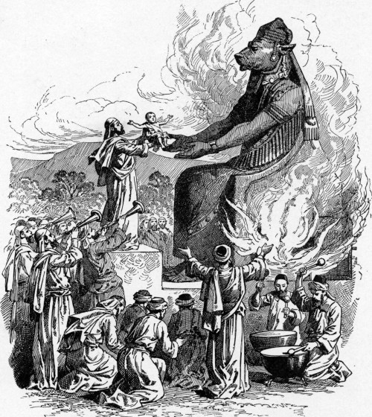

**https://deusnexus.wordpress.com/2016/04/12/canceled-temple-baal/**

**The Cult of Baal Never Died**

Baal (also known as Moloch/Enlil) is an ancient god that was worshiped by civilizations around the Levant; what is now known as the Middle East.

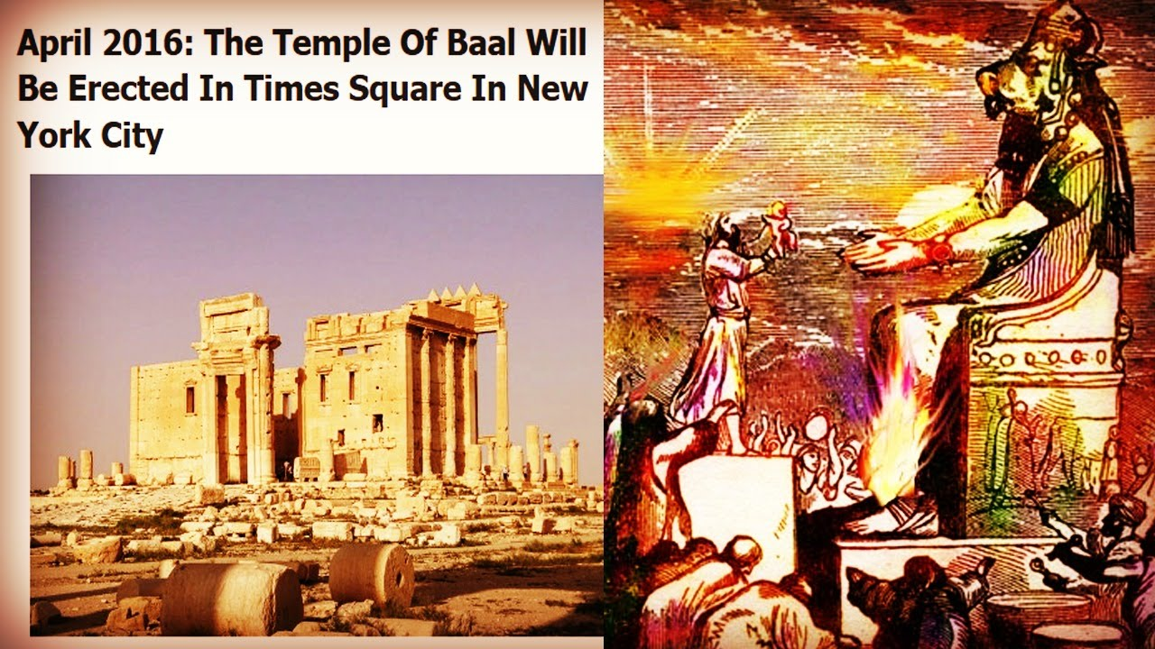

**Baal was the name of the supreme god worshiped in ancient Canaan and Phoenicia. The practice of Baal worship infiltrated Jewish religious life during the time of the Judges (Judges 3:7), became widespread in Israel during the reign of Ahab (1 Kings 16:31-33) and also affected Judah (2 Chronicles 28:1-2). The word baal means “lord”; the plural is baalim. In general, Baal was a fertility god who was believed to enable the earth to produce crops and people to produce children.  
-gotquestions.org, Who Was Baal?**

The cult of Baal was particularly brutal as it involved human sacrifices – especially newborn babies.

**Baal worship was rooted in sensuality and involved ritualistic prostitution in the temples. At times, appeasing Baal required human sacrifice, usually the firstborn of the one making the sacrifice (Jeremiah 19:5). The priests of Baal appealed to their god in rites of wild abandon which included loud, ecstatic cries and self-inflicted injury (1 Kings 18:28).  
-Ibid.**

**“And they built the high places of Baal that are in the valley of Ben-Hinnom, to cause their sons and their daughters to pass through the fire to Molech” (Jeremiah 32:35).**

**“They have built also the high places of Baal, to burn their sons as offering to Baal” (Jeremiah 19:5).**

Today’s occult elite still observes these rites, but with one major difference: They are now carried out on unsuspecting civilians and spread across the world through mass media. Fed and amplified by the fear and trauma of the masses, these mega-rituals are seen by all, but only celebrated by the occult elite. More than ever, we are dealing with Black Magick.

**April 19th – Blood Sacrifice to the Beast**

Three years ago, I published an article entitled  where I explained how the second half of April was a particularly “magickal” and violent period which culminated on May 1st – Mayday. The occult date of April 19th was specifically mentioned.

**“April 19 – May 1 – Blood Sacrifice To The Beast, a most critical 13-day period. Fire sacrifice is required on April 19. April 19 is the first day of the 13-day Satanic ritual day relating to fire – the fire god, Baal, or Molech/Nimrod (the Sun God), also known as the Roman god, Saturn (Satan/Devil). This day is a major human sacrifice day, demanding fire sacrifice with an emphasis on children. This day is one of the most important human sacrifice days, and as such, has had some very important historic events occur on this day.”  
– Occult Holidays and Sabbaths,**[**Cutting Edge**](http://www.bibliotecapleyades.net/cienciareal/cienciareal20.htm)

Here’s a short list of awful events that occurred during the second half of April.

April 19 the first battle of American Revolution… At about 5 a.m., 700 British troops, on a mission to capture Patriot leaders and seize a Patriot arsenal, march into Lexington to find 77 armed minutemen under Captain John Parker waiting for them on the town’s common green. British Major John Pitcairn ordered the outnumbered Patriots to disperse, and after a moment’s hesitation the Americans began to drift off the green. Suddenly, the “shot heard around the world” was fired from an undetermined gun, and a cloud of musket smoke soon covered the green. When the brief Battle of Lexington ended, eight Americans lay dead or dying and 10 others were wounded. Only one British soldier was injured, but the American Revolution had begun.

On April 19, 1861, the first blood of the American Civil War is shed when a secessionist mob in Baltimore attacks Massachusetts troops bound for Washington, D.C. Four soldiers and 12 rioters were killed.

* April 19, 1993 – Waco Massacre: An FBI assault lead to the burning down of the compound of a sect named Branch Davidians, killing 76 men, women and children.
* April 19, 1995 – Oklahoma City bombing – 168 people killed.
* April 20, 1999 – Columbine High School Massacre – 13 people murdered, 21 injured.
* April 16, 2007 – Virginia Tech Massacre – 32 killed; 17 injured.
* April 16, 2013 – Boston Marathon Explosions – 3 killed; 107 injured.

Knowing these facts, is it a coincidence that a replica of the Temple of Baal will be erected on April 19th? The occult elite is all about symbolism and numerology. Nothing is coincidence.

**The Occult Elite Celebrates**

On April 19th, replicas of the entrance to the Temple of Baal will be unveiled in the two most “powerful” and visited squares in the world today: Times Square and Trafalgar Square. This week-long celebration of Baal will take place during his own “holiday”, one that is often celebrated with death. In this bold move, the occult elite is showing its true face and symbolically invites the world to enter the gateway into its dark occult world.

So, no, this is not about “architecture” and defying ISIS. Several ancient, priceless ruins were destroyed by various Islamic groups in the past years. Only Baal will stand tall in New York and London.

**Replicas of the Temple of Baal to Be Unveiled in New York and London on an Important Occult Date**

***On April 19th 2016, which happens to be the occult day of “Blood Sacrifice to Baal”, replicas of the Temple of Baal will be unveiled in New York and London***

On April 19th 2016, which happens to be the occult day of “Blood Sacrifice to Baal”, replicas of the Temple of Baal will be unveiled in New York and London.

***Update: Reports claim that the New York event has been cancelled and that London will instead be erecting the Arch of Triumph of Palmyra. Still awaiting official confirmation.***

Reproductions of the 50-foot arch that formed the entrance of the Temple of Baal in Palmyra Syria will be installed in Times Squares, New York and Trafalgar Square, London on April 19th. The ruins of the original structure were destroyed by ISIS last year.

The Temple of Baal in Palmyra (before destruction).

**“The temple has been systematically razed, with the 50-foot-tall arch among the few remaining elements of the building still standing. The temple, dedicated in 32 A.D. to the Mesopotamian god Bel, attracted 150,000 tourists per year until 2011, when the civil war in Syria began.**[**The full-scale replicas**](http://www.theguardian.com/world/2015/dec/28/palmyra-temple-bel-arch-survived-isis-syria-london-new-york?CMP=twt_b-gdnnews)**, now under construction in China, will stand in London’s Trafalgar Square and New York’s Times Square during World Heritage Week in April 2016.**

**The project comes after researchers from the Institute for Digital Archeology — an effort by Harvard University, Oxford University in Britain and Dubai’s Museum of the Future — embarked on a “Million Image Project” to obtain**[**3D photographic data**](http://www.telegraph.co.uk/news/worldnews/middleeast/syria/12071316/Replica-of-historic-Syrian-arch-attacked-by-Isis-to-be-recreated-in-Trafalgar-Square.html)**to reconstruct the arch digitally. The full-scale models are being recreated with the world’s largest 3D printer, and made of stone powder and lightweight composite materials. The structures will be temporary.**

**They are meant to show defiance of IS attempts to erase the Middle East’s pre-Islamic history and to demonstrate how new technology can be used in archeology.”  
– UPI, Palmyra, Syria, arch threatened by Islamic State to be recreated in London, NYC**

Despite courageous claims of “defiance” versus ISIS and [near-sob-stories](http://www.nytimes.com/2016/03/20/opinion/sunday/life-among-the-ruins.html?_r=4) about the emotional meaning of the temple for locals printed in mass media, there is much more at stake here. ISIS also destroyed the ancient cities of Nimud and Hatra in Iraq, the Shagraf shrine and the St. Elian monastery in Homs – but it is the Temple of Baal that is being honored, in the two most significant “power points” of the world today. Why? Because Baal is an important figure in the occult elite’s mythology. And he is celebrated on one specific, violent day.

**The temple of Baal-Berith at Shechem**

Posted on [March 9, 2010](https://ferrelljenkins.wordpress.com/2010/03/09/the-temple-of-baal-berith-at-shechem/) | [1 Comment](https://ferrelljenkins.wordpress.com/2010/03/09/the-temple-of-baal-berith-at-shechem/#comments)

The book of Judges describes the situation at Shechem after the death of Gideon.

*After Gideon died, the Israelites again prostituted themselves to the Baals. They made Baal-Berith their god. (Judges 8:33 NET)*

Abimelech, the son of Gideon was such a desperate politician that he took money from the Shechemites from the temple of Baal-Berith (Judges 9:4). Dr. Bryant Wood describes the temple of Baal-Berith.

*References to the “house of Baal-berith” (v. 4), “Beth-millo” (v. 6,20), “house of their god” (v. 27), “tower of Shechem” (vv. 46,47,49), and “temple of El-berith” (v. 46), all appear to be the same structure at Shechem. Berit is the Hebrew word for covenant, so the temple was for “Baal of the covenant.”*

*A large fortress (or Migdal) temple discovered on the acropolis of Shechem has been identified as the temple of Judges 9. It was  constructed in the seventeenth century B.C. and lasted until the destruction of the city by Abimelech in the twelfth century B.C. The largest temple yet found in Canaan, it measures 21.2 x 26.3 m, and has foundations 5.1 m thick that supported a multistoried superstructure of mud bricks and timber. On the east, two towers containing stairwells to the upper stories flanked the entrance. Inside, two rows of columns, three in each row, divided the space into a nave and two side aisles (cf. vv. 46-49)” (Bryant Wood. “From Ramesses to Shiloh.”Giving the Sense. Kregel, 2003).*

The photo shows the foundation of the Temple of Baal-Berith at Shechem. This structure was brought to light in the

https://ferrelljenkins.wordpress.com/2010/03/09/the-temple-of-baal-berith-at-shechem/

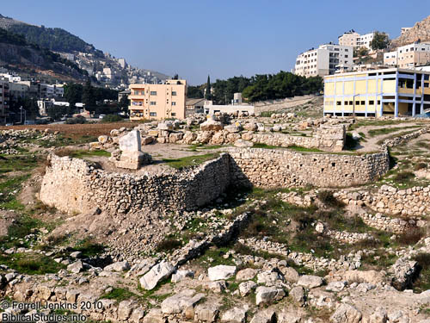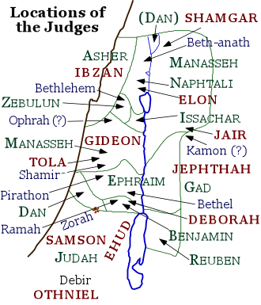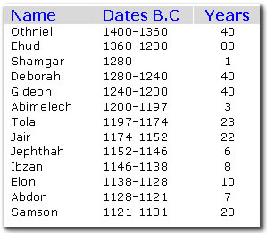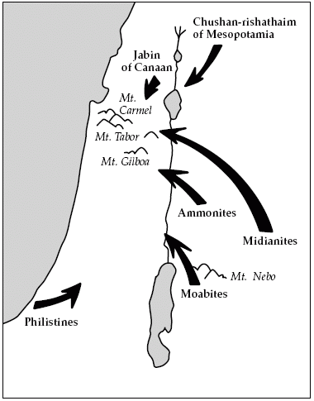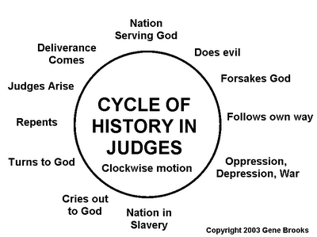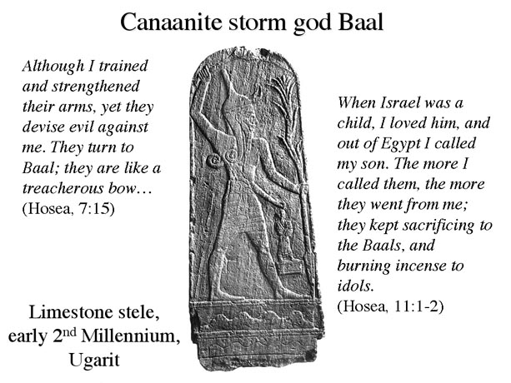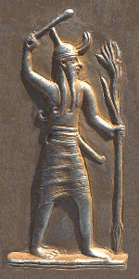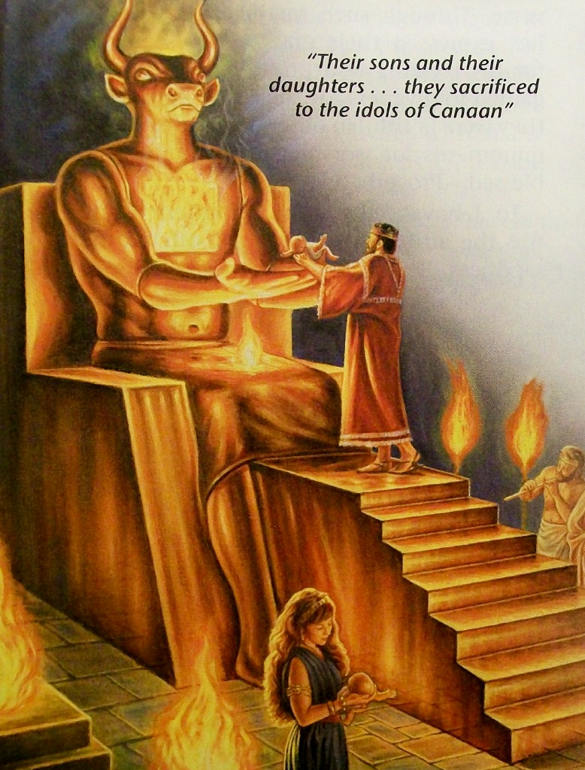

34 They did not destroy the peoples as the LORD had commanded them

35 but mingled with the nations and adopted their ways.

36 They served their idols, which became a snare to them.

37 They sacrificed their sons and daughters to demons.

38 They shed innocent blood-- the blood of their sons and daughters whom they sacrificed to the idols of Canaan; so the land became polluted with blood. (Psalm 106:34-38 CSB)

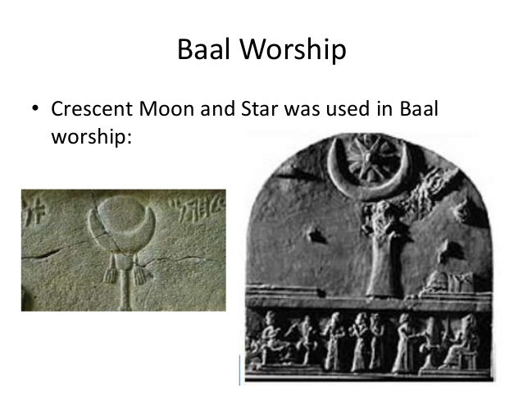

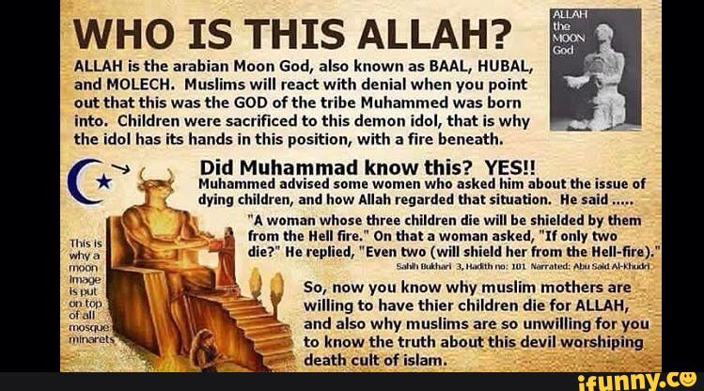

Ṣaḥīḥ al-Bukhārī (Arabic: صحيح البخاري‎), also known as Bukhari Sharif (Arabic: بخاري شريف‎), is one of the Kutub al-Sittah (six major hadith collections) of Sunni Islam. These prophetic traditions, or hadith, were collected by the Muslim scholar Muhammad al-Bukhari, after being transmitted orally for generations. It was completed around 846 AD / 232 AH. Sunni Muslims view this as one of the two most trusted collections of hadith along with Sahih Muslim. [1][2] The Arabic word sahih translates as authentic or correct.[3] Sahih al-Bukhari, together with Sahih Muslim is known as Sahihayn.

https://en.wikipedia.org/wiki/Sahih_al-Bukhari

Sahih al-Bukhari Book 3 Hadith 101

[Some women requested the Prophet to fix a day for them as the men were taking all his time. On that he promised them one day for religious lessons and commandments. Once during such a lesson, the Prophet said, "A woman whose three children die will be shielded by them from the Hell fire." On that a woman asked, "If only two die?" He replied, "Even two (will shield her from the Hell-fire)."]

(Psalm 106:34-38 CSB)

34 They did not destroy the peoples as the LORD had commanded them

35 but mingled with the nations and adopted their ways.

36 They served their idols, which became a snare to them.

37 They sacrificed their sons and daughters to demons.

38 They shed innocent blood-- the blood of their sons and daughters whom they sacrificed to the idols of Canaan; so the land became polluted with blood.

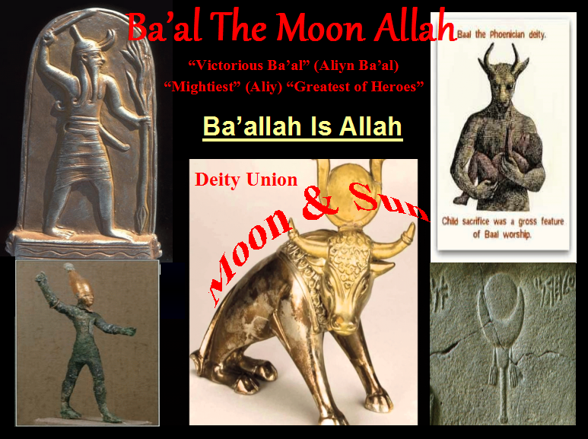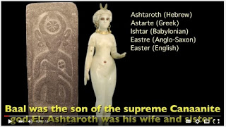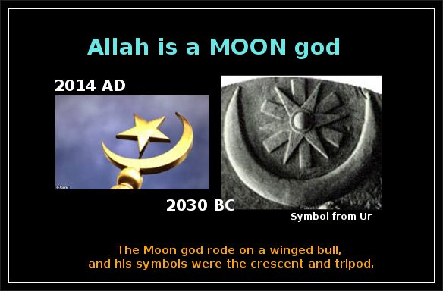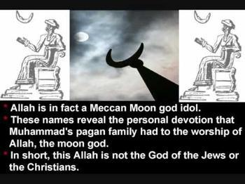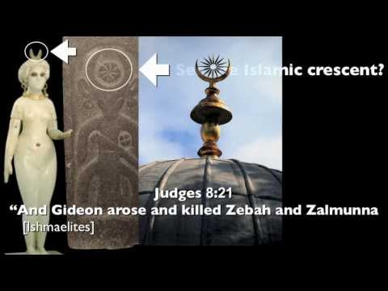

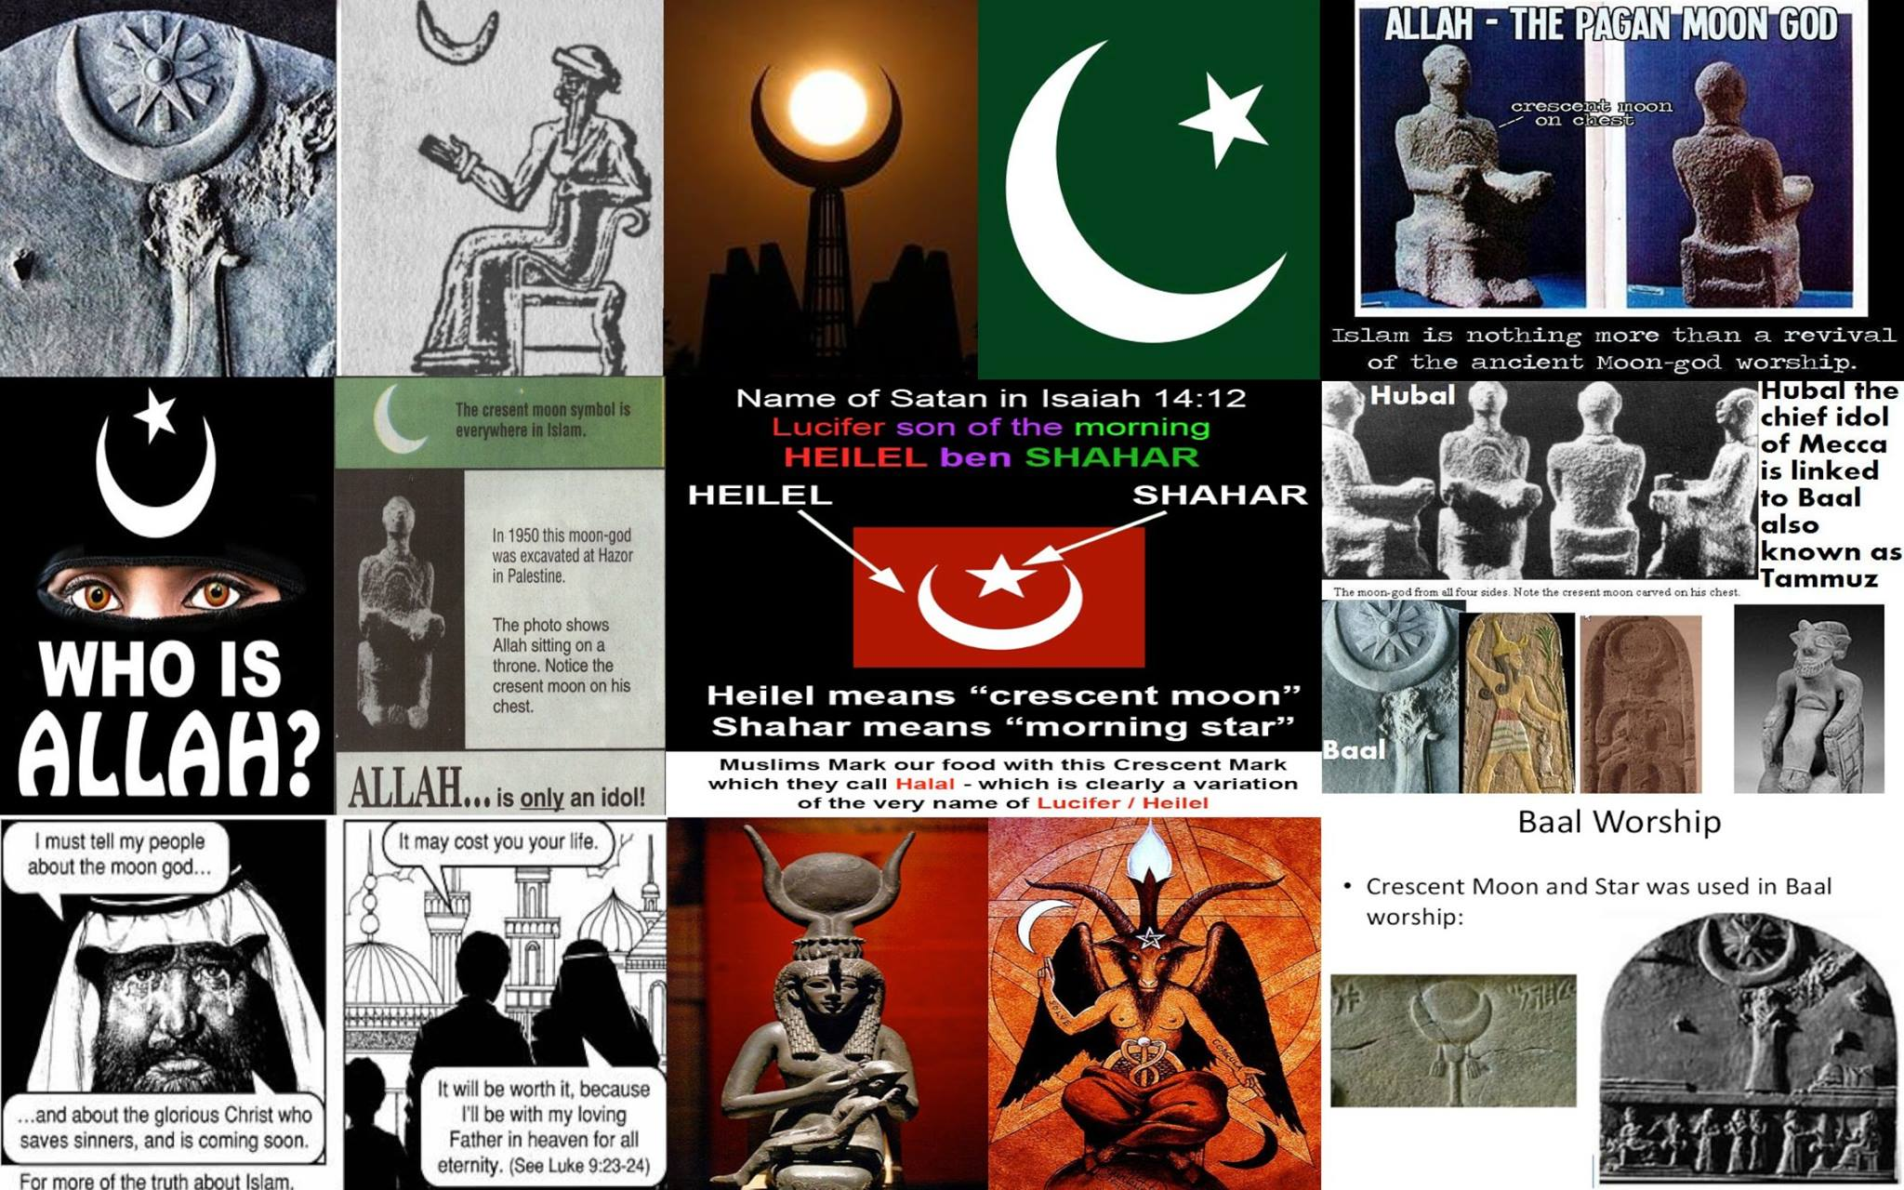

11 Your splendor has been brought down to Sheol, along with the music of your harps. Maggots are spread out under you, and worms cover you."

12 Shining morning star, how you have fallen from the heavens! You destroyer of nations, you have been cut down to the ground.

13 You said to yourself: "I will ascend to the heavens; I will set up my throne above the stars of God. I will sit on the mount of the gods' assembly, in the remotest parts of the North. (Isaiah 14:11-13 CSB)

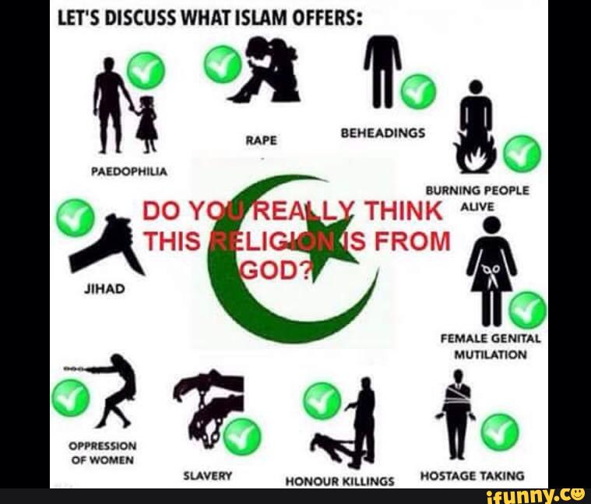

CSB **John 16:1** "I have told you these things to keep you from stumbling.

2 They will ban you from the synagogues. In fact, a time is coming when anyone who kills you will think he is offering service to God. (John 16:1-2 CSB)

