Round Top Church Christian Fellowship
Sermon
The Good News According to Mark,
An Apostle of Jesus Christ
365 Day Disciple
God’s Purpose for The Church
Pastor ~ Matthew Diehl
November 4th In the Year of Our Lord 2018
(Unless otherwise noted, ESV text is quoted)

What defines the Church and those in the Church, the Congregation, the called-out ones, Assembly of Believers, Greek: Ekklesia, Fellowship, Community of Faith, members of the Way?
Over the centuries, the word in English “church” used in translating the Greek “Ekklesia” transferred the visual from a group of people to a building, a place of meeting. To a large degree, this shift took the focus off the individual as the body of Believers that constituted a congregation to the idea that a building (complete with officials) was somewhat necessary to have a real Christian presence. To a public viewing from the outside, the components that make the flesh and bones, hearts and minds shifted to stone, brick, wood and officials.
Then, as the centuries passed, there became the on-going process of joining the masses of Believers to the state; there came state-sanctioned officials in the buildings that were to hold the masses together with spiritual teachings codified at Church Councils (example being at Nicaea in 325A.D.). The Roman Emperor Constantine called a Christian Bishop to Nicaea to settle theological issues. The product of the council to this day is monumental. The high points being that Christ is of the same essence of God the Father and that Christ was not created. This is a Biblical truth that can be ascertained from reading the Bible. Another key point is that there is one apostolic “universal” (Latin – Catholic) Church. Note: the council did not say, “Roman Catholic”. The fallout is that all Bishops who did not sign the Nicaea statement were banished and not recognized by the state as legitimate Bishops.
This is important because the view was that without a legitimate Bishop to officiate over the Lord’s Supper, water-baptism and receive confession, there could be no forgiveness of sin, no salvation. Therefore, there was eternal pressure placed on the general population to have a state-approved Bishop or their eternal destination was at stake. They could burn in Hell forever. With the emergence of the state-church, there was a shift from a personal relationship to God to a relationship that went through the state-church and its officers. A person had to keep these state-clergy officials satisfied. Thus, salvation shifted to being controlled by the state-church. Therefore, faith alone was believed insufficient to save. A person must have the state-church’s blessings through their officers.
During times of persecution in 250 A.D., the Bishop of Carthage (Cyprian) was focused on holding Believers together under the leadership of devout leaders. Cyprian may have been well-intended but when he promoted the statement that “where the Bishop is, there is the Church, and there is no Church where there is no Bishop”, he shifted the understanding of the Believers-Church to the Bishop-Church. This meant that the individuals as a body were no longer the Church, but the Church started with and was constituted on the office of one man. All questions of faith and practices of faith went through the Bishop. So, when Constantine came, the Bishop structure was already in place.
Bringing these events to our present day; people seeking salvation and peace with God are often confused in seeking the right church to attend. “Which one has the right path to God?” ‘Which church has the leaders who have been chosen by God?” The focus has been placed on the institution, its structures and teaching and away from a personal surrender to God outside the agency of a denominational group.
Head of State is God Sovereign
Starting with Constantine, the idea grew that the King or Emperor had to be coronated, approved, ordained, set aside by God and became the norm. The head of state then became linked to God as His chosen and sovereign leader and all under the ruler’s realm had to obey. If you disobeyed to the head of state then you where disobeying God. This world-view brought the state-righteous laws of heresy to bear on the masses. Break the religious laws (charges brought by the church) and the state would punish the violator. Thus, the two (state and church), were linked in a governance power for over one thousand years. This is also called the Dark Ages. Not until the Reformation was in full swing did this system start to break.
We still see a semblance of this system in the modern state. When the head of a state is sworn-in, the Bible is often present for the office holder to place their hand and take the oath of office. Today, this is not received as a compulsory action by the person taking the oath (or that the Dark Age policy of the Inquisition is to be implemented), but that the person taking the oath is publicly stating, with their hand on the Bible, that they recognize God and His Word is present and should be considered as a guiding Light to their rule. That there is a higher power than theirs. No doubt it is difficult to define what each office holder is thinking when they take their oath of office. However, to the on-looking public, there is a recognition of God and His Word. This, in balance, is a good thing.
So, the Church is present in public life, in government and in private life. The Church, as we know it, has a presence everywhere throughout Western history.
Vacationing in the American West
As many of you know, Renee and I just took a road trip, a vacation, across Texas to New Mexico and Colorado. In every town we went through, there was a local church building. There were some settlements we went through that we did not see a church building. Then we saw church buildings not in a town; they just stood alone on the side of the highway where we presumed the local community attended. As we went through a few museums, the Church was part of the history of the area. True, the history of these museums by-in-large chronicled the history of the state-church, as the church was in partnership with Spanish and Mexican governments in the age of exploration. This history of the area we traveled started in the 1500’s. The sad history told the tell that the Church relied upon the allegiance-partnership with the state to evangelize the indigenous people who rebelled, and the state relied upon the Church to legitimize its presence and conquest of foreign lands for God. Therefore, there has been a constant war whereby the indigenous people (American Indians) have struggled to keep their culture and way of life.
“Give the natives to understand that there is a God in heaven and the emperor on the earth to command and govern it, to whom all have to be subjected and to serve.” Viceroy Antonio De Mendoza, Mexico City 1538 [New Mexico Museum -Santé Fe, NM]
The painting below “We Come In Peace.” Note the churchmen in front of the column of soldiers.
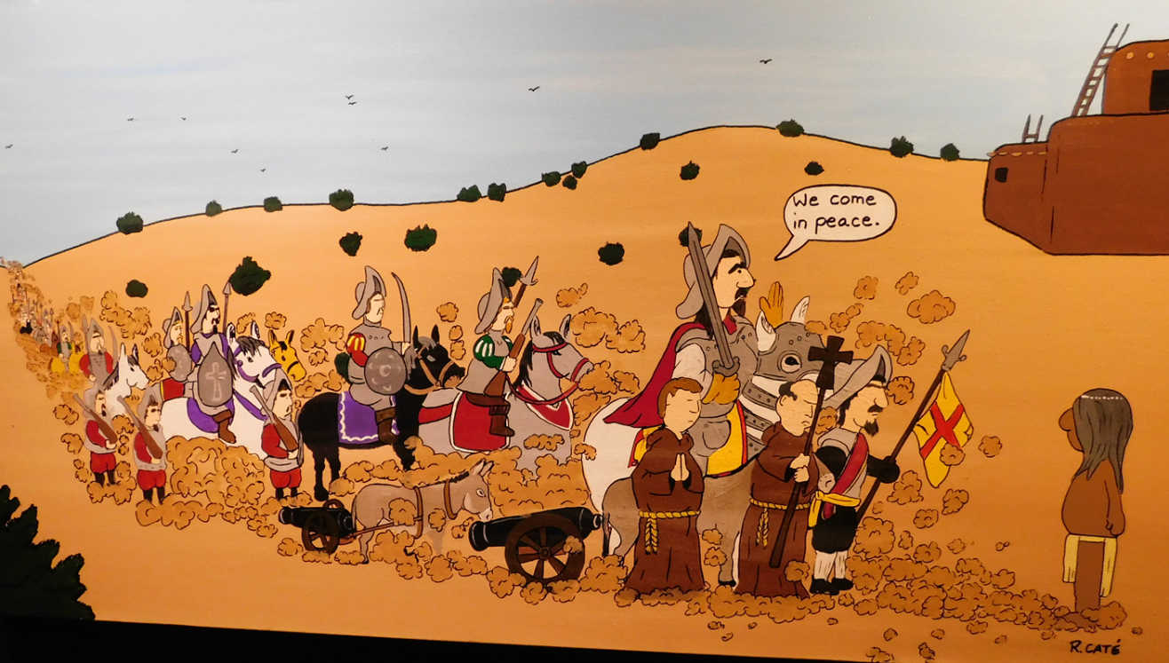
Indian Pueblo Cultural Center: Albuquerque N.M.
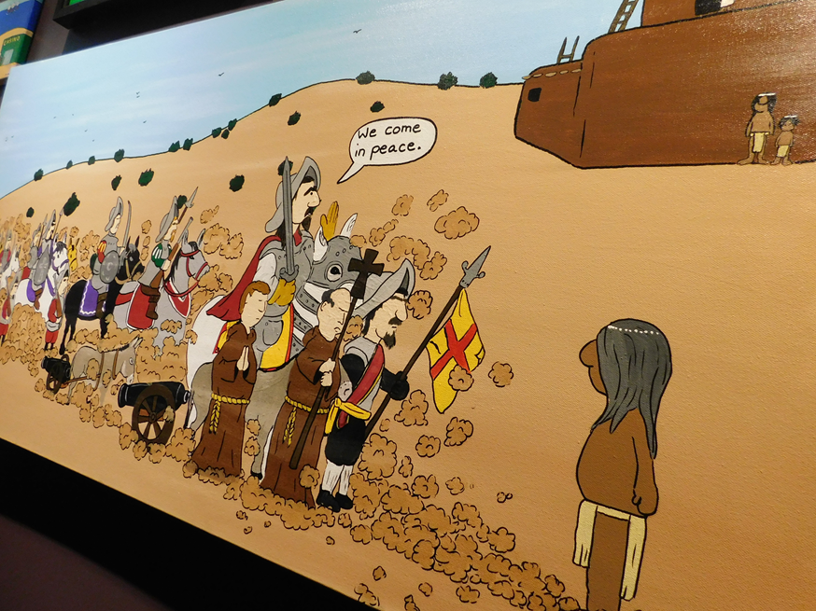
No doubt some over the centuries have willfully converted to Christianity. The historical record often reveals the forced-by-death to convert to the European or western way of life which included Christianity. The governments worked through the Church to remove the Indian culture and belief system. When this policy failed and the Indians rebelled and there was bloodshed. In American history people need to read the history of Sitting Bull, Crazy Horse and Geronimo. The History of the Indians wars under President Grant is most revealing. Wounded Knee (December 29, 1890) sums up American Indian policy at the time. This is an embarrassment in American history. The Spanish and Mexican and American governments all used the same approach. This is a sad and conflicting history for the United States. Jesus didn’t wield any power from the state to evangelize. God incarnated himself into a Roman-ruled world that found Him not guilty of breaking their laws. It was the religious Jewish leaders that pushed for Jesus’ crucifixion.
The Real Conquest
The real conquest taught by Jesus is in the hearts and minds of people and not in the government military overthrow of a people.
Let us review what a Believer is.
Remember, Believers have surrendered to God’s Holy Spirit conviction and, therefore, became eligible to receive the Holy Spirit and His gifts (Acts 2:35ff). We are the People of God. God works through us in seeking the redemption of the fallen world. The Church, the People of God, is purposed by God to redeem this fallen world. This is the main goal of the Church. Jesus never taught that Believers needed a secular government. However, Jesus demonstrated that there needs to be a freedom of speech as was in the Roman world in Jesus’ life-time. The Romans tolerated Jesus’ teachings. They were allowed. It is true that Christians were eventually persecuted (tortured and killed) by different Roman rulers for not pledging allegiance to the Emperor as god. These times came and went. We all know that Christians and others are persecuted, in our lifetime, in many Muslim countries.
In this eternal-redemptive drive of God working through the Believer’s Church, there is practiced worship, prayer, Bible study, confession, witness, song and proclamation of God’s Word. We do all of these representing God’s will for people. These works of God in the Believer’s Church are not religious as many say. These are God at work in the lives of people. We have often said that religion is man’s attempt to be God or create a path to God. The Believers who make the Church do not have to create a god or a path to God. We are not building a tower to Babel. God is building His character in us in a process we can call sanctification.
The Church “First Century”
Luke-Acts is one letter that we receive in two parts; hence, the two names, and the book of John divides the letter. Luke 1:3 and Acts 1:1 both site Theophilus as the person who physically writes the letter. Acts is a continuation of Luke. The transition between the two is the Ascension of Jesus and His instruction to wait for the Holy Spirit in Jerusalem, but this waiting was not to receive the Holy Spirit for the first time; it was to receive a special empowerment.
Many have positioned the beginning of the Church as we know it with the events of the Holy Spirit chronicled in Acts 1 and 2 (Pentecost). True enough that the witness of the Apostles and other disciples of Jesus garnered additional gifts and powers from the day of Pentecost and from that experience went forth and witnessed to the world the account of Jesus’ life and the Resurrection. In these is the compelling spiritual power behind the Resurrection and Ascension that drove the Apostles and disciples of Jesus to witness in His name in the face of state and religious opposition.
This compelling Spirit-power is not just an external force but an external force that indwells a person in spiritual marriage, a spiritual bonding within the individual that drives them to their eternal works. So, the marriage of a person to God is sealed by His Holy Spirit (Ephesians 1:13; 4:30) and is the bind that is eternal. This marriage analogy is used by Jesus in Ephesians 5. This is in contrast to New Age philosophy that teaches there is a power already deep within you that you must access/utilize. New Age teaches that man already possesses the power to save himself or elevate himself. This is in contrast to the teachings of God. Man is totally depraved and cannot save himself (Romans 3:10ff). Mankind doesn’t possess any power to save himself.
Ephesians 5:25-28 CSB17

²⁵ Husbands, love your wives, just as Christ loved the church and gave himself for her ²⁶ to make her holy, cleansing her with the washing of water by the word. ²⁷ He did this to present the church to himself in splendor, without spot or wrinkle or anything like that, but holy and blameless. ²⁸ In the same way, husbands are to love their wives as their own bodies. He who loves his wife loves himself.

Jesus binds His mission to the Church as one in marriage. God intends marriage to be sustained. Christ never abandoned the Church. Instead, He died to make payment for the sins of the Church, to sustain the Church through this temporal time. In this transition, Jesus breathes His presence into the Disciples (John 20:22). Jesus is no longer going to physically be with the disciples so He breathes His Spirit into them (John 20:19-22). This is the one and only time the living God breathes His Spirit into people to demonstrate that He can live inside of people as Spirit. This is what happens in Acts 2 when the people surrender to Peter’s message. They are saved. Jesus empowered His disciples to do the work He would do if He was physically present.

The Mission of Jesus Sustained through the Believer’s Church.
The Gospels teach that Jesus died for the sins of the Believers who compose the Church in order to protect and sustain the eternal relationship between God the Father and the Church, the people of God.
Why do I use the term “Believer’s Church?” Because we live in an age where the word “Church” is ambiguous. “Church” could mean anything.
The Believer’s Church Grows - Therefore, the spiritual picture of the events of Acts 1 and 2 demonstrate God working in people. God makes it possible for fallen people to become Believers in a fallen world that elevates them to witness and sustain life as God has planned and sets Believers on a course to eternal life. God sent Peter, and God opened the Gospel to them. God loves and makes the first move toward fallen man. Man only has to surrender to God’s outreach.
²¹ Jesus said to them again, "Peace to you. As the Father has sent me, I also send you."
²² After saying this, he breathed on them and said, "Receive the Holy Spirit.
²³ If you forgive the sins of any, they are forgiven them; if you retain the sins of any, they are retained."
(Jn. 20:21-23 CSB17)

Commissioning the Church to tell people they can be forgiven.

¹⁸ Truly I tell you (plural), whatever you (plural) bind on earth will have been bound in heaven, and whatever you loose on earth will have been loosed in heaven. Matthew 18:18 CSB17

Matthew 16:19 I will give you the keys of the kingdom of heaven, and whatever you bind on earth will have been bound in heaven, and whatever you loose on earth will have been loosed in heaven."

It is not only the events of Acts 1 and 2 that gather our attention to this transitional time. John 16:19; 20:21-23 and Matthew 18:18 highlight Jesus’ intent for the Church. This commissioning is to all the Disciples (not just Peter) who went to all the surrounding lands of the Middle-East and witnessed the life teachings of Jesus, the Resurrection, the Ascension and Pentecost.
From these verses and the Pentecost event, we can see the formation of the Believer’s Church such as we know. However, we need to make observations that are critical to understanding how God has worked through history. This is not a different Believer’s Church. It is the same throughout history. Galatians 3:9 ‘So then those who are of faith are blessed with Abraham, the believer.’ (NAU) God has operated in people the same way throughout the biblical account as He did in the New Testament, described particularly at Pentecost with the Holy Spirit empowering people. It is clear that the Holy Spirit already indwelled the Apostles in John 20. So, the Holy Spirit action was not a point of salvation or the first-time involvement with people at Pentecost. We see prior involvement in the Old Testament as well.
Previously, we have looked at Ezekiel 36 (at least 500 years before Christ) where God declares that He will allow the people to ask Him to change their hearts and install His Spirit in them and give them a new heart.

Ezekiel 36:25-28
²⁵ I will sprinkle clean water on you, and you shall be clean from all your uncleannesses, and from all your idols I will cleanse you.
²⁶ And I will give you a new heart, and a new spirit I will put within you. And I will remove the heart of stone from your flesh and give you a heart of flesh.
²⁷ And I will put my Spirit within you, and cause you to walk in my statutes and be careful to obey my rules.
²⁸ You shall dwell in the land that I gave to your fathers, and you shall be my people, and I will be your God.

Ezekiel 36:37 "Thus says the Lord GOD: This also I will let the house of Israel ask me to do for them: to increase their people like a flock.

Another example of God’s Holy Spirit working in people is David in Psalm 51:11 pleading with God not to remove His Holy Spirit from him (because of his sin with Bathsheba and her husband Uriah). Evidence that 900 years before Pentecost that God’s Holy Spirit is active in people.

Isaiah 44:3 For I will pour water on the thirsty land and streams on the dry ground; I will pour out my Spirit on your descendants and my blessing on your offspring.
Ezekiel 37:14 I will put my Spirit in you, and you will live, and I will settle you in your own land. Then you will know that I am the Lord. I have spoken, and I will do it. This is the declaration of the Lord. "
Ezekiel 39:29 I will no longer hide my face from them, for I will pour out my Spirit on the house of Israel." This is the declaration of the Lord God.
Joel 2:28 After this I will pour out my Spirit on all humanity; then your sons and your daughters will prophesy, your old men will have dreams, and your young men will see visions.
Joel 2:29 I will even pour out my Spirit on the male and female slaves in those days.
Isaiah 59:21 "As for me, this is my covenant with them," says the Lord: "My Spirit who is on you, and my words that I have put in your mouth, will not depart from your mouth, or from the mouths of your children, or from the mouths of your children's children, from now on and forever," says the Lord.

Ezekiel 11:20 so that they will follow my statutes, keep my ordinances, and practice them. They will be my people, and I will be their God.
Zechariah 7:12 They made their hearts like a rock so as not to obey the law or the words that the Lord of Armies had sent by his Spirit through the earlier prophets. Therefore intense anger came from the Lord of Armies.
Deuteronomy 30:6 The Lord your God will circumcise your heart and the hearts of your descendants, and you will love him with all your heart and all your soul so that you will live.
Jeremiah 31:33 "Instead, this is the covenant I will make with the house of Israel after those days" the Lord s declaration. "I will put my teaching within them and write it on their hearts. I will be their God, and they will be my people.
Zechariah 7:12 They made their hearts like a rock so as not to obey the law or the words that the Lord of Armies had sent by his Spirit through the earlier prophets. Therefore, intense anger came from the Lord of Armies.

So, we see that God as the Holy Spirit is at work in people in the Old Testament. There isn’t any separation of God, The Creator, The Father, The Holy Spirit or God incarnate as Jesus Christ. They are all one and the same God.
Genesis 1:1 “In the beginning Eloheem made the heavens and the earth.”
‎ בְּרֵאשִׁ֖ית בָּרָ֣א אֱלֹהִ֑ים אֵ֥ת הַשָּׁמַ֖יִם וְאֵ֥ת הָאָֽרֶץ׃ (Gen. 1:1 WTT)
noun common masculine plural absolute
Strong’s 0430 אֱלֹהִים 'elohiym {el-o-heem'}
The point being is that God (Eloheem is in the Hebrew plural form) in all His presences (Father, Son, Holy Spirit), all His manifestations, has been at work in the creation and in people from the beginning. John 1 tells us that through Jesus all things were created through Him. There is only One Creator – GOD.
The two names of Lord God – Hebrew: Yehovah Eloheem is used throughout Genesis 2. The reality is that there isn’t any language of man that can accurately describe God. We can say that God’s presence is with us and active. This is what we see throughout the Old and New Testament record and in the Believer’s Church today. By the way, there aren’t any other Believers. The Spirit-filled (indwelled) Believer as defined by Paul in Romans 8:9, these make the Church.
Romans 8:9 However, you are not in the flesh but in the Spirit, if indeed the Spirit of God dwells in you. But if anyone does not have the Spirit of Christ, he does not belong to Him.
Therefore, the Believer’s Church, with the names of Abel, Enoch, Abraham, Elijah and the like (Hebrews 11 – Hall of Faith)…that is, surrendered-humbled people with God at work in them, talking to them, directing them, forgiving them has been here from the beginning. To be clear, the Believer’s Church is people who have been justified, made righteous by their faith. There aren’t any religious classes to take. There aren’t any physical works of water-baptism. There aren’t any meritorious pilgrimage walks to gain or retain salvation. There isn’t a state-church, institutional-church, building-church through which people must go. There is simply a surrender to God’s grace, mercy as displayed on the Cross of Jesus.
Distinctions
There needs to be a distinction about God working in the lives and hearts of people. God came to Cain and talked to him, but Cain rejected God’s direction. The people of God are not just those with whom God talks but those who receive and surrender to Him in their hearts. Yes, God makes a point with “all” His presences and, yes, the Holy Spirit is one of those presences throughout the Bible. To readers of the New Testament, the Book of Acts stands out. Rightfully so, the Holy Spirit is highlighted in the Book of Acts as a letter chronicling the Acts of the Holy Spirit. Remember, the Believer’s Church is defined as People who have God at work in them, because they have surrendered to Him. God was at work in Adam and Eve, in Able, in Enoch, in Abram and the Patriarchs just as He was at work in Peter, John, James, Paul and others. These are all part of the Believer’s Church, the Assembly, the Congregation of God. These did not walk away. Jesus knows who Believers are from the beginning (John 6).
⁶³ The Spirit is the one who gives life. The flesh doesn't help at all. The words that I have spoken to you are spirit and are life. ⁶⁴ But there are some among you who don't believe." (For Jesus knew from the beginning those who did not believe and the one who would betray him.) ⁶⁵ He said, "This is why I told you that no one can come to me unless it is granted to him by the Father." ⁶⁶ From that moment many of his disciples turned back and no longer accompanied him.
John 6:63-66 CSB17
The difference in the Pentecost event is that it was after the Resurrection and the Ascension. This action from God drives people to action. These events took place as a result of the incarnation and catapulted people into spiritual action beyond their normal mortal human abilities. And one more thing, the world took notice.
God’s presence is powerful. God came to Moses in the presence of a burning bush, and Moses surrendered to God’s call for his life. Therefore, the Exodus took place. God speaking through Moses went to Pharaoh and said, “Let my people go!” Satan working through Pharaoh said, “No!” Satan does not want people to think they have a choice for God. Satan makes the choice for God appear unattainable. Or the choice for God is too costly or there are better alternatives. Satan came to Jesus after He had spent forty days in the wilderness and presented tests, presenting choices (Matthew 4). Jesus, being God in the flesh, knew that if He would have taken Satan’s offers then people would have never had an opportunity to be set free. There would never be an Exodus from a sinful life. Satan’s message is that there in only darkness and no light; man has no way out. Jesus says . . I am the way, the truth, and the life (John 14:6).
The Church is the symbol, the structure in a fallen world that says people have a choice; people are not trapped. We Believers have exercised our choice for God. We, The Believer’s Church are the visual to the fallen community of man who represent the choice for God.
AMEN

