Round Top Church Christian Fellowship
Sermon
The Good News According to Mark,
An Apostle of Jesus Christ
365 Day Disciple ~ Mark 13:1-2
God’s Indestructible Temple ~ In You
July 15th, In the Year of Our Lord 2018

Every thought of God’s Temple in you? This sermon is about God tabernacling with you – a place that cannot be torn down.
¹⁹ Or do you not know that your body is a temple of the Holy Spirit who is in you, whom you have from God, and that you are not your own? ²⁰ For you have been bought with a price: therefore, glorify God in your body. (1 Corinthians 6:19-20)
Mark 13 Context
Jesus just finished a time of teaching in the Temple and making some of the more acute statements to the religious leaders. Now, as He walks out, He prophecies that not one stone shall be left upon another which will not be torn down. Wow, God in the flesh walks in the Temple, the headquarters of the Jews Leaders, publicly prosecutes the leaders for their rebellion against God, and, on His way out He declares their headquarters shall be torn down. No doubt, His words did not sit well with the Scribes, Pharisees, Sadducees, Sanhedrin and High Priest. Given fallen human nature to be what it is, they were even more set on taking Jesus’ life. This was unbearable. They were publicly humiliated. Jesus disqualified them in front of the very people they had held sway over for hundreds of years.
The disciples were in a constant state of learning and becoming more aware all the time. Jesus constantly taught them and reiterated His teaching. They were steeped in Jewish customs and ways. The Temple had been a part of their life. The Temple had been expanded by Herod and, by man’s standards, was a magnificent complex. However, all this world is perishing all the time. God has prepared a place for us, and it is not here in any wonderful building. Jesus even calls the building ‘great’ recognizing man’s architectural achievement.
To the Jews, the Temple in Jerusalem was more than a wonderful building. The Temple represented their life-line to God. The leadership of the Temple positioned themselves as the conduit to God for the people. This was another mistake they made. There isn’t supposed to be an intercessor between God and man; there is only one mediator (1 Timothy 2:5) and that is Jesus who is God in the Flesh. Man cannot be his own mediator to God, so God incarnated Himself and became ONE. Man is too sinful to fulfill this role.
Mark 13:1 And as He was going out of the temple,
one of His disciples said to Him,
"Teacher, behold what wonderful stones and what wonderful buildings!"
² And Jesus said to him,
"Do you see these great buildings?
Not one stone shall be left upon another which will not be torn down."
Micah 3:12 Therefore, on account of you, Zion will be plowed as a field, Jerusalem will become a heap of ruins, And the mountain of the temple will become high places of a forest.
Matthew 24:1-2 1 And Jesus came out from the temple and was going away when His disciples came up to point out the temple buildings to Him. 2 And He answered and said to them, "Do you not see all these things? Truly I say to you, not one stone here shall be left upon another, which will not be torn down."
Luke 19:44 and will level you to the ground and your children within you, and they will not leave in you one stone upon another, because you did not recognize the time of your visitation."
Luke 21:6 "As for these things which you are looking at, the days will come in which there will not be left one stone upon another which will not be torn down."
Acts 6:14 for we have heard him say that this Nazarene, Jesus, will destroy this place and alter the customs which Moses handed down to us."
Jesus did say in the Gospels, “destroy this temple, and I will rebuild it in three days”. However, he was talking about His body as a temple and not the physical building in Jerusalem called the Temple. This took place during one of Jesus’ early Temple visits at the time of the Passover. Remember that Mary and Joseph took Jesus as a boy to the Temple at Passover on a yearly basis.
John 2:13-22 ¹³ And the Passover of the Jews was at hand, and Jesus went up to Jerusalem.
¹⁴ And He found in the temple those who were selling oxen and sheep and doves, and the moneychangers seated.
¹⁵ And He made a scourge of cords, and drove them all out of the temple, with the sheep and the oxen; and He poured out the coins of the moneychangers, and overturned their tables;
¹⁶ and to those who were selling the doves He said, "Take these things away; stop making My Father's house a house of merchandise."
¹⁷ His disciples remembered that it was written, "Zeal for Thy house will consume me."
¹⁸ The Jews therefore answered and said to Him, "What sign do You show to us, seeing that You do these things?"
¹⁹ Jesus answered and said to them, "Destroy this temple, and in three days I will raise it up."
²⁰ The Jews therefore said, "It took forty-six years to build this temple, and will You raise it up in three days?"
²¹ But He was speaking of the temple of His body.
²² When therefore He was raised from the dead, His disciples remembered that He said this; and they believed the Scripture, and the word which Jesus had spoken.

Matthew 26:61 and said, "This man stated, I am able to destroy the temple of God and to rebuild it in three days. "
Mark 14:58 "We heard Him say, I will destroy this temple made with hands, and in three days I will build another made without hands. "
Matthew 27:40 and saying, "You who are going to destroy the temple and rebuild it in three days, save Yourself! If You are the Son of God, come down from the cross."
Mark 15:29 And those passing by were hurling abuse at Him, wagging their heads, and saying, "Ha! You who are going to destroy the temple and rebuild it in three days,

Jesus did resurrect, and therefore fulfilled His own prophecy.
The Resurrection is God’s visible demonstration that He has the power of life and death. God has the power to create us and bring us into life and has the power to bring us back to life after these earthly bodies fail us. If you believe in the Creation then the Resurrection is the logical conclusion. Believers will all be resurrected to be with the Lord forever.
So also, is the resurrection of the dead. It is sown a perishable body, it is raised an imperishable body; (1 Corinthians 15:42)
We must remember that there will be a resurrection of those who have not surrendered to God. These are the ones whose names are recorded in the Book of Deeds. They too will have an eternal life but not with God and His saints in Heaven (Revelation 20:10-15).

However, the Jews revolted against their Roman occupiers in 66 A.D. By 70 A.D., the Temple in Jerusalem was destroyed. There is the Arch of Titus in Rome depicting the Romans carrying the spoils from the Temple in Jerusalem.
What did the Romans do after looting the Temple treasury? Historians tell us that they built the Colosseum in Rome, where, in time, many were slaughtered for public amusement, including Christians.
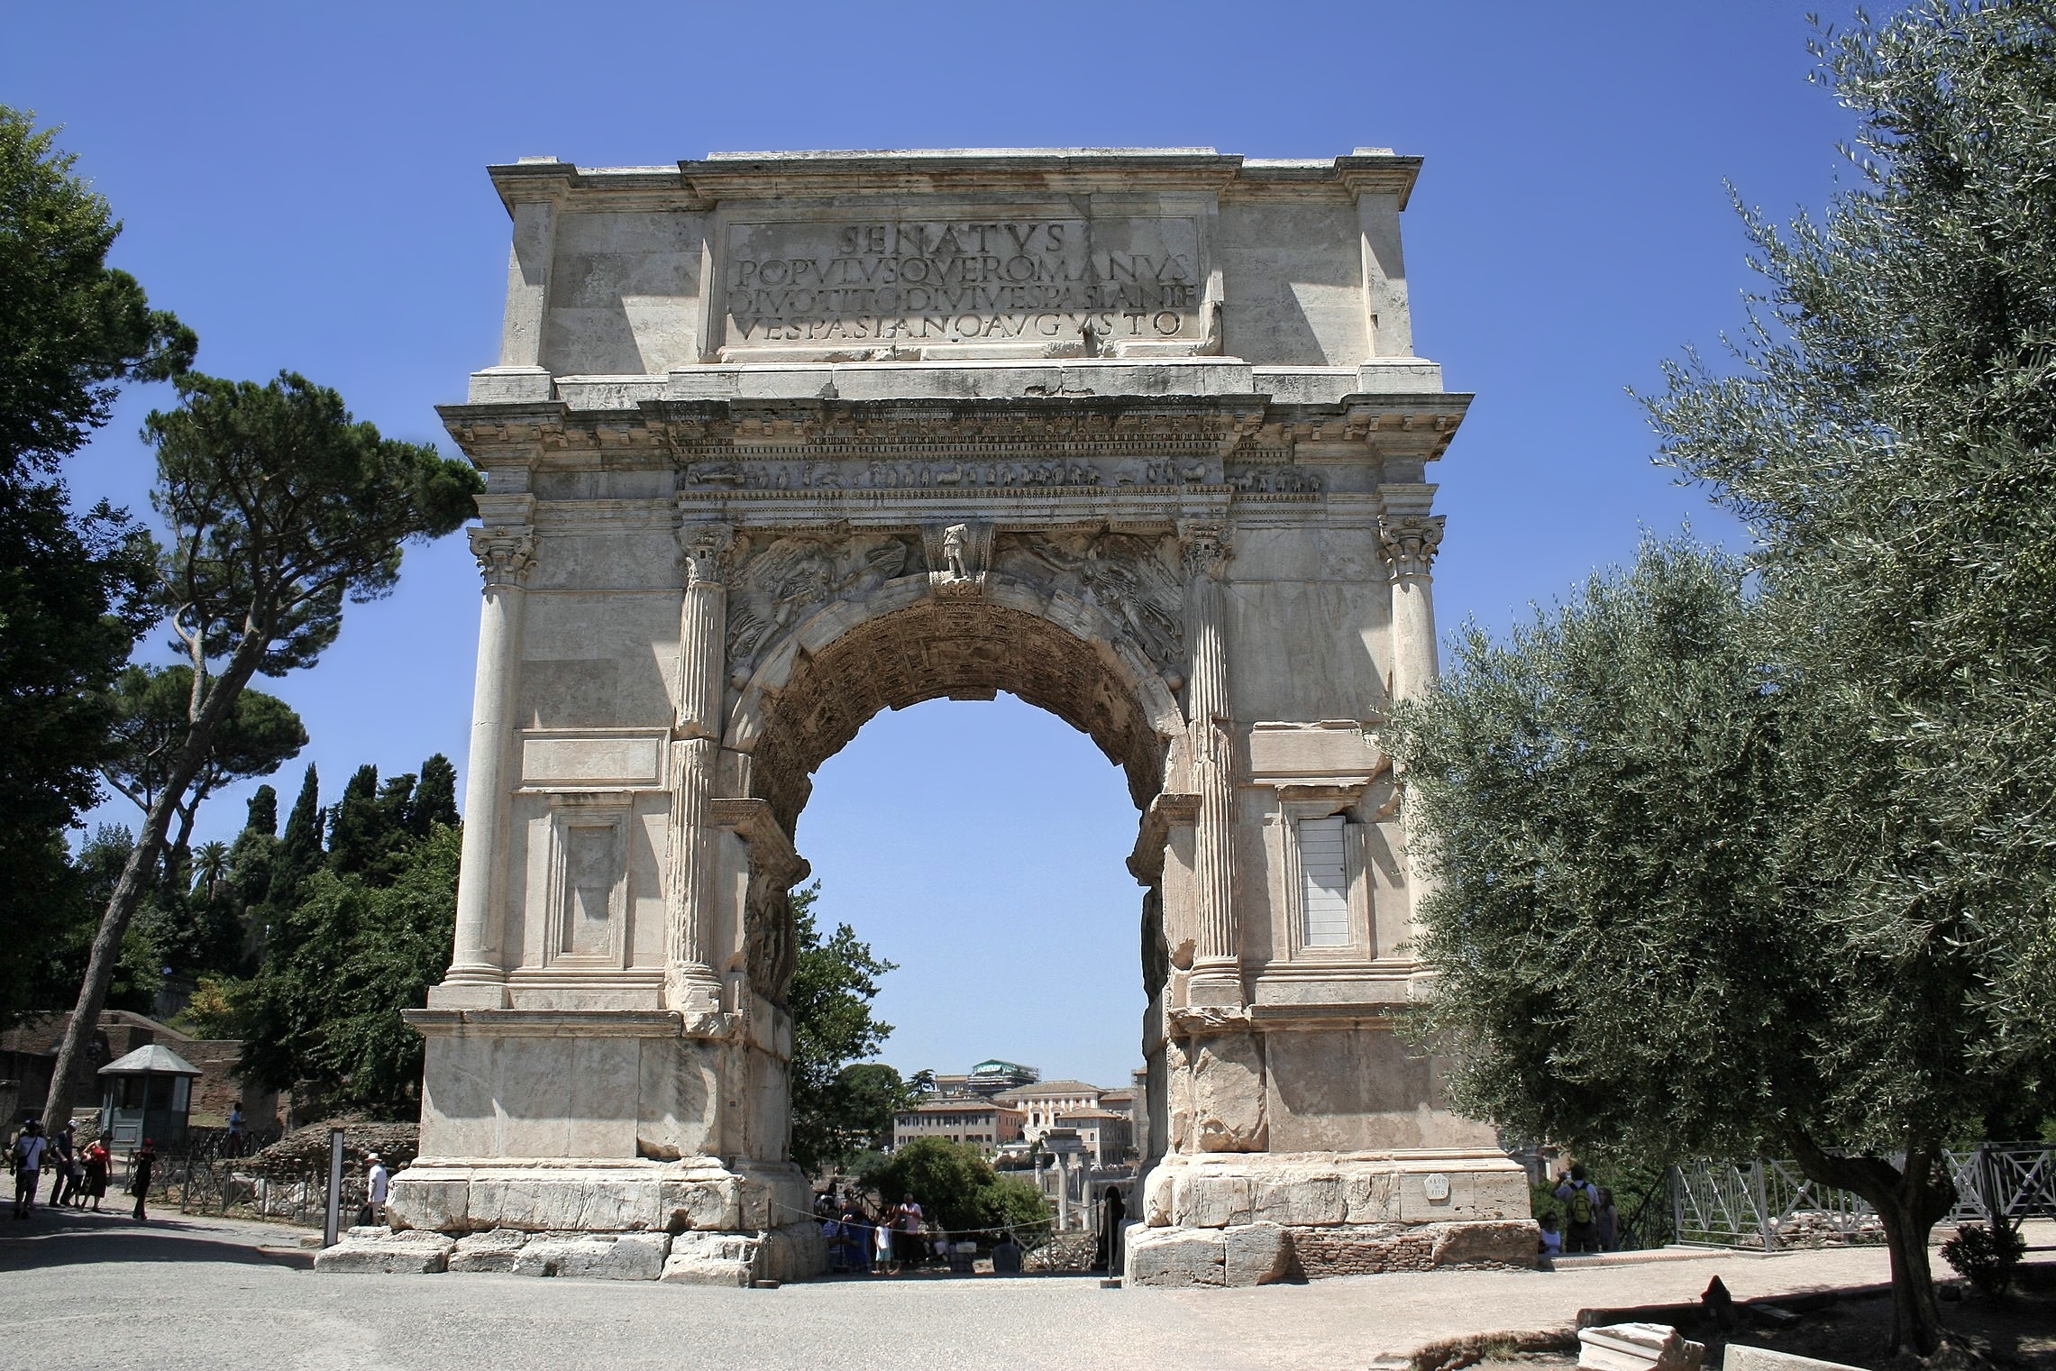

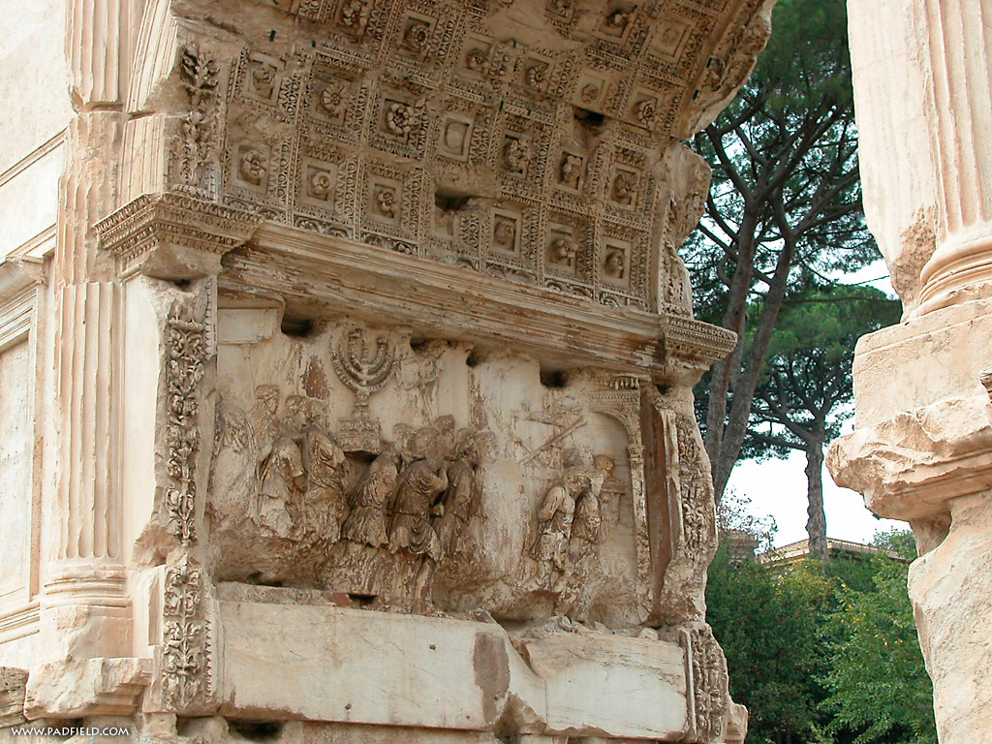
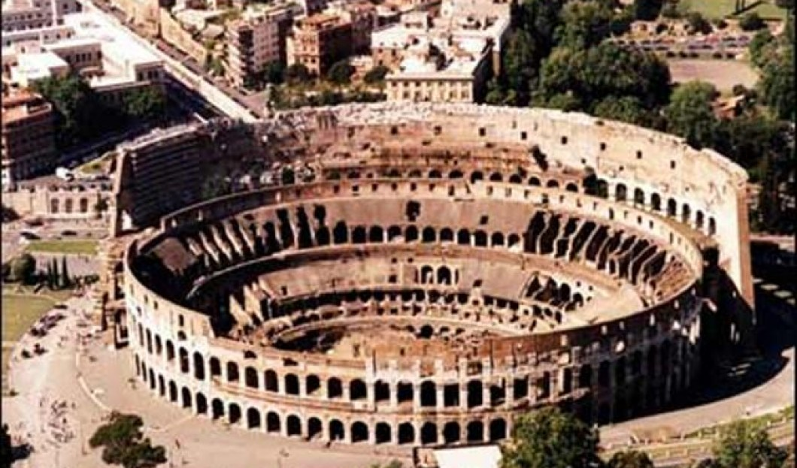

NOTE: When we read in the Bible that Jesus prophesied that the Temple in Jerusalem would be destroyed, we should know the full extent of the prophecy. Reading Josephus, a first century historian, we see that there is more to the account than just dismantling a structure. It is of great significance that Josephus chronicles the siege of Jerusalem and the Temple to have begun at a time of Passover and the Feast of Unleavened Bread (Chapter 9 paragraph 3 (421)). It is not to go unnoticed that Jesus was also crucified during this same time of Passover and Feast of Unleavened Bread. God has His timing.
Josephus Describes the Roman Sack of Jerusalem
The Wars of the Jews, Book 6
CHAPTER 8
(403) So the Romans being now become masters of the wars, they both placed their ensigns upon the towers, and made joyful acclamations for the victory they had gained, as having found the end of this war much lighter than its beginning; for when they had gotten upon the last was, without any bloodshed, they could hardly believe what they found to be true; but seeing nobody to oppose them, they stood in doubt what such an unusual solitude could mean. (404) But when they went in numbers into the lanes of the city, with their swords drawn, they slew those whom they overtook, without mercy, and set fire to the houses wither the Jews were fled, and burnt every soul in them, and laid waste a great many of the rest; (405) and when they were come to the houses to plunder them, they found in them entire families of dead men, and the upper rooms full of dead corpses, that is of such as died by the famine; they then stood in a horror at this sight, and went out without touching anything. (406) But although they had this commiseration for such as were destroyed in that manner, yet had they not the same for those that were still alive, but they ran every one through whom they met with, and obstructed the very lanes with their dead bodies, and made the whole city run down with blood, to such a degree indeed that the fire of many of the houses was quenched with these men's blood. (407) And truly so it happened, that though the slayers left off at the evening, yet did the fire greatly prevail in the night, and as all was burning, came that eighth day of the month Gorpieus [Elul] upon Jerusalem; (408) a city that had been liable to so many miseries during the siege, that, had it always enjoyed as much happiness from its first foundation, it would certainly have been the envy of the world. Nor did it on any other account so much deserve these sore misfortunes, as by producing such a generation of men as were the occasions of this its overthrow.
CHAPTER 9
1. (409) Now, when Titus was come into this [upper] city, he admired not only some other places of strength in it, but particularly those strong towers which the tyrants, in their mad conduct, had relinquished; (410) for when he saw their solid altitude, and the largeness of their several stones. and the exactness of their joints, as also how great was their breadth, and how extensive their length, he expressed himself after the manner following:-(411) "We have certainly had God for our assistant in this war, and it was no other than God who ejected the Jews out of these fortifications; for what could the hands of men, or any machines, do towards overthrowing these towers!" (412) At which time he had many such discourses to his friends; he also let such go free as had been bound by the tyrants, and were left in the prisons. (413) To conclude, when he entirely demolished the rest of the city, and overthrew its wars, he left these towers as a monument of his good fortune, which had proved his auxiliaries, and enabled him to take what could not otherwise have been taken by him.
2. (414) And now, since his soldiers were already quite tired with killing men, and yet there appeared to be a vast multitude still remaining alive, Caesar gave orders that they should kill none but those that were in arms, and opposed them, but should take the rest alive. (415) But, together with those whom they had orders to slay, they slew the aged and the infirm; but for those that were in their flourishing age, and who might be useful to them, they drove them together into the temple, and shut them up within the walls of the court of the women; (416) over which Caesar set one of his freed men, as also Fronto, one of his own friends; which last was to determine every one's fate, according to his merits. (417) So this Fronto slew all those that had been seditious and robbers, who were impeached one by another; but of the young men he chose out the tallest and most beautiful, and reserved them for the triumph; (418) and as for the rest of the multitude that were above seventeen years old, he put them into bonds, and sent them to the Egyptian mines. Titus also sent a great number into the provinces, as a present to them, that they might be destroyed upon their theaters, by the sword and by the wild beasts; but those that were under seventeen years of age were sold for slaves. (419) Now during the days wherein Fronto was distinguishing these men, there perished, for want of food, eleven thousand; some of whom did not taste any food, through the hatred their guards bore to them; and others would not take in any when it was given them. The multitude also was so very great, that they were in want even of corn for their sustenance.
3. (420) Now the number of those that were carried captive during this whole war was collected to be ninety-seven thousand, as was the number of those that perished during the whole siege eleven hundred thousand, (421) the greater part of whom were indeed of the same nation [with the citizens of Jerusalem], but not belonging to the city itself; for they were come up from all the country to the feast of unleavened bread, and were on a sudden shut up by an army, which, at the very first, occasioned so great a traitness (toughness) among them that there came a pestilential destruction upon them, and soon afterward such a famine, as destroyed them more suddenly.
From The Works of Josephus,
translated by William Whiston
Hendrickson Publishers, 1987
The story of Mary of Bethezuba is a story of cannibalism told by Josephus in his “Jewish War” (VI,193)^{[1]} which occurred as a consequence of famine and starvation during the siege of Jerusalem in August AD 70 by Roman legions commanded by Titus. The tale is only one account of the horrors suffered at Jerusalem in the summer of 70.
Josephus relates that there was a Mary, daughter of Eleazar originally from the village of Bethezuba in the district of Perea, east of the Jordan River, who had previously fled to Jerusalem. Distinguished in family and fortune, her property, treasures and food had been plundered by the Jewish defenders of the city during the siege. Famine was “eating her heart out, and rage consuming her still faster”. Maddened by hunger she took the infant at her breast and said to him: “Poor little mite! In war, famine, and civil strife why should I keep you alive? With the Romans there is only slavery and that only if alive when they come; but famine is forestalling slavery, and the partisans are crueler than either. Come you must be food for me, to the partisans an avenging spirit, and to the world a tale, the only thing left to fill up the measure of Jewish misery”. And in “defiance to all natural feeling” she killed her son, then roasted him and ate one half, hiding the rest.
Almost immediately the rebels appeared (“sniffing the unholy smell”) and threatened to kill her on the spot unless she revealed what she had prepared. As she uncovered what was left of the child she offered them a share. They left her in horror and the “entire city could not stop thinking of this crime and abomination”. When the news reached the Romans, “some refused to believe, some were distressed but on most the effect was to add enormously to their detestation” of the enemy at hand. Titus disclaimed all responsibility as he had repeatedly offered peace and amnesty for surrender.
https://en.wikipedia.org/wiki/Mary_of_Bethezuba
Josephus tells us the Romans destroyed Jerusalem during the feast of Unleavened Bread.
More References:
First, the original instructions clearly stipulate that Passover is a single day—Abib 14—followed by the seven-day Feast of Unleavened Bread, beginning on Abib 15 (Exodus 12:6-20; Leviticus 23:5-8; Numbers 9:2-5). These original instructions also direct the Israelites to keep the Passover in individual homes rather than at the Tabernacle or Temple—to catch the blood of the lamb in a basin and smear it on the doorposts and lintel of the house (Exodus 12:22).
While God intended the Passover and Feast of Unleavened Bread to be separate (though adjacent) observances, the Jews ended up combining the two during the Babylonian exile, as the Encyclopaedia Judaica confirms: "The feast of Passover consists of two parts: The Passover ceremony and the Feast of Unleavened Bread. Originally, both parts existed separately; but at the beginning of the [Babylonian] exile they were combined" (vol. 13, p. 169). This careless and unscriptural merging of festivals resulted in the Jews observing Passover late on Abib 14, just hours before the Feast of Unleavened Bread began. Thus, a third variation of Passover observance was added to the mix.
At the time of Jesus Christ, this mixture was on full display.
Another critical point is that, despite Passover and the Feast of Unleavened Bread being distinct festivals, they were commonly grouped together and simply called "Passover." Thus, when the gospel writers mention "Passover," it can sometimes refer to the Passover sacrifice itself (Matthew 26:17; Mark 14:12), the day when the sacrifice was made (Mark 14:1), or the whole eight-day period of Abib 14-21 (Passover plus Unleavened Bread; Luke 22:1).
In actuality, then, there were really two Passover observances happening at the time of Jesus: one led by the priests at the Temple and the other observed by the people in their homes. These separate observances were also at different times: The Temple-kept Passover was observed late in the afternoon of Abib 14, while the home-kept Passover was kept at the beginning of Abib 14. As the gospels show, Jesus and His disciples ate the Passover in a home rather than at the Temple, observing it the evening before the priests did at the Temple. In other words, Jesus kept it as Abib 14 began, while the priests kept it as Abib 14 ended.
https://www.cgg.org/index.cfm/fuseaction/Library.CGGWeekly/ID/741/Is-Passover-on-First-Day-Unleavened-Bread-Part-One.htm
Titus began his siege a few days before Passover,^{[6]} surrounding the city, with three legions (V Macedonica, XII Fulminata, XV Apollinaris) on the western side and a fourth (X Fretensis) on the Mount of Olives to the east.^{[7][8]} If the reference in his Jewish War at 6:421 is to Titus' siege, though difficulties exist with its interpretation, then at the time, according to Josephus, Jerusalem was thronged with many people who had come to celebrate Passover.^{[9]}
https://en.wikipedia.org/wiki/Siege_of_Jerusalem_(70_CE)
From the first few verses of Mark 13, we can see that Jesus’ prophecy came true within the lifetime of those who heard His words. About 37 years later, the Temple was destroyed. The Jews had rejected the long-anticipated Messiah and were totally dismantled as a people by the Romans within a generation of the Cross. The Jews had rebelled against their earthly overlords. The Jews wanted Jesus be their deliverer from the Romans. However, Jesus declared His kingdom was not of this world.
What do we learn from Mark 13:1-2?
In God’s foreknowledge, we learn that He knew the Temple would be destroyed. The Temple was destroyed due to the Jews failing to surrender to the real Messiah. The Jews wanted to hold on to their earthly kingdom. They failed to see that God’s goal for them, and all of mankind, is to surrender to His Spirit, and thereby one day reach the Eternal Kingdom of God that we call Heaven.
Application and Lesson to us.
We seem to be drawn into battles in life. We must pick and chose which ones God has planned for us. These life-battles do not compare to the scale of the Roman wars with the Jews, but they are personal and can consume us. I see that the most attention Jesus gives to confrontation is when He saw people being abused by the community leaders or other bullies in society. In Jesus’ day, these were the Jewish religious leaders. Jesus did confront them severely. I see that we are also, with Jesus as our model, called to defend those who are disadvantaged and have a challenge defending themselves.
Jesus and the Romans
However, Jesus did not confront the Romans, and the Romans did not actually find Jesus guilty of anything. The only reason the Roman leaders turned Jesus over to the Jews is so the Jews would calm down.

Matthew 27:11-26 ¹¹ Now Jesus stood before the governor, and the governor questioned Him, saying, "Are You the King of the Jews?" And Jesus said to him, "It is as you say." ¹² And while He was being accused by the chief priests and elders, He did not answer.
¹³ Then Pilate said to Him, "Do You not hear how many things they testify against You?"
¹⁴ And He did not answer him with regard to even a single charge, so the governor was quite amazed.
¹⁵ Now at the feast the governor was accustomed to release for the people any one prisoner whom they wanted.
¹⁶ At that time they were holding a notorious prisoner, called Barabbas.
¹⁷ So when the people gathered together, Pilate said to them, "Whom do you want me to release for you? Barabbas, or Jesus who is called Christ?"
¹⁸ For he knew that because of envy they had handed Him over.
¹⁹ While he was sitting on the judgment seat, his wife sent him a message, saying, "Have nothing to do with that righteous Man; for last night I suffered greatly in a dream because of Him."
²⁰ But the chief priests and the elders persuaded the crowds to ask for Barabbas and to put Jesus to death.
²¹ But the governor said to them, "Which of the two do you want me to release for you?" And they said, "Barabbas."
²² Pilate said to them, "Then what shall I do with Jesus who is called Christ?" They all said, "Crucify Him!"
²³ And he said, "Why, what evil has He done?" But they kept shouting all the more, saying, "Crucify Him!"
²⁴ When Pilate saw that he was accomplishing nothing, but rather that a riot was starting, he took water and washed his hands in front of the crowd, saying, "I am innocent of this Man's blood; see to that yourselves."
²⁵ And all the people said, "His blood shall be on us and on our children!"
²⁶ Then he released Barabbas for them; but after having Jesus scourged, he handed Him over to be crucified.
Jews and the Romans
The Jews rebelled against God and the Romans. It is understandable to some degree why the Jews rebelled against Rome. However, the Romans were pleased with their subjects as long as they paid their taxes and did not create rebellion by placing a man over the authority of Caesar. The Roman system was oppressive at times but manageable. The Romans were satisfied to leave the Temple standing and the Jewish religious orders in place as it was in Jesus’ day. But the Jews, being a rebellious people, pressed the Romans. The Jews objected to their pagan ways and the presentation of Caesar as god.
Jesus conquered the Jewish religious leadership and replaced the function of the Temple by being the High Priest according to the order of Melchizedek, by being the unblemished sacrifice and going to the Cross to pay the price of all mankind’s sin. This replaced the animal sacrifice system. The final victory statement was the Resurrection. Resurrection was a not a function of the Temple. Neither was the Ascension. Jesus demonstrated to anyone who was paying attention that the Temple was built as God desired but used by the Jews in a way that missed the mark.
Jesus pointed to His own body as the Temple and claimed He would raise it in three days (John 2:19). Jesus is the transitional instrument. By this Temple transition, Jesus was and is the Temple. The Holy of Holies. The place where God meets man. Where the High Priest entered and sprinkled animal blood on the Mercy Seat and forgiveness was achieved. Or was it? This whole system only pointed to God’s forgiveness. God never intended for the sacrificial system to take away sin (Psalm 40:6; Hebrews 10). The Law was only a shadow of God’s intentions.
The Jews failed to see that the Temple and its functions only pointed to God’s unmerited forgiveness. They failed to see that the sacrificed animals only represented the substitutionary atonement for sin and not the mechanism that actually took away sin.
The sacrificial work of the Cross is the mechanism that takes away the sins of the world. Accessing the power of the Cross comes through Faith. Faith is a gift of God to which we must surrender. The Holy Spirit constantly presses on man to surrender to God. Once this surrender takes place, faith enters a person’s heart. Therefore, at that point, faith justifies a person. Abraham was made righteous by his faith in obeying God when he took Isaac to be sacrificed. Abraham already had faith and demonstrated his faith with Isaac. Read Romans 4. By faith, Abraham trusted God. In the end, God provided a substitute, and man does not have to provide his own blood for the forgiveness of sin.
The Temple represented God’s grace, love, and forgiveness. God in the flesh as Jesus represents all of these.
People build their own temples. People’s temples become the place they can control. Sacred places. However, the only Temple people need is the Temple of God, of Jesus Christ, where God lives with you as the Holy Spirit. One of my professors in seminary called this “tabernacling with God”. The reality that God came to Moses and directed Him to build a portable tabernacle where there would be a cloud by day and a fire by night to indicate the constant presence of God. Inside the portable tabernacle, there was the Holy of Holies. This is the inner sanctuary where God meets people. This union place symbolized the fact that God forgives a person who comes forward with a humble heart seeking forgiveness. Once surrender is made, a person will receive God’s blessings, and life is at peace.
Where is your tabernacle? The Good News is that God’s Tabernacle in you is not made with human hands. Man cannot tear down the Tabernacle he did not make with his hands. No one can take away from you the place where God meets you. God’s inner sanctuary is in your being. God created each one of us to contain His inner sanctuary. The place where, in the darkest of times, God’s Light will shine. The place that is eternal. The place were God’s peace, love and forgiveness prevail.
^{ASV} Isaiah 45:22 Look unto me, and be ye saved, all the ends of the earth; for I am God, and there is none else.

^{ESV} Isaiah 45:22 "Turn to me and be saved, all the ends of the earth! For I am God, and there is no other.

^{KJV} Isaiah 45:22 Look unto me, and be ye saved, all the ends of the earth: for I am God, and there is none else.

^{NAS} Isaiah 45:22 "Turn to Me, and be saved, all the ends of the earth; For I am God, and there is no other.

^{NKJ} Isaiah 45:22 "Look to Me, and be saved, All you ends of the earth! For I am God, and there is no other.

^{RSV} Isaiah 45:22 "Turn to me and be saved, all the ends of the earth! For I am God, and there is no other.

^{YLT} Isaiah 45:22 Turn to Me, and be saved, all ends of the earth, For I am God, and there is none else.

AMEN

Continue in Mark 13:3 And as He was sitting on the Mount of Olives opposite the temple, Peter and James and John and Andrew were questioning Him privately,
⁴ "Tell us, when will these things be, and what will be the sign when all these things are going to be fulfilled?"
⁵ And Jesus began to say to them,
"See to it that no one misleads you.
⁶ "Many will come in My name, saying,
'I am He!' and will mislead many.
⁷ "And when you hear of wars and rumors of wars,
do not be frightened; those things must take place;
but that is not yet the end.

⁸ "For nation will arise against nation,
and kingdom against kingdom;
there will be earthquakes in various places;
there will also be famines.
These things are merely the beginning of birth pangs.

⁹ "But be on your guard;
for they will deliver you to the courts,
and you will be flogged in the synagogues,
and you will stand before governors and kings for My sake,
as a testimony to them.

¹⁰ "And the gospel must first be preached to all the nations.

¹¹ "And when they arrest you and deliver you up,
do not be anxious beforehand about what you are to say,
but say whatever is given you in that hour;
for it is not you who speak, but it is the Holy Spirit.

¹² "And brother will deliver brother to death, and a father his child; and children will rise up against parents and have them put to death.

¹³ "And you will be hated by all on account of My name,
but the one who endures to the end, he shall be saved.

¹⁴ "But when you see
the abomination of desolation
standing where it should not be (let the reader understand),
then let those who are in Judea flee to the mountains.
¹⁵ "And let him who is on the housetop not go down,
or enter in, to get anything out of his house;
¹⁶ and let him who is in the field not turn back to get his cloak.
¹⁷ "But woe to those who are with child
and to those who nurse babes in those days!

¹⁸ "But pray that it may not happen in the winter.
¹⁹ "For those days will be a time of tribulation such as has not occurred since the beginning of the creation which God created, until now, and never shall.

²⁰ "And unless the Lord had shortened those days,
no life would have been saved;
but for the sake of the elect whom He chose,
He shortened the days.
²¹ "And then if anyone says to you,
'Behold, here is the Christ';
or, 'Behold, He is there'; do not believe him;

²² for false Christs and false prophets will arise,
and will show signs and wonders, in order,
if possible, to lead the elect astray.

²³ "But take heed;
behold, I have told you everything in advance.

²⁴ "But in those days, after that tribulation,
the sun will be darkened, and the moon will not give its light,
²⁵ and the stars will be falling from heaven, and the powers that are in the heavens will be shaken.
²⁶ "And then they will see the Son of Man coming in clouds with great power and glory.
²⁷ "And then He will send forth the angels,
and will gather together His elect from the four winds,
from the farthest end of the earth, to the farthest end of heaven.

²⁸ "Now learn the parable from the fig tree:
when its branch has already become tender, and puts forth its leaves, you know that summer is near.
²⁹ "Even so, you too, when you see these things happening, recognize that He is near, right at the door.

³⁰ "Truly I say to you,
this generation will not pass away
until all these things take place.
³¹ "Heaven and earth will pass away,
but My words will not pass away.
³² "But of that day or hour no one knows,
not even the angels in heaven, nor the Son, but the Father alone.

³³ "Take heed, keep on the alert;
for you do not know when the appointed time is.
³⁴ "It is like a man, away on a journey, who upon leaving his house and putting his slaves in charge, assigning to each one his task, also commanded the doorkeeper to stay on the alert.
³⁵ "Therefore, be on the alert—
for you do not know when the master of the house is coming, whether in the evening, at midnight, at cockcrowing, or in the morning--
³⁶ lest he come suddenly and find you asleep.
³⁷ "And what I say to you I say to all,
'Be on the alert!'"

