Round Top Church Christian Fellowship
Sermon
Roman Series
God’s Roman - Paul
Pastor ~ Matthew Diehl
June 23rd In the Year of Our Lord 2019

(Unless otherwise noted, NAS quoted)

Acts 9:15-16 15 But the Lord said to him, "Go, for he is a chosen instrument of Mine, to bear My name before the Gentiles and kings and the sons of Israel;
16 for I will show him how much he must suffer for My name's sake."
God is the Father of Time and Events
He knew that one day a Hebrew named Saul would persecute Believers thinking he himself was a defender of his faith.
God knew that a settlement on the Tiber River, in Italy, would grow to a world power for over 500 years.
God knew the timing of His incarnation would meet two lives: one Saul of Tarsus and the other being the life of a fallen culture. Those of us who have read the New Testament know that this Saul of Tarsus became Paul, an Apostle of the incarnate God, Jesus Christ, who by the grace of God was saved at a time he was marching to persecute God’s witnesses.

Acts 9:1-2
1 Now Saul, still breathing threats and murder against the disciples of the Lord, went to the high priest,
2 and asked for letters from him to the synagogues at Damascus, so that if he found any belonging to the Way, both men and women, he might bring them bound to Jerusalem.

During Paul’s imprisonments, God tells him that he will go to Rome for His cause.
Acts 23:11
11 But on the night immediately following, the Lord stood at his side and said, "Take courage; for as you have solemnly witnessed to My cause at Jerusalem, so you must witness at Rome also."

Acts 28:16-31
16 When we entered Rome, Paul was allowed to stay by himself, with the soldier who was guarding him.
17 After three days Paul called together those who were the leading men of the Jews, and when they came together, he began saying to them, "Brethren, though I had done nothing against our people or the customs of our fathers, yet I was delivered as a prisoner from Jerusalem into the hands of the Romans.
18 "And when they had examined me, they were willing to release me because there was no ground for putting me to death.
19 "But when the Jews objected, I was forced to appeal to Caesar, not that I had any accusation against my nation.
20 "For this reason, therefore, I requested to see you and to speak with you, for I am wearing this chain for the sake of the hope of Israel."
21 They said to him, "We have neither received letters from Judea concerning you, nor have any of the brethren come here and reported or spoken anything bad about you.
22 "But we desire to hear from you what your views are; for concerning this sect, it is known to us that it is spoken against everywhere."
23 When they had set a day for Paul, they came to him at his lodging in large numbers; and he was explaining to them by solemnly testifying about the kingdom of God and trying to persuade them concerning Jesus, from both the Law of Moses and from the Prophets, from morning until evening.
24 Some were being persuaded by the things spoken, but others would not believe.
25 And when they did not agree with one another, they began leaving after Paul had spoken one parting word, "The Holy Spirit rightly spoke through Isaiah the prophet to your fathers,
26 saying, 'GO TO THIS PEOPLE AND SAY, "YOU WILL KEEP ON HEARING, BUT WILL NOT UNDERSTAND; AND YOU WILL KEEP ON SEEING, BUT WILL NOT PERCEIVE;
27 FOR THE HEART OF THIS PEOPLE HAS BECOME DULL, AND WITH THEIR EARS THEY SCARCELY HEAR, AND THEY HAVE CLOSED THEIR EYES; OTHERWISE THEY MIGHT SEE WITH THEIR EYES, AND HEAR WITH THEIR EARS, AND UNDERSTAND WITH THEIR HEART AND RETURN, AND I WOULD HEAL THEM."'
28 "Therefore let it be known to you that this salvation of God has been sent to the Gentiles; they will also listen."
29 When he had spoken these words, the Jews departed, having a great dispute among themselves.
30 And he stayed two full years in his own rented quarters and was welcoming all who came to him,
31 preaching the kingdom of God and teaching concerning the Lord Jesus Christ with all openness, unhindered.

Paul writes a letter to Believers in Philippi while imprisoned in Rome. In fact, scholars believe that Paul wrote many books while in prison: Ephesians, Colossians, Philemon, 1 Timothy and the last letters to Titus and his last being 2 Timothy. Paul used his last days writing to others about the Lord.

Philippians 1:1-8 1 Paul and Timothy, bond-servants of Christ Jesus, To all the saints in Christ Jesus who are in Philippi, including the overseers and deacons:
2 Grace to you and peace from God our Father and the Lord Jesus Christ.
3 I thank my God in all my remembrance of you,
4 always offering prayer with joy in my every prayer for you all,
5 in view of your participation in the gospel from the first day until now.
6 For I am confident of this very thing, that He who began a good work in you will perfect it until the day of Christ Jesus.
7 For it is only right for me to feel this way about you all, because I have you in my heart, since both in my imprisonment and in the defense and confirmation of the gospel, you all are partakers of grace with me.
8 For God is my witness, how I long for you all with the affection of Christ Jesus.
Philippians 4:21-23
21 Greet every saint in Christ Jesus.
The brethren who are with me greet you.
22 All the saints greet you,
especially those of Caesar's household.
23 The grace of the Lord Jesus Christ be with your spirit.

The consensus of scholars is that Paul was beheaded in Rome or outside the city before the end of Nero’s reign (who died by suicide in 68 A.D.). There was a highpoint in Christian persecution in about 64 A.D. Therefore, many scholars view that it was at that time Paul did not survive being that he was already in custody. Paul was taken to Rome by 62 A.D.

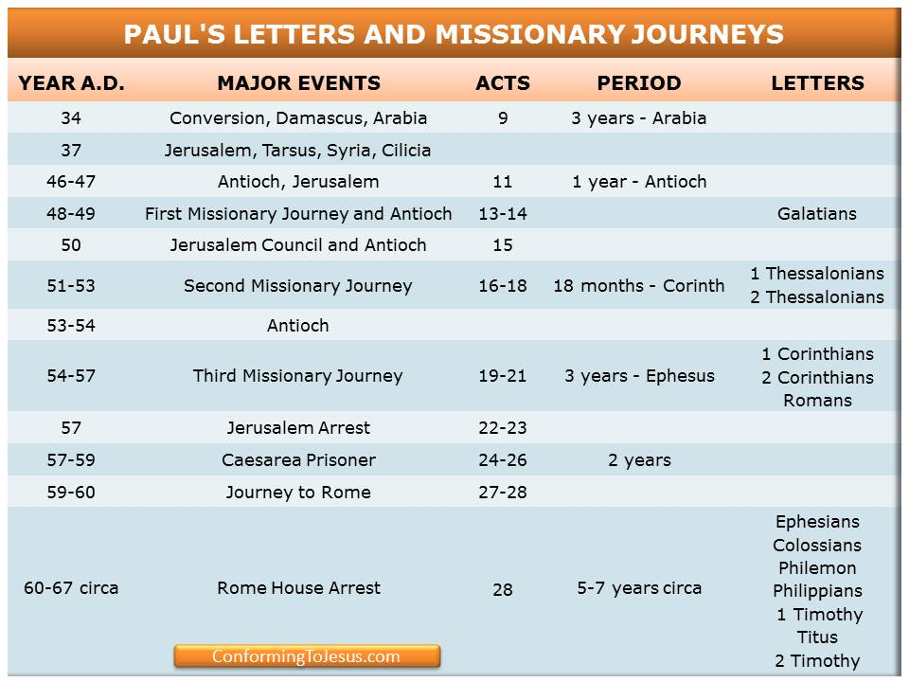
2 Timothy 4:5-13 5 But you, be sober in all things, endure hardship, do the work of an evangelist, fulfill your ministry.
6 For I am already being poured out as a drink offering, and the time of my departure has come.
7 I have fought the good fight, I have finished the course, I have kept the faith;
8 in the future there is laid up for me the crown of righteousness, which the Lord, the righteous Judge, will award to me on that day; and not only to me, but also to all who have loved His appearing.
9 Make every effort to come to me soon;
10 for Demas, having loved this present world, has deserted me and gone to Thessalonica; Crescens has gone to Galatia, Titus to Dalmatia.
11 Only Luke is with me. Pick up Mark and bring him with you, for he is useful to me for service.
12 But Tychicus I have sent to Ephesus.
13 When you come bring the cloak which I left at Troas with Carpus, and the books, especially the parchments.
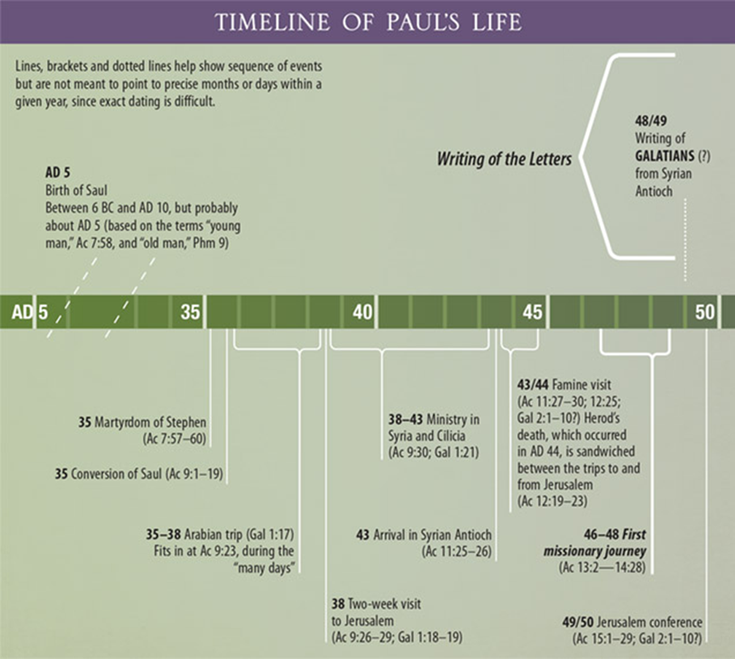

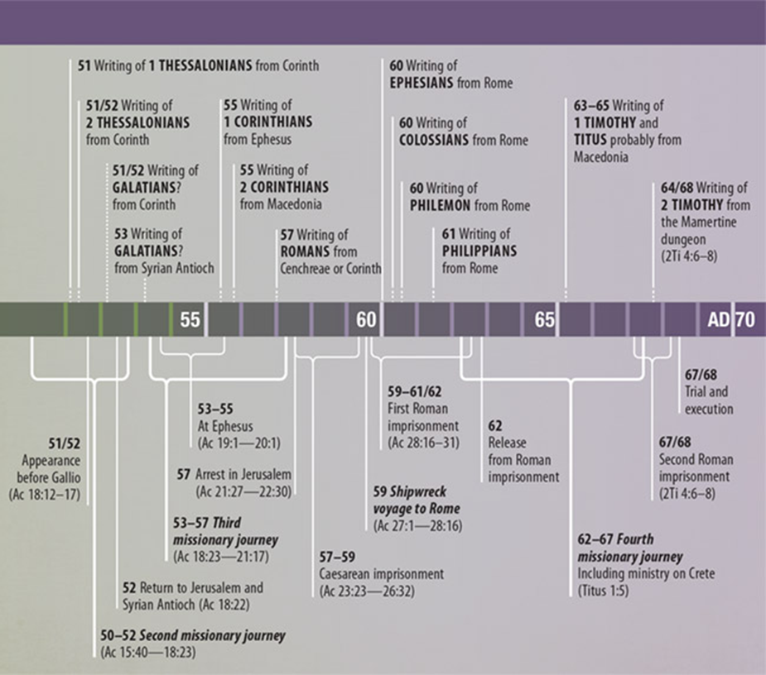
https://mpichurch.org/2017/02/12/paul-the-apostle/

Some scholars believe the following time line for the end of Paul’s life.
63 A.D.
In the Spring of the year, in Rome, the apostle Paul is acquitted of the charges against him and is set free. This is due to no witnesses from Judea coming to Rome to testify against Paul, Being a Roman citizen, with rights, Paul was set free. He then sails from Rome to the island of Crete in order to meet with Titus (Titus 1:5). He then leaves Titus in Crete and sails to Nicopolis (Titus 1:5, 3:12). From Nicopolis he writes the New Testament books of 1Timothy and Titus.
63 A.D. to 67 A.D.
Paul continues his mission of spreading the gospel by traveling to Spain. In the winter of 57 A.D. He writes to the church at Rome regarding his planned travel to this western part of the empire.
67 A.D. Paul is back in a prison in Rome. While prisoner he writes his last book which is addressed to his best friend Timothy.
68 A.D.
Paul is beheaded, under Roman Emperor Nero, around May or June. His death occurs just before Nero's suicide on June 9, 68 A.D. in Greece. He is about 66 years old.

Nero is the first emperor of the Roman Empire to actively persecute and kill Christians. Rome will carry out at least TEN major efforts to exterminate Christians and expunge Christianity from the empire. The persecutions first start under Nero in 67 A.D. and continue until 313.
https://www.biblestudy.org/maps/apostle-paul-fifth-missionary-journey-map.html

About Rome
By the 1st century, Rome is estimated to have a population of about one million people in about a ten square mile area. The surrounding area, no doubt, had more people living around the seven hills of Rome. Rome, a city founded upon the Greek and Etruscan cultures, was developed from a settlement on Tiber River in Italy. Rome’s origins and history are common among the settlement of mankind, a struggle from the beginning to carve-out an existence from its competing neighbors. Below are accounts of Rome’s beginnings that also compete for legitimacy.

According to legend, Ancient Rome was founded by the two brothers, and demi-gods, Romulus and Remus, on 21 April 753 BCE. The legend claims that, in an argument over who would rule the city (or, in another version, where the city would be located) Romulus killed Remus and named the city after himself. This story of the founding of Rome is the best known but it is not the only one.

Other legends claim the city was named after a woman, Roma, who traveled with Aeneas and the other survivors from Troy after that city fell. Upon landing on the banks of the Tiber River, Roma and the other women objected when the men wanted to move on. She led the women in the burning of the Trojan ships and so effectively stranded the Trojan survivors at the site which would eventually become Rome. Aeneas of Troy is featured in this legend and also, famously, in Virgil's Aeneid, as a founder of Rome and the ancestor of Romulus and Remus, thus linking Rome with the grandeur and might which was once Troy.

Still other theories concerning the name of the famous city suggest it came from Rumon, the ancient name for the Tiber River, and was simply a place-name given to the small trading centre established on its banks or that the name derived from an Etruscan word which could have designated one of their settlements.

Early Rome
Originally a small town on the banks of the Tiber, Rome grew in size and strength, early on, through trade. The location of the city provided merchants with an easily navigable waterway on which to traffic their goods. The city was ruled by seven kings, from Romulus to Tarquin, as it grew in size and power. Greek culture and civilization, which came to Rome via Greek colonies to the south, provided the early Romans with a model on which to build their own culture. From the Greeks they borrowed literacy and religion as well as the fundamentals of architecture.

The Etruscans, to the north, provided a model for trade and urban luxury. Etruria was also well situated for trade and the early Romans either learned the skills of trade from Etruscan example or were taught directly by the Etruscans who made incursions into the area around Rome sometime between 650 and 600 BCE (although their influence was felt much earlier). The extent of the role the Etruscans played in the development of Roman culture and society is debated but there seems little doubt they had a significant impact at an early stage.
https://www.ancient.eu/Rome/

Why were there Christians in Rome?

The Christian Church in Rome has an unknown date and founder. We can say that God/Jesus Christ is the founder, because it was those Believers, whoever their names may be, that first came to Rome or perhaps they were already Roman citizens, like Paul, who converted to the “Way” as Christians were called in Acts 9:2.
(Also see Acts 19:23, 9:9, 22:4, 24:14, 24:22)

Some scholars support the idea that after Pentecost, and with the stoning of Steven, people who surrendered to God’s Message, as given by Jesus, came to Rome. Perhaps someone visiting Rome for Pentecost returned to their home in Rome. The Jews were there as part of the Jewish commerce that flourished around the Mediterranean. Obviously, they built a Jewish synagogue.

The Jewish community of Rome goes back to the 2nd century B.C when the Roman Republic had an alliance of sorts with Judea under the leadership of Judah Maccabeus. At that time, many Jews came to Rome from Judea. Their numbers increased during the following centuries due to the settlement that came with Mediterranean trade. Then, later, after Jesus was crucified, large numbers of Jews were brought to Rome as slaves following the Jewish–Roman wars in Judea from 63 to 135 CE.
https://en.wikipedia.org/wiki/Great_Synagogue_of_Rome

View of Christians by Rome
As we study the spread of Christianity (The Way), there needs to be an understanding, that the Roman government and culture viewed Christianity as an offshoot of Judaism. All the Apostles were Jews. The leading voices of Paul, Peter, James, John and others were all Jews. Paul, as Jesus did, visited Jewish Synagogues to preach the Good News. In the eyes of the world, the movement in which Jesus started was just another variety of Judaism.

Points of Separation: Judaism and Christianity
As Christians, we must know that the Messiah the Jews were seeking with great anticipation, as today, is a geopolitical leader like Moses. The Jews in the 1st century and today are not looking for a Messiah who dies for payment for the sins of the world. This is the great divide. This one difference points to many other differences. Judaism, in the time of Jesus, like today, still has a very works-orientated way of life to justify their relationship with God. James, the Jewish convert to the Way, explains very well the difference in James 2. Faith produces works. Works are indicative of the Believer’s life, but works do not justify a person to God. Part of Paul’s life mission was to enlighten Jews that the Law cannot justify a person to God. However, Paul witnessed to the Jews several times but rejected his witness, so they beat Paul and left him for dead a number of times. The most clarifying verse Paul writes to the Believers in Ephesus (2:8) declares that we are saved by faith due to God’s grace and not by works. As we go through Romans, we will see that Paul details the difference between the Law as the Jews misunderstood and God’s original plan of salvation through faith. Yes, active faith which produces works is indicative of a person going through sanctification.

Romans Written from Where? And Date?
Romans is Paul’s magnificent theological statement. There isn’t any doubt that Paul wrote the letter from Corinth in about 55 or 56 A.D.
The letter was most probably written while Paul was in Corinth, probably while he was staying in the house of Gaius, and transcribed by Tertius, his amanuensis.[6] There are a number of reasons why Corinth is considered most plausible. Paul was about to travel to Jerusalem on writing the letter, which matches Acts [Acts 20:3] where it is reported that Paul stayed for three months in Greece. This probably implies Corinth as it was the location of Paul's greatest missionary success in Greece.[7] Additionally, Phoebe was a deacon of the church in Cenchreae, a port to the east of Corinth, and would have been able to convey the letter to Rome after passing through Corinth and taking a ship from Corinth's west port.[7] Erastus, mentioned in Romans 16:23, also lived in Corinth, being the city's commissioner for public works and city treasurer at various times, again indicating that the letter was written in Corinth.[8]

he precise time at which it was written is not mentioned in the epistle, but it was obviously written when the collection for Jerusalem had been assembled and Paul was about to "go unto Jerusalem to minister unto the saints", that is, at the close of his second visit to Greece, during the winter preceding his last visit to that city.[9] The majority of scholars writing on Romans propose the letter was written in late 55/early 56 or late 56/early 57.[10] Early 55 and early 58 both have some support, while German New Testament scholar Gerd Lüdemann argues for a date as early as 51/52 (or 54/55), following on from Knox, who proposed 53/54. Lüdemann is the only serious challenge to the consensus of mid to late 50s. https://en.wikipedia.org/wiki/Epistle_to_the_Romans

Authorship https://www.blueletterbible.org/study/intros/romans.cfm
The letter itself claims Pauline authorship (1:1) and there has not been much controversy over this. Early church tradition affirms Pauline authorship. According to Geisler and Nix, it was either cited or alluded to by Clement of Rome (ca. AD 95-97), Polycarp (ca. 110-150), the Didache (ca. 120-150), Justin Martyr (ca. 150-155), Tertullian (ca. 150-220), and Origen (ca. 185-254). [5] It has been named as authentic by Irenaeus (ca. 130-202), Clement of Alexandria (ca. 150-215), Cyril of Jerusalem (ca. 315-386), Eusebius (ca. 325-340), Jerome (ca. 340-420), and Augustine (ca. 400). And it was included in the canons of Marcion (ca. 140), Muratorian (ca. 170), Barococcio (ca. 206), Apostolic (ca. 300), Cheltenham (ca. 360), and Athanasius (367). [6]

Paul, the author of thirteen New Testament Epistles, was born as an Israelite in Tarsus of Cilicia (Acts 22:3; Phil 3:5). The name that he went by was Saul. He studied under Gamaliel in Jerusalem (Acts 22:3) and became a Pharisee (Phil 3:5). He was present at the stoning of Stephen (Acts 7:58; 8:1) and became a persecutor of the church (Acts 8:1-3; Phil 3:6). While seeking to have Christians bound, he was converted on the road to Damascus as Christ appeared to him (Acts 9:1-9). He went into Damascus (Acts 9:10-19) then went to Arabia for some time (Gal 1:17) before returning to Jerusalem (Acts 9:26-29; Gal 1:18). In the Galatians 1 Paul gives a brief biography of his calling and life. He met up with Barnabas and ministered with him in Antioch (Acts 11:25-26). Then he began to go on various missionary journeys to bring the Gospel to the Gentiles. He was imprisoned in Rome on two occasions and was martyred under Caesar Nero.

Why did Paul write Romans? Galatians 2:7-9
7 But on the contrary, seeing that I had been entrusted with the gospel to the uncircumcised, just as Peter had been to the circumcised 8 (for He who effectually worked for Peter in his apostleship to the circumcised effectually worked for me also to the Gentiles), 9 and recognizing the grace that had been given to me, James and Cephas and John, who were reputed to be pillars, gave to me and Barnabas the right hand of fellowship, so that we might go to the Gentiles and they to the circumcised.
Paul turns to witness to the Gentiles.
To the Jews, Paul shook off the dust of his feet in protest.
Acts 13:14-16
14 But going on from Perga, they arrived at Pisidian Antioch, and on the Sabbath day they went into the synagogue and sat down.
15 After the reading of the Law and the Prophets the synagogue officials sent to them, saying, "Brethren, if you have any word of exhortation for the people, say it
16 Paul stood up, and motioning with his hand said, "Men of Israel, and you who fear God, listen:
Acts 13:44-52
44 The next Sabbath nearly the whole city assembled to hear the word of the Lord.
45 But when the Jews saw the crowds, they were filled with jealousy and began contradicting the things spoken by Paul, and were blaspheming.
46 Paul and Barnabas spoke out boldly and said, "It was necessary that the word of God be spoken to you first; since you repudiate it and judge yourselves unworthy of eternal life, behold, we are turning to the Gentiles.
47 "For so the Lord has commanded us, 'I HAVE PLACED YOU AS A LIGHT FOR THE GENTILES, THAT YOU MAY BRING SALVATION TO THE END OF THE EARTH.'"
48 When the Gentiles heard this, they began rejoicing and glorifying the word of the Lord; and as many as had been appointed to eternal life believed.
49 And the word of the Lord was being spread through the whole region.
50 But the Jews incited the devout women of prominence and the leading men of the city, and instigated a persecution against Paul and Barnabas, and drove them out of their district.
51 But they shook off the dust of their feet in protest against them and went to Iconium.
52 And the disciples were continually filled with joy and with the Holy Spirit.

At some point in Paul’s career, he had become well-known and very affective in planting churches and writing letters. Peter refers to Paul’s letters as Scripture. Peter was also martyred in the time of Nero. Thus, scholars date 2nd Peter to be written before 68 A.D. This is after the accepted date of Paul writing Romans. However, this citation indicates that Paul was a well-respected spokesperson for God.

2 Peter 3:15-16 5 and regard the patience of our Lord as salvation; just as also our beloved brother Paul, according to the wisdom given him, wrote to you,
16 as also in all his letters, speaking in them of these things, in which are some things hard to understand, which the untaught and unstable distort, as they do also the rest of the Scriptures, to their own destruction.

The fact that Paul writes the letter with the introduction detailing his credentials lends to Roman Believers knowing who Paul was. Paul recounts his status with God to substantiate his calling. So, by the time Paul writes the Roman letter in about 57 A.D., he is a known witness, missionary, church planter and apostle of God. Paul’s conversion was in 34 A.D. By the time he wrote to the Roman Church, he had been in ministry for about twenty-three years.
With this said, Paul still introduces himself to the Believers in Rome with substantial resume-building. A bond-servant called an apostle who is set apart for the Gospel of God. Paul then attaches Old Testament (verse. 2,3) authority to the letter, knowing that some who will read the letter are Gentiles who may not know the Hebrew Scripture. In verse 4, Paul notes that Jesus was “declared the Son of God with power”, by the only power that could, that is the power of the resurrection of the dead. This is all witnessed to Paul and to the world by the Holy Spirit which is Jesus Christ. Paul wants to verify that Jesus is the long-anticipated Messiah.
This is a key point Paul makes in verse 5. Paul does not claim apostleship. He carefully states that it is through the Holy Spirit that we have received not only grace but his apostleship. This is not a static title or one to be set aside once obtained. No, Paul emphasizes that this title is functional as evidenced in him writing to them and a proposed future visit.
Romans 1
1:1 Paul, a bond-servant of Christ Jesus,
called as an apostle, set apart for the gospel of God,
2 which He promised beforehand through His prophets in the holy Scriptures,
3 concerning His Son,
who was born of a descendant of David according to the flesh,
4 who was declared the Son of God
with power by the resurrection from the dead,
according to the Spirit of holiness, Jesus Christ our Lord,
5 through whom we have received grace and apostleship
to bring about the obedience of faith among all the Gentiles for His name's sake,
6 among whom you also are the called, of Jesus Christ;
7 to all who are beloved of God in Rome, called as saints:
Grace to you and peace from God our Father and the Lord Jesus Christ.
8 First, I thank my God through Jesus Christ for you all,
because your faith is being proclaimed throughout the whole world.
9 For God,
whom I serve in my spirit in the preaching of the gospel of His Son,
is my witness as to how unceasingly I make mention of you,
10 always in my prayers making request,
if perhaps now at last by the will of God I may succeed in coming to you.
11 For I long to see you
so that I may impart some spiritual gift to you, that you may be established;
12 that is, that I may be encouraged together with you while among you,
each of us by the other's faith, both yours and mine.
13 I do not want you to be unaware, brethren,
that often I have planned to come to you (and have been prevented so far)
so that I may obtain some fruit among you also,
even as among the rest of the Gentiles.
14 I am under obligation both to Greeks and to barbarians,
both to the wise and to the foolish.
15 So, for my part, I am eager to preach the gospel to you
Also, who are in Rome.
==============================================
Verse 7 contains Paul’s standard salutation as seen in most of his thirteen New Testament letters. Grace and peace are God’s calling cards. We remember that God’s authority comes through grace and peace. These two powers are the engines that drive God’s love, joy, hope, gentleness, kindness, self-control, against which no law can stand.
Paul holds-up the saints in Rome up for their faith to the world. A strong statement, but, then again, these saints are in the capital of the Roman world. Paul goes even further and calls upon God’s Spirit to be his witness as to Paul’s remembering the Roman Believers in his prayer life. Paul then announces his intent to visit them in the future.
We know that Paul states he plans to go to Spain (Romans 15:24) and on his way he plans to visit the Roman Believers. However, other than stated plans, there is not biblical evidence actually placing Paul in Spain. We have many accounts of Paul’s travels in Asia planting Churches. So, the evidence of Paul’s presence in Asia is in the fact that churches were planted. 1 Clement 5:7 says that he reached "the extreme limit of the west." This is a 2nd century source that is reliable. Due to this “Clement” passages, some see that Paul traveled to England as it is further to the West.
Paul details that when he visits, they can exchange spiritual gifts and encouragement that would be valuable to both.
14 I am under obligation both to Greeks and to barbarians,
both to the wise and to the foolish.
15 So, for my part, I am eager to preach the gospel to you
Also, who are in Rome.
We take note of Paul obligation which is part of his commissioning by the Resurrected Lord. Paul is commissioned to Greeks, barbarians, wise and the foolish and places this charge squarely at the doorstep of the Roman church. This makes it abundantly clear that Paul had never been to Rome, and he did not start the church there despite what some long-standing traditions claim.
So, let’s review Paul’s reasons for writing Romans.
- His commissioning.
- His prayer life.
- His love for them.
- God’s Holy Spirit directing his missionary efforts. Paul feels responsible for the Roman church.
- Paul seeks to encourage the Believers in Rome and, also, at the same time, receive encouragement from them.
- Paul sees the Believers in Rome as another witnessing point to the world.
- Paul fulfills his calling from God as Jesus directed Him.

From these, Paul is our witness. These seven reasons, these elements to the Believer’s witness, are exactly what God has called us to do. We most likely will not all attain the works of Paul in our lifetime, but, with God’s Spirit working inside us, with our hearts beating at times with fear and trembling, not because we are afraid of God but because we are in awe of God working through us, we can accomplish the plan God has for our lives (Ephesians 2:10).

What does it take to understand these elements of faith that the Apostle Paul is writing about?
Paul starts with a basic understanding of the Faith.
His approach is:
1. Through Prayer - which means that we recognize a
higher power than ourselves (God).
2. Through an Attitude - we cannot achieve true life on our own.
3. Through a Spiritual understanding and discernment.
4. Through a Belief - the Bible is true.
5. Through Fellowship - the body of Christ is the Church.
6. Through the belief that the teachings of God can
be passed onto all people.
7. Through the Belief that these teachings make
you a more complete person in relationship to
God the Father.
AMEN

