Round Top Church Christian Fellowship
Sermon
Ekklesia Series
God’s Spirit Working in People
Moves His Church Forward
April 7th, In the Year of Our Lord 2019
Pastor Matthew Diehl
(Unless otherwise noted, NAU text is quoted)
God has placed in our hands the power and authority to live so that others shall live. (The Gospel of Jesus Christ) This is true for all Believers. God’s grace, peace and forgiveness runs through our hands, hearts and minds. God chose us through whom to work.
ISLAM WATCH
U.S. New: Feb. 27, 2019 - The 10 Worst Countries for Gender Equality, Ranked by Perception
https://www.usnews.com/news/best-countries/slideshows/10-worst-countries-for-gender-equality-ranked-by-perception?slide=5
All but India (75 % plus Hindu) are Islamic majority counties.
1. United Arab Emirates
2. Saudi Arabia: Some of the strictest interpretations of Sharia law are practiced in Saudi Arabia, enforced by the nation’s religious police force. Women are considered minors under male guardians known as ‘mahrams,’ whom they are not permitted to leave home without, whether it be to go shopping or to a doctor’s appointment. A historic election in 2015 granted Saudi women the right to vote for the first time, but they are not permitted to drive and most public spaces are segregated.
3. Qatar 4. Malaysia 5. India 6. Iran 7. Egypt 8. Jordan 9. Iraq 10. Indonesia
See also Global Gender Gap Index 2015.
http://www3.weforum.org/docs/GGGR2015/The%20Global%20Gender%20Gap%20Index%202015.pdf

Middle East Nations http://reports.weforum.org/global-gender-gap-report-2015/social-media/

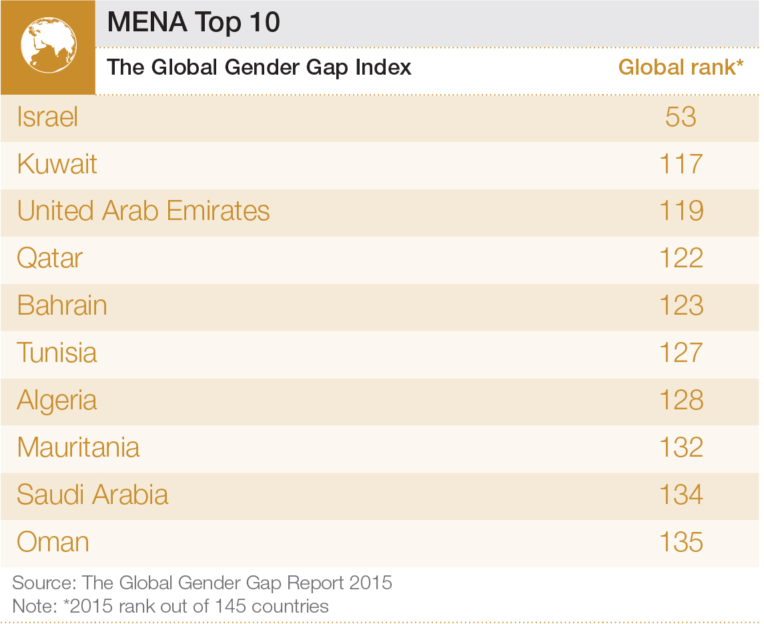

Picking up where we stopped last week, we were observing the reasons the State Church eventually failed. Historians have classified time-eras by name. We will consider the Reformation, Renaissance and Enlightenment. All of these impacted the decline of the State Church. The latter two, in time, eroded all religious beliefs in Europe and then in America, reflected in Thomas Paine’s “Age of Reason” published in 1794, 1795 and 1802. Paine is known for writing “Common Sense” published in 1776 calling for independence from King George. In his book “Age of Reason” (http://www.ushistory.org/paine/reason/), Paine openly challenges the Bible’s accuracy and validity. Paine is a known Deist. From reading his work, it is evident he is mainly repudiating the State Church. His anger comes through his text. However, he makes numerous errors in his cretic of the biblical text and manuscripts. One error, he makes the case that Abraham was never called (or referenced as) a prophet. (See Genesis 20:7)
The Reformation (I observe this era to have it origins with Wycliffe in 1382 publishing an English New Testament), the era of Enlightenment (late 1600’s to early 1800’s) and the Renaissance (1300’s to 1600’s) all contributed in breaking the forced submission hold on people’s lives. All these eras assisted people from pulling away from the religion of man attempting to be god or create and control a path to God. As time passed the State Church could not control God’s Spirit.
Marvel not that I said unto thee, Ye must be born again. 8 The wind bloweth where it listeth, and thou hearest the sound thereof, but canst not tell whence it cometh, and whither it goeth: so is every one that is born of the Spirit. 9 Nicodemus answered and said unto him, How can these things be? 10 Jesus answered and said unto him, Art thou a master of Israel, and knowest not these things? (John 3:7-10 KJV)

So, like the State Church and anyone who subscribes to the same methods, like Islam, the Spirit of God is outside their authority.
Therefore, the point needs to be made that if Islam does not accept God’s indwelling presence in their hearts then how can they have victory in this life over sin.
2 Corinthians 3:4-64 Such confidence we have through Christ toward God. 5 Not that we are adequate in ourselves to consider anything as coming from ourselves, but our adequacy is from God, 6 who also made us adequate as servants of a new covenant, not of the letter but of the Spirit; for the letter kills, but the Spirit gives life.
John 6:63 The Spirit is the one who gives life. The flesh doesn't help at all. The words that I have spoken to you are spirit and are life.
These Scriptures are a few examples that shed light that Islam and Christianity do not worship the same God. To be clear Muslim do not worship God at all. They worship a man-made political- military god. Muslims teach that their god calls for us to earn our salvation by good works. However, Muslims also teach that even with good works, it can be the will of allah that a person goes to hell. Once again, people need not to forget that if the Muslim murders for allah, they are guaranteed to go to Islam heaven.
Indeed, Allah has bought from the faithful their souls and their possessions for paradise to be theirs: they fight in the way of Allah, kill, and are killed. A promise binding upon Him in the Torah and the Evangel and the Qurʾān. And who is truer to his promise than Allah? So, rejoice in the bargain you have made with Him, and that is the great success. http://al-quran.info/#9
We Christians worship the Eternal God who is not limited in form or Spirit. In fact, according to Old and New Testament Scriptures, God justifies, makes righteous, approves, affords salvation and eternal life through His Holy Spirit transforming a person’s surrendered heart. The Koran never mentions God’s Spirit interacting with people. It is only an angel from allah who interacts with people. Their man-made god allah is not a personal god, because he is no god at all. The god of Islam is fictitious created in the mind of a man who used religion to bond a political-military movement within the Arab culture. Jay Smith, a noted historian on Islam, has researched that it was not until the Dome of the Rock was built in 691 A.D. that the name of Muhammad appears. To that point in history, the Arab people had been raiding towns and villages expanding the Arab empire. https://www.youtube.com/watch?v=Zd9lIuUjPs0
The Dome of the Rock is an Islamic shrine located on the Temple Mount in the Old City of Jerusalem. It was initially completed in 691–92 CE at the order of
Umayyad Caliph Abd al-Malik during the Second Fitna on the site of the Second Jewish Temple, destroyed during the Roman Siege of Jerusalem in 70 CE. - Wikipedia
What is coming to light? That Malik knew like Constantine did in his time (early 4th century) was to unit a people under a religion. This calls for a prophet and a book. With Constantine, the prophet was Jesus and the book was the Bible. Malik knew of Muhammad’s life and claim of a visit from an angel. Malik puffed-up Muhammad to be a man under which soldiers could fight. Even though Muhammad died in 632 A.D., his persona, propped up by Malik as “The Messenger of God” telling all men what they can do in war, legitimized the military conquest for the Arab people. When you actually read the Quran, and accompanying Hadiths they give a blank check from god to conquer the whole world (the infidels) militarily, taking others property and women, complete with seventy-two maidens awaiting the soldier who dies for the cause.
I urge everyone to go to this link and take the time to listen and study what Jay Smith is saying. Jay is not the only one. He does an excellent job of putting the historical account together. What is really revealing is that he uses mainly Islamic sources, and he does not leave the audience with the destruction of Islam. He invites Muslims to come to Jesus, the real prophet of God. The God who died on the Cross for our sins.
BUT WE BELIEVERS,
due to our simple indwelling faith in the Lord God Jesus Christ are promised, guaranteed, in the bank that we will be with the Lord when we transition, graduate, pass through the doors of death from our temporal bodies into the Lord’s waiting arms. It is the Lord’s indwelling faith that produces good works in us. And once again, almost goes without saying, God, incarnated as The Lord Jesus Christ, does not ask us to take the life of another to secure our eternal life in His heaven.
Ephesians 1:2-5 (CSB17)
2 Grace to you and peace from God our Father and the Lord Jesus Christ.
3 Blessed is the God and Father of our Lord Jesus Christ,
who has blessed us
with every spiritual blessing in the heavens in Christ.
4 For he chose us in him, before the foundation of the world,
to be holy and blameless in love before him.
5 He predestined us to be adopted as sons
through Jesus Christ for himself,
according to the good pleasure of his will,
Note: We keep in mind that Believers are predestined once we surrendered ourselves to God. God does know who will surrender to Him. He has known from the beginning as also noted by Jesus in John 6:53-71.
Romans 8:29 For those he foreknew he also predestined to be conformed to the image of his Son, so that he would be the firstborn among many brothers and sisters.
John 1:12 But to all who did receive him, he gave them the right to be children of God, to those who believe in his name,]
Psalm 116:13 13 I shall lift up the cup of salvation And call upon the name of the LORD.
Rom. 10:13 for "WHOEVER WILL CALL ON THE NAME OF THE LORD WILL BE SAVED."
Joel 2:32 Then everyone who calls on the name of the Lord will be saved, for there will be an escape for those on Mount Zion and in Jerusalem, as the Lord promised, among the survivors the Lord calls.
Ephesians 1 continued, vs. 6-16 (CSB17)
6 to the praise of his glorious grace
that he lavished on us in the Beloved One.
7 In him we have redemption through his blood,
the forgiveness of our trespasses,
according to the riches of his grace
8 that he richly poured out on us
with all wisdom and understanding.
9 He made known to us the mystery of his will,
according to his good pleasure that he purposed in Christ
10 as a plan for the right time-- to bring everything together in Christ, both things in heaven and things on earth in him.
11 In him we have also received an inheritance,
because we were predestined
according to the plan of the one
who works out everything in agreement
with the purpose of his will,
12 so that we who had already put our hope in Christ
might bring praise to his glory.
13 In him you also were sealed with the promised Holy Spirit when you heard the word of truth,
the gospel of your salvation, and when you believed.
14 The Holy Spirit is the down payment of our inheritance,
until the redemption of the possession, to the praise of his glory.
15 This is why,
since I heard about your faith in the Lord Jesus
and your love for all the saints,
16 I never stop giving thanks for you
as I remember you in my prayers.
Scripture is clear. The connection to God-functioning salvation and regeneration of people is through His Holy Spirit. God’s Holy Spirit is on display in Genesis during the Creation when His Spirit moved over the surface of the earth/waters (Genesis 1:2). David prayed to God not to remove His Holy Spirit from him in Psalm 51:11. God declares to the nation of Israel that He will place His Spirit inside of them if they ask/call upon Him (Ezekiel 36). Paul is clear in Romans 8:9, Jesus is clear in His teaching to Nicodemus, we have to be reborn of Spirit to be saved (John 3). Rebirth of Spirit is the same as circumcision of the heart that God desired in the Law stated in Deuteronomy 30:6. God’s work in man is clearly described in Ezekiel 36 and seen in operation in Acts 2:36,37,38 when the hearts of the Jews listening to Peter were cut/circumcised. Their hearts were cut/circumcised by God’s Holy Spirit speaking through Peter and then they received the gift of the Holy Spirit. Then they were able to live the life God had purposed for them.
As David prays to God in Psalm 51:10, ‘God, create a clean heart for me and renew a steadfast spirit within me’, we see the combination of God restoring a man. God creates a clean heart and renews “A” “steadfast” spirit in man. Who does this? God! When does this happen? When David asked God. When we ask God. Isaiah 55:7 Let the wicked one abandon his way and the sinful one his thoughts; let him return to the Lord, so he may have compassion on him, and to our God, for he will freely forgive. (See also 1 John 1.) God’s Spirit works through a remnant of people who did not turn away from the Lord or through people who had not been corrupted by evil. Thus, the younger generation who did not die in the wilderness during the Exodus. Similarly, God worked through the next generation after the Jews were taken to Babylon. Regarding the word “remnant” as applied to Jeremiah 24:8 deals with God not letting those responsible off the hook of His judgement.
Jeremiah 24:5-10 (CSB17)
5 "This is what the Lord, the God of Israel, says: Like these good figs, so I regard as good the exiles from Judah I sent away from this place to the land of the Chaldeans.
6 I will keep my eyes on them for their good and will return them to this land. I will build them up and not demolish them; I will plant them and not uproot them.
7 I will give them a heart to know me, that I am the Lord.
They will be my people, and I will be their God
because they will return to me with all their heart.
8 "But as for the bad figs, so bad they are inedible, this is what the Lord says: In this way I will deal with King Zedekiah of Judah, his officials, and the remnant of Jerusalem-- those remaining in this land or living in the land of Egypt.
9 I will make them an object of horror and a disaster to all the kingdoms of the earth, an example for disgrace, scorn, ridicule, and cursing, wherever I have banished them. 10 I will send the sword, famine, and plague against them until they have perished from the land, I gave to them and their ancestors."
A word about God’s Judgement is in order here.
God’s righteous judgment even falls on His own chosen people, the Hebrews. Their rebellion and disobedience from the time of the United Monarchy (ca 1020 B.C. – 900 B.C.) to about 600 B.C., is at least three hundred years of mostly rebellion, brought God’s judgement. God gives a lot of room/time for sin then He judges. People can accurately say that the God of the Old Testament is a God of wrath and judgement. Many say that the God of the New Testament is one of love and forgiveness. That there is a contrast. That God had two approaches to man and sin. This is not so. An examination of the historical facts in the Bible and in ancient historical sources will accurately detail that God acted the same regarding judgement.
As noted, there was three hundred years of rebellion to the Babylonian captivity. It is observed that the Northern Kingdom of Israel had already been destroyed by the Assyrians in 722 B.C. because of rebellion. The Old Testament records that every Northern King did evil in the sight of God. So, from about 900 B.C. to 722 B.C. (ca 180 years), the Lord ‘put up’ with rebellion.
Examining the time of the Temple dedication (515 B.C.) after the return of the Jews from the 75-year Babylonian captivity to 70 A.D. there was 685 years. What happened in 70 A.D.? The Romans destroyed the Temple, and Jerusalem was laid waste. However, looking at the New Testament era, considered to be from the birth of Jesus Christ, there was only a 70-year period before God allowed the Romans to destroy Jerusalem and the Temple. Jesus, God in the flesh, told the Jews the Temple would be destroyed. Jesus himself pronounced judgement on the Jews. (Matthew 24:2; Mark 13:2; Luke 21:6) Within a generation after the Cross, the Temple was gone and many Jews (men, women and children) lost their lives or were taken into slavery. The wealth of the nation was taken by the Romans as spoils of war. God/Jesus’ judgement. God as Jesus pronounced Judgement upon God’s people just like Jeremiah and all the Old Testament prophets, and judgement came.
So, what do we Christians tell the world about God’s judgement? In reality, judgment is healing. Society could not survive if we did not have Judges on the bench leveling decisions about people’s actions and statements. America’s whole system of government is based upon making judgements. We have a balance of power in the three branches of government and then we have freedom of religion, speech and of the press. The Founding Fathers insured the power stayed with the people in guaranteeing citizens the right to bear arms. This is the balance in judgment under which we, the Citizen-American live. We can call this the “Rule of Law.” With this structure, there is judgment at every turn in life. In the Sermon on the Mount, Jesus states:
Matthew 7:1 "Do not judge so that you will not be judged.
2 "For in the way you judge, you will be judged;
and by your standard of measure, it will be measured to you.
3 "Why do you look at the speck that is in your brother's eye,
but do not notice the log that is in your own eye?
4 "Or how can you say to your brother,
'Let me take the speck out of your eye,'
and behold, the log is in your own eye?
5 "You hypocrite,
first take the log out of your own eye,
and then you will see clearly
to take the speck out of your brother's eye.
The context of Jesus’ teaching is to an audience of Jews steeped in the Law. They were judging harshly by the Law and the many additional traditions they added to the Law. Jesus’ words are to be carefully read. Jesus does not rule-out judging. It is the method, the way, of judging Jesus is questioning. The Jews ruled by strictly enforcing their standard of the Law. Their view to remove sin was animal sacrifice, blood atonement and extracting money from people. This is why Jesus overturned the moneychangers at the Temple. We know they misunderstood the Law in that Hebrews 10:1 and Psalm 40:6 declares that God never intended for the blood of animals to take away sin.
In King David’s confession in Psalm 51, we read. . .
16 For You do not delight in sacrifice, otherwise I would give it; You are not pleased with burnt offering.
17 The sacrifices of God are a broken spirit; A broken and a contrite heart, O God, You will not despise.
So, God and His Word judges us. What is God looking for in judgment? He is looking for a broken and contrite heart. Therefore, our standard of judging is to repair, to restore and protect, not condemn. We all know people condemn themselves.
18 "He who believes in Him is not judged; he who does not believe has been judged already, because he has not believed in the name of the only begotten Son of God. 19 "This is the judgment, that the Light has come into the world, and men loved the darkness rather than the Light, for their deeds were evil. 20 "For everyone who does evil hates the Light, and does not come to the Light for fear that his deeds will be exposed. 21 "But he who practices the truth comes to the Light, so that his deeds may be manifested as having been wrought in God." (Jn. 3:18-21 NAU)
The difference in the Jewish measure of judgment is that they sought to extract some material thing from a person. God desires a changed heart, and so do we.
AMEN

