Round Top Church Christian Fellowship
Sermon
The Good News According to Mark,
An Apostle of Jesus Christ
365 Day Disciple ~ Mark 15: 16 - 21
Carry The Cross
Pastor ~ Matthew Diehl
September 16th In the Year of Our Lord 2018
(Unless otherwise noted, CSB17 - Christian Standard Bible 2017 quoted)

Mark 15: 16 The soldiers led him away into the palace (that is, the governor's residence) and called the whole company together.

Pontius Pilate, Herod, the High Priest, and all the religious leaders represent fallen man in this fallen world. They represent total depravity. God came into the world, as one of us, to save us from ourselves. However, you could count on fallen man’s total depravity to carry the day. Man, without God is too self-centered to look at the Savior in the face and accept Him. So, do not feel bad the next time someone rejects your testimony of God, of why you are a Christian, why you believe in Heaven and Hell or why your love for God is greater than any factor in this life. Fallen man is self-absorbed in what he wants, that is to be the center of the universe.
Man is God’s crowning creative achievement, but man was not created to be the center of the universe. God is the center of all things. Man is not created by God to be like God. Man is created in the image of God. This means that we can contain God’s Spirit but not be God. By saying God is the center of all things is not meant to identify God geographically but in His spiritual presence. This is the conflict the religious leaders had with Jesus. Jesus taught that He is the king of a kingdom that was not of this world. The High Priest and the Jewish leaders heard Jesus say that he was the Son of Man and admit that he was King of the Jews.
Matthew 27:11 Now Jesus stood before the governor. "Are you the King of the Jews?" the governor asked him. Jesus answered, "You say so."
This claim by Jesus placed Him in a higher public office than they. To protect their turf at the Temple, they plotted a plan to kill Jesus. They did not have a spiritual reference to what Jesus was teaching, because the Spirit of God did not operate in them. Jesus constantly used the phrase, “eyes to see and ears to hear.” An example is when Jesus said that if the Temple is destroyed, he would rebuild it in three days. The Jewish leaders received this literally even though they did not understand how Jesus was going to fully accomplish this goal. Obviously, Jesus was pointing to His person, (as Scripture details) His body and His kingdom which were not of this world. The Jewish leaders were attempting to protect what Jesus did not come to destroy. They crucified a man for an act that he did not commit.
However, it was the Jews themselves that rebelled against the Romans in sixty-six A.D. and caused the Temple to be destroyed in 70 A.D., thirty-five years after Jesus was crucified. If they would have only seen that irrespective of what the Romans did in Jerusalem that they could never touch the kingdom of God. Jesus conducted His ministry for three-and-one-half years, and the Romans found Him ‘not guilty’ of committing any crime which was proof that Jesus’ teaching can be present with the Romans. The kingdom of God resides in the hearts of Believers. The one thing that Believers take with them when they die is the kingdom of God which resides in their hearts.
All this parading with Jesus from Jewish leader to one and two Roman leaders demonstrates man’s attempt to have a just trial, but, without God, there is not a just trial. A just trial is one in which God is seen overlooking. This is why it is important for people to be sworn-in on a Bible in a court of law. Also, it is important for public office holders to take their public oath with their hand on the Bible. Once again, calling on America’s first President’s (George Washington) closing address to the nation.
Let it simply be asked: Where is the security for property, for reputation, for life, if the sense of religious obligation desert the oaths which are the instruments of investigation in courts of justice? And let us with caution indulge the supposition that morality can be maintained without religion.

More About Pilate
Historians place Pilate’s headquarters at Caesarea. Pilate had come to Jerusalem for Passover. Obviously, not to observe himself but to govern a population that was gathering in mass for a religious event. Here is some historical information we know about Pilate.
Pilate
https://www.britannica.com/biography/Pontius-Pilate
Pontius Pilate, Latin in full Marcus Pontius Pilatus, (died after 36 CE), Roman prefect (governor) of Judaea (26–36 CE) under the emperor Tiberius who presided at the trial of Jesus and gave the order for his crucifixion.
According to the traditional account of his life, Pilate was a Roman equestrian (knight) of the Samnite clan of the Pontii (hence his name Pontius). He was appointed prefect of Judaea through the intervention of Sejanus, a favourite of the Roman emperor Tiberius. (That his title was prefect is confirmed by an inscription from Caesarea in Palestine.)
Protected by Sejanus, Pilate incurred the enmity of Jews in Roman-occupied Palestine by insulting their religious sensibilities, as when he hung worship images of the emperor throughout Jerusalem and had coins bearing pagan religious symbols minted. After Sejanus’s fall (31 CE), Pilate was exposed to sharper criticism from certain Jews, who may have capitalized on his vulnerability to obtain a legal death sentence on Jesus (John 19:12). The Samaritans reported Pilate to Vitellius, legate of Syria, after he attacked them on Mount Gerizim (36 CE). He was then ordered back to Rome to stand trial for cruelty and oppression, particularly on the charge that he had executed men without proper trial. According to Eusebius of Caesarea’s Ecclesiastical History, Pilate killed himself on orders from the emperor Caligula.
Mark 15:17 They dressed him in a purple robe, twisted together a crown of thorns, and put it on him.
From Luke’s account, a gorgeous (literal Greek: bright) robe was placed on Jesus by Herod and his soldiers, and they sent Jesus back to Pilate.
Luke 23:11 Then Herod, with his soldiers, treated him with contempt, mocked him, dressed him in bright clothing, and sent him back to Pilate.
So, the robe, be it described as purple or scarlet, or bright, has an origin of being placed on Jesus before he goes back to Pilate. Once in front of Pilate for the second time, the soldiers continued to mock Jesus as he wore his purple/bright robe and, with the irony of placing a crown of thorns on his head, hailed Him as “King of the Jews.” It can be assumed the same Roman soldiers that escorted Jesus to Herod are the same who returned Him to Pilate, leaving us to envision that the same group of Roman soldiers was with Jesus during the trials before both Herod and Pilate. Hence, the presence of the robe and its origin is with them.

The Gingrich, Greek NT Lexicon defines the word purple from the Greek πορφύρα πορφύρα, ας, ἡ purple (cloth) Luke 16:19; purple (garment) Rv 18:12; cf. 17:4 v.l. Of the reddish purple cloak of the Roman soldier Mk 15:17, 20.* [porphyry] [pg 165].
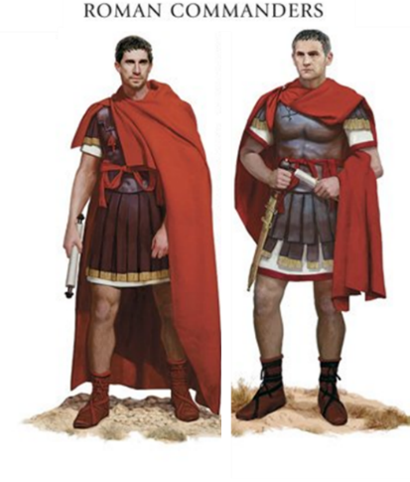Roman Soldier
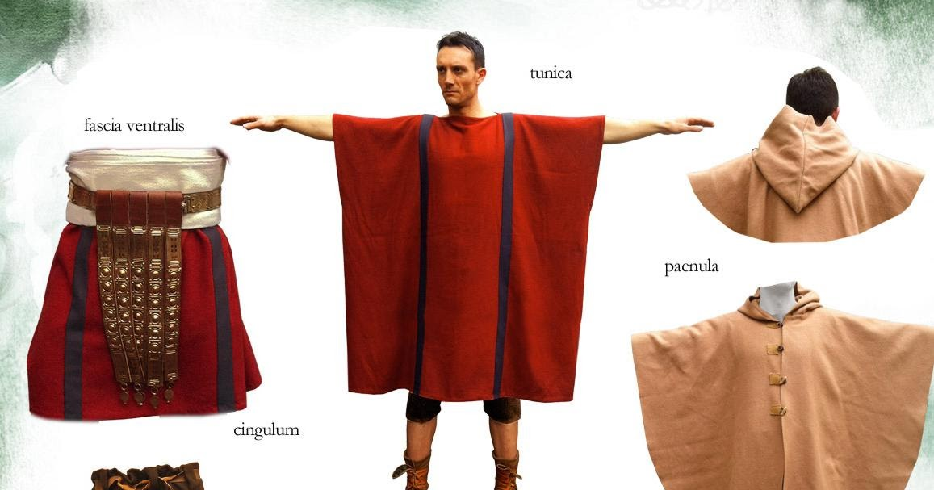
Roman soldiers were known to have been well paid, and it is known that they wore reddish, or could be viewed as somewhat purple, tunic. The garment described may very well have been provided by the Roman soldiers themselves in their mockery of Jesus.
Treatment of Jesus the Prisoner
In our world today, it is against the codes of war and all nations, in what can be considered the civilized world, to physically torture a prisoner the way Jesus was tortured. Irrespective of a soldier’s country of origin, the condition of the mind to treat another human being the way they did Jesus is telling of the brutality accepted in the 1st century. The Romans were not alone in their brutality. Up until recent times, history can detail the abusive treatment of prisoners. Obviously, today, many prisoners around the world are brutalized like Jesus was. The point being that without God and a God centered code of conduct for its citizens and its officers there is brutality in the world.
It is of note, that after the soldiers physically tortured Jesus, they took the purple robe from Him and put on His clothes again (Mark 15:20). However, we also note in John 19:4-5 ⁴ And Pilate came out again, and said to them, "Behold, I am bringing Him out to you, that you may know that I find no guilt in Him." ⁵ Jesus therefore came out, wearing the crown of thorns and the purple robe. And Pilate said to them, "Behold, the Man!" So, at some point before Jesus was presented to the crowd, the purple robe was placed back on Jesus.
Mark 15:17 They dressed him in a purple robe, twisted together a crown of thorns, and put it on him.
Luke 23:11 (NAS) And Herod with his soldiers, after treating Him with contempt and mocking Him, dressed Him in a gorgeous robe and sent Him back to Pilate.
Compare to
CSB17 Luke 23:11 Then Herod, with his soldiers, treated him with contempt, mocked him, dressed him in bright clothing, and sent him back to Pilate.
Friberg, Analytical Greek Lexicon

[Fri] λαμπρός, ά, όν shining, bright, radiant; (1) of heavenly bodies shining, bright (RV 22.16); (2) of pure water clear, sparkling (RV 22.1); (3) of clothes elegant, resplendent, shining (LU 23.11); (4) neuter as a substantive τὰ λαμπρά as elegant things for luxurious living dainties, splendor, lavish things (RV 18.14)
λαμπρός A--NM-S λαμπρός

John 19:2 (NAS) And the soldiers wove a crown of thorns and put it on His head, and arrayed Him in a purple robe;
Matthew 27:28 (NAS) And they stripped Him, and put a scarlet robe on Him.
Scarlet Robe (Purple or Scarlet?)
κοκκίνην. adjective accusative feminine singular no degree from κόκκινος
BYZ Mat 27:28 Notes: ¹ N περιέθηκαν αὐτῷ χλαμύδα κοκκίνην > χλαμύδα κοκκίνην περιέθηκαν αὐτῷ
Friberg, Analytical Greek Lexicon
κόκκινος, η, ον scarlet, crimson, red; neuter as a substantive τὸ κόκκινον scarlet cloth, dyed with κόκκος, a scarlet "berry," actually the female of a scale insect that clings to oak leaves, dried and crushed to prepare a red dye (RV 17.4)
Gingrich, Greek NT Lexicon (GIN) [GING] κόκκινος
κόκκινος, η, ον red, scarlet Mt 27:28; Hb 9:19; Rv 17:3; scarlet cloth or garment 17:4; 18:12, 16.* [pg 111]
Danker, Greek NT Lexicon (DAN) [DANK] κόκκινος
κόκκινος,η,ον [κόκκος] ‘having a shade of red’, scarlet – a. as adj. Matthew 27:28; Hebrews 9:19; Revelation 17:3; 18:12, 16. – b. as noun but without art. Revelation 17:4; 18:16.

Mark 15 continued
18 And they began to salute him, "Hail, King of the Jews!"
19 They were hitting him on the head with a stick and spitting on him. Getting down on their knees, they were paying him homage.
20 After they had mocked him, they stripped him of the purple robe and put his clothes on him. They led him out to crucify him.

Description of the Temple/Tabernacle veil separating the Holy of Holies.
Exodus 25:4 blue, purple and scarlet material, fine linen, goat hair,
Exodus 26:1 "Moreover you shall make the tabernacle with ten curtains of fine twisted linen and blue and purple and scarlet material; you shall make them with cherubim, the work of a skillful workman.
Exodus 26:31 "And you shall make a veil of blue and purple and scarlet material and fine twisted linen; it shall be made with cherubim, the work of a skillful workman.
Exodus 36:8 And all the skillful men among those who were performing the work made the tabernacle with ten curtains; of fine twisted linen and blue and purple and scarlet material, with cherubim, the work of a skillful workman, Bezalel made them.
Purple/Red/Scarlet
πορφύραν noun accusative feminine singular common from πορφύρα

Friberg, Analytical Greek Lexicon
[Fri] πορφύρα, ας, ἡ strictly, a species of shellfish yielding costly purple dye; in the NT of expensive garments made from cloth dyed purple purple garment (LU 16.19); (royal) purple robe (MK 15.17); purple cloth (RV 18.12)
πορφύραν N-AF-S πορφύρα _________________________________
Gingrich, Greek NT Lexicon (GIN)
[GING] πορφύρα
πορφύρα, ας, ἡ purple (cloth) Lk 16:19; purple (garment) Rv 18:12; cf. 17:4 v.l. Of the reddish purple cloak of the Roman soldier Mk 15:17, 20.* [porphyry] [pg 165] __________________________________
Danker, Greek NT Lexicon (DAN)
[DANK] πορφύρα
πορφύρα,ας,ἡ [origin uncertain, loanword in Lat. purpura ‘shell-fish, purple dye, purple-dyed cloth’] in NT not of purple dye itself, but of cloth or a garment colored w. purple dye and in the high grades very costly, purple garment Mk 15:17, 20; Lk 16:19; perh. of yard goods rather than finished garment purple (cloth) Rv 18:12.

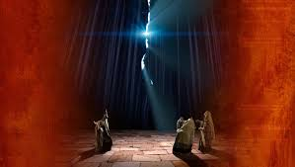
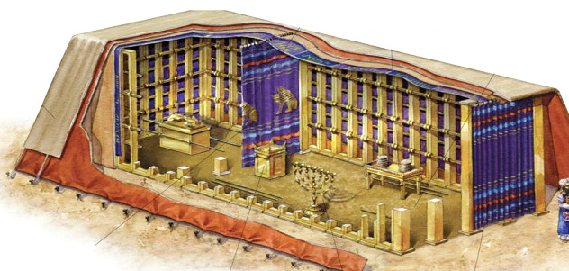

What Can We Take Home?
What most people do not know and have never read.
There is the obvious symbolism of the bright/scarlet/purple robe placed on Jesus as compared to the veil in the Temple that hung before the Holy of Holies and the inner court. Remember, the Holy of Holies is the place where the sacrificed blood from an unblemished animal was spilt by the High Priest on the Day of Atonement so that there would be forgiveness of sin to the nation of the Hebrew People. We have referenced the book of Hebrews previously (Hebrews 10; the whole book makes this statement) to identify Jesus as the superior One who takes the place of the High Priest and the whole sacrificial system and comes in the figure of (order of) Melchizedek, the Priest of Salem (Jerusalem, Mt. Moriah) who paid tithes to Abraham.
Therefore, to most observers, the robe is viewed by Biblical eyewitnesses as composed of the same color as the Temple Veil that split in two pieces upon Jesus’ last breath (Mark 15:38).
The instructions God gave to build the portable Tabernacle (Exodus passages noted above) detail blue, purple and red in that order with purple being in the center. When you mix blue and red, you get violet or a purple color Purple is the middle color listed in Exodus. The robe placed on Jesus represents (symbolic of) that He is the middle-man (mediator) between God and man. Jesus’ body was torn, and the Temple veil was torn symbolizing that man has direct access to God without any religious system in-between. For by one offering he has perfected forever those who are sanctified. (Hebrews. 10:14). The torn veil is the visual showing man’s direct access to God for forgiveness of sin. Because God, as Jesus the man, paid the price for the world’s sins and not a sacrificed animal which God never intended to take away sin.
Hebrews 10:1-8 1 Since the law has only a shadow of the good things to come, and not the reality itself of those things, it can never perfect the worshipers by the same sacrifices they continually offer year after year. ² Otherwise, wouldn't they have stopped being offered, since the worshipers, purified once and for all, would no longer have any consciousness of sins? ³ But in the sacrifices, there is a reminder of sins year after year. ⁴ For it is impossible for the blood of bulls and goats to take away sins. ⁵ Therefore, as he was coming into the world, he said: You did not desire sacrifice and offering, but you prepared a body for me. ⁶ You did not delight in whole burnt offerings and sin offerings. ⁷ Then I said, "See-- it is written about me in the scroll-- I have come to do your will, O God." ⁸ After he says above, You did not desire or delight in sacrifices and offerings, whole burnt offerings and sin offerings (which are offered according to the law),
The Jews had turned the Law into a border between man and God. Example being the money-changers. The Law was intended to demonstrate to people that there is no way to live life without making a mistake. Therefore, we are to turn to God in prayer, with a humble heart seeking forgiveness of sin. We seek the spiritual power from God to overcome our shortcomings. Thus, we live a better life. This is the difference between a Believer and non-believers.
This is basic Christianity. However, this is also a teaching that most people have never read, been taught or thought. In every act of the trial of Jesus, His death on the Cross, the Resurrection, the Resurrection teachings and the Ascension are for the benefit of man, for the redemption of man. God sincerely desires for fallen-man to come to Him, to surrender to Him. Reading the account of the Cross details a death that is symbolic of the condition of man. In man’s depravity, he crucifies his Savior. In God’s total love for man, He endures the Cross. He rises from the tomb to indwell His disciples who are then empowered to continue in His name to go forth and preach the Good News.
Carrying the Cross
21 They forced a man coming in from the country,
who was passing by, to carry Jesus's cross.
He was Simon of Cyrene, the father of Alexander and Rufus.

Matthew and Luke also have this account. People from Cyrene are identified as being in Jerusalem on the day of Pentecost (Acts 2:10). Cyrene is a city in modern day Libya. Men from Cyrene are also identified as being in Antioch (Acts 11:20) preaching the Lord Jesus. Also, in Acts 13:1, Lucius of Cyrene is noted as being among the prophets and teachers. Simon’s son is named Rufus. This name is also a name listed by Paul in his list of people to greet on his behalf who are in Rome (Romans 16:13). This could be another, but it is worth noting due to the fact that Simon and his sons were no doubt affected by his traumatic experience of carrying Jesus’ Cross. They may have all surrendered to the Cross. Remember, even the Centurion made an observation and a declarative statement, "Truly this man was the Son of God!" as Jesus breathed His last breath.
Simons’ sons were old enough to travel with their father to Passover and witnessed the Cross at a young age. We cannot help but to think about what was going through the minds and hearts of Simon and his sons, Alexander and Rufus, as their father was forced to carrying a man’s cross who was being crucified by the Romans. Would they ever see their father again? Might they too be taken into custody? We can see them attempting to keep-up with the procession from Pilate’s quarters to Golgotha. Both Luke and Matthew provide a witness that Simon was forced to carry Jesus’ cross right after they left Pilate. Historians tells us that it is at least 500 yards to Golgotha. Jesus had been tortured and was weakened. His physical ability to carry the Cross had been greatly diminished. There is much debate if Jesus was only to carry the cross-bar of the Cross or was the lumber basically a 4”x4”. The point in Mark’s account is that no matter how much the Cross weighed it was too heavy, and Simon was forced by the Romans to carry the Cross. Isaiah gives a prophetic insight into the physical condition of Jesus.
¹⁴ Just as many were appalled at you-- his appearance was so disfigured that he did not look like a man, and his form did not resemble a human being-- (Isa. 52:14)
²⁶ And when they led Him away, they laid hold of one Simon of Cyrene, coming in from the country, and placed on him the cross to carry behind Jesus. (Luke 23:26 NAS) (see Matthew 27:31)
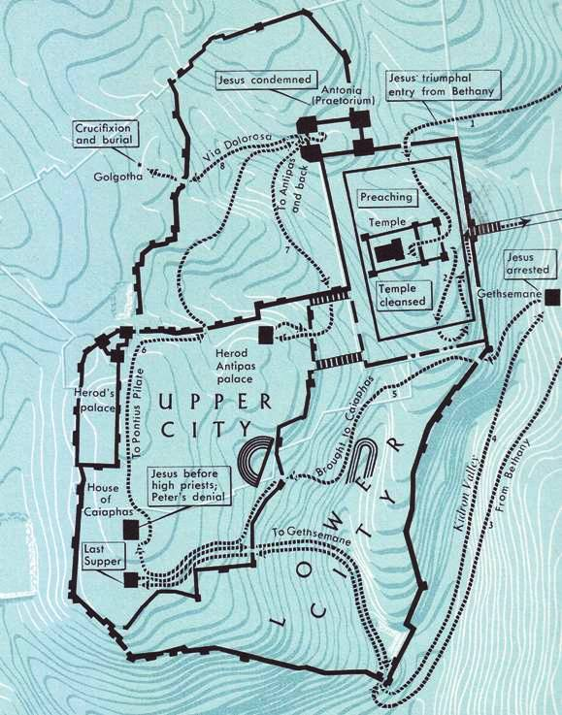

For Simon, force or not, a human being would be greatly impacted by this event in their life. Was Simon a follower of Jesus and that is why he was there at Jesus’ trial? Or was he a Jew who had viewed Jesus as a heretic and the events of the Cross converted him like it did the others?
Placing ourselves in Simon’s thought process. Can you imagine yourself as the one who was forced to carry the Cross of Jesus? However, at the time, you might have just thought Jesus was simply a condemned man. Would there be fear that the Romans would crucify you at the end of the journey just for good measure? Would you think perhaps your fellow countrymen might think you were a follower of Jesus? Most likely Simon was a Jew in town for Passover. Jesus was not from Jerusalem. It can be said that Jesus was from the country (coming in from the country). The crucifixion of Jesus was a spectacle for the masses. So, Simon was curious and got too close to the action. However, the text gives us his name. Simon obviously becomes known after the Cross?
What We Can Tell People
The challenge, I believe, most people will have after they hear the story of Simon being forced to carry Jesus’ Cross is to accept the account as true. People can dismiss the Bible as fables. However, what happened after the Cross of Christ to the world is as inescapable as the forced conscription of Simon by the Romans. It HAPPENED. Within three hundred years after the Cross, the very authority that gave the Jews permission to crucify Jesus turned to the very Cross for their own salvation as an empire.
It was an inescapable decision by Constantine just as it was an inescapable truth for Simon. He was forced to carry the Cross of Christ. It was his reality. Constantine was compelled to acknowledge Christ and His Cross after he heard a voice when he saw a starburst of light in the sky resembling The Cross. He reported that he heard a voice and that under this sign he would conquer. This was in the year 312 A.D. as he marched towards Rome to do battle with Maxentius for control of the empire.
The Battle of the Milvian Bridge took place between the Roman Emperors Constantine I and Maxentius on 28 October 312. It takes its name from the Milvian Bridge, an important route over the Tiber. Wikipedia
The account of the Cross, once heard, compels a person to make a decision: accept or deny. There is no in-between. This week, tell someone the story of Simon. How he was just part of the crowd watching a man fall who had been sentenced to crucifixion by the Romans. Then the Roman’s forced Simon to carry Jesus’ Cross. Some, see Simon as possibly surrendering to God willingly after he was forced by the Romans to carry the Cross. Simon’s experience will never be repeated. We will never be physically force to carry Jesus’ Cross. God gives us a choice. I pray that you choose to tell someone about Simon and his sons. Be in prayer as you are led by God’s Spirit regarding the person you share Simon’s experience with. Be prepared with the rest of the story. I mean, be prepared to tell the person that they too can join Christ with His Cross. Tell them that they can start with a simple prayer. ‘Lord, take me. I surrender to you. I accept you as my Savoir who died on The Cross to pay the price for my sins.’
Or perhaps a person does not have the exact words, because they have not read the Bible; they simply know they have an emptiness inside that needs to be filled. Perhaps all they can say with all sincerity from a humble heart is that they want to become a Christian and a simple prayer that says, ‘God, take me just as I am.’ AMEN

